THURSDAY
COMMUNITY EUCHARIST

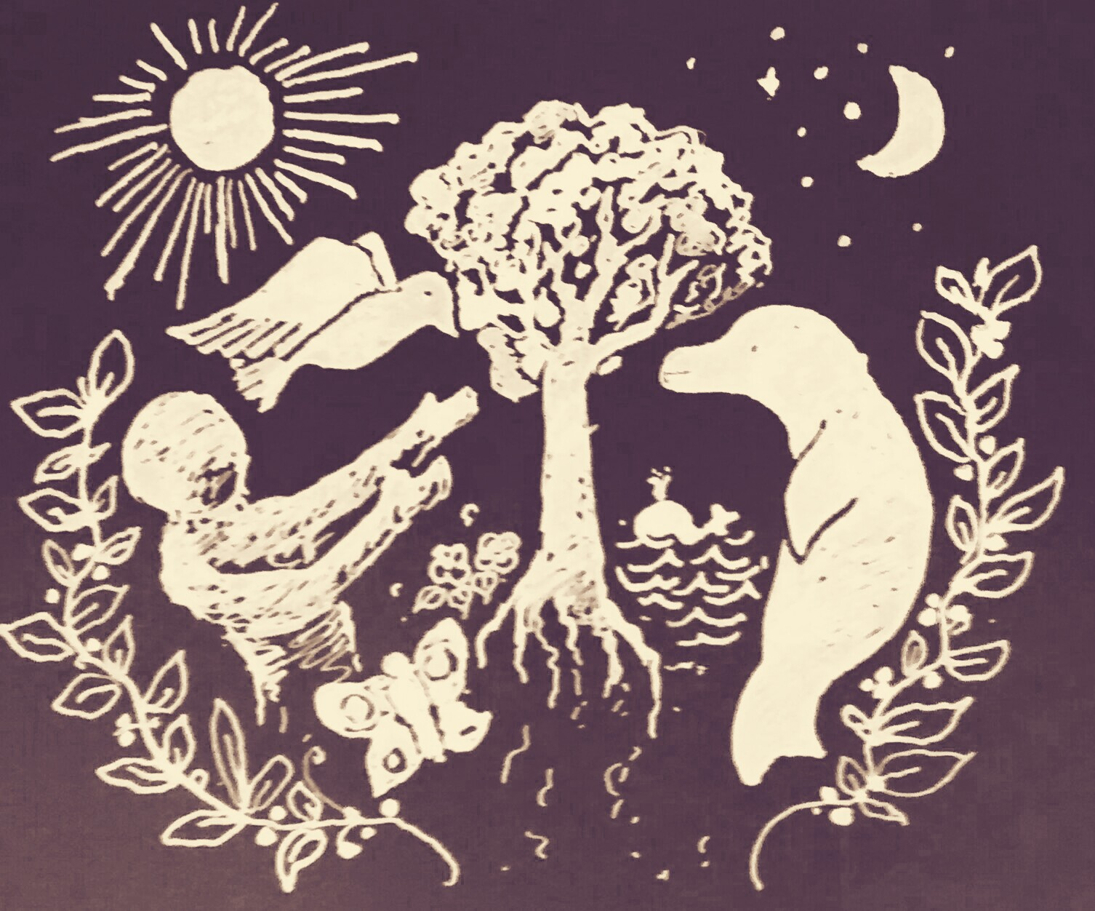

Context and Reflection

We started with the idea of some kind of plough service where we would give thanks for food and sustenance. We thought this would be a good learning opportunity for those of us going to or considering a rural parish ministry.

Plough services often include the participation of local farmers and involve the blessing of land, livestock and farming equipment such as ploughs. In the absence of a rural setting and direct links with the farming community we developed this idea further to consider our stewardship of the earth. With regret we reflected on the lack of focus within the church regarding environmental concerns and in response to this we developed this service, specifically in support of the 5th Anglican Mark of Mission: To strive to safeguard the integrity of Creation and sustain and renew the life of the earth.

The United Society explains that this mark of mission powerfully reminds us that God longs for harmony in the whole of Creation, not just in the human family. In contrast, humanity has become proficient in spoiling the planet, poisoning seas, rivers and land, cutting down forests, and endangering plants and animals. This is a terrible legacy to leave to future generations. Dave Bookless reflects that “… the fifth mark of mission is not an optional extra, or simply a contemporary reaction to our current environmental crisis, but rather a genuine recovery of a biblically integrated understanding of mission”.

The feast of Thomas Aquinas provides us with the opportunity to reflect on the church’s teachings with regard to mission and the stewardship of the earth. Through the service’s liturgy, bible readings, garden blessing, prayers and teaching we seek to renew and reinvigorate both our commitment to God’s creation and address the very real and serious ecological problems facing the planet.

The Gathering
Hymn
As the days begin to lengthen
With the hallowing of the year,
Christian people come to strengthen
Faith and hope amid doubt and fear;
Trusting all to God, the Father:
high in heaven, and ever near.

And when soil is ripe for turning,
Seeds of generous love are sown;
Then, by grace and holy learning,
Peace and providence can be known:
Fruits of wisdom and compassion
In the Kingdom of the Son.

So we come in expectation,
For the Spirit of God to bless
Land and plough and all who labour
With prosperity, joy and rest;
‘til Creation, Church and Nation
Come to know His loving best.

Glory be to God the Father:
Great Creator of everything,
And to Jesus Christ, our Saviour:
Earth’s Redeemer and heaven’s King;
And through God’s abiding Spirit,
Saints and Nature ever sing.

The president says:

In the name of the Father, and of the Son, and of the Holy Spirit.
All Amen.

The Greeting

The Lord be with you
All And also with you

The president welcomes the community

Prayer of Preparation

The earth is yours O Lord
All You created it and gave it form

You called life out of chaos
All Made humankind in your image,
co-creators with you

You looked at all you had made
and pronounced it good
All Blessed be God forever

Creator God, the whole earth sings of your glory. From the grandeur of the mountains and the forests to the quieter beauty of field and garden, Your hand is seen and praise resounds. From the sure footed sheep and cattle to the crops in the field Your hand is seen and praise resounds. From our care of creation, to our care of one another; Your hand is seen and praise resounds. Creator God, Father, Son and Holy Spirit all the world belongs to you, receive our praise.

All Amen.

Hebrew Bible Reading: Genesis 1: 26-31

At the end of the reading:

This is the word of the Lord
All Thanks be to God.

We stand to sing psalm 8. All are invited to join in the refrain.
O Lord our / governor,
how glorious is your name in / all the / world!
Your majesty above the heavens is / praised
out of the mouths of babes / at the / breast. Refrain
You have founded a stronghold against your / foes,
that you might still the enemy / and the a-/venger.
When I consider your heavens, the work of your / fingers,
the moon and the stars that / you have or-/dained. Refrain
What are mortals, that you should be / mindful of them;
the son of man, that you should / seek him / out?
You have made him little lower than the / angels
and crown him with / glory and / honour. Refrain
You have given him dominion over the works of your / hands
and put all things under his feet,
All sheep and oxen, even the wild beasts / of the / field,
The birds of the air, the fish of the / sea
and whatsoever moves in the / paths of the / sea. Refrain

Garden Blessing

The Altar Party moves to the garden and cloister area followed by the congregation. Sides-people will be on hand to guide you.

We gather together to ask God’s blessing on our garden and to reflect on our own blessings. We dedicate our efforts in this garden to the glory of God, to be used for God’s purposes here on earth.

As all the earth is a garden, Lord, we ask that you bless this small piece of the earth. As Your Light shines upon us and upon this garden, giving us life, likewise help us to give light and life to others.

All We pray you, Lord, to bless our garden.

We ask you, Lord, to bless the water that will nourish this garden. Help the roots of our plants tap into life-giving water. Help us to always be rooted in your love and in the water of the Holy Spirit.

All We pray you, Lord, to bless our garden.

We ask you, Lord, to bless the soil that nourishes new life in this ground and in this community. Help us to look in awe at the mysteries of your work not yet seen. Help us to appreciate the nourishment of your earth and use it wisely.

All We ask you, Lord, to bless our garden.

We ask you, Lord, to bless the seeds planted here. Help them to sprout and grow. Give all new life within this garden the right conditions to grow and bear fruit in Your Light.

All We pray you, Lord, to bless our garden.

We ask you, Lord, for the knowledge, wisdom, and tools to best tend our garden and do your work to give life to ourselves and others.

All We pray you, Lord, to bless our garden.

We ask for this blessing in the name of God, Father, Son and Holy Spirit.

All Amen.

Prayers of Penitence
Invitation to Confession

We confess our sin, and the sins of our society, in the misuse of God’s creation.

All God our Father, we are sorry
for the times when we have used your gifts carelessly, and acted ungratefully.
Hear our prayer, and in your mercy:
forgive us and help us.

We enjoy the fruits of the harvest,
but sometimes forget that you have given them to us. Father, in your mercy:
forgive us and help us.

We belong to a people who are full and satisfied, but ignore the cry of the hungry.
Father, in your mercy:
forgive us and help us.

We are thoughtless,
and do not care enough for the world you have made. Father, in your mercy:
forgive us and help us.

We store up goods for ourselves alone, as if there were no God and no heaven. Father, in your mercy:
forgive us and help us.

The priest says

The Lord enrich you with his grace, and nourish you with his blessing; the Lord defend you in trouble and keep you from all evil; the Lord accept your prayers, and absolve you from your offences, for the sake of Jesus Christ, our Saviour

All Amen.

The Priest will bless the garden and congregation with water.

All sing the Gloria in Excelsis. During the Gloria the younger members of Westcott are invited to the Cunningham Room for Little Saints. The remaining congregation is invited to follow the Altar Party procession to All Saints. As you enter All Saints you will be given a packet of seeds for use during the Act of Commitment, the Peace and the Dismissal.

Glory to God, glory to God, glory in the highest!
Glory to God, glory to God, glory in the highest!
To God be glory forever! To God be glory forever!
Alleluia, Amen! Alleluia, Amen!
Alleluia, Amen! Alleluia, Amen!
Alleluia, Amen! Alleluia, Amen!
Glory to God, glory to God, glory to Christ Jesus!
Glory to God, glory to God, glory to Christ Jesus!
To God be glory forever! To God be glory forever!
Alleluia…
Glory to God, glory to God, glory to the Spirit!
Glory to God, glory to God, glory to the Spirit!
To God be glory forever! To God be glory forever!
Alleluia…

The Liturgy of the Word

Remain Standing

Gospel Acclamation

Alleluia, alleluia, alleluia.
All Alleluia, alleluia, alleluia.

Hear the Gospel of our Lord Jesus Christ according to Matthew
All Glory to you, O Lord.

Gospel Reading: Matthew 25:14-30

At the end
This is the Gospel of the Lord.
All Praise to you, O Christ.
All sit
Sermon

The Prayers of Intercession

In addition to the Prayers of Intercession there will be an Act of Commitment during which you will need your packet of seeds.

The President introduces the Prayers of Intercession with these words:

In the power of the Spirit and in union with Christ,
let us pray to the Father.

Commitment

We ask you all to hold your packet of seeds for a moment. Packets of potential food, with the hope of a rich harvest and abundant growth from something so small and insignificant.

Knowing that God has blessed us with abundant riches, let us commit ourselves to strive to safeguard the integrity of creation, and sustain and renew the life of the earth.

(Take a moment to think of a practical action which you could make: maybe turning the heating down, turning off unused lights, avoiding stand-by mode)

Will you order your life to protect and preserve the earth’s resources, living simply so that others may simply live?

All We will.

(Take a moment to think of a practical action which you can take: maybe recommitting to choosing Fairtrade goods, avoiding palm oil in your food, shopping more efficiently to cut down the amount of food thrown away)
Will you pray for all who sow in the hope of an abundant harvest, for those who will grow and be fed by it?

All We will.

(Take a moment to think of a way you and your church might better provide for the hungry, e.g. through food banks, allotment projects, community cafes or by raising political awareness)
Will you preach the good news of God’s new creation that others may learn to tend and nurture it; and will you welcome others to feast on bread and wine at His table?

All We will.

Merciful God, you have blessed us richly, yet we offer to you our fears that what we sow may not grow to fruition. Sustain and nurture us as we make known your work in creation, and give us compassion as we look with wonder at even the smallest of seeds.
We pray that the good news rooted within us will feed the world around us, and knowing that you planted us in the garden of your delight, we pray that we may be counted in the harvest of your kingdom, through Jesus Christ the first fruits.
All Amen.

Merciful Father,
All Accept these prayers, for the sake of your Son,
Our Saviour Jesus Christ. Amen.

The Liturgy of the Sacrament

The Peace

The President introduces the Peace. During the Peace, as an outward sign of your commitment, we invite you to exchange your packets of seeds and perhaps a word or two to explain your commitment with those you greet.

Peacemakers who sow in peace raise a harvest of righteousness.
The peace of the Lord be always with you
All and also with you.

Let us offer one another a sign of peace.

Preparation of the Table

Offertory Hymn

Sides people will collect seed packets during the Offertory Hymn for you to collect following the Blessing and Dismissal.

“Great is Thy faithfulness,” O God my Father,
There is no shadow of turning with Thee;
Thou changest not, Thy compassions, they fail not
As Thou hast been Thou forever wilt be.
“Great is Thy faithfulness!” “Great is Thy faithfulness!”
Morning by morning new mercies I see;
All I have needed Thy hand hath provided—
“Great is Thy faithfulness,” Lord, unto me!
Summer and winter, and springtime and harvest,
Sun, moon and stars in their courses above,
Join with all nature in manifold witness
To Thy great faithfulness, mercy and love.
Pardon for sin and a peace that endureth,
Thine own dear presence to cheer and to guide;
Strength for today and bright hope for tomorrow,
Blessings all mine, with ten thousand beside!

Taking of the Bread and Wine

Prayers of Preparation

Blessed are you, Lord God of all creation: through your goodness we have this bread to set before you, which earth has given and human hands have made. It will become for us the bread of life.
All Blessed be God for ever.

Blessed are you, Lord God of all creation: through your goodness we have this wine to set before you, fruit of the vine and work of human hands. It will become for us the cup of salvation.
All Blessed be God for ever.

Blessed be God, by whose grace creation is renewed, by whose love heaven is opened, by whose mercy we offer our sacrifice of praise.

All Blessed be God for ever.

The Eucharistic Prayer

All |  | The Lord is here.  His Spirit is with us
 |  | Lift up your hearts.
All |  | We lift them to the Lord.
 |  | Let us give thanks to the Lord our God.
All |  | It is right to give thanks and praise.
 |  | Blessed are you, Lord God,
 |  | our light and our salvation;
 |  | to you be glory and praise for ever.
 |  | From the beginning you have created all things
 |  | and all your works echo the silent music of your praise.
 |  | In the fullness of time you made us in your image,
 |  | the crown of all creation.
 |  | You give us breath and speech, that with angels and archangels
 |  | and all the powers of heaven
 |  | we may find a voice to sing your praise:
 |  | How wonderful the work of your hands, O Lord.
 |  | As a mother tenderly gathers her children,
 |  | you embraced a people as your own.
 |  | When they turned away and rebelled
 |  | your love remained steadfast.
 |  | From them you raised up Jesus our Saviour, born of Mary,
 |  | to be the living bread,
 |  | in whom all our hungers are satisfied.
 |  | He offered his life for sinners,
 |  | and with a love stronger than death
 |  | he opened wide his arms on the cross.
 |  | On the night before he died,
 |  | he came to supper with his friends
 |  | and, taking bread, he gave you thanks.
 |  | He broke it and gave it to them, saying:
 |  | Take, eat; this is my body which is given for you;
 |  | do this in remembrance of me.
 |  | At the end of supper, taking the cup of wine,
 |  | he gave you thanks, and said:
 |  | Drink this, all of you; this is my blood of the new covenant,
 |  | which is shed for you and for many for the forgiveness of sins.
 |  | Do this, as often as you drink it, in remembrance of me.
 |  | Christ is the bread of life
All |  | When we eat this bread and drink this cup
 |  | we proclaim your death, Lord Jesus,
 |  | until you come in glory.
 |  | Father, we plead with confidence
 |  | his sacrifice made once for all upon the cross;
 |  | we remember his dying and rising in glory,
 |  | and we rejoice that he intercedes for us at your right hand.
 |  | Pour out your Holy Spirit as we bring before you
 |  | these gifts of your creation;
 |  | may they be for us the body and blood of your dear Son.
 |  | As we eat and drink these holy things in your presence,
 |  | form us in the likeness of Christ,
 |  | and build us into a living temple to your glory.
 |  | Remember, Lord, your Church in every land.
 |  | Reveal her unity, guard her faith, and preserve her in peace.
 |  | Bring us at the last with the blessed Virgin Mary and all the saints
 |  | to the vision of that eternal splendour
 |  | for which you have created us;
 |  | through Jesus Christ, our Lord,
 |  | by whom, with whom, and in whom,
 |  | with all who stand before you in earth and heaven,
 |  | we worship you, Father almighty, in songs of everlasting praise:
All |  | Blessing and honour and glory and power
 |  | be yours for ever and ever. Amen.

The Lord’s Prayer

Rejoicing in God’s new creation we pray with confidence as our Saviour has taught us:

All Our Father, who art in heaven,
hallowed be thy name;
thy kingdom come; thy will be done;
on earth as it is in heaven.
Give us this day our daily bread.
And forgive us our trespasses,
as we forgive those who trespass against us.
And lead us not into temptation;
but deliver us from evil.
For thine is the kingdom,
the power and the glory,
for ever and ever. Amen.

Breaking of the Bread

We break this bread to share in the body of Christ.
All Though we are many, we are one body,
because we all share in one bread.

Giving of Communion

Jesus is the Lamb of God

who takes away the sin of the world.

Blessed are those who are called to his supper.

All Lord, I am not worthy to receive you,

but only say the word, and I shall be healed.

Invitation to Holy Communion

As the grain once scattered in the fields and the grapes once dispersed on the hillside are now reunited on this table in bread and wine, so, Lord, may your whole Church soon be gathered together from the corners of the earth into your kingdom.

Communion Hymn

At the distribution of communion the choir sings the Agnus Dei.

Hymn
Now the green blade rises from the buried grain,
Wheat that in the dark earth many years has lain;
Love lives again, that with the dead has been:
Love is come again, like wheat that springs up green.
In the grave they laid Him, Love Whom we had slain,
Thinking that He’d never wake to life again,
Laid in the earth like grain that sleeps unseen:
Love is come again, like wheat that springs up green.
Up He sprang at Easter, like the risen grain,
He that for three days in the grave had lain;
Up from the dead my risen Lord is seen:
Love is come again, like wheat that springs up green.
When our hearts are saddened, grieving or in pain,
By Your touch You call us back to life again;
Fields of our hearts that dead and bare have been:
Love is come again, like wheat that springs up green.

After communion, a period of silence is kept and after the silence,

the President says:

Prayer after Communion

Father of Light in whom is no change or shadow of turning, you give us very good and perfect gift and have brought us to birth by your word or truth: may we be a living sign of that kingdom, where your whole creation will be made perfect in Jesus Christ Our Lord.
All Amen.

All Almighty God,
we thank you for feeding us
with the body and blood of your Son Jesus Christ.
Through him we offer you our souls and bodies
to be a living sacrifice.
Send us out in the power of your Spirit
to live and work to your praise and glory. Amen.

The Dismissal

Blessing

As we prepare to leave and embrace the challenges of our lives and our world, let us ask for God’s blessing.

May God bless us with strength to seek justice.
All Amen.

May God bless us with wisdom to care for our earth.
All Amen.

May God bless us with love to bring forth new life.
All Amen.

Come, Lord Jesus.
All Amen, Come Lord Jesus.

Hymn
O Lord my God, when I in awesome wonder
consider all the works thy hand hath made,
I see the stars, I hear the mighty thunder,
thy power throughout the universe displayed:
Then sings my soul, my Saviour God; to thee,
How great thou art, how great thou art!
Then sings my soul, my Saviour God; to thee,
How great thou art, how great thou art!
When through the woods and forest glades I wander,
and hear the birds sing sweetly in the trees;
when I look down from lofty mountain grandeur,
and hear the brook, and feel the gentle breeze;
But when I think that God, his Son not sparing,
sent him to die - I scarce can take it in
that on the cross, our burden gladly bearing,
he bled and died to take away our sin;
When Christ shall come with shout of acclamation
and take me home-what joy shall fill my heart!
Then shall I bow in humble adoration,
and there proclaim: My God, how great thou art!

Please turn to the back of the Church for the Dismal.
Don’t forget to collect a packet of seeds as you leave.
Tend the earth, care for God’s good creation, and bring forth the fruits of righteousness. Go in the peace of Christ.
All Thanks be to God.

Organ Voluntary

Copyright acknowledgement:
Material included in this service from Common Worship is copyright: © The Archbishops' Council 2000. All hymns and music are reproduced under CCLI Licence No. 218767 and MRL Licence No. 861200

