Creationtide and
Environment

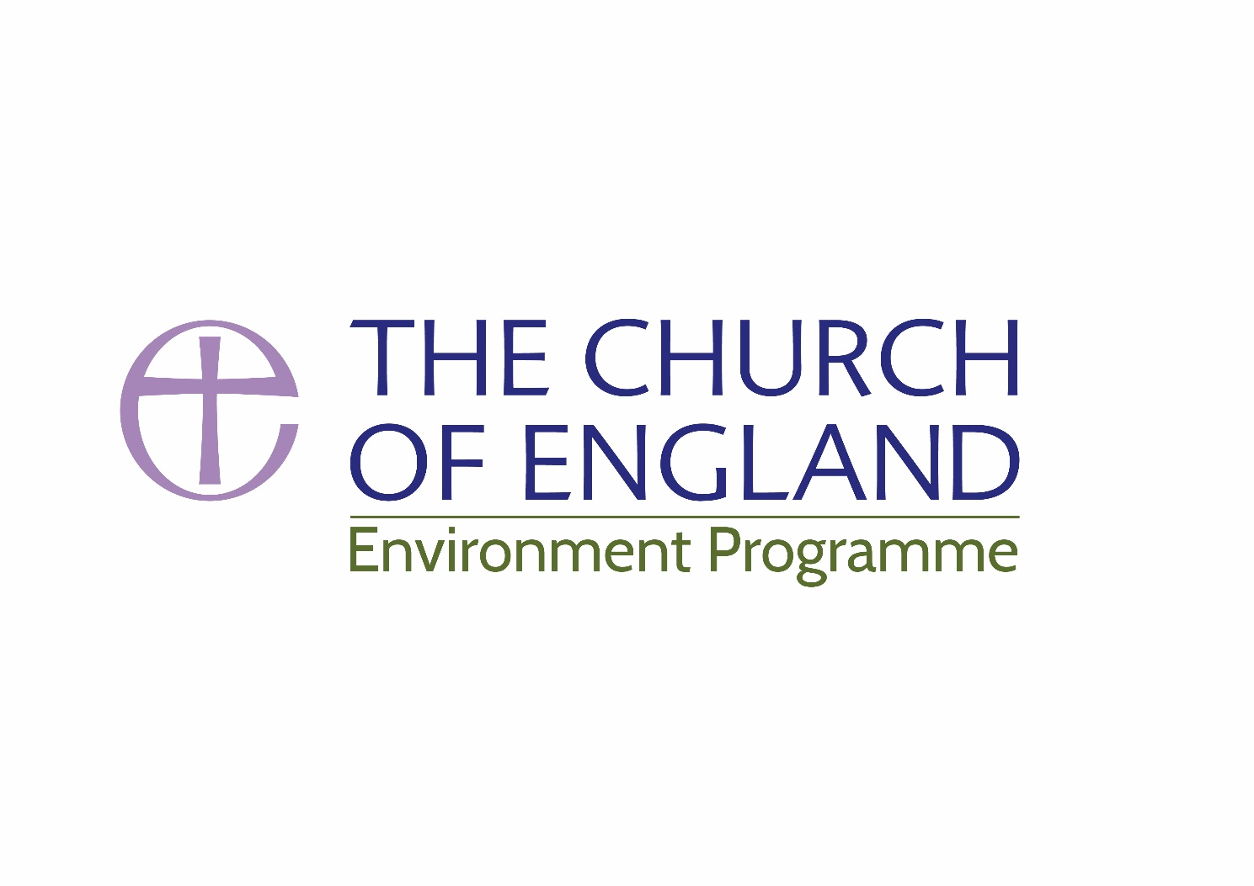
Resources for worship and prayer

Introduction

Every act of worship should be one that is thankful for all of the mysteries and wonders of God’s creation but, in a special way, Creationtide follows the Psalmists’ call to join our song of praise with the forests, rivers and fields who bring their own praise to the Creator.

Our common home is crying out to be cherished and our thankful praise should stir us to action and to tread more gently on the earth and care for our shared environment.

The following guide offers some starter suggestions for worship and prayer exploring the themes of creation and the environment to help the whole church proclaim ‘The earth is the Lord’s and all that is in it.’

The Church of England, has endorsed the observance of a "Time for Creation", from 1 September (the first day of the church year for the Orthodox Churches) to 4 October (the feast of Saint Francis of Assisi).

During this season congregations are encouraged to give particular focus to environmental issues. Time for Creation links in naturally with the time when we celebrate harvest thanksgivings.

Scripture

Old Testament
Genesis 1:26-31

Genesis 1.1-2.3
Genesis 6:11-21

Genesis 8.12-22

Genesis 9. 8-17
Exodus 16.11-15

Job 12:7-10
Isaiah 24:1-23

Isaiah 55:11-13

Deuteronomy 6. 9-14
Deuteronomy 8.7-18

Deuteronomy 11:10-15

Deuteronomy 24:19-22
Deuteronomy 26.1-11

Leviticus 25:2-5
Leviticus 23.33-43

Leviticus 26.1-13

Amos 9.13
Hosea 2.18-23

Hosea 14.2-10

Isaiah 11.1-1a
Isaiah 25.6-9; 55.6-11
Isaiah 35.1-7
Jeremiah 32.6-15

Ezekiel 34.25-31

Ezekiel 37.1-14
Ezekiel 47.6-12

Ecclesiasticus 42.15-43.12

Song of Songs 4.12-13

The story of creation

A cosmic hymn of praise
The story of Noah and the Ark

Creation restored after the deluge

God’s promise to sustain creation
God’s provision

In God’s hand is the life of every living creature
A vision of a desolate land

The trees and the fields shall clap their hands

God’s gifts to the redeemed
The gift of the land

A land for which the Lord cares

People are told not to exhaust the harvest
Offering of the first fruits

The Lord commands rest for the land
A feast of fruitfulness

The promise of a fertile land

The promise of restoration
The covenant of peace with all creation

Repentance and restoration

The harmony of animal kingdom in the messianic age

Feasting in God’s presence

The blossoming of the wilderness
A sign of a fruitful future

God promises his people a peaceable land

The hope of humankind restored
A vision of waters restoring the land

The wonder of creation

A garden as symbol of divine love

Ruth 2.1-13
Job 14.7-10

Job 38. 1-11, 16-18
Proverbs 8.1-4, 22-31
Kinship and the land

Defiant nature and the hope of immortality

God’s majesty and creation’s marvel
God’s wisdom and creation

The Psalms
Psalm 8 In praise of the wonderful order of creation

Psalm 19 The heavens are telling the glory of God

Psalm 24 The earth is the Lord’s and all that fills it
Psalm 65 The meadows and valleys shout for joy.

Psalm 104 The Creator God sustains the earth

Also Psalms 80, 90.1-6, 13-end, 100, 103, 106, 107, 112, 126, 136.1-9, 23-26, 146, 147.1-13

New Testament

Matthew 6.25-34 Sufficiency of resources and simplicity of lifestyle
Mark 4:1-9 Exploring the miracle of growth

Mark 4.35-41 The Lord of nature brings peace to violent discord
Mark 4.30-32 From the seed to a tree of life

(Luke 13.18-19; Mt.13.31-32)

Luke 13.6-9 Nurturing the fig tree
John 6.1-13 Hungry people fed on Christ’s abundance

John 15. 1-17 God’s people as a fruitful vine

John 20.15 The Risen Christ appears in the garden
John 21.1-14 The risen Christ and the abundance of life

Colossians 1:15-20 All things in heaven and earth are reconciled
Colossians 1.1-15 Christ as the new creation

Romans 8.18-22 The natural world longing for liberation

2 Corinthians 9.9-11a God’s generosity and human gratitude
1 Timothy 6.7-10,17-19 Sufficiency of resources and simplicity of lifestyle

Revelation 2.1-7 The promise of paradise restored

Revelation 22.1-5 Creation renewed for the healing of the nations

Hymns and Songs

For the beauty of the earth, Great is thy faithfulness,
Shout to the Lord, All things bright and beautiful,
Now the green blade riseth, Dance and Sing all the earth,
Creation sings the Fathers Song,
Rising, What can I do (When I see the sky),
Thou whose almighty word, As the deer pants,

God is Good, his the care,
Beauty for Brokenness, O God of earth and altar,

We sing the Greatness of our God,
All creatures of our God and King,
We plough the fields and scatter, Morning has broken,
For the fruits of his creation,
Praise to the Lord, the Almighty, You shall go out with joy,
How Great is our God, Praise God from whom all blessings flow

Songs for children

Who made the twinkling stars?
Think of world without any flowers

Who put the colours in the rainbow

My God is so big, If I were a butterfly
Autumn Days, Push little seed

When God made the garden of creation

Over the earth there is a mat of green

Taizé chant
Misericordias Domini, See I am near, Laudate omnes gentes

Listening to Classical & Popular music Joseph Haydn, Creation, Oratorio

Gustav Mahler, Das Lied von der Erde (The Song of the Earth)

Benjamin Britten, St Nicholas: Setting of 'All Creatures that on Earth Do Dwell'
John Tavener, The Lamb; The Whale

Vivaldi, The Four Seasons
John Cage, Litany for the Whale

John Rutter, A Gaelic Blessing, For the beauty of the earth.

Eric Whitacre, The Seal Lullaby, Cloudburst

The British Library has a catalogue of recordings of animals and birds which you can listen to online

Prayers for the Earth

based on the fifth mark of mission

To strive to safeguard the integrity of creation and sustain and renew the life of the earth

To Strive…
God, creator of the universe,
Fill us with your love for the creation,
for the natural world around us,
for the earth from which we come
and to which we will return.
Awake in us energy to work for your world;
let us never fall into complacency, ignorance,
or being overwhelmed by the task before us.
Help us to restore, remake, renew. Amen

To Safeguard
Jesus, Redeemer of the World,
Remind us to consider the lost lilies,
the disappearing sparrows;
teach us not to squander precious resources;
help us value habitats:
seas, deserts, forests and seek to preserve this world in its diversity.
Alert us to the cause of all living creatures
destroyed wantonly for human greed or pleasure;
Help us to value what we have left
and to learn to live without taking more than we give. Amen

Integrity of Creation
Spirit of the Living God
At the beginning you moved over the face of the waters.
You brought life into being, the teeming life
that finds its way through earth and sea and air,
that makes its home around us, everywhere.
You know how living things flourish and grow
How they co-exist; how they feed and breed and change
Help us to understand those delicate relationships,
value them, and keep them from destruction. Amen

To Sustain…
God, of the living earth
You have called people to care for your world –
you asked Noah to save creatures from destruction.
May we now understand how to sustain your world –
Not over-fishing, not over-hunting,
Not destroying trees, precious rainforest
Not farming soil into useless dust.
Help us to find ways to use resources wisely
to find a path to good, sustainable living
in peace and harmony with creatures around us. Amen

To Renew
Jesus, who raised the dead to life
Help us to find ways to renew
what we have broken, damaged and destroyed:
Where we have taken too much water,
polluted the air, poured plastic into the sea,
cut down the forests and soured fertile soils.
Help all those who work to find solutions to
damage and decay; give hope to those
who are today working for a greener future. Amen

Anne Richards, Mission Theology Advisory Group,
The Dispossession Project: Eco-House
Resources available on www.ctbi.org.uk

Quotes

The world has been created for everyone's use, but you few rich are trying to keep it for yourselves. For not merely the possession of the earth, but the very sky, the air, and the sea are claimed for the use of the rich few… The earth belongs to all, not just to the rich. St. Ambrose of Milan (340-397)

Let us be ‘protectors’ of Creation, protectors of God’s plan inscribed in nature, protectors of one another and of the environment. Let us not allow omens of destruction and death to accompany the advance of this world!” From the Installation Mass Homily of Pope Francis, (2013)

We need an imaginative commitment to new ways of approaching the subject of climate change that does not accept a deterministic or selfish nationalistic policy. We cannot simply look at ourselves and say, ‘we must do better’, and kick the ladder away from the vast majority of humankind that is struggling to find the prosperity that we enjoy so richly. This is not a standalone issue. It cuts across all we do. Archbishop Justin Welby (2015)

Further Reading

Sharing God’s Planet: A Christian Vision for a sustainable future, Claire Foster (CHP) (2005)
Creation in Crisis Christian perspectives on sustainability Eds Robert S White (SPCK) (2009)
A Political Theology of Climate Change, Michael S. Northcott, (SPCK), (2014)
Together for a season series, using Common Worship through the year. (CHP) (2007)
Seven Songs of Creation: Liturgies for celebrating and healing earth, Ed: N.C.Habel, Pilgrim Press, (2004)
Renewing the Face of the Earth: A theological and pastoral response to climate change David Atkinson, Canterbury Press, (2008)
The Season of Creation: A Preaching Commentary’ Eds: Habel, N.C., Rhoads D., Santmire, H.P. Fortress Press, (2011)
Places of Enchantment: Meeting God in Landscapes, Usher, G.B. (SPCK) (2012)
Planetwise: Dare to care for God’s world, Dave Bookless, Intervarsity Press (2008)
On Earth as in Heaven: Ecological Vision and Initiatives of Ecumenical Patriarch Bartholomew, Ed J.
Chryssavgis Fordham University Press, (2012).
Laudato Si’, Encyclical Letter of the Holy Father Francis on care of our common home. (2015)

Links to worship and study resources

A Special Example: All Creation Worships (Holy Communion) New Patterns for Worship (CHP), p458: www.churchofengland.org/prayer-
worship/worship/texts/newpatterns/sampleservicescontents/npw22.aspx

Roots on the web | www.rootsontheweb.com
European Christian Environmental Network | www.ecen.org
Arthur Rank Centre | www.arthurrankcentre.org.uk
Shrinking the Footprint | www.churchcare.co.uk/shrinking-the-footprint
Christian Aid | www.caweek.org
Tearfund | www.tearfund.org
Operation Noah | operationnoah.org
Churches Together in Britain and Ireland | https://ctbi.org.uk/dispossession-project
A Rocha and Eco-Church initiative | http://arocha.org.uk
Anglican Environmental Network | http://acen.anglicancommunion.org

Common Worship: Times and Seasons also has a rich selection of resources on pages 599-606 and 623-632. Those who pray the daily office may wish to use the material on pages 536, 537 and 541 of in Common Worship: Daily Prayer to add a seasonal flavour.

