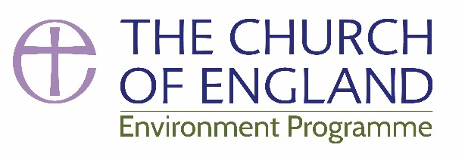
E-news Winter 18

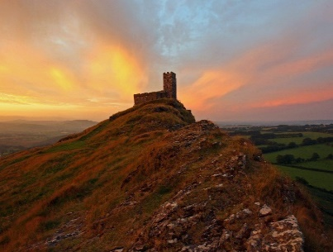
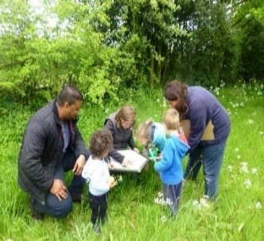
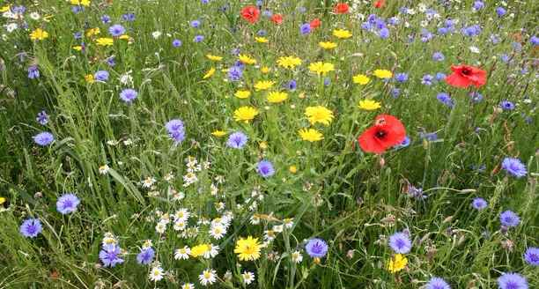
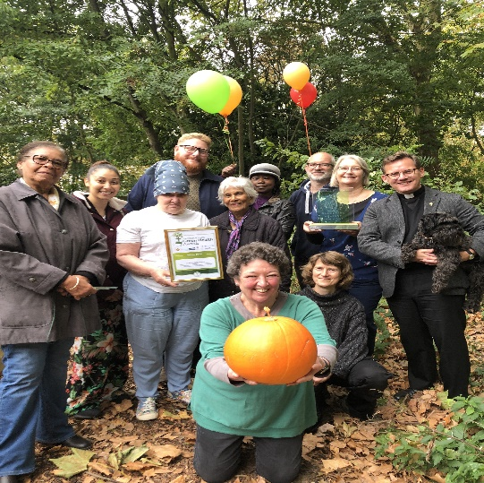

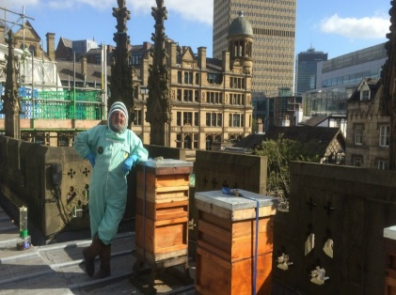
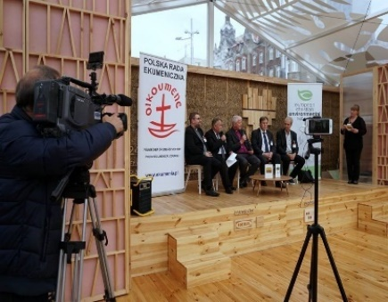
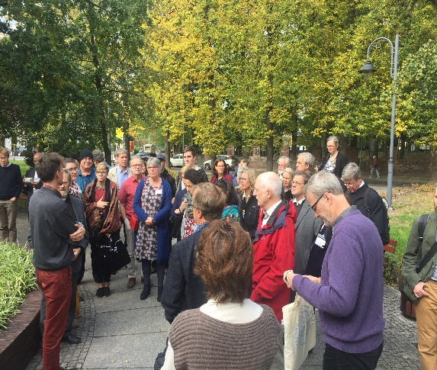
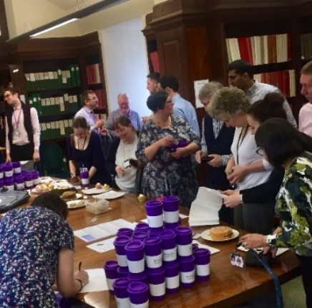

‘we must not just state our beliefs: we must live them out’
Archbishop of Canterbury Justin Welby

COP24 Climate Change Conference, Katowice
‘The most hopeful stories about climate change over the past two weeks have been from outside the walls of the summit. School children striking for their future, grass roots movements mobilising and even the world’s biggest shipping firm, Maersk, announcing it will go net zero emissions by 2050. The global transition is under way and cannot be stopped. The question is will governments help it go fast enough to help the world’s poorest on the front lines of climate change.’ Mohamed Adow, Christian Aid.

Although world leaders managed to set the framework for how to govern the Paris Agreement at Katowice last week there was little of the ‘rapid, far-reaching change’ called for in the IPCC 1.5 ºC report. Ecumenical Patriarch Bartholomew called for urgent action writing ‘The truth is that we can no longer afford to wait, indecision and inaction are not options. Faith makes it clear that we have a choice. The time to choose is now’ and David Attenborough spoke passionately at the meeting on behalf of people around the world. Read the statement from faith communities given at the summit and Christian Aid’s report.
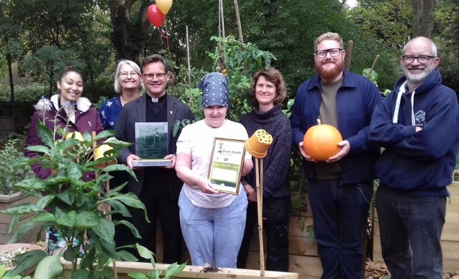
Green Health Awards - Congratulations to… St Paul’s, Camden Square, who were declared the overall winner at a ceremony in Lambeth Palace. They won an award of £2000 for their Woodland Garden which serves as both a wildlife refuge and a space for growing fruit and vegetables in the heart of London. The Green Health Awards celebrate the benefits of engaging with the natural world for mental, physical and spiritual health. Read more about the award winners
St Paul’s Church Camden Square
Some of those winning Green Health awards were involved in social prescribing programmes with NHS trusts where GPs refer patients to local projects such as community gardens to help improve mental and physical health and tackle issues like social isolation. You can read more about social prescribing here and be inspired by the project at Wharton and Cleggs Lane Church
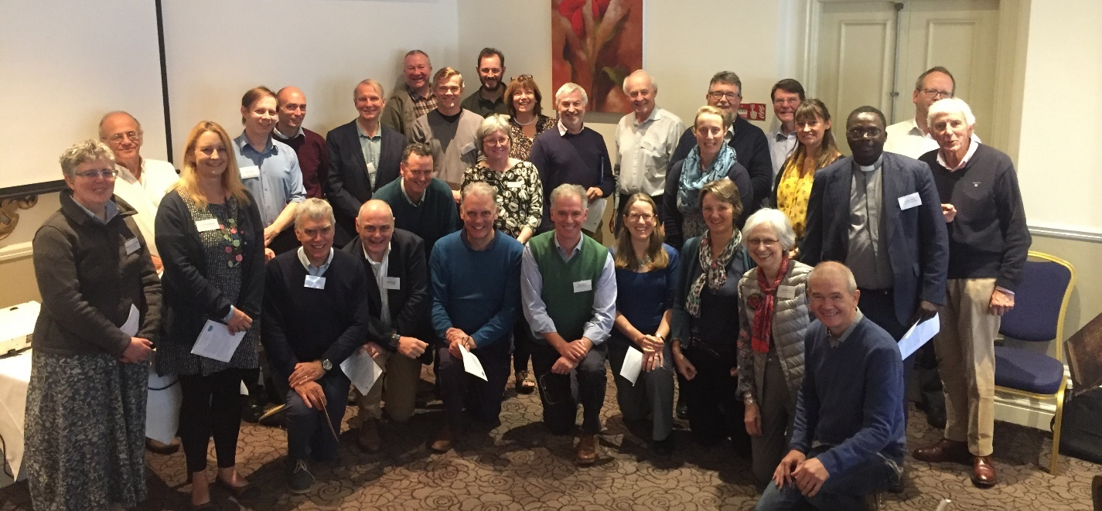
Do you know who your Diocesan Environment Officer (DEO) is? You can check here. Most DEOs are voluntary but work tirelessly to support and promote environmental action. Are you interested in helping out in your local area? Let us know.

Earlier this year DEOs and Diocesan Advisory Committee (DAC) secretaries came together for a joint event in Salisbury to discuss ways in which dioceses can support churches in being more environmentally sustainable and this will be developed further in 2019.

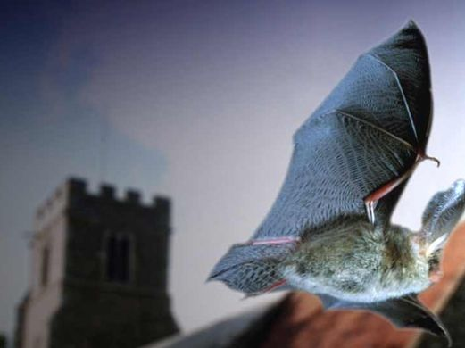
Bats in Churches - A significant £3.8m grant has been secured for a ground-breaking five-year project working on Bats in Churches. The partnership involves the Church of England, Natural England, Historic England, Bat Conservation Trust and Churches Conservation Trust. Most churches have bats but some have such large or active roosts that services, community activity and building work can be disrupted and interiors damaged. The project involves providing practical solutions for these churches and building up a picture of our bat populations nationally through citizen science work as well as training new volunteers to provide support and engage communities with their natural and built heritage. The project team are currently being recruited but as work begins you can follow the project here.

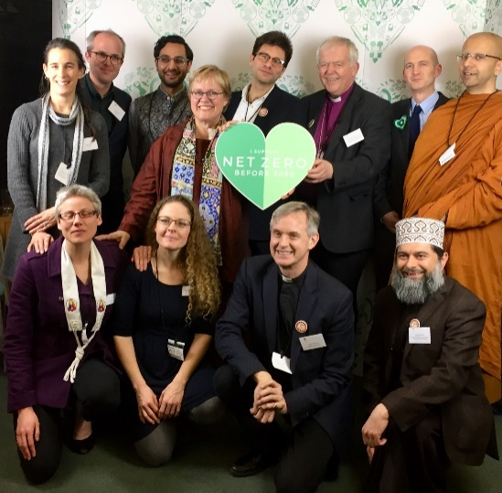
Happy Birthday to the Climate Change Act- Ten years ago, MPs across the country and across parties put their differences aside to create a unified voice—one that called for cleaner communities, greener countryside, and safer futures. The Act has achieved a lot worth celebrating but there is more to do. The Bishop of Salisbury spoke alongside Lord Deben at an event looking back at progress and forward to the future, you can read JRI’s Dr Martin Hodson’s report on the meeting here. The Bishop also joined the Climate Coalition in calling on Government for a Net Zero emissions target. You can add your voice to that call by writing to your MP.
10th birthday for the Climate Change Act
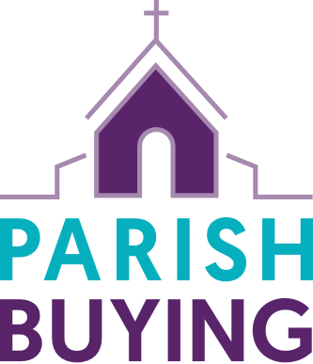
Parish Buying - don’t forget that there are deals on LED bulbs, green energy, eco cleaning products, recycled paper, Fairtrade tea & coffee and much more available through Parish Buying.
Is there anything you would like to see featured that isn’t yet available?
We are working on a preferred suppliers list for everything from reusable mugs to energy audits which will be available in mid 2019.

Church Schools in Southwark diocese will take part in the Ashden Trust’s Less CO2 energy efficiency programme in the new year. This free energy efficiency programme offers a series of half day workshops spread through the year backed up by expert advice, resources and peer mentoring.

Feed in Tariffs – are likely to end on 31st March 2019. Export tariffs may also be removed. If you are considering a solar project check here to see the latest information on this. Also take a look at Historic England’s updated guidance.

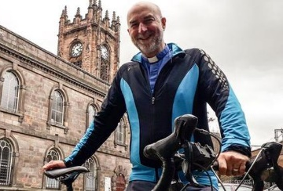
Diocese of Manchester is supporting the Beelines project - the plan by Chris Boardman and Transport for Greater Manchester to transform Manchester into Britain’s first ‘cycling city.’ The diocese is encouraging churches to welcome cycling by offering bike racks, cycling cafes and safety courses. They have even created an interactive map to help churches see where they sit on the Beeline network.
Sustainable Church Buildings Project wins European award – you can read more about this exciting programme of work bringing together environmental audits, energy bench marking, grant funding and a learning programme here.

Eco Church - Over 1200 churches and growing Eco Church is a great tool for engaging congregations with environmental issues. There are now 4 Eco Diocese Bronze award winners, congratulations to Salisbury, Birmingham, Guildford and Winchester, and 17 Eco Dioceses! Still need persuading to get involved? Take a look at this film from Winchester Diocese.

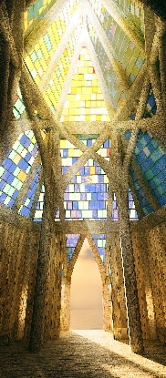
Grow Wild Seed Kits - Kew Gardens and the Big Lottery will be releasing another batch of free wildflower seed kits in the spring. The Grow Wild site has lots of useful advice on everything from sowing to assessing your soil. Get your church, community or local school group involved in a growing project. You can apply for some free seeds here.

Building Hope –an initiative from the Norwegian Diocese of Borg. The Hope Cathedral project is bringing people together from across Europe in a collective effort to clean the ocean and raise awareness of plastic pollution. Over the next two year’s volunteers will assemble a wooden cathedral inspired by traditional Norwegian stave churches and incorporating blocks made out of plastic found in the sea. The project brings together world heritage and modern art, drawing in people from all ages, nationalities and faiths.

Our global neighbours – The European Christian Environment Network and Anglican Communion Environment Network are fantastic links to Christians around the world and are a source of inspiration and encouragement. You can see the ECEN Facebook page here and visit the ACEN page here.

Voices from across the Anglican Communion are speaking out on climate change.
The Bishop of Salisbury, as lead bishop on the Environment for the Church of England, called for a "net zero emissions by 2050" commitment from the UK Government.
Archbishop Thabo (Anglican Church of Southern Africa), Archbishop Chama (Anglican Church of Central Africa) and Archbishop Brislin (Catholic Archdiocese of Cape Town) spoke out about the IPCC report and committed their Provinces to reduce their carbon footprint, pledging that church buildings will become models of energy efficiency, committing to divest from fossil fuels, to install small scale solar farms and to plant trees. Archbishop Thabo Makgoba was also the key note speaker in a virtual summit held by the Vulnerable Nations Forum in the Marshall Islands.

In Australia the Dean of Brisbane spoke out saying "Climate Change is a moral issue" and "Care for God's Creation requires us to act now". You can also see letters from across the Anglican Communion on our Letters for Creation project site.

All these voices will come together at the Lambeth Conference in 2020 and 17 African Anglican bishops from Southern, Central and East Africa have issued a call for ecological and climate justice to be at the top of the agenda.

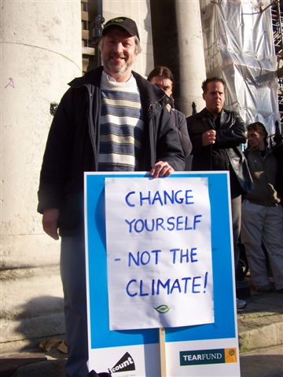
Goodbye to Martyn Goss
Martyn has been involved with environmental and social-justice work for almost 30 years and is stepping down as Director of Church & Society in the Diocese of Exeter and from the national Environmental Working Group at the end of this month. In 2010, he helped to found EcoChurch Southwest, a partnership that brings together seven dioceses and the renewable-energy provider Ecotricity. It has resulted in more than 400 renewable energy installations and more than 100 church buildings using green electricity and gas only. Beyond this he has been involved with a huge range of projects from community energy and food waste to global justice and land use. He will be greatly missed. We thank him for all that he has contributed and wish him the very best for his retirement. You can read Martyn’s Advent blog here.

Resources:
Lent resources – the Church of England Lent resources are available here. Some groups have asked for the 2018 Lent Plastics Challenge in Word format for alteration and re-use this coming year, this can be found here.

A green church is a just church – take a look at Naomi Osinnowo’s piece on the Evangelical Alliance site which asks, is caring for our planet an essential part of social justice?
Powering God’s Northern Powerhouse – after an excellent conference on sustainable heating and lighting the presentations are available online here.

Are you an ordinand or minister in training? Green Christian are offering a free two year GC membership (with digital magazine).

Looking for environmental bible study courses? Take a look at this list from Diocese of Leeds for inspiration.

Pray and Fast for the Climate - Don’t forget that there are some fantastic resources available to help you pray and fast on the 1st of each month.

Faith for the Climate Network – a group of more than 100 faith-based organisations and individuals working on climate issues. Follow the network on Twitter @fftcnetwork

ECIU Briefings - The Energy & Climate Intelligence Unit provide some excellent briefings which distil complex issues into straightforward and accurate articles.

Earth Day Network – an environmental movement that works across 192 countries across the world. Activity focuses on Earth Day (22 April) but there a lots of useful resources on the website including a great page on ways to take action.

UK Climate projections have been upgraded. The UKCP18 was published in November and is the most comprehensive picture yet of how the climate could change over the next century. You can read more about the projections and how they may be used in the not-for-profit sector here.

Michael Gove on ‘A Harvest for the World’ - Report by Dr. Martin Hodson on the Theos Annual Lecture.

Talk by Bishop David Atkinson at the recent Green Christian annual members meeting. Take a look here.

Wild Christian has launched - In the chaos of modern living, it’s often difficult to stay connected to nature. Wild Christian is A Rocha’s new programme for Christians to re-engage with nature in the context of our faith. You can join the community here.
Do you use the Eco search engine Ecosia? Switch your searches and plant trees!

Dates for the diary:
11-13 Jan. Future Earth? - Sustainability for the Environment. For Farming and for Healthy Food. Christians Aware Annual Conference, Swanwick
1 Feb. Faith, Hope and Action in a Changing Climate, with Greg Clark MP and Dr Ruth Valerio
2 Feb. Caring for our Common Home, Keswick
9 Feb. Festival of Transformation, Bristol
14 Feb. Show the Love, Climate Coalition
2 March Eco Church Conference, London
30 March Eco Church Conference, Wells
22 April Earth Day
18-20 June Flood and Coast, Telford International Centre
1 Sept. - 4 Oct. Creationtide
3 -7 Sept. Zero Waste Week
22 Sept. World Car Free Day
13 Sept. UN Climate Summit, New York

Didn’t receive this newsletter directly but would like to? Please sign up on our website.

www.shrinkingthefootprint.org @CofEEnvironment @ShrinkingtheFootprint

Shortly to be moving to www.churchofengland.org/environment
©Colin Sargent/David Harris

