Mission Theology Advisory Group

Who we are and what we do

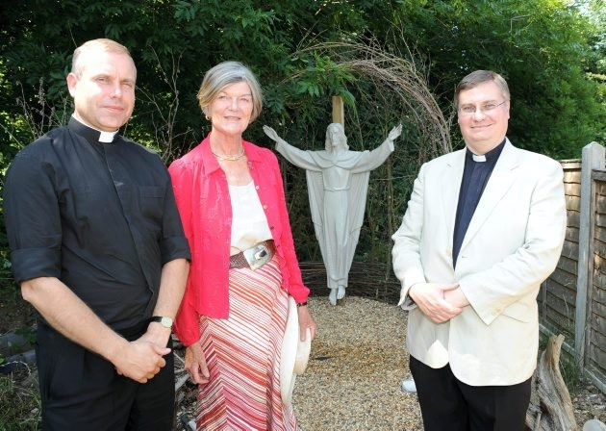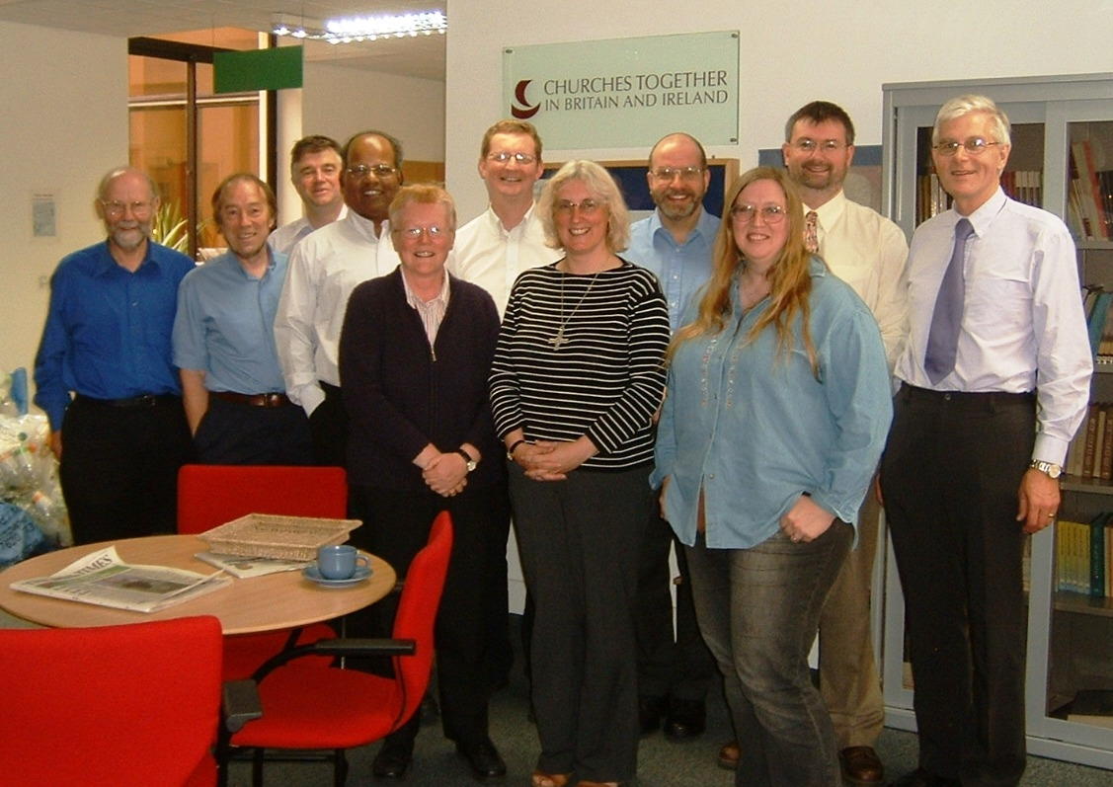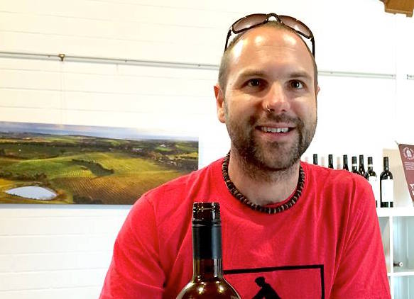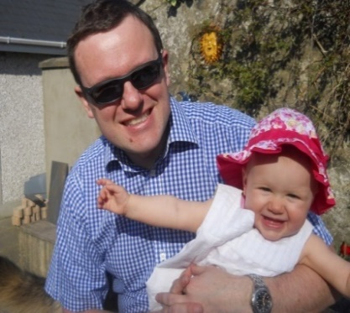******MISSION THEOLOGY ADVISORY GROUP**

**A PARTNERSHIP BETWEEN CHURCHES TOGETHER IN BRITAIN AND IRELAND AND THE CHURCH OF ENGLAND**

And Mission

Evangelism

Reconciliation

Theology

Spirituality

We are committed to appropriate and effective evangelism using our book *Sense Making Faith* and our work on five themes in the theology of evangelism

We provide materials on peace and reconciliation through our book *Unreconciled?* And through active peacemaking through our members in Calais

We provide mission theological thinking on current issues, including on Migrants Money Flooding Trafficking Food banks Lent and Advent

We provide resources for people searching for faith through our website *Spiritual Journeys* with more than 1000 things to explore, look, do, ask and dream

[www.spiritualjourneys.org.uk](http://www.spiritualjourneys.org.uk) [www.facebook.com/missiontheologyadvisorygroup](http://www.facebook.com/missiontheologyadvisorygroup) [www.dispossessionproject.org](http://www.dispossessionproject.org)

We specialise in mission in relation to social action, through *The Dispossession Project*, and in our work on social engagement and evangelism