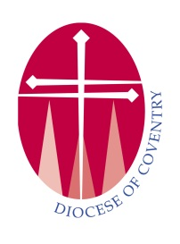
Diocese of Coventry
Training Post for Deacon who expects to be ordained Priest

Curate @ St Mark’s, Coventry

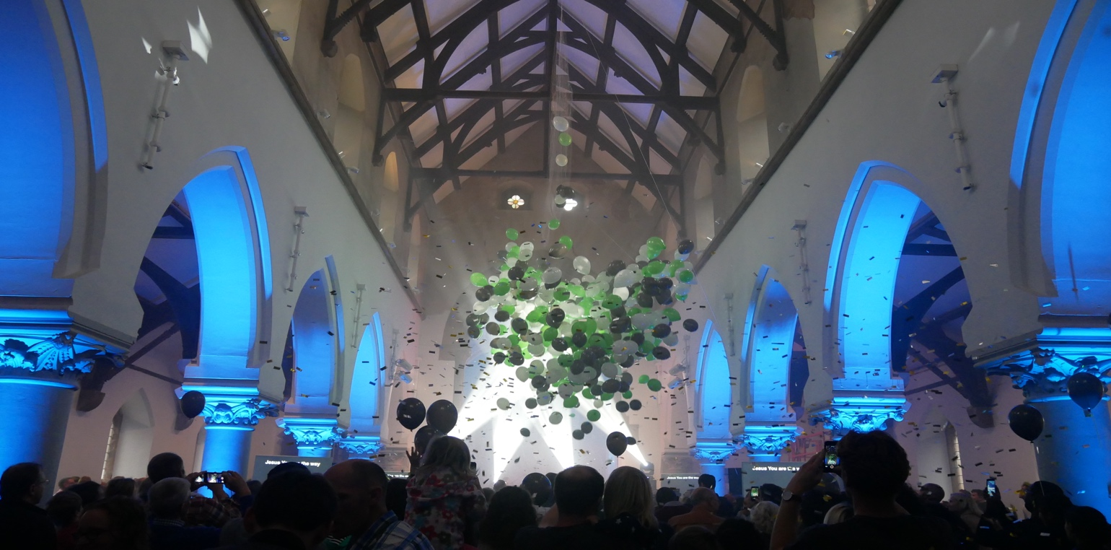
www.stmarkscoventry.org

The Training Minister
The Revd Dr Phil Atkinson, St Mark’s Church, Bird St, Coventry

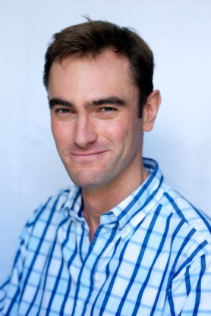
Following 14 years in the NHS, as a Consultant in Public Health – I trained at Ridley Hall, Cambridge. St Aldates Oxford was the location for both my curacy and an associate position – where I had particular responsibility for both the morning congregation and social justice ministries. I’m married to Rachel, a theological educator, who has worked at St Mellitus and Spurgeon’s College. We have two young-ish children.

Back in 2016, Bishop Christopher invited us to plant a city centre resource church in the diocese, in partnership with Holy Trinity Brompton. City centre resource churches are established to be overtly missional, particularly towards young people and students. They exist to serve and resource the wider church, and to plant churches.

We moved to Coventry early 2017, to be part of St Luke’s Gas Street, Birmingham with the purpose of recruiting and training a team to bring to Coventry to start the new church. Meanwhile, extensive renovations began on the building, and St Mark’s was launched in Oct 2017, with well over 400 people celebrating the opening.

Vision and Priorities

St Mark’s has established a three-stranded vision:
- To see people find faith in Jesus;
- To see people set free and become all they were intended to be;
- To see the city flourish.
Within these strands, we have considered the main priorities of the church at this early stage to be centered around providing opportunities for people to respond to the gospel, and establishing and nurturing communities in which discipleship is fostered, and people find freedom from that which holds them back in their walk with Jesus.
The Location

St Mark’s is physically located in Swanswell, on the north-east edge of the city centre, a relatively poor area that is gradually becoming home to more and more students (with a large hall of residence planned to be built on empty land opposite the church).

St Mark’s has been disused for 45 years, and does not have its own parish. It will operate as a conventional district in the first instance, with a Bishop’s Mission Order to reach out to young people and students across the city.

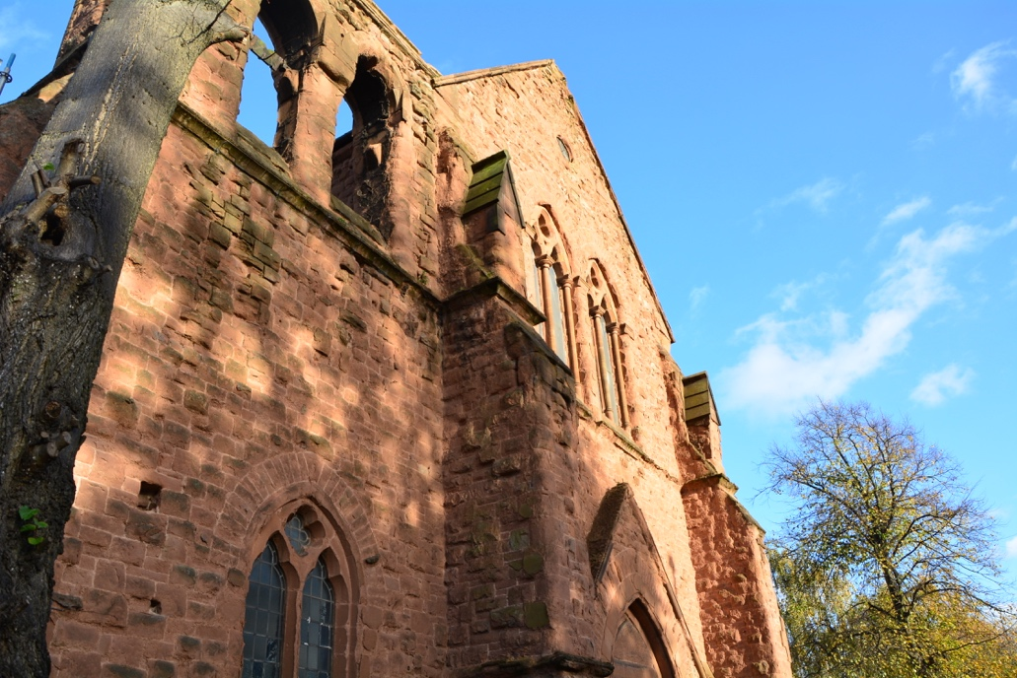
The Church

When we arrived in Coventry, St Mark’s was in a state of disrepair, with considerable work needed to renovate both the church and the hall. Money was raised for the renovation costs, which enabled the church to launch on 1st October 2017. The breakout space attached to the church building, which has since become known as ‘The Hub’ has recently been renovated. Once an NHS clinic, it now operates as staff offices during the week, as well as the space used for the childrens’ and youth work on a Sunday.
Pattern of worship and congregations

St Mark’s has a focus on vibrant and contemporary worship that tends to appeal to the target group of young people and students. At our launch, we started with just one 4pm Gathering on a Sunday. Almost two years later, we now have a morning Gathering at 10.30am, which focuses its attention towards the families that call St Mark’s home, attracting around 170 people. Our evening gathering –now at 6pm – has a younger feel with many students and young people. Regularly attendance is around 120-130 people.

Pattern of Prayer and Daily Offices

Corporate prayer is practiced amongst the whole staff team on working days throughout the week. Individual offices will be encouraged.

Staff or Team Members

The staff team as it stands consists of a worship leader, children’s worker, EA and parish administrator, Academy Principal and six Academy students. We currently have 2 curates (one due to move to become an incumbent in 2021) and 3 St Melitus ordinands on placement with us.

Lay Involvement

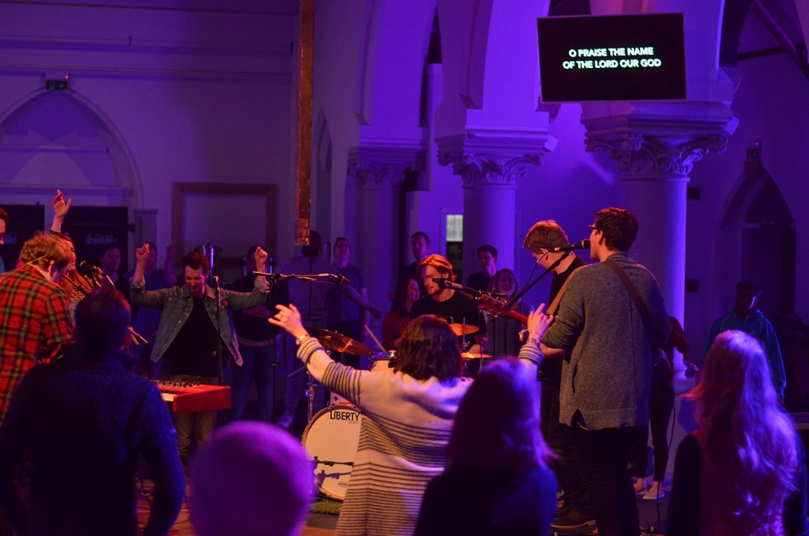

In launching a new church, lay involvement has been critical for the success of the venture. We have placed a large emphasis on encouraging all members of St Mark’s to be involved in the ministry of the church, and have seen many people step into voluntary leadership roles within our student, and youth teams.

House, study and prayer groups – holistic small groups

After trialing the 24/7 Prayer Course in informal small-group settings in the Summer of 2018, the Autumn saw the arrival of official, formal ‘connect groups’ which run around the city with a range of focuses. We have seen the congregation respond really well with a great proportion of the church committing to a weekly group.

Areas of particular mission and ministry

Mission to young people and students is paramount – with emphasis on use of the Alpha and associated courses. Particular effort has been placed in building relationships the Christian Unions in Coventry and Warwick universities and other student bodies. We’ve seen a growing community of young professionals at St Mark’s and have therefore sought to give time and effort to them through the provision of a couple dedicated to discipling this group.

Our youth work is growing, and we are about to launch after school clubs for young people at risk of isolation, gang membership and associated violence.

In time, especially given its location, we expect the church to develop a ministry with the poor. We have a number of church members who have specifically mentioned their heart to work in areas of social action. We currently run a food bank providing culturally specific food to refuges and asylum seekers in the city, play football with refugees, run alpha in our local prison, and partner with others to support vulnerable women in the sex industry.

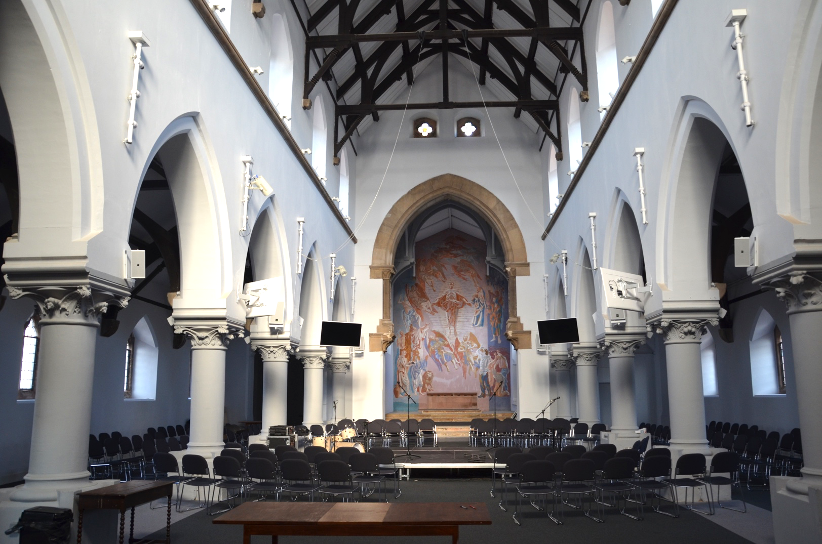

Approach to Training

Our approach to training is supportive, encouraging and reflective. Together we identify learning outcomes (within and beyond the national framework), I would provide support in stepping forward, and encourage good practice. We would reflect on experiences together. There would also be considerable training provided in a team setting, learning how to work alongside and complement each other in a ministerial setting. To successfully establish the church, every member of staff will need to pitch in – a setting which will provide great learning opportunities!

I have had substantial experience training staff in both church and public sector settings. At St Aldates, I trained and led a team of 11, with comments such as “the team is one of the best things about working here”. In the NHS I have trained junior staff and interns on an almost continual basis.

The likely role of the curate – specifically church planting
Church planting setting is a demanding yet exciting setting to train in. We are looking for candidates of the highest calibre, with the potential to themselves go on and plant towards the end of their training. It is likely they will be involved in every area of the life of the church, in particular working with young people and students, leading alpha and running small groups.

The hope with this specific role is that the curate will go on to lead a new church plant within the diocese. There are a wide variety of potential planting locations – from affluent towns, urban areas that are more deprived through to rural settings. Both location and model will be influenced by the calling and competencies of the curate in post.

St Mark’s has a passion for planting, and will devote significant resources to support the curate in developing their skills and experience ready for planting. The diocese greatly values mission and invests heavily in training, making this an attractive option for potential planters.

Accommodation

The Diocesan Property Department will provide an appropriate house.

Contact

For further information, please either email the Principal of the Coventry Training Partnership, the Revd Canon Dr Richard Cooke on Richard.Cooke@Coventry.Anglican.org (Tel: 07952544820) or the Incumbent, the Revd Dr Phil Atkinson on phil.atkinson@stmarkscoventry.org.

