Guidance Note

Model Diocesan Scheme for the Inspection of Churches



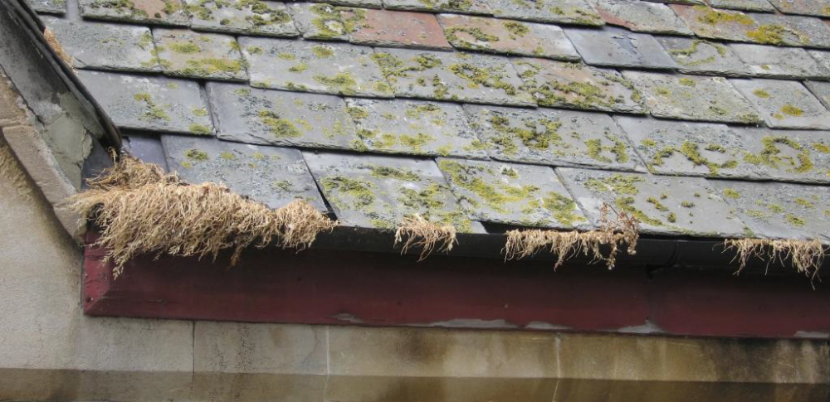

INTRODUCTION

Under the provisions of the Ecclesiastical Jurisdiction and Care of Churches Measure 2018, as amended by the Church of England (Miscellaneous Provisions) Measure 2020, referred to hereafter as “the Measure”, all parish churches in the Diocese, all other consecrated churches and chapels including licenced places of worship opted in under paras 38 to 44 of the Measure (previously the Care of Places of Worship Measure 1999), and buildings licensed for public worship, must be inspected at least once in any five-year period.

The Diocesan Scheme which follows should be studied carefully with the relevant guidance documents (attached as appendices) from the Church Buildings Council (“the CBC”).

THE DIOCESAN SCHEME

1 This scheme was established by the Diocesan Synod by a resolution of xx xxxxxxxxx 20xx and it supersedes all previous schemes. It comes into operation on xx xxxxxxxxxxx 20xx.

2 The Scheme shall be administered through the Diocesan Advisory Committee (the DAC). All correspondence concerning matters dealt with under the Scheme should be addressed to the DAC Secretary.

3 The fund currently established by the previous Scheme to comply with the Measure will be maintained. Monies will be paid into the Fund by the Diocesan Board of Finance.

4 The fees for the inspection of churches in the Diocese under the terms of this Scheme shall be paid by the Parochial Church Council of each parish in accordance with the following terms of this Scheme.

5 Nothing in this Scheme affects the legal responsibility of every PCC for the proper care of each church under its authority, and its duty to apply for a Faculty or for permission under Schedule 1 of the Faculty Jurisdiction Rules 2015 (as amended by the Faculty Jurisdiction (Amendment) Rules 2019). before any work is commissioned.

6 All parish churches in the Diocese, as well as all other consecrated churches and chapels and buildings licensed for public worship, which are required to be inspected under The Measure, shall be inspected at least once in any five-year period (“the Quinquennial Inspection”) under this Scheme. For the avoidance of doubt, where a Quinquennial Inspection has taken place under a previous Diocesan Scheme the five-year period shall commence from the date of that previous report.

The scope and contents of the report

- The Quinquennial Inspection shall be completed in accordance with the current guidance of the CBC. There is an interactive report template within the Church Heritage Record entry for each church. The DAC recommends that this template is used, although reports submitted in a similar digital format which is compliant with the Scheme and the accompanying CBC guidance will be accepted.

8 The structure and content of the Quinquennial Inspection Report shall follow the recommendations set out in the CBC guidance.

9 The report shall summarise the works needed in the following categories:

1 - Urgent, requiring immediate attention
2 - Requires attention within 12 months
3 - Requires attention within the next 12 – 24 months
4 - Requires attention within the quinquennial period
5 - A desirable improvement with no timescale (as agreed with the PCC)

Any routine items of maintenance (including repairs) within these timescales may fall under Schedule 1 of the Faculty Jurisdiction Rules, ie under List A or B, and the Inspector must indicate if he/she considers this to be the case. All other matters will require faculty permission.

10 Broad indicative costs within the bands set out in the CBC guidance and template for all such works will be given, to enable the PCC to understand the level of funding which is likely to be necessary. When considering executing such works, PCCs may need to get accurate costings from a Quantity Surveyor.

Appointing and reviewing the Inspector

11 Advice on appointing a new inspecting professional can be found in the CBC Guidance. The DAC Secretary holds a register with details of current Quinquennial Inspectors within the diocese and can offer advice on the appointment process. A suitably experienced and where appropriate accredited professional who is not presently on the register can be employed as a Quinquennial Inspector, but the PCC should seek the advice of the DAC before making an appointment.

12 The DAC strongly encourages parishes to periodically review the appointment of their Quinquennial Inspector in a competitive tendering process, and the most appropriate time would be when the next inspection is due. Reviewing the appointment does not imply that the PCC must change their inspector, but offers the opportunity to reflect on whether the PCC is receiving good quality service and best value, and has a good relationship with the inspector.

13 Many parishes find that there is advantage in renewing an appointment, as an ongoing relationship with an experienced inspector who fully understands the building and its ongoing needs, and has a good relationship with the PCC and Churchwardens, is invaluable.

Appointing for project work recommended in the report

14 It is for the PCC to decide who to commission to undertake any project work identified in the report, for which a separate agreement would be needed. If the PCC wishes to carry out any publicly funded works which require tendering (where fees are over £10,000) under the supervision of the Inspector without a further tendering process, it will need to be able to demonstrate that the Inspector was appointed or re-appointed (see 12 above) within the last 5 years through a competitive tendering process.

Duties and responsibilities of the PCC, Inspector, DAC and Archdeacon

15 All Quinquennial Inspectors shall be responsible for entering into and maintaining adequate and appropriate Professional Indemnity Insurance cover, and shall provide written evidence thereof.

16 A person who is appointed as a Quinquennial Inspector shall enter into agreement with the PCC of the church (or body acting on their behalf) which they are to inspect. The DAC Secretary can provide advice if requested.

17 Agreement of the fee to be charged, including the preparation and issue of the report shall be included in the contract between the PCC (the client) and the Quinquennial Inspector (the service provider) before the inspection takes place. If the inspection necessitates additional professional services, access provision, or work which necessitates a higher fee, additional contracts or a variation must be entered into by the PCC beforehand.

18 Within three months of making the inspection, the Quinquennial Inspector shall send copies of the report in paper and digital format to the relevant Archdeacon, the PCC of the parish in which the church is situated, the Incumbent or Priest in Charge, and to the DAC Secretary. The report will be uploaded to the Church Heritage Record, if it has not been compiled on the template there.

19 The DAC Secretary is responsible, as per the Measure, for keeping a register of those buildings which are covered by the Scheme, containing details of the current Quinquennial Inspector and dates of inspection. The PCC Secretary shall inform the DAC Secretary of the date of the inspection. If the PCC finds it difficult to agree a date with the Quinquennial Inspector they should consult the DAC Secretary who will offer support.

20 Nothing in this Scheme shall affect the powers of an Archdeacon to ensure the inspection of every church in their archdeaconry once in five years, as laid down in the Measure.

21 In order to provide for the cost of inspections and therein recommended works, every PCC should budget for the report and fabric repairs. They should not, however, use the report as a specification for such works.

Interpretation and Amendment of the Scheme

22 Any questions which arise concerning the interpretation of this Scheme shall be referred to the Registrar, whose decision shall be binding.

23 This Scheme shall be subject to amendment only be means of a formal motion, presented after due notice to the Diocesan Synod, and approved by it.

