Our Church

We are an evangelical, charismatic and prayerful worshipping community and are so thankful for the people and resources God has blessed us with.

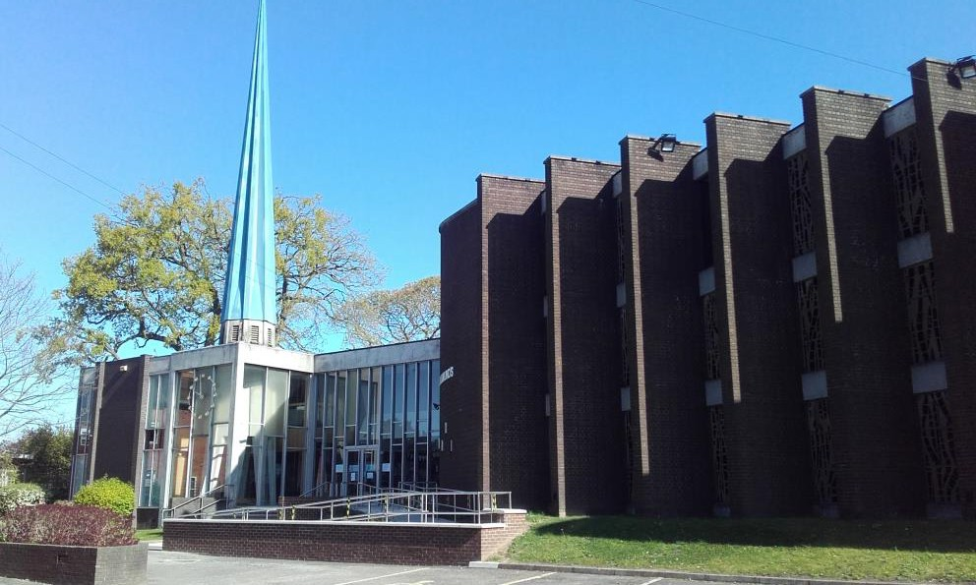
We long to bring hope to peoples’ lives by using our gifts and ministries to impact the broader community at all stages of life. We want to be available and willing to help meet the spiritual, physical and emotional needs of our parish and city.

We place emphasis on worship, community groups and connections outside of church, and are excited about strengthening links with our neighbouring parishes.

We have a strong culture of serving volunteers and lay led ministry working alongside staff and clergy teams, and over the years, many of our congregation have been sent from St. Alkmund’s to ordained and lay ministry across the diocese and beyond.
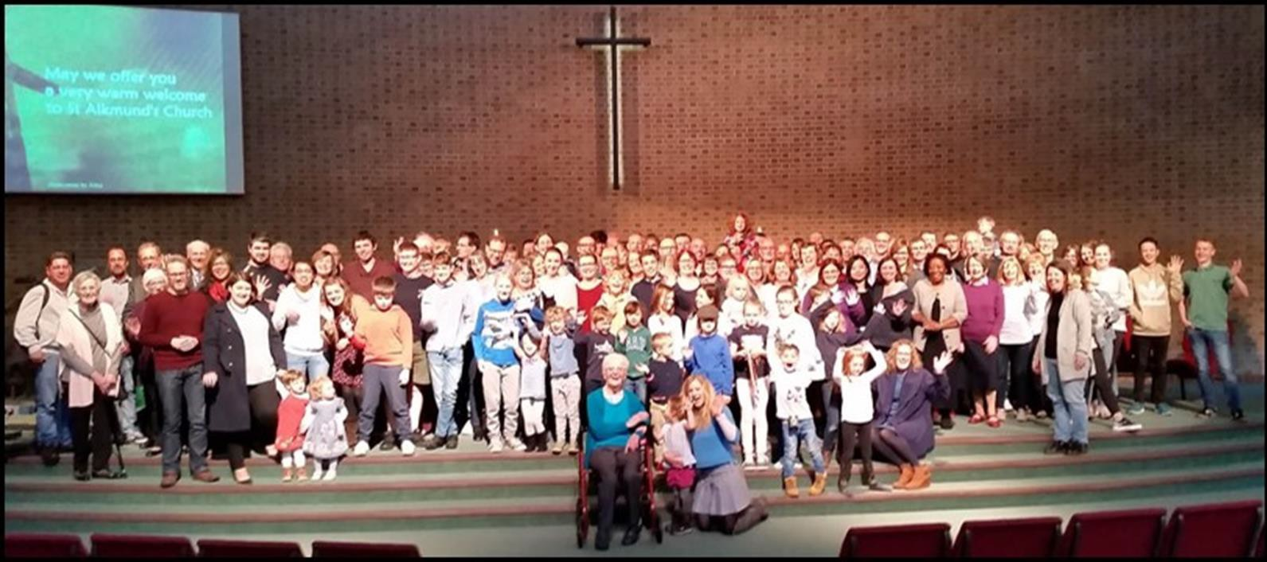
We have had a number of different seasons in recent times – of prophetic vision, of decline, of growth, of bereavement and grief, of a great sense of community, and are currently being blessed with an abundance of new young families joining the church.

Pre Covid we had a typical Sunday morning attendance of 150, with a similar number on the electoral roll. COVID-19 has brought many changes- some life-giving and some more challenging- and we are now beginning to discern and create a new vision to bless our church family and community as we go into the future.

Our Parish

Our building is situated on Kedleston Road, a busy route into the city. The parish is a largely residential area with a mix of Victorian/Edwardian terraced and semi-detached, mainly owner occupied housing as well as newer social housing and rentals
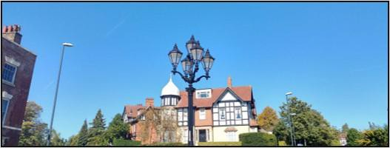

The congregation is both local (17% within 2 miles) and gathered (from as far as 15 miles).

The parish extends into part of the city centre, includes the Kedleston Road campus of Derby University to the north-west and, to the south-east, the Handyside area by the river Derwent with mostly social housing.

The parish has a population of 5900 and its deprivation index is high (Index of Multiple Deprivation 21.1%) but this masks a mixed picture. The parish contains several nursing and residential homes, sheltered warden-aided homes and a few small businesses. We have strong links with Markeaton Primary School and the University Chaplaincy in the parish.

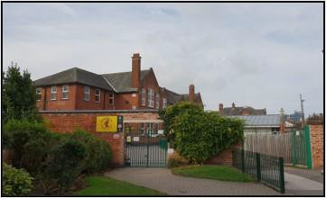

Our Building

At the moment, one of our biggest challenges (as well as a huge potential opportunity!) is our building.

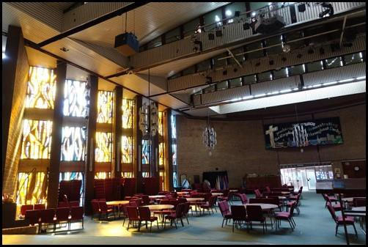
The large main worship area was re-ordered in 2002, which included removing the pews and replacing them with chairs. The area lends itself well to different layouts which facilitates a wide variety of social and community events.

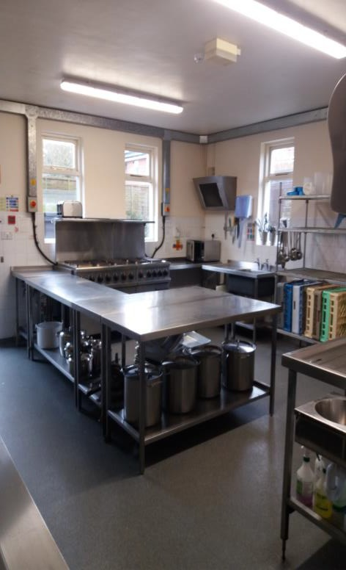
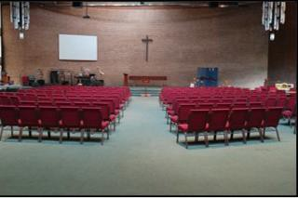
The ground floor of the church includes St Aidan’s chapel, a hall, smaller meeting rooms, office space, storage, toilets and a kitchen. Upstairs there are further meeting rooms, storage for resources and office space. We hire rooms within the building to some local groups such as Weight Watchers and Emmanuel Christian School located across the road.

We need £1.4 million to repair the roof and this has brought us to a real moment of discernment. As we discern the new vision for our church we will need to decide what part our building has to play in our future journey.

Our Story and A New Direction

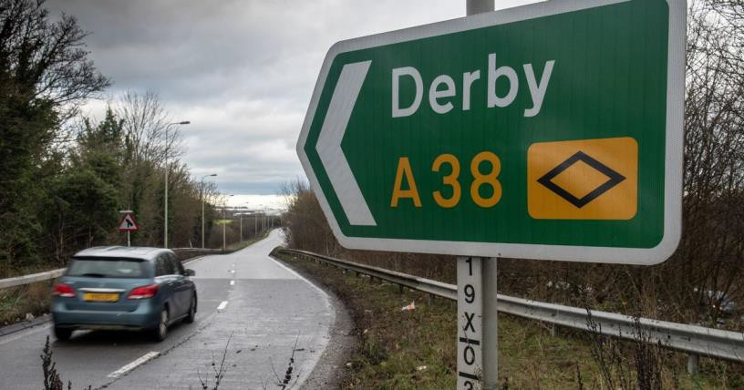
After an extended period of crisis and recovery St Alkmund’s advertised for a new Vicar at the end of 2018. Our much-loved Associate Minister applied for and was appointed to the role. However, before Ian was able to be licensed, he received a cancer diagnosis, underwent several months of treatment, but died in December 2019. This has been a terribly painful time for us.

Through Ian, a dialogue began with the Diocese and Deanery about a new, closer relationship between Anglican churches in our part of the city, with St Alkmund’s acting as the ‘hub’ in a hub and spoke model of church.

This vision of collaboration and of resourcing both our local churches and the local community is beginning to be worked out in practical ways:
Rev James Durrant is working as Priest in Charge at St Paul’s, Chester Green (a neighbouring parish) and Associate Minister at St Alkmund’s, sharing his time between these 2 parishes.
In addition to this, our pioneer minister, Ben, and his family have moved into the Mission House of nearby St Anne’s parish. They are working closely with the church and community there to share God’s love, while also working to develop pioneering and youth work in St Alkmund’s parish.

We are excited to see how we might collaborate with other churches in the city, including St Werburgh’s, the HTB church plant situated in our parish. In November 2021, Revd Mina Munns took up the post of Vicar of St Alkmund’s and we were truly able to begin discerning our vision for the future, emerging from the roots laid down by Ian. We are expectant about the future and looking forward to see where God will lead us as we discover His vision together. If you are open to the leading of the Holy Spirit and ready to step out and take some risks, Come and join us!
Our Team

We have a dedicated, talented and friendly team of people who help to lead the church, including two readers and several others who lead services and preach. We also have a brilliant set of people leading sound, projection, technology, prayer, music, children, youth, fabric, safeguarding, communications and many other ministries.

The church leadership team consists of clergy and church wardens and we also have a busy staff team including a full time children and families worker, a full time lay pioneer, a part time administrator and a caretaker.

Training Incumbent

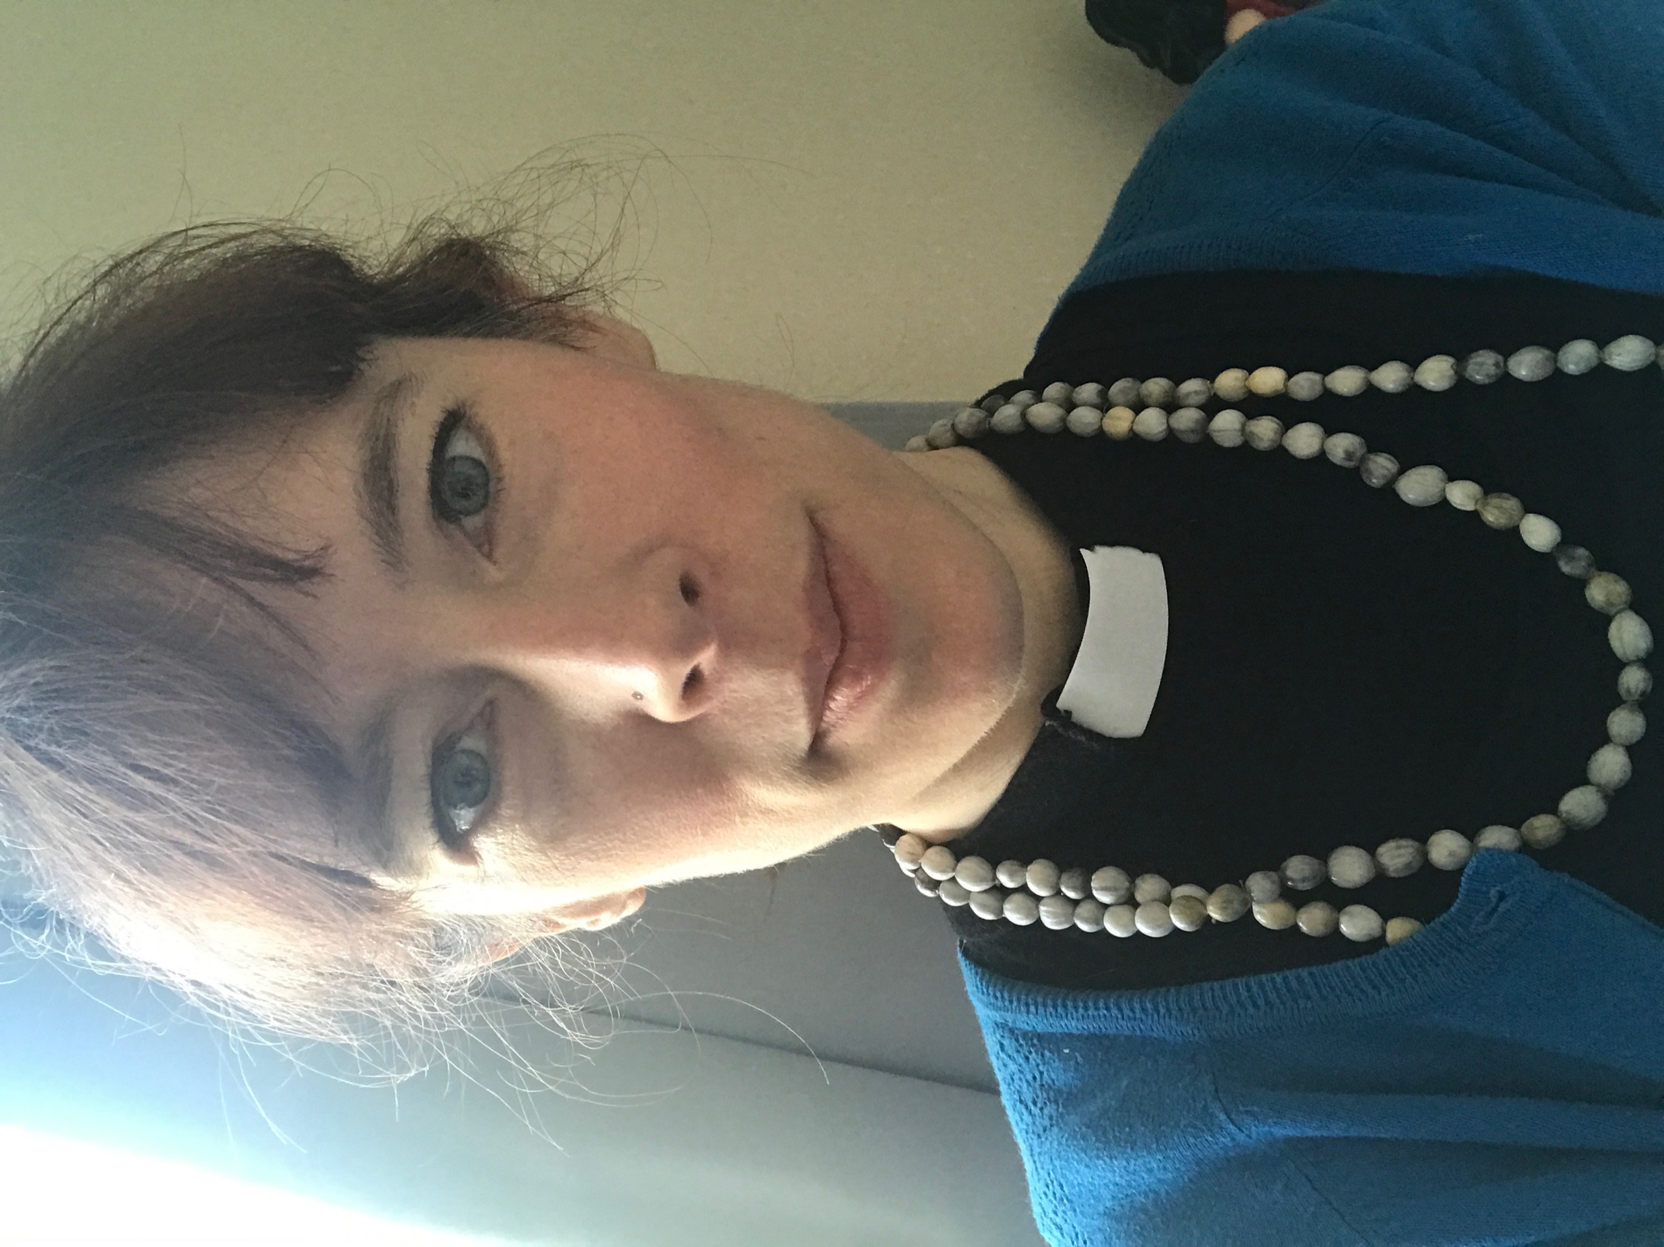
I’m Mina and I was ordained in 2015. Before ordination I worked as a primary school teacher and a church children and families worker. I have a passion for developing intergenerational worship and speak and lead workshops across the country, focussing on helping to develop children’s spirituality, creative prayer and working with under 5s. I have written books on creativity in prayer and on introducing Holy Communion to under 5s through play. I maintain 2 resource websites for creative work with children and am a monthly contributor to Premier Youth and Children’s Work magazine. I also have an interest in ministry around death and have begun a podcast project called ‘Dust to Dust’ with a hospital chaplain friend.
My curacy was served in the Nottinghamshire coal fields and then I worked as priest in charge and pioneer minister in ex-mining villages on the Northumberland coast, developing pioneering within the parish and deanery and building relationships and networks within the local community.
I am a pioneer at heart, with an interest in mentoring and developing leadership within the church- both lay and ordained. I believe strongly in working ‘with’ rather than ‘for’ the community and, as a newcomer to the diocese and the parish, I can’t wait to see what God has in store for us here.

If you fancy an informal chat about a curacy with us, please don’t hesitate to contact me:
mina@stalkmunds.org.uk
07960 250497

