Resources for Schools
PHASE: PRIMARY
Hope for the Future

KEY CONCEPT/MESSAGE:
Jeremiah 29:11 “For I know the plans I have for you,” declares the LORD, “plans to prosper you and not to harm you, plans…. to give you hope and a future.”
Change can be unsettling, but it can also be an opportunity to re-start or change direction. New leadership can bring bright hope for the future, but to do that we must overcome our loss of the past and the fear of the present. What is our hope for our new monarch?
The Bible offers us examples of people who experienced change, sometimes unexpectedly or even with reluctance, and brought about possibilities not realised before: Jacob’s son Joseph overcame the loss of his family to thrive in service of the Pharaoh and succeed in a different time. Esther was taken from her family but then bravely rose up to challenge those plotting against her people. When David became King, the country rejoiced for the opportunity to follow God more nearly and grow as a nation and flourish as a community.
BIBLE PASSAGE OF THE WEEK:
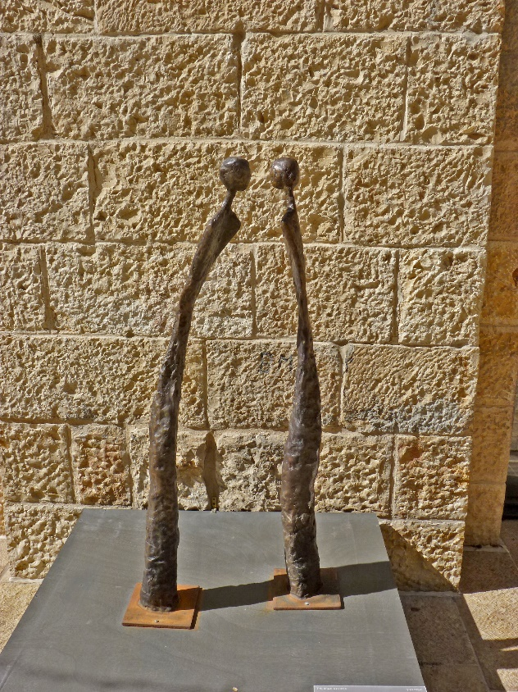
Ruth
The book of Ruth tells of a family who went through many changes but who found hope. Naomi’s family were forced to leave their home because of a famine. Tragedy struck with the death of Naomi’s husband, leaving her with two sons to raise. They married, but tragedy struck again when both sons died, leaving Naomi with her daughters-in-law. Feeling her future was uncertain, Naomi set out to return to Bethlehem, and her daughter-in-law Ruth accompanied her. Because of this move, Ruth met and married Boaz, and among those numbered as their descendants are King David and Jesus.
This story can be encouraging for those who feel lost, with no sense of a future or hope, that God can use all opportunities to encourage and bring hope to everyone.
In these times of looking to the future:
Who or what helps us to be hopeful?
Who or what helps us to remain strong as we wait to see what happens next?
Image: ‘Ruth and Naomi – the dialogue’
https://diglib.library.vanderbilt.edu/act-imagelink.pl?RC=55327

Gathering

Ask the children to think about things that have happened or ways they have changed since they started school.
Project a montage of school photos from the last few years to illustrate this, or a video clip could be used to show the changes we go through growing up, such a Portrait of Lotte https://www.youtube.com/watch?v=yfqpqiTMUEg (stop at 2.12 when she reaches 12 years old) or her brother Portrait of Vince https://www.youtube.com/watch?v=ESSguWx2mtg (stop at 1.55 when he reaches 12 years old). Another example here is of Ani, from birth to age 14: https://www.youtube.com/watch?v=K_lPKPpZUtA
Sing together One More Step along the Way I Go, a reminder that God is with us throughout our lives, whatever happens.

Engagement

Ruth was a young woman, but lots of things changed in her life. At times it felt that she had no hope. Encourage the children to listen out for the changes as they hear the story.
You might want to use this video https://www.youtube.com/watch?v=V0t2gWjZDug or images from here https://www.freebibleimages.org/search/?book=Ruth to help with the retelling.
Who or what do you think gave Ruth hope?

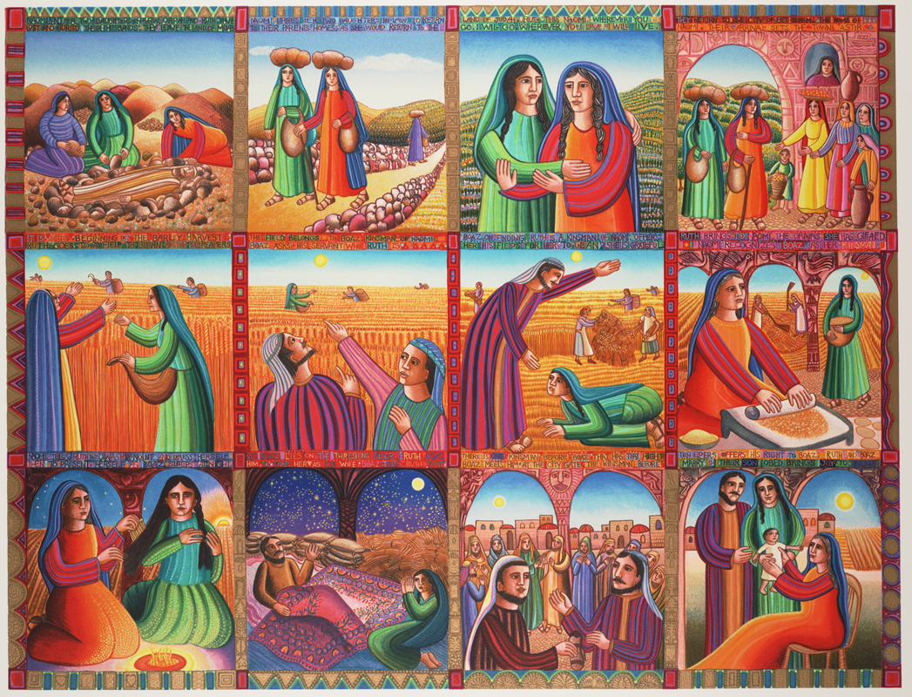
https://diglib.library.vanderbilt.edu/act-imagelink.pl?RC=56561

Response

Things are changing in our country and for the Prince of Wales. He was 3 years old when his mother became Queen. Their family had to move home to Buckingham Palace. Now his mother has died and he has become our King.
Who or what do you think gives our new Monarch hope?
He has been very committed to environmental causes. What hopes do you think he might have for his time as Monarch?
What hopes do you have for our new King’s reign?
Make simple crowns, and decorate these with words or images which represent what you think the new King’s hopes might look like.
Encourage the children to offer words or phrases and turn some of these into a prayer.
Sending

Read Jeremiah 29:11 “For I know the plans I have for you,” declares the LORD, “plans to prosper you and not to harm you, plans to give you hope and a future.” Jeremiah wrote these words to God’s people when they were in a strange land and feeling lost. He was encouraging them that God was still with them and would bring them hope. That’s what Ruth discovered, even when things were uncertain. It is what we pray for our new King as he begins his reign – that he will know God with him every step he takes into the future.
Sing Every Step by Nick and Becky Drake
Prayer:
Dear God,
You are with us every step and give us hope.
Be with our new King.
Help him to make wise decisions.
Give him hope for the future.
Amen

SPIRITUAL DEVELOPMENT
(practical ways to help us explore faith and develop spiritually at home together)

EXPERIENCES that can help us ENCOUNTER:

‘For surely I know the plans I have for you, says the Lord, plans…to give you a future with hope’ Jeremiah 29:11
Take some time, maybe listen to some reflective music, (for example https://www.youtube.com/watch?v=gqo3chyRj-8 and think about:
What things give you hope? What things do you hope for?
Use sticky notes to share and explore our different thoughts.
The book of Psalms has many poems written when the writer is going through a tough time. Read Psalm 70.
I wonder if it is easier to be hopeful if you believe in God?
Or
Whistlestop Tales by Krish and Miriam Kandiah locates Bible stories in the place they would be in the world today. Read the story of Ruth. It takes place in the country we now call Jordan. Find out about what Jordan was like then and what Jordan is like today. What can we learn about hope from this story?
What hopes might people from different parts of the world have for the new King?
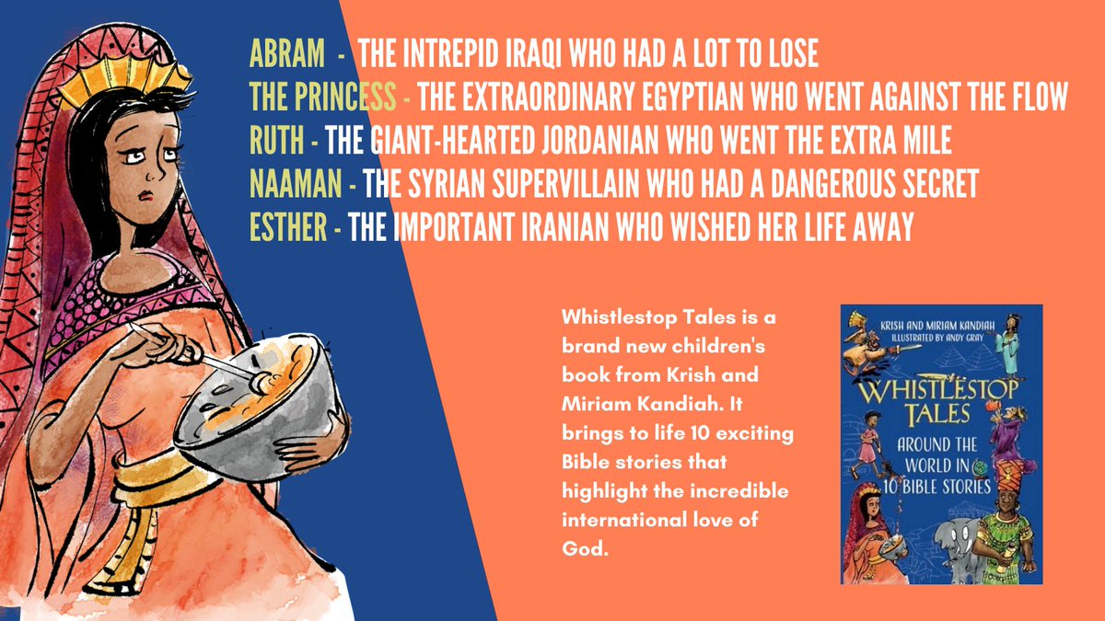

ACTIVITIES that can develop PRACTICES-HABITS:

Write a letter to the new Monarch. How can you acknowledge the sadness in his family and in our country? How might you encourage him as he takes on his new role? What will you tell him about your hopes and concerns for the future?
Encourage him and tell him what you hope for the future.

PRAYERS that can help us REFLECT and GET BACK ON TRACK:

PRAY ABOUT IT: Use the 5 step examen prayer to reflect on your hopes.
1. GIVE THANKS for the life and faith of the Queen, and others of faith who have gone before us, for the things she achieved.
2. ASK FOR HELP with your hopes for with the new Monarch.
3. REFLECT on the ways our world can be better.
4. SAY SORRY for the times you gave up hope or took away someone else’s hope.
5. DECIDE how you could play a part in bringing about a brighter future.

OR
Together, create an image to represent hope. Write prayers to surround it on a notice board, prayers for communities that need a brighter hope for better times, and prayers for our new Monarch to have strength and faith and compassion in everything they do.
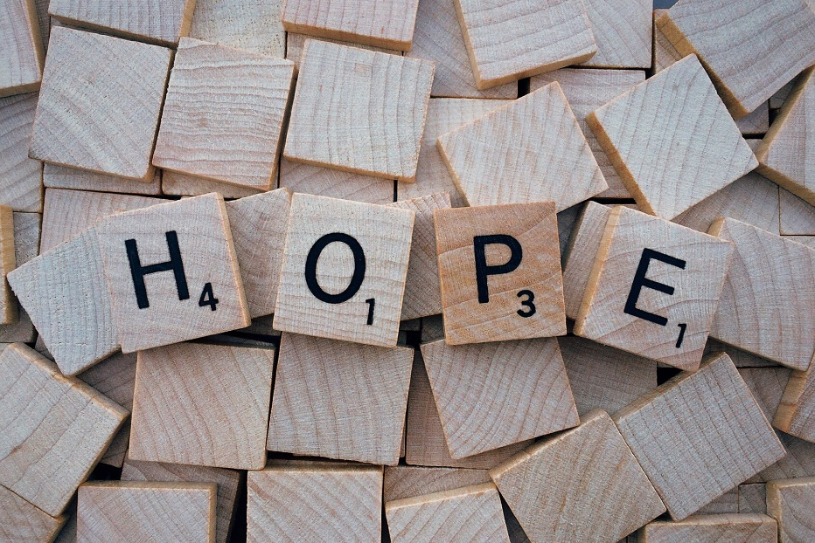

CONVERSATIONS which CONNECT COMMUNITIES:

Some further resources from different organisations
Hope For the Future- are seeking to solve the climate crisis through community political engagement
https://www.hftf.org.uk/
Rise again- In late June 2021 TEAR Fund linked up with Impact: life to reimagine with world as it moves forward. Find resources through their website.
https://www.tearfund.org/

COLLECTIVE WORSHIP – OUR APPROACH
INVITATIONAL
Everyone is welcome to take part in collective worship, as much or as little as they or their parents and carers are comfortable with. This means we use invitational language and consider carefully our choice of words and songs. Children are invited to pray but are not compelled or expected to do so; they always have a choice. We invite them to pray or reflect in whatever way they would usually as a family, if that is part of their home experience.

INCLUSIVE
Acts of worship need to be inclusive of all. Therefore, we choose topics and ideas that are shared by different faiths and worldviews. When we present Christian teaching, we make it clear that this is ‘what Christians believe’, saying things like:
‘I wonder why this story might be important to Christians?’
‘The story today comes from the Bible (the holy book of Christians), which teaches that …
Our worship should be accessible for children and young people with a range of different backgrounds, and so we take care that activities do not require expensive resources. We also offer a variety of activities, so that children and young people with differing needs can all find something they can engage with.

INSPIRING
We aim for our acts of worship to inspire those engaging with them. How might it engage their emotions, enabling a sense of peace, comfort, hope or motivation? How might it inspire them into action, into thinking differently and considering their behaviour or actions? How might it inspire them to reflect on their faith or beliefs, and on the faith or beliefs of others?

