Resources for Schools
PHASE: SECONDARY
Stewards
of the Future
Steward – To take care of, to be responsible for, to look after.

KEY CONCEPT/MESSAGE:
“The secret of change is to focus all of your energy not on fighting the old,
but on building the new” -Socrates

Change can be unsettling, but it can also be seen as an opportunity to re-start or change direction. New leadership can bring bright hope for the future, but to do that we must overcome our loss of the past and the fear of the present.
The Bible offers us examples of those people who have taken on new leadership, sometimes unexpectedly or even with reluctance, and brought about successes not seen before: Jacob’s son Joseph overcame the loss of his family to thrive in service of the Pharaoh and succeed in a different time. Esther was taken from her family but then bravely rose up to challenge those plotting against her people. When David became King, the people rejoiced for the opportunity to follow God more nearly and grow as a nation and flourish as a community.
BIBLE PASSAGE OF THE WEEK:

Jeremiah 29:11
For surely I know the plans I have for you, says the Lord, plans for your welfare and not for harm, to give you a future with hope.
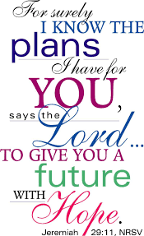
This verse comes within a letter from Jeremiah to God’s people in exile, living as strangers in another land. A letter encouraging those who feel lost, with no sense of a future or hope that actually God can use all opportunities to encourage and bring hope to everyone.
In these times of looking to the future, reflecting on our opportunities as stewards and facing loss and change –
What words encourage us? Who helps us to feel safe to make bold choices?
What helps us to remain strong as we see what happens next?

Gathering
A video clip could be used to reflect on changing seasons and the potential wonders of change, such as:

https://www.youtube.com/watch?v=-n_cXcOe6xk

Read Ecclesiastes 3 verse 1-8 ‘There is a time for everything.’
As the royal seasons change what hope do you have for the next reign?
We know that the Prince of Wales has been very committed to environmental causes. What hopes do you think he might have for his time as Monarch?

Engagement

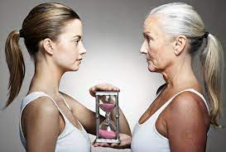
The University of Washington has conducted a study exploring how a child will look in the future.
https://www.washington.edu/news/2014/04/09/see-what-a-child-will-look-like-using-automated-age-progression-software/

I wonder - how do we feel about facing future change and planning ahead?
How easy do you find it to forward plan?
How hard is it to think ahead by 1 month, 1 year, 5 years? Over the last few years, things have happened in our world we couldn’t possibly have predicted. Does this alter your view of the future?
Spend a few moments thinking, then share ideas. Talk about what has changed in the last 5 years and what might change in the next 5 years. Record ideas on a whiteboard or paper.
What has changed for you in the last 5 years? | How might things change for you in the next 5 years?
What has changed in the last 5 years in this world? | How might things change in the world in the next 5 years?

On your copy:
- put a star beside ones that were planned
- a question mark beside those that were unplanned
- circle around those which were easy or straightforward
- underline those that were difficult or uncomfortable
What helped you change? Are you making plans for other changes?
What helps us when the world around us changes? How do we feel about future world changes?
What would we like to know that would help us feel better about the time to come?
What enables us to be better stewards of the future?
(In particular, you might like to think about how we can care better for the environment to steward the earth for future generations)

Response

Read Revelation 21: 1-4 from the Bible. See link :
https://www.biblegateway.com/passage/?search=Revelation%2021:1-4&version=NRSV
It tells of a new time when everything has changed. It speaks of a time and place where everything will be better, brighter, more hopeful. It is a time where God is present. It is a beautiful vision of what the future might hold.
Why not share a future vision for what your community, your country and what the world might be like if we, the stewards of the future, work for love, joy, peace, patience, goodness, kindness, generosity, self-control or compassion in everything we do as service to our heavenly King and also our new Monarch of Great Britain.
Write prayers to share or speak them or ask others to read them out for you.
Pause to ask God to be in these plans and hopes. In the Bible it says that unless the Lord builds, the workers build in vain. (Psalm 127)
Sending
Share this image with your students.
What might a new monarch have been to be planning for? What would be on their signs as priorities and opportunities?
Visualise these new opportunities, bright futures and the hope that comes from a new person to lead the nation – a new King.

Be encouraged by the reminder that although some things change, God never changes. His steadfast love never leaves us, his bountiful blessing is for all people.
May God go with you.
Amen

SPIRITUAL DEVELOPMENT
(practical ways to help us explore faith and develop spiritually at home together)

EXPERIENCES that can help us ENCOUNTER:

‘Faith is the assurance of things hoped for, the conviction of things not seen.’ Hebrews 11:1
Take some time, maybe listen to some reflective music, (for example https://www.youtube.com/watch?v=FW2DVahTk94&list=RD1zESzN4B62Y&index=13)
and think about:
The things we have FAITH in. The things we HOPE for. The PEACE we feel when we have faith and hope.
Use sticky notes, perhaps in 3 colours to symbolise faith, hope and peace, to share and explore our different thoughts.
Faith breeds faith, hope brings out the hope in others, peace brings joy when it is shared widely.
Another more informal translation of Hebrews 11:2 might also help us in reflecting further about faith:
‘…, this faith, is the firm foundation under everything that makes life worth living. It’s our handle on what we can’t see. The act of faith is what distinguished our ancestors, set them above the crowd.’
The poem ‘I am a woman of faith’ by Maggie Gultiano could be read and used to consider what this poem suggests for facing the future.

https://www.ilovepoems.net/poem/a-woman-of-faith-by-meggie-gultiano/

ACTIVITIES that can develop PRACTICES-HABITS:

Draw up a 7-year plan.
Think about how old you’ll be, what you will hope to know, what you hope to be doing.

What will your school be like in 7 years’ time? What grades will you have? What experiences do you want to have had?

Think about how you want your community to be, how you want the country to be.
Think about the world issues we face at the moment and how they might change or improve in 7 years’ time.

– Does your 7-year plan include how to stay strong and focussed? What habits will you need?
Are there milestones to meet and things to achieve before you reach your goal?

OR

Write a letter to the new Monarch. Acknowledge the sadness in their family and in the country, but perhaps also a sense of opportunity and anticipation.
Encourage him and tell him what you hope for the future.
Ask him to address the things that most concern you about the future of our world.

PRAYERS that can help us REFLECT and GET BACK ON TRACK:

PRAY ABOUT IT: Use the 5 step examen prayer to reflect on your hopes.
1. GIVE THANKS for the life and faith of the Queen, and others of faith who have gone before us, for the things she they achieved.
2. ASK FOR HELP with something you hope for with the new Monarch.
3. REFLECT on the way our world can be better.
4. SAY SORRY for the times you gave up hope or took away someone else’s hope.
5. DECIDE how you could bring about a brighter future.
OR
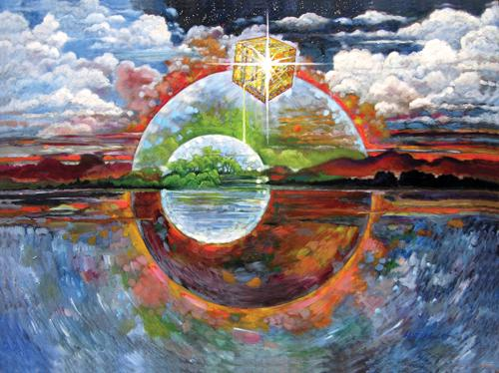
Project or make a large copy of an image to represent a brighter future (or ask for ideas of what this image could be).
Write prayers to surround it on a notice board.
Pray for communities or issues that need a brighter hope for better times.
Pray for our new Monarch to have strength and faith and compassion and to show the gifts or fruit of the spirit in everything they do.

CONVERSATIONS which CONNECT COMMUNITIES:

Some further resources from different organisations:
Hope For the Future- are seeking to solve the climate crisis through community political engagement
https://www.hftf.org.uk/
Rise again- In late June 2021 TEAR Fund linked up with Impact: life to reimagine with world as it moves forward. Find resources through their website.
https://www.tearfund.org/
This section might be really helpful to revisit before the document is published, as they may be some groups who have developed some current ideas.

COLLECTIVE WORSHIP – OUR APPROACH
INVITATIONAL
Everyone is welcome to take part in collective worship, as much or as little as they or their parents and carers are comfortable with. This means we use invitational language and consider carefully our choice of words and songs. Children are invited to pray but are not compelled or expected to do so; they always have a choice. We invite them to pray or reflect in whatever way they would usually as a family, if that is part of their home experience.

INCLUSIVE
Acts of worship need to be inclusive of all. Therefore, we choose topics and ideas that are shared by different faiths and worldviews. When we present Christian teaching, we make it clear that this is ‘what Christians believe’, saying things like:
‘I wonder why this story might be important to Christians?’
‘The story today comes from the Bible (the holy book of Christians), which teaches that …
Our worship should be accessible for children and young people with a range of different backgrounds, and so we take care that activities do not require expensive resources. We also offer a variety of activities, so that children and young people with differing needs can all find something they can engage with.

INSPIRING
We aim for our acts of worship to inspire those engaging with them. How might it engage their emotions, enabling a sense of peace, comfort, hope or motivation? How might it inspire them into action, into thinking differently and considering their behaviour or actions? How might it inspire them to reflect on their faith or beliefs, and on the faith or beliefs of others?

