How to create a Christmas App Campaign in Give a Little:

- Log in to Give a Little with SumUp.
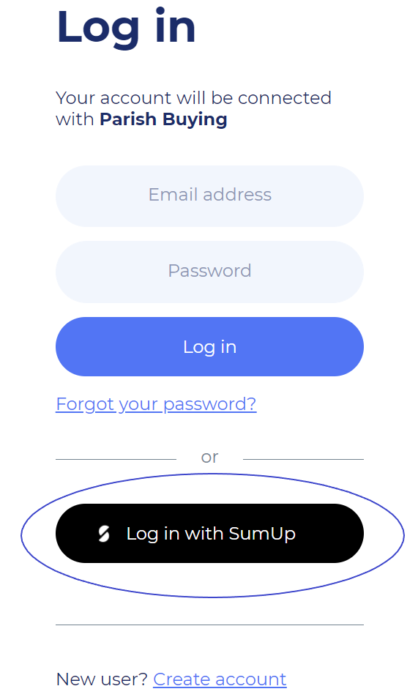

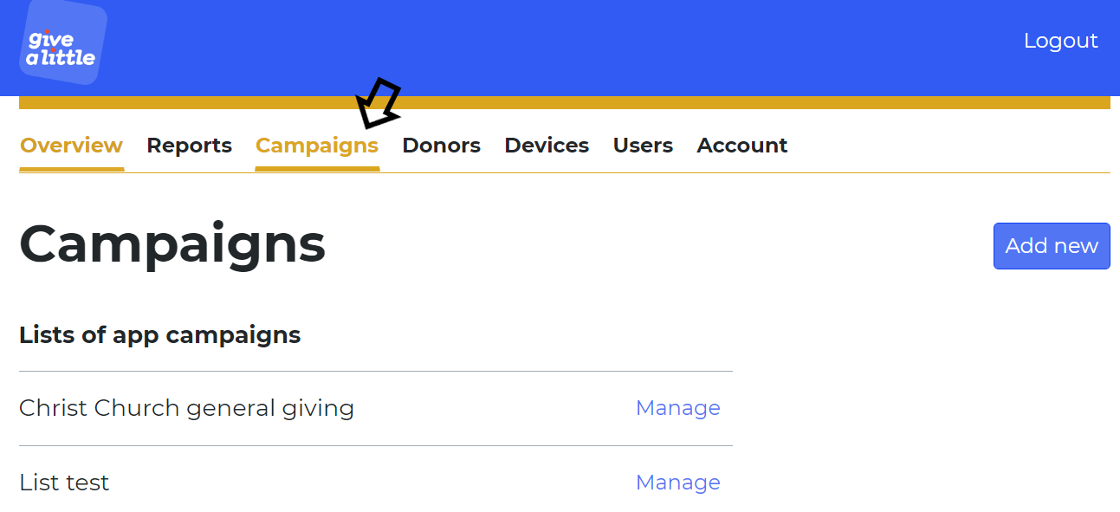
- Once logged in, click on “Campaigns”.

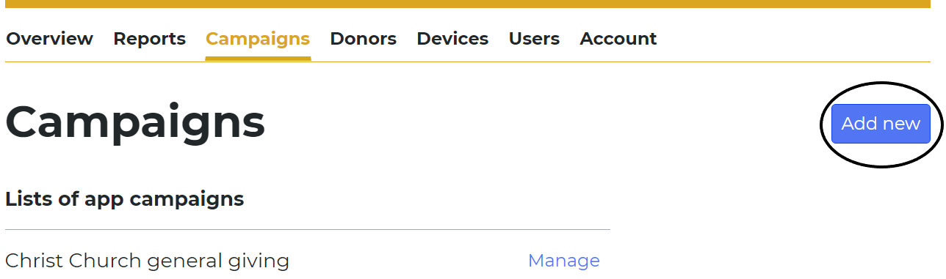
- Click on “Add New” in the right hand side.

- Then select “App Campaign” and press “Next”.
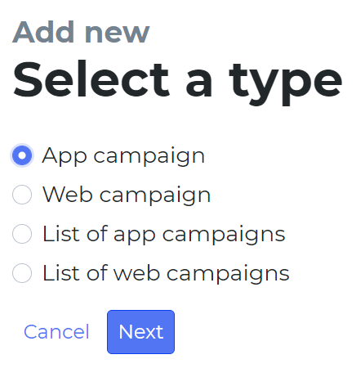

- Click on the “Background” option.
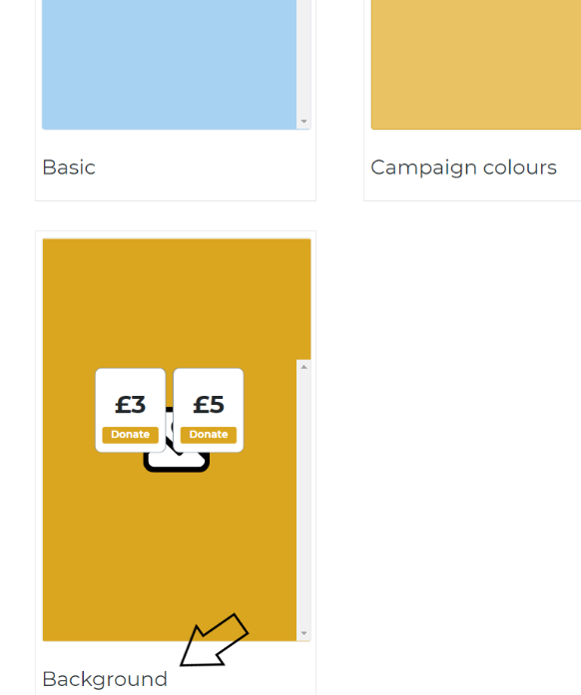

- You can then click on “Choose File” and upload the Canva file you downloaded earlier. Then press “Next”.
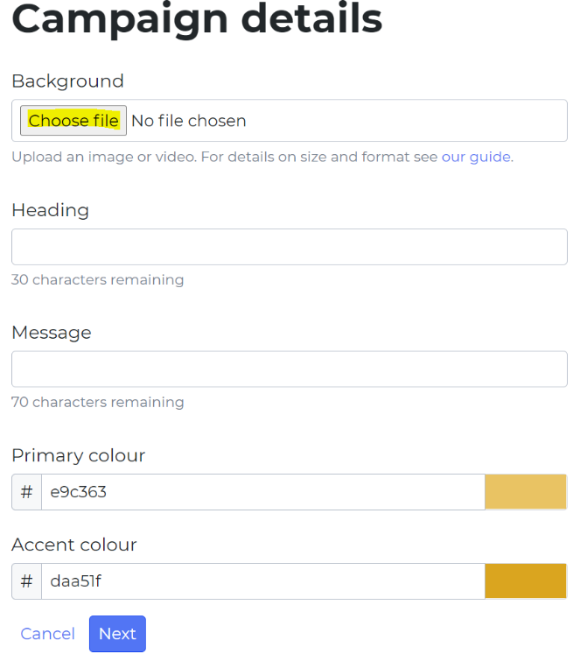

- You will then be able to add amounts and also a “Choose Your Own Amount” option. You can then press “Next”.
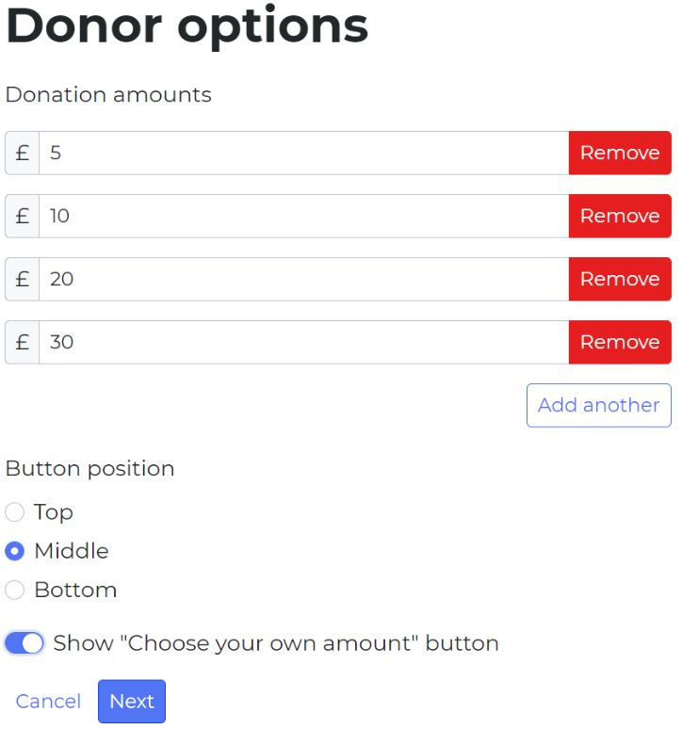

- The next page is for whether you want a Gift Aid option to be available or not. (If you add this, it could slow down the process when people are queuing to donate).
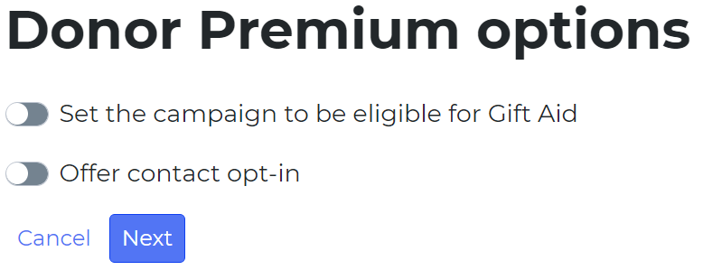

- On the Thank You screen, you will need to delete the text in the “Thank You message” box. Then click on “Choose file” and upload the Canva thank you file you downloaded earlier then press “next”.
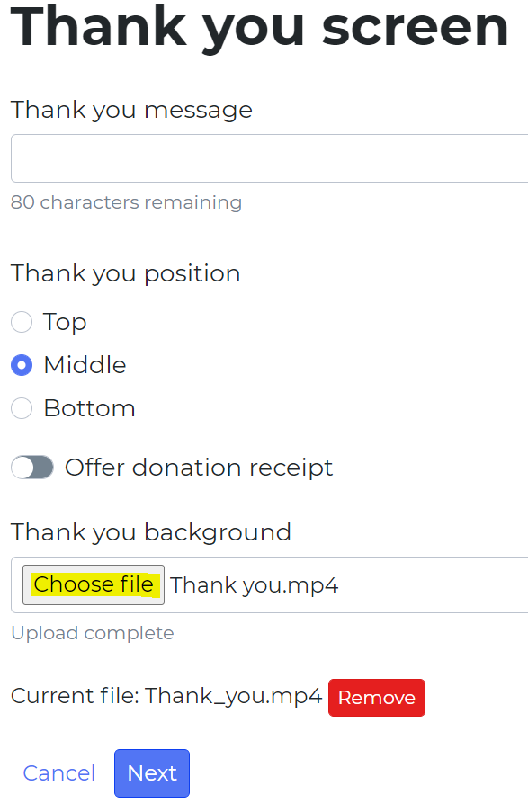

- You will then be able to name the campaign and press “Save”.
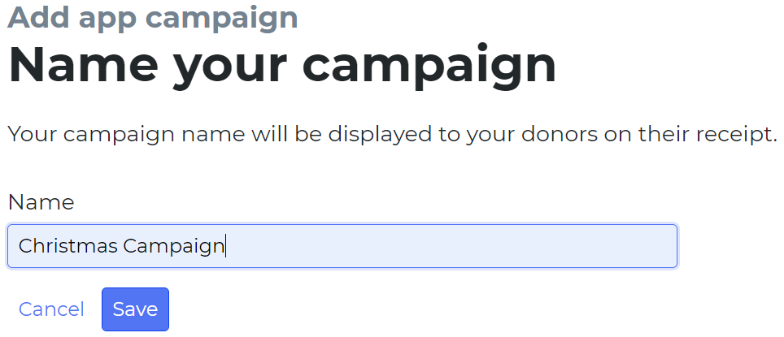

- The campaign should now be available to use on your contactless device!

