Annual Report 2017
Engagement, Screening and Voting

January – December 2017

Adam Matthews, Carlota Garcia-Manas, and Sheila Stefani

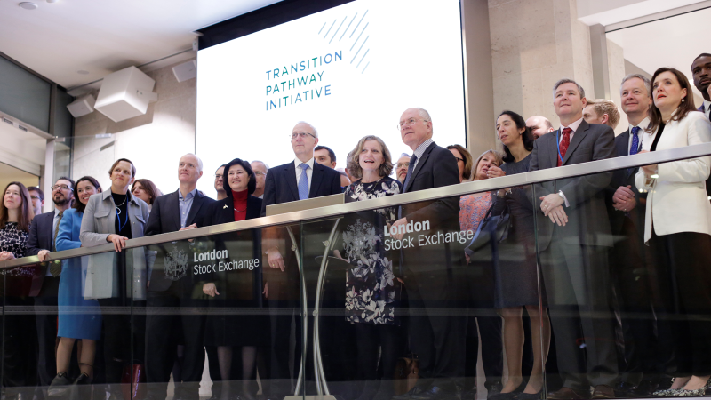
- Introduction

- This report provides the Pensions Board’s Investment Committee with an annual update on the implementation of engagement, screening and voting in accordance with the ethical policies and stewardship responsibilities of the Pensions Board. There are five sections to this report:

Section 1: Introduction Page 2
Section 2: 2017 Summary Page 3
Section 3: Ethical Screening Page 8
Section 4: Voting Report Page 10

- All three activities are undertaken by a dedicated Engagement Team of 2.5 FTE staff with support from communications and occasional use of consultants supporting particular engagement programmes. The Team serves both the Commissioners and the Church of England Pensions Board. In December, we welcomed Sheila Stefani as our new Screening and Stewardship Manager. Sheila provides a wealth of governance expertise from her previous roles as Stewardship Manager at Manifest and as Principal Analyst with EIRIS.
PENSIONS BOARD’ PRIORITY ENGAGEMENT PROGRAMMES

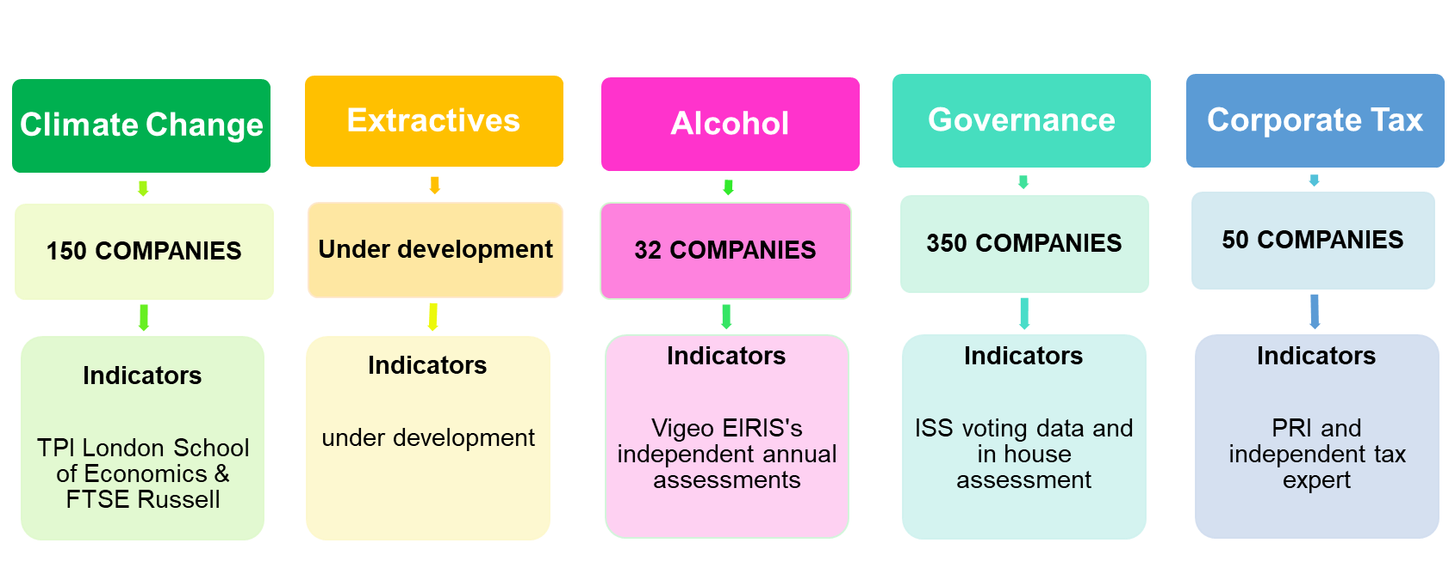

- 2017 Summary

- Engagement Activity in 2017: There was a significant increase in the number of engagement contacts with companies. During the year the Team undertook 94 engagements on behalf of the Pensions Board. The majority were letter-based but all aligned to clear sets of expectations and independent indicators that the Team will use to track company performance. The largest proportion of face to face meetings remained with companies in the extractive industries. Contact and depth of engagement with companies will continue to increase as we roll out our engagement programmes detailed in Section 3. Future reporting will be tracking performance against our indicators.

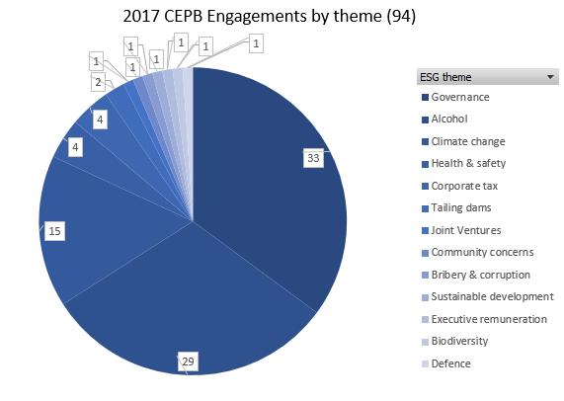
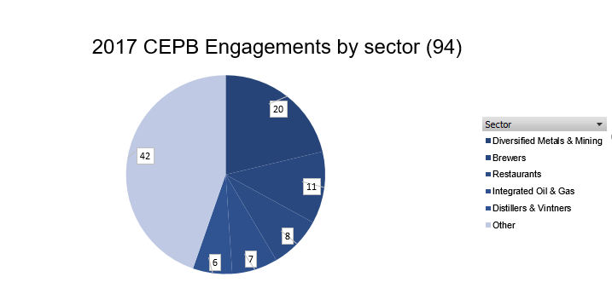
- Climate Change Programme: 2017 was an important year in advancing the Pensions Board’s engagement programme on climate change. January saw the launch at the London Stock Exchange of the Transition Pathway Initiative (TPI) which is now supported by funds with over £5 trillion in assets under management.

- Transition Pathway Initiative (TPI): During the year, a series of sector specific TPI analysis were released by the London School of Economics Grantham Research Institute. TPI assess companies on two metrics; Management Quality (Fig.1) and Future Project Performance (Fig. 2). So far TPI assessment have been released for 99 companies the following five sectors oil & gas, mining, electricity utilities, steel and cement. These transparent company assessments provide the basis for our engagement on disclosure, TCFD reporting and future carbon performance against 2 degrees. Important dialogues have also been established with mining companies through the International Council on Mining and Metals (ICMM) and with oil and gas companies through IPIECA a global oil and gas industry association for environment and social issues. An internal audit report of TPI gave a ‘substantial assurance’ and noted that “Much of [TPI’s success] is a testament to the rigorous and thorough product development process that was undertaken during the planning and development stages.” and that “There has been an e]efficient and effective use of FTSE Russell, LSE, Technical Advisory Group etc. to quality assure all the outcomes of the assessments. The process is thorough and objective and includes the companies.”

Figure 1 TPI Management Quality Assessment of the World’s top coal mining companies
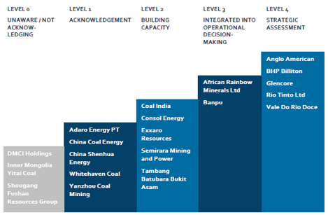

Figure 2 TPI Assessments of Emissions intensity paths for electricity utility companies with targets

- ExxonMobil: A particular achievement on engagement was the response of Exxon to the shareholder resolution seeking a company assessment of the impact of 2 degrees upon Exxon’s business. The resolution was opposed by the Board but received 62% vote in favour of this additional disclosure. At the turn of the year Exxon confirmed it would comply with the resolution. This joint engagement with New York State Common Retirement Fund led to considerable media coverage commenting on the significance of the vote and company response. This was led by the Commissioners Head of Responsible Investment. The Pension Board supported this initiaitive.

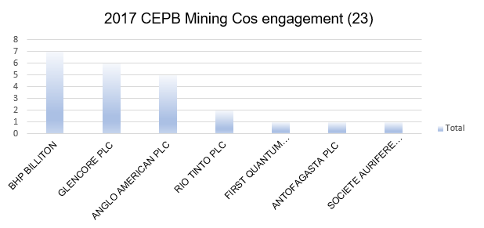
- Extractive Industries Programme: A high level of engagement continued with individual extractive industry companies on issues of health and safety, climate, tailings dams and their licence to operate. Following the launch of the National Investing Bodies new Extractive Industries Ethical Investment Policy these individual engagements will now form part of a dedicated Extractive Industries Programme that will be launched in Spring 2018.

- Mining Faith Reflections Initiative: The Engagement Team continued to support Bishop David Urquhart and to represent the wider Church of England perspective in the Mining and Faith Reflections Initiative (MFRI) with company CEOs. A half day roundtable was hosted jointly with participants from the Vatican and Methodist Church at Lambeth Palace and CEOs from five mining companies. The outcome was a commitment to a common vision for the mining sector that supported the Common Good. The First Estates Commissioner presented the new extractive industries policy.

- Alcohol and Tax Programmes: Two new engagement programmes were developed and launched in 2017 on alcohol and corporate tax. Both programmes will run to 2020 and involve independent data analysis. The Alcohol Programme is a collaborative engagement with CBF/CCLA and the Tax Programme is a collaborative engagement through the Principles of Responsible Investment (PRI) involving 12 other asset owners and over 30 fund managers.
Case Study: Alcohol Programme

The three Church of England National Investing Bodies initiated the core of this engagement program in Q4 of 2017. This included the development and consultation on a set of alcohol responsibility standards. Company performance against the indicators are being independently assessed by VigeoEiris. Following the finalisation of the standards a letter and questionnaire was sent to all UK and global companies in scope. A number of responses were received by the end of 2017 and progress on this effort will be reported during 2018. The majority (72%) of companies in scope are not currently investments for the Church Commissioners or Pensions Board. Companies will become unrestricted if they are able to demonstrate tangible progress in implementing the alcohol responsibility standards.

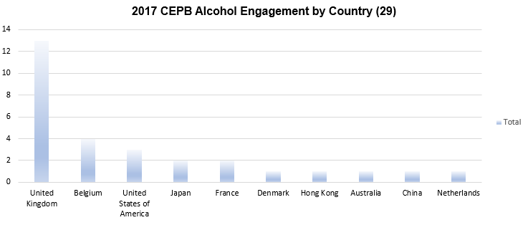

- Governance Programme: The Team have continued to strengthen engagement on governance issues relating to company board independence, diversity, executive remuneration and length of service of company auditors. Many of these issues are translated in to the Pensions Board’s joint voting template with the Church Investors Group. For the first time, we publicly outlined to the media our voting intentions ahead of the main AGM season. This generated considerable media coverage. Additionally, we contacted companies in the FTSE350 that we voted against and that had high levels of shareholder dissent.

- PRI Assessment: The Principles for Responsible Investment (PRI) assessment of engagement undertaken by the team on behalf of the Pensions Board in 2016 (reported in 2017) gave the following ratings:

A+ | Individual and collaborative engagement
A+ | Collaborative engagement
B | Proxy voting

The overall rating is A because the proxy voting could not receive an A+ score as we do not publicly disclose our holdings and how we voted. This is an improvement on the previous year’s rating and a significant improvement on two years ago.

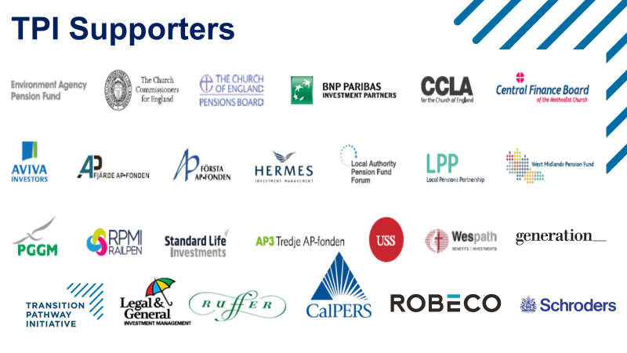

Section 3. Ethical Screening

- We implemented commitments that resulted in screening exclusions from eight policies and one area of historic exclusion. The ethical screens of the Pensions Board are as follows:

Pensions Board Policies  converted into Ethical Screens | Revenue  Threshold
2011 Adult Entertainment | 3%
2011 Alcohol | 5% UK only  25%
2013 Civilian Firearms | 10%
2015 Climate Change (Thermal Coal/Oil Sands) | 10%
2010 Custom Defence | 10%
2003 Gambling | 10%
2011 High Interest Rate Lending | 10%
1965 Tobacco | 10%
2008 Human Embryonic Cloning | 0%

The following table details those companies captured by the screens:

Screen category | Companies Screened | % of total exclusions
Gambling | 96 | 27.2
Defence | 92 | 26.1
Alcohol | 51 | 14.4
Climate Change | 41 | 11.5
Tobacco | 31 | 8.8
Special | 20 | 5.7
HIRL / Predatory Lending: | 13 | 3.7
Alcohol-Tobacco | 6 | 1.7
Adult Entertainment-Alcohol | 1 | 0.3
Alcohol - Gambling | 1 | 0.3
Human Embryonic Stem Cell Cloning | 1 | 0.3
Total | 353

Special related to companies such as Vedanta and Soco International that have been excluded on an individual basis as a result of engagement or following assessment for the alcohol engagement.

Section 4. 2017 Voting Report

2017 SEASON: CONVERTING
ETHICAL POLICIES INTO VOTING
EXECUTIVE REMUNERATION POLICY |  |  | Excessiveness of executive pay;  Fairness of pay compared to pay at below-executive level;  Use of non-financial criteria in the determination of incentives;  Long-term balance of the incentive framework;  Breaches of local good practice |  | VOTE: Against remuneration report / policy  or incentive schemes |  |  | Board Composition
STATEMENT OF ETHICAL INVESTMENT POLICY |  |  | Board Composition and Independence |  | VOTE: Against re-election of non-independent directors when the Board independence is not in line with local good practice.
STATEMENT OF ETHICAL INVESTMENT POLICY |  |  | Board  Diversity |  | VOTE: Against Chair of Nomination Committee when Board female balance is below 25%
STATEMENT OF ETHICAL INVESTMENT POLICY |  |  | External Auditor Independence  Length of Tenure;  Size of non-audit fees;  Other concerns over independence of external or internal audit |  | VOTE: Against the Re-election of director: Chair of the Audit Committee when conditions in the policy are met.  REFER: Re-election of all audit committee members if conditions in the policy are met.
CLIMATE CHANGE POLICY |  |  | Lack of disclosure against CDP assessment.  (this will be translated into TPI based assessments in coming years) |  | ABSTAIN the Report and Accounts where the Church Investors Group considers a FTSE350 constituent company to be a CDP laggard
EXECUTIVE REMUNERATION POLICY |  |  | Living Wage  (UK only) |  | AGAINST FTSE 100 constituent in either the Financial Services or Pharmaceuticals sector where the company is not a Living Wage accredited employer or met Church CIG’s engagement standard
 | 2017 Voting Activities
 | ALL Resolutions | ISS Recommendations |  | Church Template  Recommendations |  | Actual  Votes
 | FOR | 88.7% |  | 79.2% |  | 81.2%
 | AGAINST (including WITHHOLD | 8.4% |  | 14.5%% |  | 15.8%
 | ABSTAIN | 0.2% |  | 0.3% |  | 0.4%
 | REFERS | 0.3% |  | 3.9% |  | 0%
 | Other | 2.4 % |  | 2.1% |  | 2.6%

- Particular highlights from 2017 are:

      - The Pensions Board opposed management on 15.8% of resolutions for both the UK and the Global market.

      - Votes that were referred for consideration: (Management proposals only)
UK: 115 Refers (3.5% of UK votes) resulting in:
- Abstain: 1.7%
- Against: 33.0%
- For: 65.2%
Globally: 943 referrals (3.7% of Global votes) resulting in:
    - Abstain: 3.9%
    - Against (plus Withhold): 40.1%
    - For: 48.3%.

      - Discretion was used 254 times to deviate from standard voting outcomes under the CIG Template. Examples include: InterContinental Hotels Group plc (Remuneration Report), Reckitt Benckiser Group plc (voted against the re-election of Non-Executive Chairman Adrian Bellamy).

      - There has been a continuing increase in the number of climate change shareholder proposals in the US (Exxon, Occidental Petroleum) and also in Q3 in Australia, as well as shareholder proposals on nuclear power generation at Japanese utilities. Potentially section 844 of the Financial Choice Act would alter the rules governing the inclusion of shareholder proposals in company proxy statements; these include potential requisitionists having to hold at least 1% of the company’s shares for a least three years, raise of resubmission thresholds, and prohibition of shareholder proposals by proxy. The bill passed the House on June 8, 2017 and now passes to the US Senate.

      - We supported the “Follow This” resolution on climate change at Shell along with major Dutch Asset Owners. We also made our position on the vote public ahead of the AGM which was reported in various media. The resolution received 6.3% of support which was a considerable increase on the previous year when we abstained. The resolution was the cause of some debate amongst investors and in December Shell responded by being the first O&G company to produce scope 3 aspirations. The significance of Shell’s disclosure means that for the first time we should be able to assess an O&G company against the TPI performance metric.

      - Vote Counting to Exclude Abstentions (the Procter & Gamble, Tohuko Electric Power, and Kansai Electric Power.): Pensions Board opted to withdraw support for these shareholder proposals as these companies consistently adopted a vote threshold for both management and shareholder proposals which counted abstentions as ‘For’ votes.

- Detailed Voting Report

The detailed voting report is split into two parts: A and B covering respectively the UK and Rest of the World (with the exclusion of share blocking markets).

Advice was prepared and voting enacted by the Commissioners’ and Pensions Board’s specialist proxy voting firm ISS Europe Ltd (“ISS”) in line with an agreed bespoke policy template. Whilst the majority of votes cast were as generated under the approach set out in the template, on occasion discretion was exercised to cast a different vote. Discretion is applied whenever the vote generated under the template does not reflect the Pensions Board’ ethical investment objectives. In these instances, the explicit consent of investment staff is first obtained before votes are cast in alignment with the agreed procedures.

All voting activity was overseen by the Engagement Team, principally by the Voting & Screening Manager. The team is responsible for the voting activities of the Church Commissioners and Pensions Board.

The tables in the following sections have been augmented with arrows to reflect trends in votes with regard to annual volumes for 2016. Where there is no arrow there is no change or the change is immaterial.

Section 4.A: Voting Overview – UK

Management Resolutions

During the year 2017, the Pensions Board voted on 3,244 management resolutions of which we opposed management on 13.6% of resolutions in UK meetings.

The majority of resolutions opposed were related to remuneration related matters , political donations and director elections.

The percentage of votes aligned with our voting advisor remains high at 87.5%. There has been a slight increase in the number of times the CIG Template vote outcomes differed from ISS standard vote recommendation. This can be explained by the fact that H1 2017 saw the second round of remuneration policies, which is a type of proposal where we typically vote differently from ISS.

Alignment with ISS Policy and Church Investors Group (CIG) Voting Template

Management Resolutions

Votes | For | Oppose | Abstain | % of Total
Template instructions same as ISS | 2,732 | 69 | 11 | 87.5
Template instructions differed from ISS | 94 | 359 | 25 | 14.8
Template instruction overridden | 20 | 15 | 1 | 1.6
Number of meetings voted during the year |  |  |  | 191
Number of companies holding meetings (including investment trusts) |  |  |  | 167

Shareholder Resolutions

Votes | For | Oppose | Abstain | Total
Vote Instructions | 1 | 1 | 2 | 4

In 2017, the Pensions Boards voted on four shareholder resolutions which were presented at the company meetings of BHP Billiton (i.e. climate change and shareholder rights), London Stock Exchange Group (i.e. board election) and Royal Dutch Shell (i.e. climate change). In the UK, there is a smaller number of shareholder proposals compared to other markets such as the US. This is partly explained by the fact that in the UK it is harder to file shareholder proposals (for example, UK Companies law requires a 5% ownership threshold as oppose to a 1% ownership threshold required by the SEC for US listed companies) and partly by the fact that UK institutional investors tend to prefer engaging privately with companies rather than filing proposals.

CASE STUDY:

Request Royal Dutch Shell (“Shell”) to Set and Publish Targets for Reducing Greenhouse Gas (GHG) Emissions

A consortium of shareholders coordinated by the group ‘Follow This’ filed a binding proposal requiring Shell to set and publish Scope 3 GHG reduction targets. ISS recommended investors not to support as it considered the proposals to be overly prescriptive in terms of scope, as such targets on Company products could result in significant operational disruption, which would be damaging to shareholders. While the Pensions Board recognised the potential for the proposal to be prescriptive, a vote in support of the proposal was instructed in light of the strong alignment between the spirit of the proposal and the Pensions Board’s climate policy. The proposal received the support of 6.3% of the votes cast. A number of major Dutch Asset Owners supported the resolution. In December Shell published Scope 3 emission ambitions in part as a response to the resolution and was a major break with the rest of the O&G sector.

Vote: FOR

Remuneration – UK

Remuneration-related resolutions

In 2017, the Pensions Board voted on 326 remuneration related resolutions. Remuneration related resolutions include advisory votes on the remuneration report and for many this year a binding vote on the remuneration policy.

While the vote on the remuneration policy would normally assess the framework for executive remuneration, votes on remuneration reports concern the application of the policy for the year under review.

Our votes take into consideration any specific circumstance applicable to the year under review, such as the grant of exceptional bonuses (“golden handshakes”/”parachutes”) or the use of discretion used in determining the grant of bonuses or termination payments.

Alignment with ISS Policy and Church Investors Group (CIG) Voting Template

Votes | For | Oppose | Abstain | % of Total
Template instructions same as ISS | 131 | 23 | - | 51.5
Template instructions differed from ISS | 41 | 153 | - | 59.5
Template overridden | 5 | 11 | - | 5.2

UK Remuneration and Climate Change

In 2017 the Pensions Board refined their assessment of UK remuneration to take into account climate change risk and pledge support for the transition to a low carbon economy. In line with the recommendations of the Law Commission and market best practice, CIG template requires that all companies include non-financial criteria in their executive remuneration frameworks. The Pensions Board changed the requirement to be more specifically linked to climate change risks and opportunities by looking at how remuneration packages are aligned to an effective transition to a low carbon economy.

The companies selected at this initial stage were BP and Shell, whose Boards accepted the “Aiming for A” proposals submitted at the 2015 AGMs (both of which received over 98% shareholder support). The parameters used for this assessment included the type of performance criteria used, the weight given to climate change criteria over other KPIs, and the use of discretion to adjust the level of remuneration in light of any progress towards low carbon or other climate change-related issue.

While both companies showed some evidence of climate change integration into their remuneration frameworks, the overall assessment for both companies was that the remuneration policies did not meet the Pensions Board’expectations.

In particular Shell’s remuneration raised a number of concerns given that a substantial proportion of the incentive package is still reliant on volume-based performance criteria such as oil & gas production. Furthermore, while Shell decided to include GHG emission targets as a remuneration KPI, this came at the expense of other environmental targets such as water consumption, energy efficiency and oil spills.

Directors – UK

Director Elections Resolutions

In 2017, the Pensions Board voted on 1,430 resolutions related to director election, of which we voted 12.2% against management recommendations.

Director related resolutions cover the election and re-election of directors as well as the chair and members of various committees. The Pensions Board assess independence and Board composition in looking at the elements of nomination of Board members.

Alignment with ISS Policy and CIG Voting Template

Votes | For | Oppose | Abstain | % of Total
Template instructions same as ISS | 1,203 | 27 | 10 | 87.3
Template instructions differed from ISS | 12 | 168 | 1 | 12.8
Template overridden | 9 | 10 | 1 | 2.02

Section 5.B: Voting Overview – Global

During the period, the Pensions Board voted on 24,946 global resolutions of which 96.0% were management proposed resolutions

We opposed management on 16.2% of resolutions. Similar to UK votes, the majority of the withheld votes were related to resolutions pertaining to remuneration, political donations and director elections. 35.1% of the global dissent votes were cast to meetings held in the United States. It is also worth noting the substantial annual decrease (70%) in the absolute number of resolutions and meetings
voted. This is due to the discontinuation
of the global passive mandate during H2 2016.

In the UK, the average number of resolutions per annual meeting was over 16, in the global context, the average was around 14 resolutions. This can be explained by the lower number of resolutions in regions such as Japan and Korea. Whilst a high number of resolutions does not guarantee good practice in a region; low numbers of resolutions may reduce the level of scrutiny and investors’ engagement opportunities with investee companies.

Alignment with ISS Policy and CIG Voting Template

Management Resolutions

Votes | For | Oppose | Abstain | Withhold | % of Total
Template instructions same as ISS | 18,897 | 1,653 | 37 | 112 | 88.2
Template instructions differed from ISS | 246 | 1,678 | 8 | 160 | 8.7
Template overridden | 103 | 31 | - | 1 | 0.7
Number of meetings voted during the period |  |  |  |  | 1,911
Number of companies holding meetings (including investment trusts) |  |  |  |  | 1,770

Shareholder Resolutions

Votes | For | Oppose | Abstain | Withhold | Total
Vote Instructions | 617 | 242 | 36 | 5 | 969

Shareholder Proposals in 2017: Geographical assessment, and ESG examples:

In 2017 the Pensions Board voted on 969 ballots on global shareholder proposed resolutions which were heavily concentrated in the United States (45.4%), Sweden (21.1%), Japan (13.2%) and Italy (6.9%). The US is traditionally the most active and representative market for shareholder proposals, and this was again the case during 2017. Most of the shareholder proposals in the US covered by the Pensions Board were governance-themed, covering issues such as proxy access, reporting on gender pay gap and reporting on political lobbying. Reporting on gender pay gap was prominent at some of the US’s largest corporations such as Citigroup, Bank of America, American Express Company, Facebook and Mastercard Although, none of the gender pay gap proposals were approved.
USA Climate Change Resolutions

Successes:

2017 represented a turning point for Climate Change shareholder resolutions in the USA.

Starting with Occidental Petroleum (which received 68% of shareholder support), Chevron (whose disclosure satisfied the co-fillers to withdraw the proposal) and the substantial support to the Pensions Board co-filed Exxon resolution.

Climate Change proposals were amongst the most recurrent in the US and the most frequent amongst environmentally-themed shareholder proposals. 2017 also marked a milestone when the shareholder proposal, co-filed by the Pensions Board, asking the Exxon Mobil (Exxon) to report on climate change was approved with the support of 62.1% of the votes cast. The co-filers of the proposal, which alongside the Pensions Board included the New York State Common Retirement Fund, asked Exxon to annually assess the long-term impacts of public climate change policies, particularly those policies aimed at reaching the globally agreed reduction of emissions to constrain future temperature increases to no more than 2 degrees Celsius. This follows an intense engagement process led by the Pensions Board. It is also reported that Exxon has set to lift its ban on shareholders meeting
members of the board.

Remuneration - Global

The figures provided below represent a holistic view of voting on a range of compensation issues and reflect proposals such as: remuneration policies; remuneration reports; long and short-term incentive plans for executives and/or employees; remuneration for directors and certain other specified individuals; retirement benefits and severance packages; advisory votes on executive
compensation (also known
as “Say on Pay”); and requests for
authority to issue stock to employees.

Alignment with ISS Policy and CIG Voting Template

Votes | For | Oppose | Abstain | % of Total
Template instructions same as ISS | 1,005 | 434 | - | 68.3
Template instructions differed from ISS | 162 | 901 | 1 | 36.4
Template overridden | 78 | 19 | - | 3.7

Remuneration Proposals (Breakdown by Country) As the map below, followed by the dataset table, shows the United States was the country where the Pensions Board vote more frequently against Remuneration proposals. The main reasons behind our dissent vote were broadly excessive generous pay packages as well as lack of reporting between pay and performance metrics.

Dataset of % of Remuneration Dissent Votes (per ballot)
Country | Number of dissent votes | % of dissent vote
USA | 573 | 42.3%
France | 257 | 19.0%
Sweden | 85 | 6.3%
Australia | 75 | 5.5%
Switzerland | 70 | 5.2%
Canada | 62 | 4.6%
Spain | 42 | 3.1%
Italy | 32 | 2.4%
Japan | 20 | 1.5%
Belgium | 19 | 1.4%
Ireland | 19 | 1.4%
Netherlands | 17 | 1.3%
South Africa | 14 | 1.0%
Denmark | 11 | 0.8%
Germany | 10 | 0.7%
Israel | 7 | 0.5%
Portugal | 7 | 0.5%
Brazil | 4 | 0.3%
Papua New Guinea | 4 | 0.3%
Singapore | 4 | 0.3%
Cayman Islands | 3 | 0.2%
Hong Kong | 3 | 0.2%
Panama | 3 | 0.2%
South Korea | 3 | 0.2%
China | 2 | 0.1%
Austria | 1 | 0.1%
Curacao | 1 | 0.1%
India | 1 | 0.1%
Liberia | 1 | 0.1%
Luxembourg | 1 | 0.1%
Taiwan | 1 | 0.1%
Turkey | 1 | 0.1%
Virgin Isl (UK) | 1 | 0.1%
Total | 1,354

Directors – Global

Global Directors’ Elections Outlook

In 2017, the Pensions Board voted overall on 12,656 resolutions related to director elections, of which we voted 10.7% against management. The most frequent concerns were around lack of independence and over-boarding. Most of the director resolutions concerned companies based in USA (50.6%), Japan (7.8%), France (7.2%), Switzerland (5.3%), Canada (4.9%), Hong Kong (4.6%), Sweden (3.1%), Russia (2.6%), Australia (2.0%), and Spain (2.0%).

Most of the markets show vote outcomes on directors’ elections in line with the general trend. On the other hand, Japan sees votes FOR, for almost of all directors standing for elections. This is a result of local voting guidelines which the Pensions Board apply to the Japanese market. Japan still lags behind more developed markets in terms of governance best practice and most of the Japanese Boards are still in their majority comprised of non-independent ‘insider’ (executive) directors. In order to promote a higher number of ‘outsider’ (non-executive) directors, the Pensions Board follow ISS’s standard recommendation to support the election of outside directors even when they are not deemed independent.

Further Information

If you would like any further information, please contact the Engagement Team at engagement.team@churchofengland.org.

Under the label “Other”, it is included votes on resolutions related to timeframes of remuneration reporting as well as instances of non-votes.
Including companies domiciled in similar markets: these are Bermuda, Guernsey, Jersey and the Isle of Man.
Share blocking (and equivalent provisions) can either arise as part of established market practice or through requirements introduced by custodians operating within markets, meaning that voted shares must be held until after a future date. Markets in which the Pensions Board’s voting practice has been affected by this or similar provisions in the period include Italy, Norway, Switzerland and Germany.
From this edition, the dataset covers all the resolutions classified as remuneration related by Broadridge.
Votes reflect the voting policy laid out in our policy on executive remuneration, available at: https://www.churchofengland.org/media/1717796/executive%20remuneration%20policy%20april%202013.pdf
For references, “Template instructions as ISS” refer to isntances when vote instructions which were the same of ISS recommendations. “Template instructions differed from ISS” refer to instance where CIG ISS template instructions were not the same of ISS standard recommendations. Data reported according to Vote Instruction. The current dataset does not include other types of vote, for example votes about the periodicity of remuneration resolutions.
https://s3-eu-west-2.amazonaws.com/lawcom-prod-storage-11jsxou24uy7q/uploads/2017/06/Final-report-Pension-funds-and-socia....pdf
https://www.ft.com/content/5fb43100-e438-11e7-97e2-916d4fbac0da

