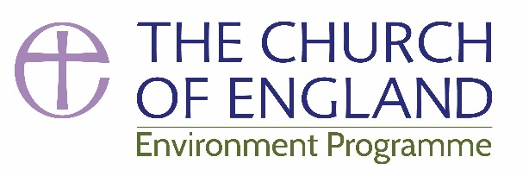
E-news Spring 18

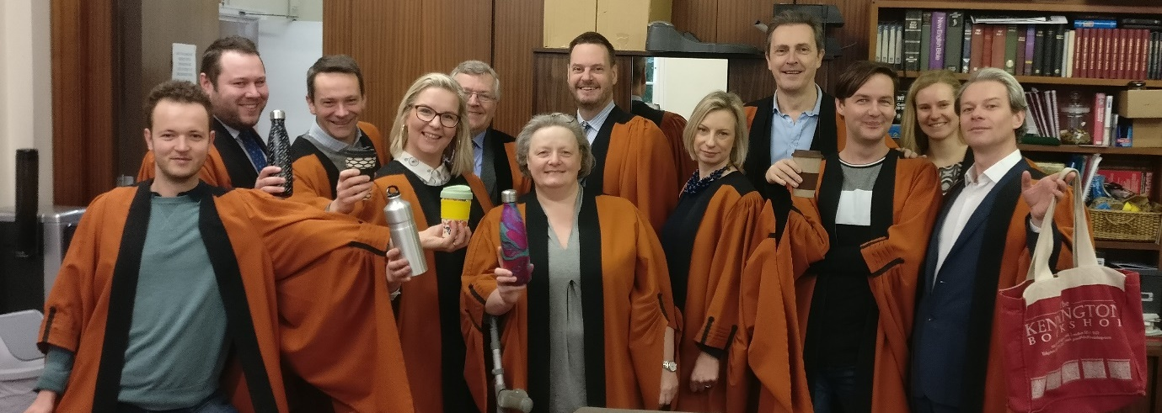
The choir of St Bride’s (London Diocese) tackling Plastic-less Lent – find out more about their experience here

‘Care for God’s creation and the people who inhabit it is instrumental to the life of faith’.
Archbishop of Canterbury Justin Welby

The Lent Plastics Challenge was taken up by parishes across the country and featured in the press nationally and internationally including articles in the New York Times and a feature on the Canadian Global News. We have produced a short follow up flyer with five easy steps to reduce single-use plastics but if you want more tips on plastic-less living take a look at this fantastic Facebook Group. The Bishop of Salisbury has welcomed the Government’s proposal to ban a number of single-use plastics and the environment campaign will continue to push for action on plastic waste.
Keen to take on another challenge? Watch out for the Creationtide Calendar – daily actions from 1st September to 4th October.

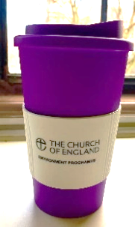
This Easter every member of Church of England staff was offered a free re-usable mug to encourage a reduction in the unsustainable use of disposable cups and single-use plastics. We are considering making these available more widely at the cost price of £6.55 – let us know if this would be of interest so we can gauge demand.

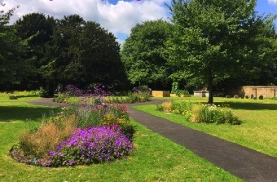
Green Health Awards - The benefits of engaging with the natural world for mental, physical and spiritual health is increasingly recognised. These new awards, run in partnership with the Church Times, will recognise churches who are engaging with this work. For example, those communities which make best use of their outdoor space to promote the links between natural environment and our health. The Green Health Awards will be launched on the 4th May and will culminate in a conference on 2nd October. We’re currently looking for exciting existing projects to be used in publicity to launch the awards, let us know which projects inspire you.
Therapeutic Garden at St Mary’s, Lewisham
Grow Wild Seed Kits - thanks to Kew Gardens and the Big Lottery we have some free wildflower seed kits to give away. These are designed for a community project – a congregation, school or local group of any sort to get involved with wildflower growing and include posters, stickers, seeds and all the resources you need to get going. If you would like a kit all we ask is that you take photos and let us know how it goes. Get in touch to claim your kit!
Parish Buying - just a reminder that the electricity bulk purchased by the Church of England procurement service is now 100% sourced from UK-based renewables, with the vast majority generated through solar panels and don’t forget there is also a discounted LED deal. Find out more here.
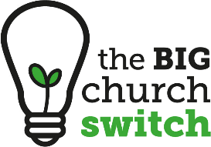
Big Church Switch – this successful partnership between the C of E, Christian Aid & Tearfund is coming to an end but the website remains and signposts to the five energy companies that only supply electricity from 100% renewable sources. Overall around 5000 churches (roughly 2000 C of E) have switched to green energy, which is a fantastic number which we hope to see grow.

Letters for Creation are now coming in from across the Anglican Communion as part of a global environmental exchange with Provinces sharing their perspective on our Christian mission to care for God’s creation. The letters are part of an international dialogue leading up to the 2020 Lambeth Conference.

Speak Up Week 20 June to 8 July - Take part in this week of action, a national conversation about how climate change is affecting the life we love. You can find tips on engaging with your MP and holding an event here. In addition, Hope for the Future have some wonderful resources on how to work with your local MP and Councillor.

Looking for ideas for your parish newsletter? The Diocese of Leeds has produced these 52 Eco top tips to last you through the year.

Diocesan Environment Officers Do you know who your DEO is? Check here.
Host a clothes recycling bank - the Salvation Army are looking for churches who have space for a clothes bank in a car park or underused area of churchyard. These banks prevent many unwanted clothes from going to landfill and also generate a small income to be split between the church and the Salvation Army. Currently 19 CofE churches are part of this scheme but we are keen to see it expand. Let us know if this is of interest.

Eco Church - Over 860 churches and growing Eco Church is a great tool for engaging congregations with environmental issues. We will be holding more events in partnership with A Rocha UK which we hope will include a major Liverpool conference in 2019. In the meantime, take a look at this great film from Winchester Diocese about the benefits of Eco Church.
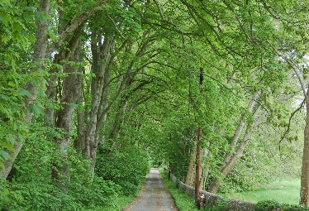
Great British Elm Survey - with the help of the country's citizen-scientists the Conservation Foundation are building an accessible, public database that records the state of the elm population and potentially disease-resistant trees for researchers. You can help by uploading the location and a photograph of any elms you see.

Has your supermarket committed to tackling food waste? Check Tearfund’s Renew Our Food campaign.

Green Christian are looking for a volunteer to help with their website, contact Poppy Pickard.

Resources:
Global Neighbours – a new school accreditation scheme run by Christian Aid in partnership with the C of E’s Education Office, to encourage a deeper understanding of global injustice and the Christian response to it in primary school pupils across England. Schools can register here. There are also some great resources from the long running Eco Schools programme including an interactive tool and take a look at Diddy Disciples for worship and storytelling materials.

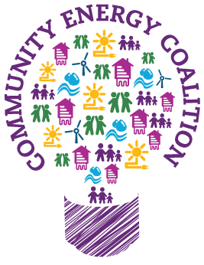
CHAD living - Choices, Habits, Actions and Decisions – a great series of films from the Diocese of Lichfield covering everything from vegetarianism to toilet twinning.

Community Energy Fortnight - will be held 23rd June – 8th July. You can see the events taking place here. Lots of community energy groups are keen to work with churches to install renewable energy. Be inspired by Power Up North London’s work with St Anne’s Highgate. Interested? Let us know.

Mission 2020 - The evidence that a 2020 climate turning point is within our grasp is growing every day but when it comes to climate, timing is everything and we must lock-in these gains now and accelerate action ahead of 2020. Christiana Figueres convenes Mission 2020, a global initiative that has outlined 6 milestones to meet by 2020 if the Sustainable Development Goals are to be achieved in 2030.

John Ray Initiative - the JRI blogs are excellent sources of considered and thoughtful reflection on topical issues. Recent additions include Carbon offsetting – a licence to pollute?, Tensions or Contradictions for Ecotheology and Of Electric Cars and Disruptive Technologies.

Microplastics Toolbox - from A Rocha International to equip you to act against microplastics in your local community- whether you are acting as an individual, a family, a church or any other group. This contributes to global efforts to fight plastic pollution in the oceans under the Sustainable Development Goal 14. Resources are categorised under: Education, Science, Theology, Lifestyle, and Media.
Tenants of the King - is a new Bible-based, Jesus-centred resource from Operation Noah. This four-part study series is designed to help you and your church consider what the Bible has to say about today’s climate crisis through interactive group sessions, video interviews with leading Christian thinkers and insightful Bible commentary. You can pre-order your copy now.

The Manchester Green Summit had some excellent and inspiring presentations, in particular, Kevin Anderson’s talk is great at challenging us on our use of climate change data and targets.

Fit for the Future - a network for Not-for-Profit organisations who want to reduce energy bills and better manage environmental impacts. The network holds useful and inspiring information sharing events. The environment campaign is a full member so that diocesan or parish representatives can attend these events for free. The events are listed here and you can see the most recent impact report here.

The Cambridge Institute for Sustainability Leadership has produced a report on the 8 business & sustainability trends that will define 2018. Based on the insight and expertise of more than 40 CISL Directors, Senior Associates and Ambassadors, this briefing identifies the top 8 sustainability trends business leaders need to be aware of in order to drive meaningful change for a sustainable global economy and long-term business success.

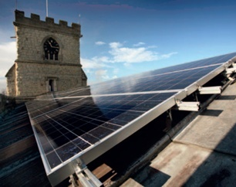
OnGen’s renewable energy feasibility platform is a software service which allows you to produce accurate feasibility studies in minutes, requiring only basic information about your site. To see if onsite renewable energy generation has potential at your church, OnGen run feasibilities assessments. While this is not a service endorsed by the C of E if it is of interest you can contact them here. If you are considering solar don’t forget to talk to your DAC Secretary as early as possible.

Focus piece:
Every church in Islington has recently had an environmental audit as part of a project led by grant-funder Cloudesley, in partnership with the Diocese of London and the Islington Deanery.

Cloudesley’s Sustainable Church Buildings Project forms part of its 500th anniversary celebrations. The charity originated from Richard Cloudesley’s will in 1517 (the same year as Luther’s 95 theses!)

We think there is a lot of potential to draw lessons from the findings of these audits, of benefit to other deaneries in London, and we hope other dioceses and churches around the country.

Perhaps it’s no surprise that the auditors from AECOM found the most effective steps churches can take to be LED lighting, solar panels, secondary glazing, draught-proofing and roof insulation.

Common recommendations around heating were to improve zoning and heating controls, to lag pipework, and in some circumstances, to install infra-red radiant panel heaters.

Far infra-red heaters are an improvement on the traditional infra-red types. The newer types are more efficient, do not glow orange, and should not roast the follically challenged! They can be useful when small areas need heating for specific periods of time, for example the altar end during concert rehearsals or side chapels for prayer meetings. However they only reduce energy consumption if any background heating is turned down low.

Of particular interest might be which recommendations are the most cost-effective to implement.

Looking just at the twenty most cost effective recommendations, in terms of environmental impact per £ spent, lighting is the most common: | And for the twenty actions most effective at cutting running costs per £ spent, energy-efficient lighting is even more dominant:
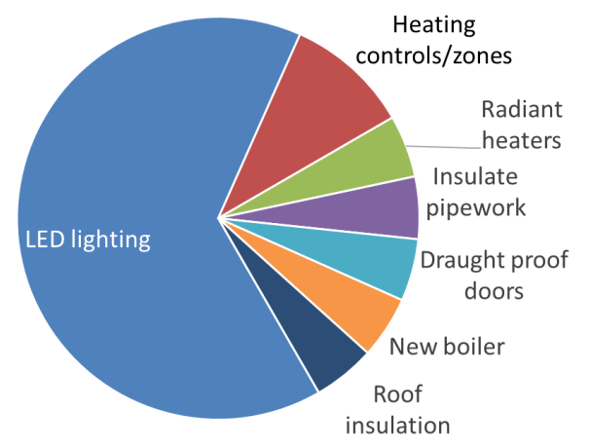 | 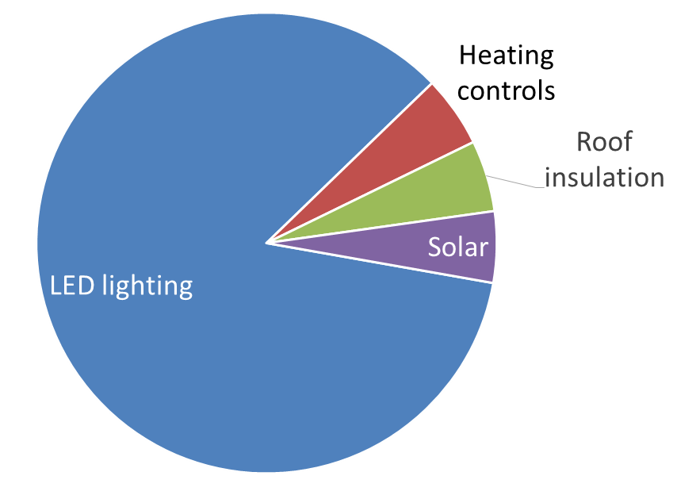

The project has demonstrated a significant impact both on church running costs and also on the environment from draught proofing and insulation, secondary glazing, energy efficient lighting. There is also a place for technologies like infra-red heaters and solar panels, but these should be considered after the building fabric has been made more energy efficient.

With LED lighting dominating the picture so strongly, and paying back relatively quickly, it is clearly worth every church considering replacing their lighting with LEDs. LED bulbs are available from Parish Buying (a discount deal with LED Hut). Complex considerations can arise depending on whether existing fittings can be re-lamped, or the whole fitting needs to be replaced. Many churches have a mixture of both. It isn’t always obvious whether an electrical contractor and/or lighting designer are needed. Guarantees available against early lamp failure are a controversial topic.

Cloudesley’s anniversary programme has been a rare opportunity to follow on directly from audits to retrofitting works – avoiding the risk that audit reports go stale before anything is done to implement them. Dioceses generally may find that identifying eligible local and national grant schemes, and planning a strategy to access them before any audit(s) are undertaken, can bring huge benefits. Many grant schemes come out of the blue, with a short response time, so being ready with a favoured programme of action, even before any means of paying it is on the horizon, can prove highly beneficial.
Thanks to Brian Cuthbertson (Diocese of London) and Catherine Ross (Cloudesley).

Dates for the diary:

28 April - Caring for Creation (with Revd Dr Rachel Mash), Reading
6 May - Rogation Sunday - service booklet
12 May - Faith and the Environment Conference 2018: Climate Change and the Coast, Lincoln
15 May - Assessing climate impacts: adaptation site visit, Newport (Fit for the Future event)
25-28 May - Forest Church Eco-Retreat, Llanberis, North Wales
2 June - Green Christian "On the Road Together", Cambridge
7 June - Our Faith, Our Planet, Our Actions, Manchester Cathedral
10-16 June - Nature and Discovery Week, Les Courmettes, France
17 June - Eco-theology and conservation, London
6 – 8 July- Green Christian retreat weekend, Northumberland.
23 June- 8 July- Community Energy Fortnight
14 – 17 Sept. Great British Beach Clean – find your nearest event
15 Sept. - Green Christian “On the Road Together”, Derby
16 Sept. - Nicolas Peel: Finding solutions to key ecological issues, London
25 Sept. - Creationtide evensong, St Paul’s Cathedral, London
29 Sept. - 5 Oct. Good Money Week
6-10 Oct. - ‘On the way to economic and ecological justice – ‘To give you a future with hope’ (Jer 29:11),’ 12th European Churches Environment Network Assembly, Katowice (Poland)

Didn’t receive this newsletter directly but would like to? Please sign up on our website.

Contact us: www.shrinkingthefootprint.org @CofEEnvironment @ShrinkingtheFootprint

©Colin Sargent/David Harris

In February the first fully off-grid solar lighting system in a church was dedicated by the Bishop of Plymouth. This thriving church, St Michael’s, Brent Tor, Diocese of Exeter is now no longer reliant on gas.

