Excarnation Project: The Spirituality of Assassin’s Creed: can people encounter theology through gaming?
The Assassin’s Creed series (Assassin’s Creed I, II, Brotherhood, Revelations) by Ubisoft Montreal is a video game falling into the following categories: historical fiction, action-adventure, open-world, and stealth gaming. The makers add a note to the game to indicate that the story was compiled by a multi-faith team.
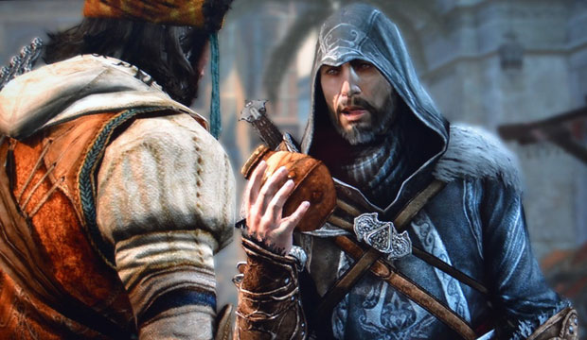
The story
There is an overall frame for the Assassin’s Creed story although it does not play a particularly important role in the game itself. The premise is that it is 2012 and humanity faces the end of the world. Abstergo Industries, a cover for the modern day Knights Templars, seek to bring all humanity under their control. They want to do this by using a man called Desmond Miles who is descended from a tradition of Assassins. Using a machine called The Animus, Desmond (‘Subject 17’) has the ability to reconnect through his DNA with the memories of his Assassin ancestors and relive their lives. Desmond is rescued by another modern day organisation of Assassins who are opposed to the Knights Templar. Now his task is to go into the Animus and use his ancestors’ memories to discover the whereabouts of hugely powerful artefacts ‘Pieces of Eden’ which can create or destroy. Both sides want to get their hands on the artefacts including the ‘Apple’ of Eden and a staff.
Desmond discovers through his quests as his ancestors that humanity was preceded by another race of beings on earth who remain in our memories as ‘gods’. The ones he encounters are called Juno, Jupiter and Minerva. They explain that although they ‘created’ humanity they were unable to save their own race, although plans and solutions for saving themselves were kept secret and humans might be able to use them now to save themselves. A few of these people of the First Civilization bred with early humans allowing some of them to develop special abilities. Desmond and his ancestors share a sixth sense (eagle vision) which allow them to see hidden codes and ciphers and to identify soldiers and targets within the game.
The important elements of the background story are: that primitive religions made gods of people who wanted humanity to survive and prosper; that salvation from death and annihilation is possible; that there are evil forces in the world which want power and control; that knowledge is hidden in our history; that we are connected to all others by our DNA and memories; that myths conceal truths of great power.
In the first game, Desmond relives the memories of his ancestor Altaïr ibn-La'Ahad, an Assassin during the Crusades. In the second game he is Ezio Auditore da Firenze, an Assassin during the Renaissance, helped by Leonardo da Vinci. In the third he is an older Ezio in Rome, working with Niccolo Machiavelli. In the fourth he is both Ezio and Altair. Ezio is this time located in Constantinople.
Many more Assassin’s Creed titles have since been created, with fewer philosophical elements and more fighting.
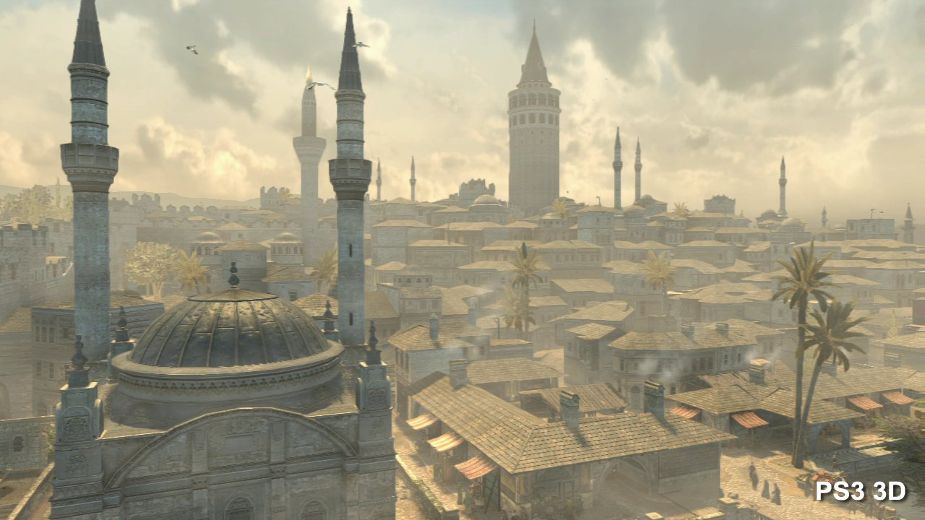
The game experience
The game player plays different memories and is given tasks to complete. Completing tasks moves the story on and gives access to new memories. The tasks are given by teachers and mentors. The tasks fall into different categories: straightforward fighting, tailing or stealth exercises, retrieval of objects, and races. The game also includes complex puzzle solving. The completion of each task gives the player access to new weapons and armour or abilities or knowledge. The player cannot die but if he is defeated he ‘desynchronizes’ from his ancestor’s memories and has to start again. Memories can be replayed to collect missed items or re-run conversations or quests.
Although Altair/Ezio has to learn fighting techniques (each game scenario has a practice arena, learning to use weapons, but also defensive moves, disarming moves etc), fighting in the early titles is often discouraged or avoided. The player is never allowed to kill civilians and doing so results in desynchronization. Some quests specifically require that enemies be engaged but not killed, and stealth objectives are prioritised over plain fighting. However Altair/Ezio is an Assassin which means that the main evil characters do have to be killed. However, whenever the player takes one of these important lives, there is typically a cut scene in which the dying character explains the reasons for his actions, sometimes causing Alatir/Ezio to doubt whether he was a legitimate target. No matter how evil, Ezio engages with his victim in his last moments before pronouncing Requiescat in Pace. One such victim is Rodrigo Borgia, Pope, who Ezio assassinates in St Peter’s. Ezio in particular also has to train his own Assassins, ordinary people whom he rescues from oppression. They thank him by serving him and he sends them off on missions to learn fighting skills. Eventually Ezio need not do any fighting himself, he can call for his Assassins and they deal with the fight themselves. In Revelations, there are areas which have to be taken from occupying Templars by military strategy, which Ezio directs. In Assassin’s Creed II Ezio uses Leonardo da Vinci’s inventions such as a flying machine to achieve quests.
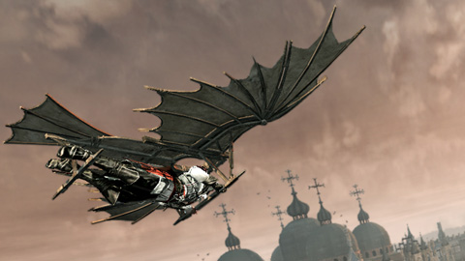
Although the quests move the story along, the game encompasses much more than this. Each game is set in a city or cities and these are beautifully rendered in exquisite detail for the player to explore. In the first game, Altair travels to Damascus, Jerusalem, and Acre as well as ‘the Kingdom’ in between. In the second, Ezio travels from his villa in Monteriggione to Florence, Venice, Forli and Tuscany. In Brotherhood, Ezio explores Rome and in Revelations, Constantinople. The player can explore the streets of the cities at will, hearing the citizens talk to one another, buy things from shops, swim in the canals and climb to the rooftops travelling all around the city by roof looking at the vista. The player also has to climb to many viewpoints on top of churches or mosques to open up new areas of the map. He can get down by performing a ‘leap of faith’ from the top of high buildings. The rendering is visually and aurally stunning and beautiful with a soundtrack which includes plainchant-like music. Sounds include street corner preaching about both the Christian and Muslim faith, aimed at rousing the crowd, such as both lauding and declaiming against the actions of Richard the Lionheart who Altair finally meets at the end of Assassin’s Creed. The voices of beggars and merchants, also rise up from the streets, many commenting humorously on what Altair/Ezio is up to.
From the second game on, whenever the player encounters a new area or meets a new historical figure, a database becomes available explaining the historical detail about the place or person. Some of the places have to be examined in minute detail in order to obtain clues, so the player becomes intimately acquainted with the architecture of churches and mosques. Further, the player obtains money by renovating broken down areas of the city, restoring shops and monuments. From this restoration the player obtains more income to spend on being healed by doctors, but also to acquire famous paintings of religious subjects and in Revelations, beautiful books. Each painting and book can be contemplated and information about them is supplied to the player. The player has a home or hideout in which he is safe and can go back to in order to look at his purchases and read more about the historical background of the people and places he has encountered. In Assassins Creed II, the player has to solve puzzles which typically involve looking at famous photographs from history usually associated with war or destruction and identifying the Apple of Eden hidden somewhere in the picture.
Behaviour
Further Ezio in particular is associated with thieves, mercenaries and prostitutes. He sometimes acts on their behalf, righting wrongs and rescuing women who are being badly treated and they in return help him in his quests. Beggars often ask Ezio for money and his can distract guards or gain thanks by giving or throwing money. Much of his work involves restoration – removing enemy flags and dealing with injustices, such as persuading adulterous husbands to go home to their wives. In this sense he is also a knight and a courtly lover, undertaking quests in one subset of memories for the woman he loves who is married to another. He also cares for his mother and sister.
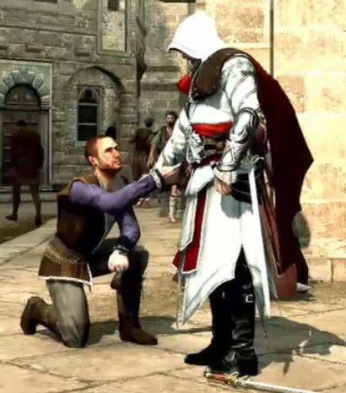
Spirituality
The story offers a background of good and evil, but the game does not allow everything to be so black and white. Altair/Ezio are servants/knights of a ‘righteous’ cause, but they discover that the people they thought were evil may have been acting because of other motives, and that those they serve may not be either good or true. Indeed the Assassin’s Creed is ‘Nothing is True. Everything is Permitted’. They have to learn to doubt even the wisest and most powerful people and to search for Truth elsewhere. Altair is betrayed by his master. The Pope is revealed as corrupt and evil. One form of ‘truth’ comes in cryptic signs from Desmond’s predecessor Subject 16, who leaves messages for Desmond that only he can see. In Revelations, Subject 16 sacrifices himself so that Desmond does not get eternally trapped in the Animus.
The cities which the characters visit are filled with churches and mosques. In one scene, Ezio has to infiltrate a Mass and mingle with the crowds of priests to remain undetected as he unravels a conspiracy. The voices of Christians and Muslims are heard everywhere. Ezio learns from artists and philosophers and he has to ponder whether there are any eternal truths, especially the misuse of power. The underlying questions seem to be: how do you obtain knowledge? Who do you trust? Why does power corrupt? What is good and evil? What do liberation and salvation mean? Altair says: ‘When I was very young, I was foolish enough to believe that our Creed would bring an end to all these conflicts. If only I had the humility to say to myself, I have seen enough for one life, I've done my part. Then again, there is no greater glory than fighting to find the truth.’
Ezio spends time liberating and befriending the oppressed, bringing justice (and vengeance) and releasing the poor to greater service. In him, displaced persons find allegiance and cause. Further in Revelations, Ezio discovers that his purpose in life is to make Desmond’s future possible – his entire existence creates a possibility for the salvation of all. He has a transcendent experience at the end in which his questions are answered. ‘I have lived my life as best I could, not knowing its purpose, but drawn forward like a moth to a distant moon; and here at last, I discover a strange truth. That I am only a conduit, for a message that eludes my understanding.’
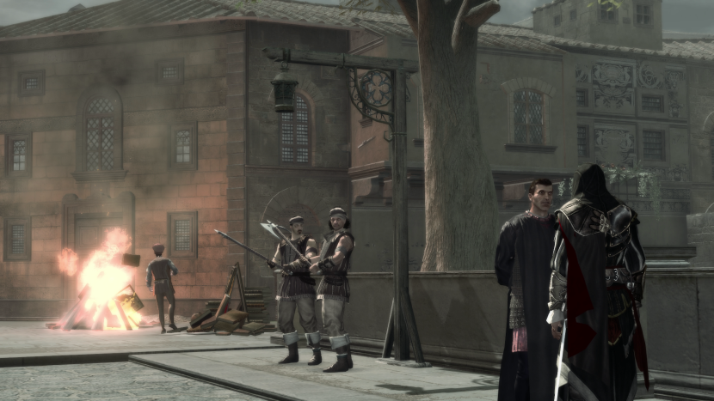
Ezio and Machiavelli discuss Savonarola
Effect on the Gamer
We might want to ask: what does contact with these themes and visual explorations of the religious world mean to the gamer? The game offers no explicit witness to Christian and/or Muslim faith but yet Christian faith especially is everywhere. Gamers who have never darkened the doors of a mosque or a church are invited to explore their buildings inside and out and to find out more about the Crusades and the Renaissance periods of history, complete with their religious backgrounds. The gamer is encouraged to work with the character as Everyman, searching for truth and befriending the poor and outcast against the corruption of the wicked. And the game asks the gamer to engage with the beautiful, books and art, to renovate the life of the cities, to spend time and effort getting the resources together to make things new. There is a journey in a religious environment, but no specific ‘message’ unless that it is that religion and religious history somehow equips us for saving the world in our time.
If we are investigating what happens to people who inhabit these virtual worlds, what do we make of the Assassin’s Creed series? Are there ways to encourage gamers who are captivated by the open world explorations to find out more about Christian history, about inter-faith relations, about the search for truth and the meaning of salvation?
http://assassinscreed.wikia.com/wiki/Assassin%27s_Creed_Wiki
http://assassinscreed.uk.ubi.com/assassins-creed-1/experience/

