‘Lost and Found’ - exploring through films
Amazing Grace How sweet the sound That saved a wretch like me. I once was lost but now am found Was blind but now I see.

Jesus tells stories about people and things which are lost, but are then found. A lost coin, a lost sheep, lost people, like the Prodigal Son. Sometimes we talk about evangelism as saving the ‘lost’ (Luke 19.10) but what does it mean to be lost?
What kinds of ‘lost’ exist in our society today? What does it feel like to be ‘lost’? And what might it feel like to be ‘found’?
In the following sections, a mainstream film is used as the basis for thinking about what it might be like to be lost in different ways and to be found again. What are the costs? What difference does it make to families and communities? And what does it show us about what Jesus was telling his disciples and followers? You might be able to think of many more films which explore the same themes.

sandeepachetan.com/flickr
For each film, there is a short synopsis, some questions to think about, a short piece of Scripture, a challenge, and an invitation to reflection.
You may like to end with a short prayer: God, you love the whole of creation. Nothing is lost to you. You know the secrets of our hearts. Find us, we pray, and turn our faces towards you. In Jesus’ name. Amen.
There are more films to explore at http://www.spiritualjourneys.org.uk/dream/dream_films.php
Contents:
Physically lost –
Spy Game
Into the Wild
I am Legend
Proof of Life
Finding Nemo
Mentally ‘lost’ -
Still Alice
Driving Miss Daisy
A Beautiful Mind
What’s Eating Gilbert Grape?
Girl, Interrupted
Emotionally ‘lost’ -
The Savages
Willy Wonka and the Chocolate Factory
Frankie and Alice
Truly, Madly, Deeply,
Shallow Hal
Spiritually ‘lost’ -
A Christmas Carol
Up
Silence
The Life of Pi
It’s a Wonderful Life
Physically lost – Spy Game (Cert 15)
(Universal Pictures)
Plot: An American secret agent is captured in China trying to save the woman he loves who has been arrested and imprisoned. The American government does not want to demand him back as the government is trying to secure a trade deal, so he is destined to die. His old boss, on the day of his retirement, uses every skill and asset he has, including his entire retirement fund, to circumvent the government officials and save his friend.
Some questions:
- Who would you give everything you have to save?
- Tom is ‘lost’ but Nathan uses all his skills to find him. Who would you trust to help you find someone who was physically missing?
- What do think the relationship is between risk and becoming lost?
- How do you think Tom felt when he realised the significance of ‘Dinner Out’?
- What is ‘found’ in the film?
- What do you think this film does to remind us of people unjustly imprisoned and what can we do about it?
Scripture pause: Genesis 21: 17 7 God heard the boy crying, and the angel of God called to Hagar from heaven and said to her, “What is the matter, Hagar? Do not be afraid; God has heard the boy crying as he lies there
Challenge: who in our community might be lost and overlooked because of political concerns or lack of will? What could we do as a Church to make them visible and help to find them?
Reflection: have you ever been physically lost? Or has someone you love gone missing, even for a little while? What does that feel like? What did you think about? How were you/they found?
Physically lost – Into the Wild (Cert 15)
© Mary Evans Picture Library
More to think about in this film here: http://www.spiritualjourneys.org.uk/pdf/IntotheWild.pdf
Plot: A teenager, who is expected to have a brilliant career at Harvard, turns his back on a glittering career and all the expectations of his parents to walk around America and get lost in the wilderness. Ultimately he is not equipped to survive alone and eventually dies (based on a true story).
Some questions:
- What does the film tell us about the pressure to succeed?
- What do you think Christopher/Alex learns about himself?
- Do you think his choice is worth the risk?
- What do you feel about his eventual death? How might his parents feel?
- What is ‘found’ in the film?
Scripture pause: Jonah 1.3 3 But Jonah ran away from the Lord and headed for Tarshish. He went down to Joppa, where he found a ship bound for that port. After paying the fare, he went aboard and sailed for Tarshish to flee from the Lord.
Challenge: what could we do to reduce pressure on young people and allow them to find breathing space and a place to ‘find’ themselves?
Reflection: have you ever wanted to get away from it all? Do you dream of exploring and finding new things? Have you ever stopped pursuing a dream because of work and responsibilities? What one thing could you change in your life to open up the possibility of exploration and personal growth?
Physically lost – I am Legend (Cert 15)
© Warner Brothers
Plot: A lethal virus wipes out 90% of the human beings on the planet. Some survivors are ruined shadows of themselves who kill anyone they find. US Army virologist Lt Col Robert Neville is lost and alone in the wreckage of Manhattan. He doesn’t know if any untouched humans have survived.
He continues to try and find a cure for the disease, hoping he might be found by other uninfected people through his radio broadcasts. Flashbacks of his life show what he has lost – family, colleagues, friends. He does have a dog and talks to mannequins and characters in films to feel less alone. He is constantly in danger from the Darkseekers at night. But he has to kill his dog when she is infected and attacks the Darkseekers in despair. He is found by some immune people and with their companionship manages to find the cure for the virus.
Some questions:
- What would it be like to be the only person left alive?
- What does this film tell us about the need for companionship?
- Why does the main character going on trying to find a cure?
- Who is really lost in this film? And found?
Scripture pause: Psalm 15.16-22 Turn to me and be gracious to me, for I am lonely and afflicted. Relieve the troubles of my heart, and bring me[a] out of my distress. Consider my affliction and my trouble, and forgive all my sins.
Challenge: what could we do to be more aware of people who are isolated and living in fear? What ‘broadcasts’ do they make, that we could hear if we took time to listen?
Reflection: what would it be like to be left behind, or having lost your family? What would it be like to be a refugee or an asylum seeker lost in countries you don’t know, or lost in the system, wondering what is going to happen to you?
Physically lost – Proof of Life (Cert 15)
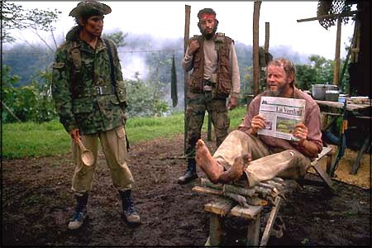
© Castle Rock Entertainment
Plot: An engineer is kidnapped for ransom in South America. His wife hires a professional negotiator to work for his release. His other family members are not happy about the process, but Alice wants to trust the negotiator. But can her husband keep going among volatile and dangerous captors who want to kill him?
Some questions:
- What do you think needs to happen in a hostage situation?
- Do you think Alice did the right thing to trust the negotiator?
- How do you think Peter felt about his situation and about being found?
- What is the importance of negotiation, compromise and persuasion in human relationships?
Scripture pause: 2 Kings 14.14 He took all the gold and silver and all the articles found in the temple of the Lord and in the treasuries of the royal palace. He also took hostages and returned to Samaria.
Challenge: what could we do as a Church to highlight the situations of people who are kidnapped, taken as hostages or used to extort from others? There might be less dramatic ways in which people are used to manipulate others. Where do people get used in this way within our own communities?
Reflection: What would it be like to be held against your will? Christians like Terry Waite were taken as hostages for years. Would faith be enough to sustain you? What would you need to get through a situation like this?
Physically lost -Finding Nemo (Cert U)
© Pixar/Disney
Plot: Nemo is a clownfish with a damaged fin who wants to explore the world, but not allowed to. He swims off and is abducted by a scuba diver. Marlin, his father, looks for him with Dory, who has memory loss. They search through various dangers. Nemo ends up in an aquarium in danger, but is helped to escape. Although Marlin thinks Nemo is lost forever, Dory remembers enough to help reunite Marlin with Nemo.
Some questions:
- What does this film say about parental stifling and the need of young people to grow?
- What do we learn about the dangers of being lost and in unfamiliar places?
- What is Dory’s role in the film?
- What are the wider questions in this film about human beings and our impact on marine environment?
Scripture pause: Jonah 2.3 You hurled me into the depths, into the very heart of the seas, and the currents swirled about me, all your waves and breakers swept over me.
Challenge: how often does your church listen to the interests and concerns of children and young people and allow them the space to experiment and explore?
Reflection: how often are we overprotective of people we don’t think can cope and don’t allow them to try things out in case they get hurt?

Mentally ‘lost’ – Still Alice (Cert 12)
© Killer Films
Plot: Alice Howland, a linguistics professor, begins to forget words and get lost aged 50. She is diagnosed with Alzheimer’s. She prepares by getting pills, setting down questions and instructing her future self to commit suicide when she can no longer answer the questions. Gradually she forgets more and more of her life, but gives a lecture on what it is like to have Alzheimer’s. Her family struggle to care for her and she understands less and less. But her final response to something her daughter reads to her, is that it is about ‘love’.
Some questions:
- What do think about Alice’s fear of losing herself?
- What does Alice lose and what do her family lose?
- What do you think they find in this story?
- How does this film help us think about the unthinkable?
Scripture pause: Ecclesiastes 12.1-8 Remember your Creator in the days of your youth, before the days of trouble come and the years approach when you will say, “I find no pleasure in them”
Challenge: there are many people in our communities with different types of dementia. How can we help them as a Church to feel more included and cared for?
Reflection: how will you face old (or older) age? How prepared are you to care for someone with dementia or to experience mental deterioration? How could we be better prepared?

Mentally ‘lost’ - Driving Miss Daisy (Cert U)
© Photofest
Plot: Daisy Werthan is an older wealthy Jewish widow who lives with a housekeeper. Her son hires Hoke, an African-American chauffeur to drive her. As they spend time together she learns about prejudice and racism and about the way Martin Luther King challenges this. Eventually Miss Daisy and Hoke become close and he visits her after she develops dementia.
Some questions:
- What do you make of the way the relationship between Miss Daisy and Hoke develops?
- How does deeper understanding of race and discrimination relate to personal and spiritual growth in the film?
- What do you make of the way Hoke ‘finds’ Miss Daisy after she ‘loses’ herself to dementia?
Scripture pause: Proverbs 27.17 Iron sharpens iron, and one person sharpens the wits of another.
Challenge: what could your church do to root out prejudice and fear of others who are different and replace it with friendship and care?
Reflection: Do we ever pause to think about the way our minds work? Where do we get our ideas from and how do we learn from people who are different from ourselves? When we get old and if our minds get less sharp, what will we find most precious, most central to our identity, our relationships and our faith?

Mentally ‘lost’ – A Beautiful Mind (Cert 12)
© Imagine Entertainment
Plot: a brilliant mathematician, John Nash, is called on by the Pentagon to work on code cracking, begins to imagine conspiracies and that he is involved in a secret plot. He is diagnosed with paranoid schizophrenia but the treatment causes unpleasant side effects and he stops taking his medication with dangerous results. He has to learn to love with his condition while continuing brilliant work on game theory.
Some questions:
- At what point do we start to realise that John is becoming mentally ‘lost’?
- What might it be like to have gifts like John, but have to take medication that blunts and subdues them?
- How does this film help us understand the inner lives of people with severe mental illnesses?

Scripture pause: Psalm 147.3 He heals the broken-hearted, and binds up their wounds.
Challenge: paranoid schizophrenia and other severe mental illnesses can be very frightening to both sufferers and their friends and families. How can we provide more understanding, knowledge and support to those who have to live with these illnesses?
Reflection: how do you feel about people with severe mental illnesses within the community? Can we reach out more to those among us, looking through the eyes of Jesus?

Mentally ‘lost’ – What’s eating Gilbert Grape? (Cert 12)
© Moviestore Collection
Plot: Gilbert Grape looks after his brother Arnie who has learning difficulties and keeps trying to climb the local water tower. His father committed suicide and his bereaved mother has become morbidly obese and cannot care for her family. When Gilbert spends time with his girlfriend he neglects Arnie, loses his temper with him and finally runs away. He returns to the family asking forgiveness. His mother also asks for forgiveness.
Some questions:
- What does this film tell us about how we judge other people?
- How do you feel about Gilbert’s actions and relationships?
- How far do we understand and look for the background to struggling families?
- What does it mean to be a carer in challenging situations?
- Who is lost and what is ‘found’ in the film?
Scripture pause: Luke 15. 32 But we had to celebrate and be glad, because this brother of yours was dead and is alive again; he was lost and is found.
Challenge: what does your church do to support struggling families, especially where there are children or young people acting as carers?
Reflection: When have you felt that your own interests were being destroyed by the needs and demands of others? How do we cope with conflicting emotions? Why does asking for, and receiving forgiveness matter?
Mentally ‘lost’ – Girl, Interrupted (Cert 15)
© Columbia Pictures
Plot: Susanna Kaysen has a mental breakdown and overdoses and ends up in psychiatric hospital. Here she meets other patients with a range of mental illnesses. Lisa, another patient, is manipulative and charismatic. Although attracted to her spirit, Susanna discovers that Lisa is bad for her and that she has to concentrate on her medication and therapy. Susanna recovers and reflects on what she has learned from her experiences.
Some questions:
- What does this film tell us about mental illness?
- What do you feel about the relationship between Susanna and Lisa?
- How do you think Susanna’s experiences might help her in the future?
- How does Susanna ‘find’ herself?
Scripture pause: Mark 5. 5-8 Night and day among the tombs and in the hills he would cry out and cut himself with stones. When he saw Jesus from a distance, he ran and fell on his knees in front of him. He shouted at the top of his voice, “What do you want with me, Jesus, Son of the Most High God? In God’s name don’t torture me!” For Jesus had said to him, “Come out of this man, you impure spirit!”
Challenge: many people suffer a period of mental illness during their lives and may need medication and therapy. Yet mental illness still carries a stigma. Susanna’s is a true story. How can we support people with these disorders within our own communities? What would it take for them to feel ‘found’?
Reflection: where have you come across people suffering problems like this? How does Christian faith in following Jesus help us respond to, and care for, people who suffer like this?
Emotionally ‘lost’ – The Savages (Cert 15)
© Fox Pictures
Plot: Two selfish and self-absorbed siblings discover that their father, whom they dislike, is suffering from Alzheimers and they have to take care of him. Neither wants to, but gradually, the process of caring for him as he begins to die, changes them and makes them into better people.
Some questions:
- How do we know that Wendy and Jon are emotionally disconnected?
- What do we learn are the reasons behind their behaviour?
- How does caring for their father make a difference to their lives?
- What are the hopeful signs at the end of the film?
- How do Jon and Wendy find their emotional integrity?
Scripture pause: 1 Peter 4. 8-10 Above all, love each other deeply, because love covers over a multitude of sins. Offer hospitality to one another without grumbling. Each of you should use whatever gift you have received to serve others, as faithful stewards of God’s grace in its various forms.
Challenge: what could we do through our Christian lives and our churches to help people care more about others rather than themselves?
Reflection: when have you been selfish and self-absorbed? How could you think about others more often? What difference does it make to our own lives to care for others?

Emotionally ‘lost’ - Charlie and the Chocolate Factory (Cert PG)
© Warner Brothers
Plot: Charlie, who lives in poverty with his family, wins one of five Golden Tickets to a special tour of Willy Wonka’s Chocolate Factory. There he meets the strange and sad Willy Wonka along with four other children who are greedy, spoiled, self-absorbed, and unkind. Those children run into trouble in the factory and disappear. Willy has a horrible past of deprivation and control which has poisoned him, so when Charlie wins the competition for the factory the condition is that he leave his family. Charlie refuses. Instead Willy joins Charlie’s family, where he finds happiness.
Some questions:
- What do we learn about the importance of family?
- What do we learn about the role of parents in this film?
- Which character do you feel most sorry for?
- How is this film a reflection of the pitfalls of modern life?
Scripture pause: Proverbs 21.2 All deeds are right in the sight of the doer, but the Lord weighs the heart.
Challenge: what could we do in our Christian lives and churches to understand a gospel for the wealthy as well as for those who are poor?
Reflection: do we think of poverty as something to be relieved with wealth or access? What have poorer people got to teach us? Do we tend to assume that not being able to have particular things leads to unhappiness?

Emotionally ‘lost’ - Frankie and Alice (Cert 15)
© Codeblack films
Plot: Frankie is a stripper who has multiple identity disorder. In one of her alter egos, she kills a man who wants her for sex. In another she is a white racist woman, Alice, although Frankie is black. She is helped to recover the memories that caused this, to reconcile them and to begin to heal. (Based on a true story).
Some questions:
- What does this film tell us about emotional loss and trauma?
- What does this film tell us about the emotional components in serious mental illness and its treatment?
- What would happen if we described Frankie’s demonic and in need of deliverance?
- What can we learn from this film about reconciliation and healing?
- Do you think Frankie’s ‘true’ identity is found or is it lost forever?
Scripture pause: Matthew 4.24 they brought him all the sick, those afflicted with various diseases and pains, those oppressed by demons, those having seizures, and paralytics, and he healed them.
Challenge: how does your church care for people with serious mental health problems
Reflection: how do we face the things inside us which we would rather not acknowledge or name? Is there a violent, frightened side to us? Do we have prejudices and biases which we keep locked up? Do we hold grudges and emotional pain which we don’t reveal to others? How do we find help and healing for these things?

Emotionally ‘lost’ – Truly, Madly, Deeply (PG)
© BBC Films
Plot: Nina is overwhelmed with grief at the death of her boyfriend Jamie, so he comes back to her as a ghost. At first overjoyed, Nina gradually realises that their relationship is not the same as before. his behaviour as a ghost drives her mad. Finally, Nina meets another man and Jamie leaves, having helped her move on to live her own life.
Some questions:
- What does this film tell us about death and bereavement?
- How do we know Jamie truly loves Nina?
- What do you suppose Jamie wants for Nina’s future life?
- What do you think about the idea that ‘grief is the price we pay for love’?
Scripture pause: John 11. 33-36 When Jesus saw her weeping, and the Jews who had come along with her also weeping, he was deeply moved in spirit and troubled. “Where have you laid him?” he asked. “Come and see, Lord,” they replied. Jesus wept. Then the Jews said, “See how he loved him!”
Challenge: how do we support the bereaved in our communities? Do we help people through the initial stages of grief but forget to support them in their future lives? How could we do that more effectively?
Reflection: have you been affected by the deaths of people you love? What has helped and supported you? How does Christian faith help us cope with grief and missing loved ones?

Emotionally ‘lost’ – Shallow Hal (Cert 12)
© Conundrum Entertainment
Plot: Hal Larson is a nice enough person but he only wants to date girls who are slim and attractive and who fulfil the stereotype of female beauty. He is attracted to Jill, but she finds him too shallow to have a relationship with. After being hypnotised, Hal finds he can see the inner beauty of women and becomes attracted to Rosemary who is fat, although in his mind she fulfils his idea of beauty. Eventually he realises what has happened and that there are more to men and women than their superficial appearance. He seeks out Rosemary and tells her how he feels.
Some questions:
- What does the film tell us about stereotyping?
- What does Hal have to learn to win Rosemary’s heart?
- What you make of Maurizio’s role in the film?
- How does Hal find himself in discovering what love really is?
Scripture pause: Proverbs 31.10 A capable wife who can find? She is far more precious than jewels.
Challenge: who in our communities might be struggling with self-image and self-esteem problems? How can we help them find their inner worth and help others to see it too?
Reflection: have you ever felt like Hal and judged only on appearances? Do you still worry about what you look like to others? How do you really get to know a person?

Spiritually ‘lost’ – UP (Cert U)
© Disney
Plot: Carl idolises an explorer, Charles, who is on the trail of a giant bird. But Carl’s life goes wrong when his beloved house gets threatened and his adored wife, Ellie, dies. He sets off in his flying house to find Paradise Falls to fulfil a promise to Ellie, along with Russell, who is trying to get a badge for assisting the elderly, and meets a talking dog. They find Charles and the giant bird and realise Charles has gone mad. Carl has to decide what is more important, life or possessions, find out how to keep his promise, and discover what life is really all about.
Some questions:
- What are the different spiritual journeys in this film?
- What do think is the significance of ‘Paradise Falls’?
- How does Ellie help Carl find the meaning of life?
- How do the different characters ‘find’ themselves in the end?
Scripture pause: Jeremiah 29.11 For surely I know the plans I have for you, says the Lord, plans for your welfare and not for harm, to give you a future with hope.
Challenge: What more could we do as Christians to help people think about what really matters in life and what they most hope for? How could we start a conversation about faith in such a context?
Reflection: Life events which don’t turn out the way we hoped can cause us to become spiritually lost and unclear what God intends for us. What resources does faith offer us to weather such times and find hope in the future?
Spiritually ‘lost’ – A Christmas Carol 1938 (Cert U)
Or The Muppets Christmas Carol (Cert U)
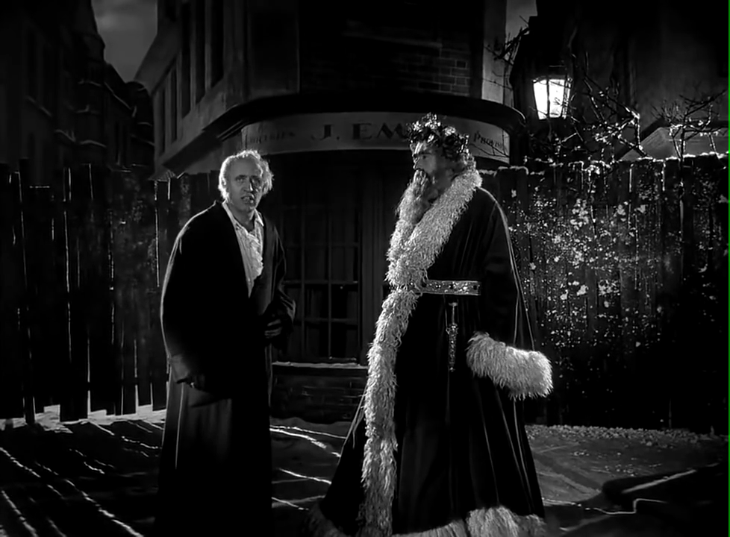
© United Artists
Plot: Ebenezer Scrooge, a wealthy miser, refuses to give money to charity and treats his nephew and his employee Bob Cratchit mercilessly. His dead business partner visits him, telling him to repent and that he will be visited by three spirits to teach him the error of his ways. The three spirits show Scrooge where he went wrong and he awakes a changed man, who gives to charity, takes his nephew into his family and makes amends to Bob Cratchit.
Some questions:
- How do we know Scrooge is initially spiritually ‘lost’?
- What lessons does Scrooge learn?
- What does the film tell us about repentance?
- What are the results of Scrooge being ‘found’?
Scripture pause: Luke 19.8 But Zacchaeus stood up and said to the Lord, “Look, Lord! Here and now I give half of my possessions to the poor, and if I have cheated anybody out of anything, I will pay back four times the amount.”
Challenge: how often do we wonder how selfish and self-absorbed people get to be like that? How can we offer those people hope and ways to find peace and happiness?
Reflection: where in your own life have you behaved like Scrooge? How might you remember to keep Christmas all the year? What would that mean?
Spiritually ‘lost’ – Silence (Cert 15)
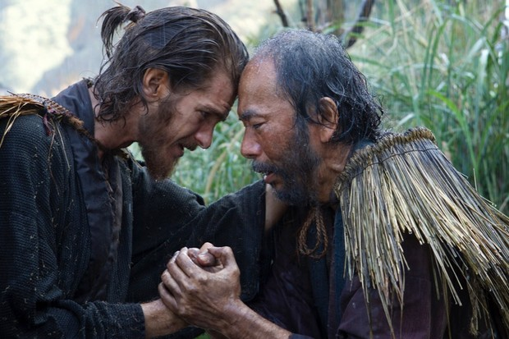
© Paramount
Plot: A priest, Cristovao Ferreira, sees five missionaries tortured to death by the Japanese. A few years later, his pupils hear that he renounced his faith under torture and go to find him. They too have to deal with being made to renounce their faith, including dying for their beliefs. One of them, Rodrigues, hears Christ giving him permission to renounce his faith to save others. Christ tells him that he is present even in the silence. At his death, years later, Rodrigues is nonetheless found to be holding a crucifix.
Some questions:
- What does this film teach us about religious persecution?
- What do you make of the ‘voice’ in the silence?
- Is it more important to die for your belief or to save others?
- What do you make of Rodrigues’ death?
Scripture Pause: Acts 7. 59 While they were stoning him, Stephen prayed, “Lord Jesus, receive my spirit.” Then he fell on his knees and cried out, “Lord, do not hold this sin against them.” When he had said this, he fell asleep.
Challenge: Christians and people of other faiths are still being persecuted and dying for their faith today. How can we support them and help them?
Reflection: There is a saying which goes, ‘if you were put on trial for your faith, would there be enough evidence to convict you?’ Is the evidence what matters, or what goes on in your walk with God?

Spiritually ‘lost’ – The Life of Pi (Cert PG)
© Fox Pictures
Plot: ‘Pi’ Patel is raised Hindu, but also encounters Islam and Christianity. His family own a zoo, but decide to move to Canada and sell their animals. Their ship is wrecked and Pi’s family is drowned. Pi survives with a tiger. After a spell on a carnivorous island, they reach land. The tiger goes into the jungle and Pi is rescued but his story is not believed, so he tells another one in which his name is that of the tiger. He points out that it doesn’t matter what the ‘truth’ is if his family is dead either way. His journey is a quest for God and for meaning. He concludes, ‘so it goes with God’.
Some questions:
- How do we know this story is a quest for God?
- What is the importance of telling a story to another person?
- How do you understand the changing relationship between Pi and Richard Parker?
- Does it matter how the journalist and the insurance company receive the story?
Scripture pause: Psalm 34.4-6 I sought the Lord, and he answered me, and delivered me from all my fears. Look to him, and be radiant; so your faces shall never be ashamed. This poor soul cried, and was heard by the Lord, and was saved from every trouble.
Challenge: how could your church learn to listen better to the stories people tell us about their lives?
Reflection: what is the story of your life? Do you tell your story differently to different people? Where does God figure in your personal story and how would you tell the story of your faith?
Spiritually ‘lost’ – It’s a Wonderful Life (Cert U)

© Liberty Films
Plot: On Christmas Eve, George Bailey considers suicide. Clarence, an Angel (second class) is despatched from heaven to save him and to earn his wings. Clarence learns about George and all the things he has done in his life for others. But things have gone wrong, George is in serious trouble and he cannot see a way out. Clarence then shows George what life would have been like without him in the world. George decides to face his life in the world only to discover that his troubles are over.
Some questions:
- What kind of person is George?
- What does this film tell us about the power of prayer?
- What does Clarence tell us about God’s care for George?
- What does the film tell us about the trace we leave on the world?
- How is George ‘found’ and saved in the film?
Scripture pause: Hebrews 1.14 Are not all angels ministering spirits sent to serve those who will inherit salvation?
Challenge: how can we help people who get into debt or other difficulty through no fault of their own.
Reflection: have you ever wished you had never been born? Have you ever been in a situation where you didn’t think there was a way out? Who was your ‘guardian angel’?

