The Mixed Economy
The term ‘mixed economy’ was first used by Archbishop Rowan Williams to refer to fresh expressions and 'inherited' forms of church existing alongside each other, within the same denomination, in relationships of mutual respect and support. Inherited and fresh expressions of church have their separate identities; they are different, but there is value in mutual recognition as they share resources, pray for one another and rejoice in each other's strengths. The diagram below expands the mixed economy to include church planting and pioneer parish spheres. It maps 4 principles:
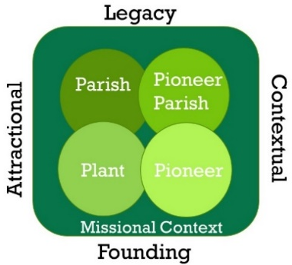
Legacy: an established worshipping and missional presence
Founding: a new emerging worshipping and missional presence
Attractional: host led, ‘worship first’ approach, serving the community out of church, an invitational (come and see) culture
Contextual: guest led, ‘serving first’ approach, church emerging out of serving the community, an incarnational (go and stay) culture

Churches could exist in any of these 4 spheres but will have a different approach within each. If in a Parish sphere (legacy & attractional) it could be a gathered church with an invitational approach building on established worshipping patterns and missional activity. There will often be strong links with the local community such with as schools, charities, social action or community cohesion groups etc. If in a Pioneer sphere (founding & contextual) it could be a new expression of church which has emerged over time through a ‘serving first’ approach by listing to the community, loving and serving it, building community that prompts questions about Christian faith and eventually leading to people asking ‘what would church look like for us? – lets grow church amongst us here’. If in a Pioneer Parish sphere (legacy & contextual), it could be a church in its own right with no expectation for people to come to church ‘on a Sunday’. It may follow a similar journey to the Pioneer sphere but will exist in parallel to the established church seeking to connect with new people and thereby extending the reach of the parish. There will often be shared leadership and perhaps some multi membership between the Parish Church and new expression of Church. If in a Planting Sphere (founding & attractional) it could be the result of a sending team engaging in a ‘worship first’ approach as church quickly forms in a new or redundant space. Mission is grown out of, or around this with an invitational approach.
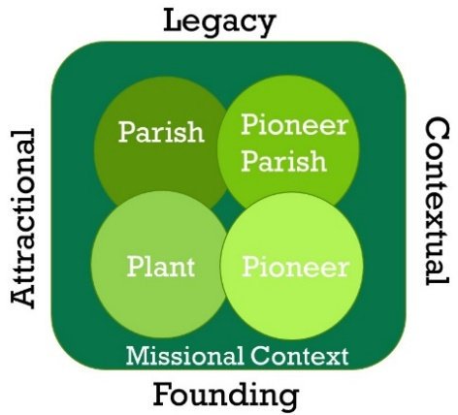
There may also be more subtle nuances within the mixed economy spheres. Some examples could include: A new congregation of a parish church designed to reach a specific demographic might be found at [A]. A church planting team that are engaging in contextual mission and inviting people back to the plant might be found at [B] a new Christian community that is more attractional in its approach could also be found at [B] . A bridge back (a missional community that is engaging in a ‘serving first’ approach and providing a pathway back to inherited church) might be found at [C]. A parish that plants a new worshipping community into a community space with a planting team engaging in a ‘worship first’ approach might be found at [D]. Community activists who engage in social cohesion/community action that lays missional foundations in a contextual way but doesn’t in itself become a new Christian community might be found at [E].
[B]
[C]
[A]
[D]
[E]

Mixed Economy Ministers
There is a growing need to affirm those engaged in ministry who feel called to minister out of an inherited and pioneer role within the ‘Pioneer Parish’ sphere.

Why is it important to support mixed economy ministry?

1.It affirms what is already happening
‘The Day of Small Things’ research revealed that 49% of those leading a fresh expression of church were clergy not designated as pioneers (26.3% were Incumbents / 22.7% were ‘Assistant Ordained’). Only 2.7% were OPMs. 9.5% were Licensed Lay Minsters (a mix of Readers and Licenced Lay). The research also found that 75% of Fresh Expressions were birthed out of parish churches. There is evidence to suggest therefore that a significant amount of pioneering is being led by lay and ordained licensed ministers who also engage in inherited church ministry. It is also reasonable to assume that this will be true for authorised and recognised ministries too.

2.It will enable lay pioneer ministry to grow.
‘The Day of Small Things’ revealed that over a third of people leading a fresh expression were the ‘lay-lay’ or recognised ministers, who are unlicensed with minimal training. The ‘Seriously Playful’ research revealed that most Messy Church leaders are doing this in their spare time, are exercising recognised ministry and are unpaid. Many of these leaders also attend their inherited expression of church and as such are embodying the mixed economy. The National Consultation for Lay Pioneering (October 2019) identified that the support and permission giving of clergy and licensed leaders was a key factor in allowing lay pioneers to flourish especially within the local mixed economy. Licensed lay and ordained Mixed Economy Ministers therefore also have an important role to play as ‘enablers’. They can do this by supporting lay people who are already pioneering new Christian communities as well as releasing more recognised minsters to pioneer new things within the mixed economy. Licensed minsters can be good advocates for this, signposting those called to non-licensed roles to the appropriate training and resources.

Mixed Economy Ministers
At present the Church of England differentiates between 2 types of pioneers, Fresh Start and Parish Based. It is unlikely for example, that if someone who is already in an inherited parish post of responsibility (especially incumbent status) will be able to ‘spend most of their time with people outside the Church’ as cited in the definition of a parish-based pioneer. They may, however, feel called to do this for some or a significant part of their time. The following description is recommended especially for lay and ordained licensed ministers:

Mixed Economy Minister: work from a parish base but from there develop new ways of mission and ministry through a ‘contextual approach’, expanding the growth and reach of the local parish. Pioneering is an important part of their focus by seeking to form new contextual Christian Communities but is held in partnership with traditional inherited parish ministry responsibilities. Mixed Economy Ministers should engage in pioneer ministry with those outside of the established church for between 25-50% of their time with the remaining time focusing on inherited ministry.

For those in an authorised or recognised role who are inhabiting their ministry in their spare time, such percentage proportions of inherited and pioneer may exist in a different way and with greater fluidity. Nevertheless, the call to engage in both modes of church will be present.

Genuine Inherited and Pioneer Ministry: to fulfil the definition above, Mixed Economy Ministers will need to be living out a genuine call to engage in both expressions of church. Therefore, they should also embody the definition of a pioneer as agreed by Ministry Council of the Church of England that a pioneer’s are: “People called by God who are the first to see and creatively respond to the Holy Spirit’s initiatives with those outside the church; gathering others around them as they seek to establish new contextual Christian community” (Ministry Council 2016). Likewise, they will also need to be genuinely called to parish ministry as well.

Pioneer Development, Ministry Division 2019
Further reading

A Fresh Expression on church is a new form of church that emerges within contemporary culture and engages primarily with those who don’t ‘go to church” https://freshexpressions.org.uk/about/what-is-a-fresh-expression/
‘Inherited’ Church: congregations within the parochial system, inherited from previous generations
Further exploration can be found here: https://freshexpressions.org.uk/guide-me/going-deep-1-the-mixed-economy/
George Lings, “The Day of Small Things,” Church Army’s Research Unit https://www.churcharmy.org/Publisher/File.aspx?ID=204265.
It is unclear from the Day of Small Things research whether these licensed lay minsters were leading a Fresh Expression as the main focus of their role, as a ‘licensed lay pioneer’ or alongside an inherited role. it would be reasonable to assume that in most cases those in a Reader role were exercising a mixed economy ministry.
Playfully Serious Research https://churcharmy.org/Groups/319979/Church_Army/web/What_we_do/Research_Unit/Playfully_Serious/Playfully_Serious.aspx
Parish Based Pioneer: work from a parish base but from there develop new ways of doing things, expanding the growth and reach of the local Church. Pioneering is the main focus of their ministry and most of their time is spent with people outside the Church (Ministry Council, 2016).

