The Blended Journey
A blended Economy can be defined as: ‘Where different expressions of church, maintaining their distinctness, live in active relationship for the mutual missional and ecclesial benefit of the kingdom of God’.
Blended principles:
The 3 underlying values of a blended economy are integration (blended) and recognition + resource (economy or ecology). The Blended journey is designed to enable these 3 values to emerge. It is something that inherited, planting and pioneer communities should engage with together. Embracing an integrated, recognising and resourcing economy could be the most powerful catalyst we have to growing the church in local places. How can this be achieved? Each stage of the Blended Journey has an analogy that accompanies the principle as a way of bringing further meaning and explanation. Six blended principles have been identified:

Noticing: [The Pathway] Being aware of other expressions of church. Choosing to walk alongside one another in some way. Recognition of another way. (e.g. sharing information of ethos & activity, across expressions). Offering: [The Gift] Being aware of what you have and what other expressions of church need. Giving a gift that can bless and grow the other. (e.g. time, resources, expertise)
Gathering: [The Tent] Finding ways of being together and forming relationship. (e.g. Sharing stories, praying for the other)
Connecting: [The Gate] Finding ways of signposting to one another out of relationship. Finding shared missional entry points or opportnites (e.g. shared pathways of Life Events from inherited into pioneer or school’s work/youth work)
Integrating: [The Salad] Active outworking of collaboration across different expressions of Church. A dependence on the other for mutual kingdom flourishing. Each expression distinguishable but part of a whole (e.g. shared training, community cohesion projects)
Co-creating: [The Bee] Active outworking of growing different expressions of church together through cross pollination. (e.g. the parish system enabling new expressions of church to start by utilising the traditional connections between communities).

These principles can be approached in two ways: a consecutive process or a multichannel network.

Cumulative Process
Similar to the ‘Fresh Expression Journey’, the Blended journey can be a 6-stage process which church communities engage with, one stage at a time (see diagram 1). Through a cumulative progression each stage might build on the one before and lead to the one ahead of it. It would make sense that noticing is a logical starting point, after all you can’t gather or connect if you don’t know who else is there. It makes sense too that for different expressions of church to help one another to co-create, connectivity and integration might need to be present. The Blended Journey may also work in conjunction with the ‘Fresh Expressions Journey’. For example, how would ‘listening’ and ‘noticing’ or ‘Loving/serving’ and ‘offering’ enable pioneers to grow a blended economy?

Diagram 1
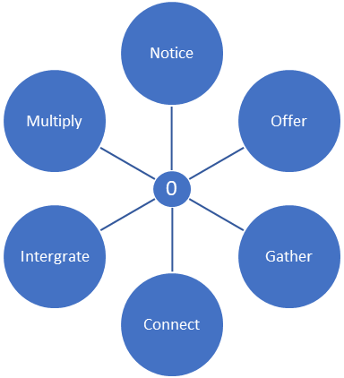
10
10
10
10
10
10
5
5
5
5
5
5
Multichannel Network
It is also clear from research development groups that the six blended principles can be accessed at any point and any time, individually or together. For example, it might be that noticing and connecting are present at the same time but without evidence of offering and gathering. There also therefore could be varying degrees of each principle present at any given time. By giving a score out of 10 for each and marking it on the diagram to the left (diagram 2), a blended shape can be identified. The nearer to the outer circles (10) the greater the opportunity to be a blended economy, the nearer to the centre (0) the less opportunity is present. A score would be obtained for each principle by asking a series of questions and citing examples from the context that identify different aspects of that principle. 0 = low blended /10= high blended

For example, if there were scores of Noticing 7, offering 4, gathering 5, connecting 3, integrating 2, co-creating 1 the blended shape would look something like this (see diagram 3). By being aware of how a blended economy is developing across the 6 principles it allows celebration and identification of where to continue to invest. Likewise, it can reveal where there is still work to be done and can set the challenge to increase investment or intention in these areas where appropriate. Over time is would be important to note which principles are ‘doorways’, in other words, which principles enable other blended principles to emerge. For example, noticing and gathering would likely be easier entry points which could be a catalyst for other principles to develop. More research and development is need to explore this.
Co-Create

Diagram 2
10
10
10

Co-Create

Diagram 3

Types of Blended Economies
Different types of blended economy could exist. Here are three examples.

Ecclesial: an economy of different expressions of Church – the integration of inherited and new contextual worshipping communities. How do they recognise and resource one another?
Leadership: an economy of different expressions of leadership – the integration of lay and ordained pioneers, inherited leaders pioneering within their context, different expressions of lay ministry (Licensed, authorised, recognized) How do they recognise and resource one another?
New Worshipping Communities: an economy of different expressions of new worshipping communities – the integration of Fresh Expressions, traditional Church plants, resource churches. How do they recognise and resource one another?

Ed Olsworth-Peter 2018.

