The Pioneer Charism

Introduction
There is no one size fits all approach to pioneer ministry and as such there is an increasing breadth and depth describing who pioneers are, what they are growing, how they are growing it and where they are living this out. Pioneers may be “parish-based” or “fresh start”, [1] they may start “seeds” or “runners” [2] and take the approach of an “adaptor” or “innovator” [3]. Pioneers will often have an apostolic ministry incorporating the role of evangelist and pastor and will embrace the prophetic and the role of teacher in different ways too. Some pioneers may be called to one particular community, others may feel called to several over time. Some will start as “citizens” whilst others may be “incomers”. Some may dwell in their context as “residents” and others as “commuters” [4]. There is also a growing recognition of the value of pioneer practitioners being enablers of indigenous leadership. “Community activists” [5] or entrepreneurs build missional relational foundations but may not necessarily initiate a new expression of church. “Developers” mine ecclesial depths in the early stages of the Christian community, often once the founding pioneer has moved on. Lastly there are those who oversee and support the work of pioneers. This includes “accommodators” [6] or advocates, who could be church leaders or permission givers, who are not necessarily pioneer practitioners but are able to call out pioneer vocation and make space for this to happen. All are valuable and all are needed. Understanding the who, what, how and where of the pioneer charism is not only useful for pioneers themselves in gaining insight into their ministry but also for those who seek to support them through discernment, formation and in exploring the role and place of pioneer ministry.

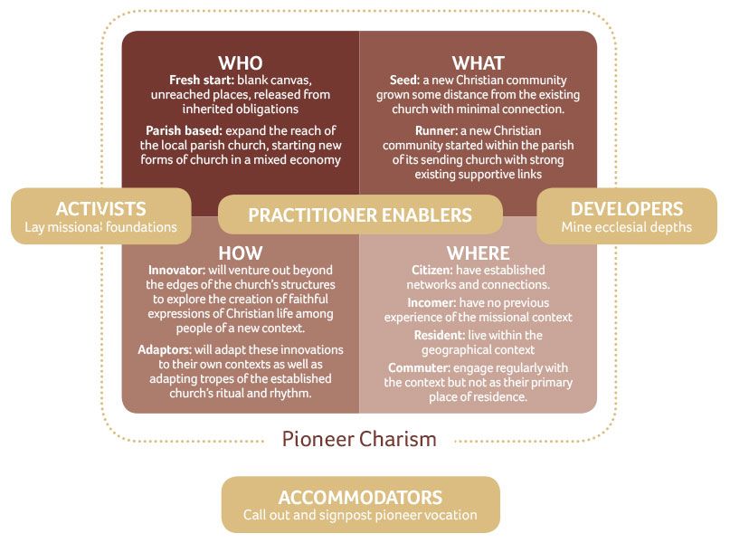

Example: Amy
Amy is a member of her local parish church and, encouraged by her vicar, she has started a café church in her village, which meets once a month. It’s reaching people who wouldn’t come to a traditional form of church, although some may come to the annual crib service in the parish church. With the help of her vicar acting as an accommodator, Amy is a parish-based pioneer, growing a runner by adapting the idea of café church for her context. She is a citizen resident living in the context where she is pioneering and as such has drawn on the relationships and connections she has already made. Her vicar is seeing the value of empowering those who are citizen residents in the community.

Example: Josh
Josh is an ordained pioneer living in the centre of a market town. He has been given permission to start a pioneer community on an area of new housing that is being built on the edge of the town. He spends time working with the developers in understanding the anticipated demographic and by making connections with the head teacher of a new school which has just been built. He has a vision to start a new contextual Christian community on the development to reach its new inhabitants. He spends time getting to know people, loving and serving them. For a year he lives in his house in the centre of town then as a house becomes available, he moves onto the estate where in time a worshipping community grows. Josh is a fresh start pioneer, growing a seed. He is an incomer commuter to start with but over time as he moves onto the estate becomes an incomer resident. As time progresses and he makes more community connections he becomes a citizen resident.

[1] “Vocations to Pioneer Ministry,” The Church of England, accessed 3 October 2019, https://www.churchofengland.org/pioneering .
[2] George Lings, “The Day of Small Things,” Church Army’s Research Unit, November 2016, accessed 3 October 2019, https://www.churcharmy.org/Publisher/File.aspx?ID=204265.
[3] Tina Hodgett and Paul Bradbury, “Pioneering Mission is… a Spectrum,” Anvil 34:1 (2018), accessed 3 October 2019, https://churchmissionsociety.org/resources/pioneering-mission-spectrum-tina-hodgett-paul-bradbury-anvil-vol-34-issue-1.
[4] https://churchmissionsociety.org/resources/contextual-inhabitation-exploring-the-where-of-the-pioneer-charism/
[5] Tina Hodgett and Paul Bradbury, “Pioneering Mission is… a Spectrum,” Anvil 34:1 (2018), accessed 3 October 2019, https://churchmissionsociety.org/resources/pioneering-mission-spectrum-tina-hodgett-paul-bradbury-anvil-vol-34-issue-1
[6] Richard and Lori Passmore, Fresh Expressions and Pioneering in Cumbria (2018), 9.

