The Pioneer Charism

See pioneer charism resource for more information about the Pioneer Charism

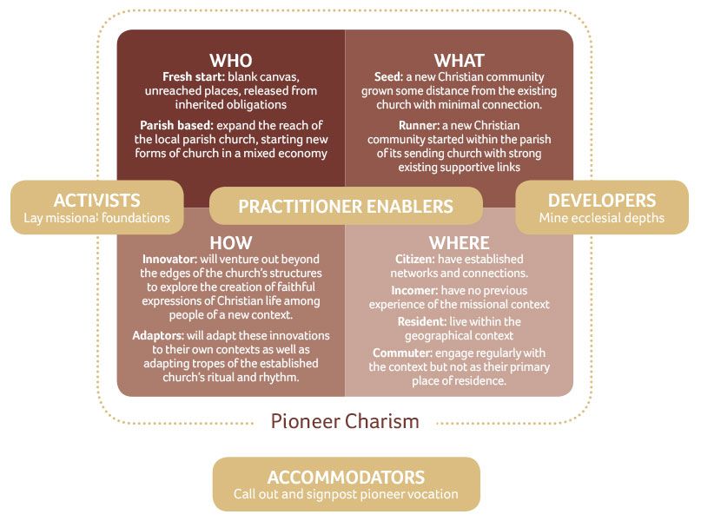

Identifying the Pioneer Charism
Working through the Who, What, How and Where, identify which trait best describes the individual. In some cases, additional charisms are listed. These are not core charisms and sit alongside the work of the pioneer but may be useful to explore. If additional charisms present as core charisms it would be important to explore if the individual also fulfils the pioneer criteria.

Who:
Fresh Start Pioneers are good at starting new things in new places well away from the reach of the established church.
Parish Based Pioneers are good at starting new things within a parish setting seeking to extend the missional reach

Additional charism
Mixed Economy Ministers: are good at starting new things in a parish setting seeking to extend the missional reach in parallel to inherited modes of church. They will feel called to work out of both the inherited and the pioneer.
What:
Seed Church will be grown some distance away from existing church with minimal connections.
Runner Church will be grown within the setting of its sending church with strong supportive links

Additional charisms
Bridge backs: providing missional pathways back into ‘inherited’ church
Edge-lands: pioneering missional activity that doesn’t necessarily form into church.

How:
Innovator They will start from a blank canvas, engaging in original thinking as they draw from the context around them.
Adapter They will be responsive to the context by borrowing from other things they have seen and make them their own.

Where:
Citizen Resident: They will have lived in their community for a period of time and have established contextual connections, intending to pioneer a new Christian community in that same context.
Citizen Commuter: They will have established connections within the missional context but will pioneer in a different context to the one in which they live and often travel between these two communities.
Incomer Resident: They will be new to the context without established contextual connections and start a new Christian community where they are living.
Incomer Commuter: They will live in one context and grow a new Christian community in a neighbouring community in which they are not yet known and without established contextual connections.

Additional Charism:
Activist: engage in social transformation and are missional and entrepreneurial. They are first on the scene and although they are not necessarily called to start a new worshipping, their primary gift is to innovate and to share their faith.
Developer: are often pastors and gifted at growing a new worshipping community into a mature expression of church. There is less emphasis on being a starter practitioner. They are good sustainers, enablers and overseers of other pioneers.
Accommodator: are not necessarily called to pioneer themselves but provide opportunity and permission for others to do so. They can also provide practical and spiritual.

Once these have been chosen, take the appropriate sentence from each to make one paragraph.
An example is below:
Who | What | How | Where
Fresh Start | Seed | Adaptor | Citizen Resident
Fresh Start Pioneers are good at starting new things in new places well away from the reach of the established church. Church will be grown some distance away from existing church with minimal connections. They will be responsive to the context by borrowing from other things they have seen and make them their own. They will have lived in their community for a period of time and have established contextual connections, intending to pioneer a new Christian community in that same context.

What is your charism?
In working out which to choose the following questions might be helpful:
- What gives you energy?
- What is your primary gifting?
- What is instinctive /What comes naturally?
- What could be taught?
- What experience backs up and affirms that charism?
- Where is a charism aspirational and where is it actual?
- In what’s ways are people following you as you minister in that charism?
- In what charism do you see God at work?

Who | What | How | Where
Description:

How to use the pioneer charism

Vocation
Vocation advisers might like to use the pioneer charism to explore the ministry shape of a pioneer candidate. By identifying their charism, it can act as a springboard to work with pioneer selection criteria. What will be important to notice? What is unique about their charism? How will this impact their formation and future ministry?

Pioneer Criteria
It will also be important to incorporate the pioneer Criteria for the Church of England (see pioneer criteria document). Below is a chat which highlights where some of the charisms and criteria interconnect.

Charism | Charism type | Pioneer Criteria
Who | Fresh start | Criteria A1,2,3 should show evidence of ministry beyond the walls of the existing church in new places and spaces. Criteria B4, 5, 6 may show examples of working with other pioneers and with those within in the missional context. They will need to manage living on the edges and being in relationship with the wider church (criteria B6). Criteria C7,8,9, will be needed to push deep into the missional landscape.
 | Parish Based | Criteria A1, 2, 3 should show innovation and risk engaging the missional community but within a parish context. Criteria B4, 5, 6 may show examples of engaging people within the existing congregation as well as those within the missional context. Criteria C7,8,9, will be needed to push deeper into the parish missional landscape and as they maintain relationship with the established church .
Additional | Mixed Economy Minister | Criteria A1,2,3 should show examples of starting church beyond the walls of the church to extend the parish reach not simply innovation within or towards the inherited church. Criteria B4, 5, 6 should show examples of working with people within and beyond the walls of the inherited church relating to the growth of a new Christian Community. B6 will be especially important to explore. Criteria C7,8,9, will be needed to push deeper into the parish missional landscape and as they maintain their co-relationship with and speak into the inherited church.
What | Seed | Criteria A1, 2, 3 should show examples of breaking new ground where church has been started in unreached places.
 | Runner | Criteria A1, 2, 3 should show examples of breaking ground where church has not yet reached within the parish setting.
Additional | Bridge-back/  Edge-land | These charisms doesn’t meet the criteria alone but could be an example of risk and learning in how to form a new contextual expression of church. (Criteria A2, B5).
How | Innovator | Examples of missional imagination, working in a non-standard way, a willingness to build from nothing and to take risks (criteria A1, A2) will be important to explore. Robustness and devotion will also be key (criteria C7,8)
 | Adaptor | Examples of adaptive practice appropriate to the context (Criteria B5) and re-shaping the church for mission (Criteria B6) along-side missional imagination and problem solving (Criteria A1) will be important to explore. Adaptation of spiritual practice will be important and developing prayer/worship in a contextual way (Criteria C8,9)
Where | Citizen Resident | Acknowledgment of the value of established existing connections and pioneer foundations will be important. It may be that it is important to remain in this context. If so it will take less time to pioneer a new contextual Christian community and ‘a this place’ ministry may be present.
 | Citizen Commuter | Acknowledgment of the value of established existing connections and pioneer foundations will be important. It may be that it is important to remain in this context for longer. It will take time to pioneer a new contextual Christian community as they will not always present. A ‘this place’ ministry may be present.
 | Incomer Resident | Acknowledgment of the need to take time to establish connections and pioneer foundations will be important. It will take more time to pioneer a new contextual Christian community due to newly arriving but residency will be assist in this. A ‘this place’ or ‘any place’ ministry may be present.
 | Incomer Commuter | Acknowledgment of the need to take time to establish connections and pioneer foundations will be important. It will take more time to pioneer a new contextual Christian community as due to newly arriving and not always being present. A ‘this place’ or ‘any place’ ministry may be present.
Additional | Activist | This charism will share aspects of the pioneer criteria especially in missional innovation, imagination and collaboration but church may not be formed (Criteria A1) and therefore may not satisfy all of the pioneer criteria. How can community activists collaborate with pioneers who are called to start a new expression of church (Criteria B 4, 5, 6)?
Additional | Developer | This chrism will share aspects of the pioneer criteria especially in collaboration (Criteria B4, 5, 6) but may show less evidence of missional imagination, and ‘building from nothing’ (Criteria A1,2) and therefore may not satisfy all of the pioneer criteria. How can developers collaborate with pioneers who are called to start new things (Criteria B 4, 5, 6)?

Appendix

Definitions in more detail

Who: (ref- Ministry Division, Dave Male)
Fresh Start Pioneers: These are classic pioneering types who start new things, love firsts, and enjoy working from a blank canvas. They need to be released from expectations of a classic Parish role and allowed to pioneer in places where the Church is not present while remaining closely connected with the parish, deanery or diocese. This is clearly echoed in the 2005 Guidelines which commented that ‘It is important Pioneers are not pressed into becoming ministers of existing churches but are deployed in pioneering contexts.’

Parish based Pioneers: These pioneers want to work from a parish base but from there develop fresh expressions of church in a mixed economy way expanding the growth and reach of the local church. This is the main focus of their ministry. It’s not a marginal or minor activity for them. Most of the person’s time is spent with those outside the Church. There is an intention to create a new ecclesial community. It may not always happen but this is the aim.

Mixed Economy Ministers: work from a parish base but from there develop new ways of mission and ministry through a ‘contextual approach’, expanding the growth and reach of the local parish. Pioneering is an important part of their focus by seeking to form new contextual Christian Communities but is held in partnership with traditional inherited parish ministry responsibilities. Mixed Economy Ministers should engage in pioneer ministry with those outside of the established church for between 25-50% of their time with the remaining time focusing on inherited ministry.

What: (ref - Church Army Research Unit, Day of Small Things)
Seed: This is based on a horticultural analogy by which small seeds can be blown on the wind some distance to start a new plant. It means the situation when people are sent out, and in that sense with support, but usually have to move area and house to begin a new work elsewhere, with permission, but largely on their own. Seeds grow outside the existing parish system.

Runner: This term, taken from the propagating habit of strawberry plants, normally means the fresh expression of Church started within the parish of its sending church and has strong existing supportive links with that church. Runners grow within the existing parish system.

How: (ref - Pioneer Spectrum, Tina Hodgett & Paul Bradbury)
Pioneer Innovators are deeply committed sodal or ‘sobornistic’ pioneer leaders who with their teams venture out beyond the edges of the church’s structures to explore the creation of faithful expressions of Christian life among people of a new context. Their innovations, which provide an initially disturbing influence on the inherited church, in some cases become welcomed by the broader church in time. It is important to affirm, however, that the length of ‘time’ may well be unknown, certainly significant, a time in which the church needs to protect the vocation of these pioneers, trusting that the fruit of their ministry may be a generation or more in the making.

Pioneer Adaptors who have the creative gift to adapt or adopt these innovations to their own contexts. They are also skilled in adapting in the other direction, as it were, taking tropes of the established church’s ritual and rhythm and adapting them into new environments. These distinctions map closely onto a growing experience in the pioneer ministry community: that a number of innovative pioneer projects have now been adopted, adapted and applied by others. Those who have applied the model may be ‘pioneer adaptors’, faithfully listening to context and shaping the model to fit their own context. Meanwhile the many iterations of cafe church are a good example of ‘adaptors’ working in the other direction.

Where: (ref- Contextual Inhabitation, Ed Olsworth-Peter)

Starting points
Incomers: those who are new to an area or network, often with no previous experience of that context. An incomer could be new to a specific community whilst being from the surrounding area. They therefore hold some of the local contextual story in broader terms but less so than someone who has lived there for a longer period of time. In this case they may be referred to as a regional incomer.

Citizens: those who have established networks and connections. These connections could be in the place where they live, in a work or social space or even within a digital community. As pioneers’ cross cultural boundaries, it is possible to be a citizen in one micro community while being an incomer in another, within the same wider community.

Dwelling Patterns
Residents: those who live within the missional context as a neighbour, customer, employee, friend. They are physically and frequently present and as such have the opportunity to make ongoing connections with people. If they have been resident for some time, they are likely to have a good understanding of the context around them. If they are new, they have the potential to get to know the context well.

Commuters: those who don’t live within the missional context but are present on a regular basis. They may develop friendships, community connections and have a strong presence within the context but travel in and out on a regular basis. As such there will be periods of time when they are not present.

In addition
(ref - Pioneer Spectrum, Tina Hodgett & Paul Bradbury)
Community Activists are often involved in issues around social justice, community cohesion and social transformation and as the name would suggest are missional and entrepreneurial. They are first on the scene and engage primarily in the first 3 stages of the Fresh Expression Journey by listening, loving and serving and building community. They are not necessarily called to start a new worshipping community but to lay foundations for a pioneer minister to do so. Their primary gift is to innovate and to share their faith.

(ref - Ministry Division, Ed Olsworth-Peter)
Developers enjoy detail, are interested in bringing something to completion, are mentors, good at discipling people and can see an end goal. They are often pastors and gifted at growing a new worshipping community into a mature expression of church. There is less emphasis on being a starter practitioner as they tend to follow in the footsteps of a forerunner who has already established a new expression of church. They will engage in the second half of the ‘Fresh Expression Journey’ by exploring discipleship, forming church but remaining within the ecclesial community during and after the ‘do it again’ (or replication) stage as others leave to pioneer something new. They are good sustainers, enablers and overseers of other pioneers.
Further Reading

[1] “Vocations to Pioneer Ministry,” The Church of England, accessed 3 October 2019, https://www.churchofengland.org/pioneering .
[2] George Lings, “The Day of Small Things,” Church Army’s Research Unit, November 2016, accessed 3 October 2019, https://www.churcharmy.org/Publisher/File.aspx?ID=204265
[3] https://churchmissionsociety.org/resources/pioneering-mission-spectrum-tina-hodgett-paul-bradbury-anvil-vol-34-issue-1.
[4] https://churchmissionsociety.org/resources/contextual-inhabitation-exploring-the-where-of-the-pioneer-charism/
[5] https://churchmissionsociety.org/resources/pioneering-mission-spectrum-tina-hodgett-paul-bradbury-anvil-vol-34-issue-1
[6] Richard and Lori Passmore, Fresh Expressions and Pioneering in Cumbria (2018), 9.

