Innovate
As church leaders and communities begin to come out of lockdown there is a need to help them on this journey, in working out what life will look like on the other side of the pandemic. Many people are asking questions about what this will be like. Pioneers principles have an important role to play in providing insight and wisdom that those engaged in mission and ministry can draw from.
‘Innovate’ is part of The Pioneer Build – the Church of England’s goal to grow 6000 pioneers by 2027. There may well be a need to encourage church leaders to explore their ministry calling once again, to go further into the missional landscape, reimagining church with imagination and risk. There is a need to encourage inherited expressions of church to innovate further into a ‘pioneer parish’ sphere as they journey further into their missional contexts. There is also a need to encourage pioneers to push deeper into the missional landscape into the pioneer sphere (see fig1). ‘Innovate’ is a pioneer development project to influence and support this culture change as inherited and pioneer church leaders and their teams live this out their calling to ‘proclaim the good news afresh’.

[b] Move from parish to pioneer parish
[a] Move from pioneer parish to pioneer
Fig 1: Pioneer Spheres

Being and doing
At the heart of this work are 5 pioneer practices which summarise the Church of England’s Pioneer criteria (listen, adapt, experiment, co-create, persist). These practices describe the ‘outward doing’ of ministry. In order to inhabit these there is a need to explore the ‘inward being’ of the self and so 5 qualities (discerning , self-sacrificing, playful, hospitable, resilient) accompany and underpin the practices as a foundation from which they can grow. Each have a natural pairing – so for example, listen and discerning/adapt and self-sacrificing but all interlink in some way. Much of the experience of lockdown has been to embrace ‘being’ as a new mode of ministry activity and with this a decrease or even a rejection of an activist nature with a high dominance of ‘doing’ (see fig 2). This presents a mixed ecology of leadership. This resource will inspire people to explore a pioneering way of innovation and accompany them as they inhabit this in their context and tradition in their own unique way. By embracing ‘becoming’ as well as ‘function’ the pioneering will come. This resource therefore is not a ‘how to guide’, it is encouraging a way of being from which innovation will grow.

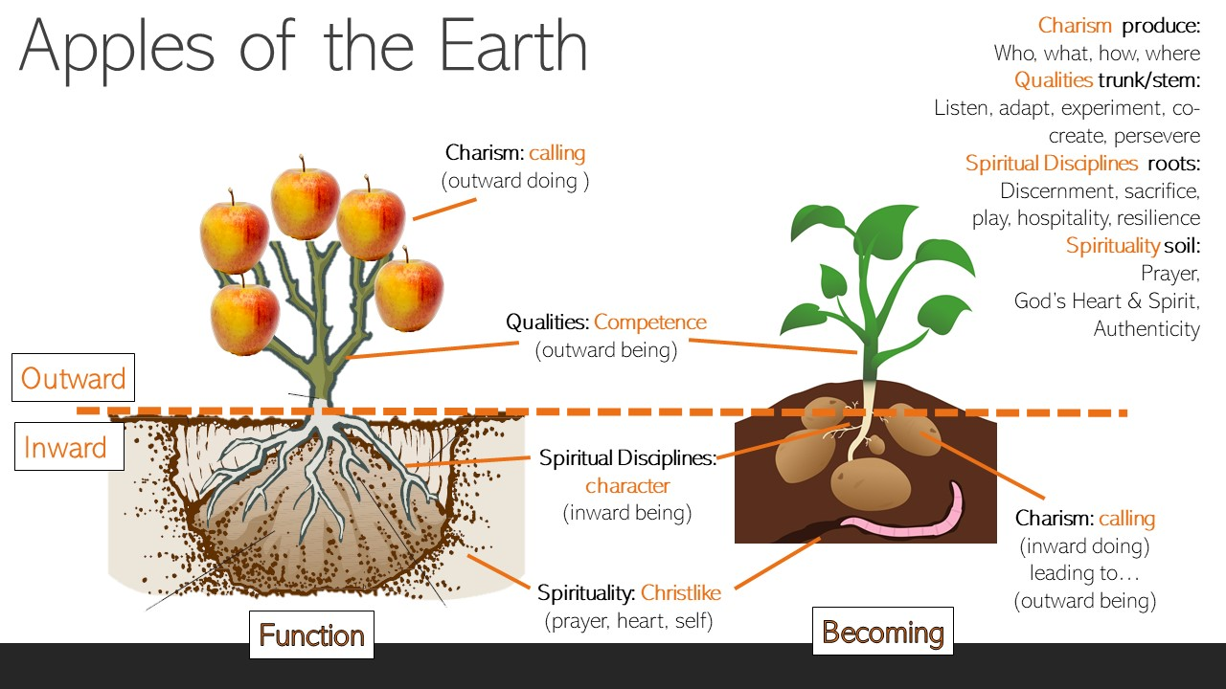
Fig 2

Resource Proposal – title ‘inhabiting innovation’
10 contributors explore the 5 pioneer practices and 5 qualities. Each will bring insight, experience and practical know how to help those engaging with the content to inhabit these principles. In addition to this, 3 contributors will cover self, space and ecosystem in 3 chapters. The resource will consist of the following from each contributor – probably produced in the following order:
3 min taster video a summary of main theme of that chapter. Filmed remotely via phone or zoom. This can be your general thoughts, your big idea/main point and why you think this is important for pioneering. It can be developed through the podcast and chapter and fine if it evolves over the writing process.
30 min podcasts discussing inhabiting self, inhabiting spaces and then each of quality and discipline paring (2 contributors interviewed by a host) to expand the theme of each quality and discipline and the relationship between the two. (5 podcasts in total). There may be an additional podcast looking at the ecosystem of all 10 principles and how they play out in self and space with some contributors invited to take part. Recorded remotely using zoom audio.
2500 word book chapter – a written expanded version of the video and podcast with accompanying questions and practical suggestions to help people ‘live this out at home’/explore further in their context. in each chapter the content will be framed and discussed in relation to 4 key areas: Christ, church, world, self.
Links to follow up resources from each contributor as applicable

Outline: ‘inhabiting innovation’

- Introduction: apples of the earth, being and doing - the need to inhabit innovation

- Inhabiting self: call character competence, charism

- Inhabiting practices: 5 pioneer innovation practices to inhabit (the how) outer self
Listen: how to read the core creeds of the context, being the first to see, the power of noticing without diagnosing, being tuned in to the Holy Spirit, how to ask the right questions, knowing when you have found an answer. Slower rhythm, the value of ‘being’ more than ‘doing’. world views
Adapt: how to be willing and able to manage change, lay aside personal preferences, to be open to alternative ways and means, to release control.
Experiment: how to take risks, the power of learning through trial and error, being creative, imagining the new, how to initiative, start .
Co-create: what it means to be a guest and a host, how to collaborate, how to inhabit the context alongside others in an incarnational way, how to gather others around you, how to curate as well as initiative, the value of ‘serving first’ before ‘worshipping first’, the value of journeying into the heart of community and staying there. How to share responsibility.
Persist how to keep going when things are tough, being robust, coping with pressure, ambiguity, change and disorientation, having a consistency of character, long term not short term. Conflict, live with uncertainty,

- Inhabiting qualities: 5 pioneer innovation qualities to inhabit (the who) inner self

Discerning: How does God speak? What is the difference between a God idea and a good idea. The role of the prophetic. what does it mean to be able to know what the right thing is, at the right time, in the right place, in the right way?
Self-sacrificing: how do we seek the common good despite our own desires. How do we put God first? How do we give away? What does spiritual tithing look like? Where are our unconscious biases at work and how do we address these? What is our true motive? What does it mean to be Christlike? Where is the place of ‘achievement’ in our spirituality and ministry? Is it wrong to be ambitious? How should we ‘succeed’ in a sacrificial way?
Playful: How is God playful and why is this important? What does it mean to play where the outcome is uncertain? How do we grow a willingness to journey into the unknown where understanding has yet to form? Where another/others may influence your direction/purpose/game plan. Where you may have a specific or changing role. Where hypothesis has open boundaries. What are the dangers of ‘blocking’ in play? What is the value of participation and collaboration?
Hospitable: What is importance of ‘spiritual welcome’? what is it to live out the principle of ‘service’ in our lives? What are the core values of hosting? How does God’s hospitality and our experience of this, inform our own? How are we hospitable in private and in public - with those close to us and with ourselves?
Resilient: How do we embody courage? How do we grow in spiritual strength? How do we discover our irrepressible purpose? What do we draw on to recover from setbacks? How do we learn from difficult experiences? How do we fill up our inner tank? How do we know when to stop and move on?

- Six foundational spiritual disciplines/principles that underpin the practices and qualities.
  - Vocation, obedience, bi-cultural, prayer, Jesus centred, Love of God
  - Linked to: Love for God, call to ministry, love for people, wisdom, fruitfulness, potential

- Inhabiting spaces:
  - Cell, chapter, garden, scriptorium, chapel, cloister, refectory
  - How could the pioneer practices and qualities be inhabited in different spaces? Drawing on monastic tradition and 7 sacred spaces for mission and ministry.

- Inhabiting the ecosystem of all 10 principles and 6 foundations.
Although the practices may be cited in the outer self and the qualities in the inner self and although they may have a natural pairing – in reality all 10 principles influence and inform one another. What is the relationship between them? What does the ecosystem of innovation look like? Explore:
- The relationship between these 10 principles
- How to put them into action as a whole
- How do they inform our Pioneer Charism (produce): who you are? What you do? How you do it?
- How do they assist with the principle of ‘folding in’ innovation from the edges.

How to use this resource
Pioneering the Local Church
‘Inhabiting innovation’ could be used to support local parish churches in exploring how they ‘proclaim afresh the good news in each generation’. They may not necessarily feel called to be out and out ‘pioneers’ but may benefit from using pioneering principles to help to reshape church within their own context and tradition. The 5 qualities and disciplines can be used in this way and adapted appropriately. The resource can be accompanied by examples of where a local church has adopted pioneer thinking and the impact this has made. There is much value in also using the priorities to explore what a mixed economy or ecosystem could look like.
Pioneering the Pioneering
‘Inhabiting innovation’ could be used as a catalyst for parish-based pioneers to explore how they ‘proclaim afresh the good news in each generation’ deeper into the missional landscape into their context. The 5 qualities and disciplines build on their existing pioneer experience and act as a bridge into developing their thinking further, helping to map the context as well as raising important ‘what next’ listening questions. They can then be signposted to further pioneer training and development through their diocese or an education partner.
Pioneering the Diocese
Innovate could also used to support a deanery or diocese in exploring how to engage with pioneer ministry as part of their strategic vision. The 5 qualities and disciplines could be used to shape strategic priorities, values and outcomes.

Discernment framework
Innovate could also used to support individuals exploring a vocation to pioneer ministry. The practices and qualities as well as the spiritual foundations describe the content of the pioneer ‘grid’ in the new Church of England shared discernment framework. This resource could be a valuable companion for candidates and vocation advisers as they explore a call to pioneering or prepare for a natioanl pioneer selection panel / BAP.

Ed Olsworth-Peter 2020

