St Mary’s church relies on the generous donation of time, talents and money by individuals to maintain its fabric and ministry.
If you would like to donate, you can do so using your Smartphone by scanning the QR code or typing in the link https://givealittle.co/campaigns/322eba20-e7b2-4489-a5bb-c547f392a5a7
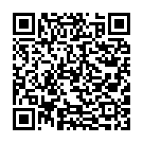

How to use your smartphone to read a QR code
Many Apple and Android devices do not need a special QR code reader.
- Open your phone camera
- Hold your phone so that the QR code appears in the viewfinder and you see a notification with a link to the ‘Givealittle.co’ website
- Don’t take a picture but click on the notification on your screen which will take you directly to our giving page.
If this does not work, you may find a QR code reader in your phone settings or you may have an app on your phone.

