Guidance for cathedrals:
Completing the application form for registration with the Charity Commission
January 2022

Table of Contents
FAQs 3
STEP 1: Registering as a new user 6
STEP 2: Starting a new application 7
STEP 3: About charity 8
About charity: Governing document 8
About charity: Charity name 9
About charity: Structure and purposes 12
STEP 4: Income 13
STEP 5: Classification 14
Classification: What 14
Classification: How 15
Classification: Who 16
Classification: Where 17
STEP 6: Public benefit 18
Public benefit: Religion 18
Public benefit: Benefits 26
Public benefit: Grant making 28
Public benefit: Membership 29
STEP 7: Property 30
STEP 8: Contact 31
Contact: Application 31
Contact: Organisation 32
Contact: Public address 33
STEP 9: Regulators 34
STEP 10: Finance 35
Finance: Accounts 35
Finance: Funding 36
STEP 11: Connections 38
Connections: Employment 38
Connections: Goods/Services 39
Connections: Other benefits 40
Connections: Connections 41
STEP 12: Trustee details 42
Trustee details: Risks 42
Trustee details: Trustee type 43
Trustee details: Add a Trustee 44
STEP 13: Declaration 45

FAQs

What level of detail is required in our answers?
Fully-fledged responses should be given. It is important to note that this is a general form that the Charity Commission require every potential charity to complete. More specific questions about cathedral policy will be asked in the Due Diligence Questionnaire. Links to websites can and should be given in your responses.
How and when will we submit our responses to the application form?
You will start drafting your responses to the Due Diligence Questionnaire and the Charity Commission application form once your cathedral has completed its governance review and started the Cathedrals Measure 2021 implementation process. You will complete your application form online alongside preparing draft new Constitution and Statutes. You will need to attach your Due Diligence Questionnaire responses and supporting documents to the application form. You will be able to do this when the form asks whether you want to attach any supplementary documentation on the “Declaration” page.
Once completed, you will submit your application form and Due Diligence Questionnaire through the Charity Commission’s online portal. However, given the unusual nature of this application, you will need to provide particular information in the “additional information” section on the “Declaration” page (see Step 13 of this guidance, below).
When you submit the application form online, you will need to tick the box to certify that all information provided has been checked by the trustees and is correct and complete to the best of your knowledge and that all trustees agree to the submission and have read and accepted the commission’s privacy notice. However, you should NOT download the trustee declaration for the Chapter to sign, as this will be done as part of a wider trustee declaration following Certificate Date 2.
When you submit the application form you will be given an application reference number which you should email to the Church Commissioners (cathedrals.regulation@churchofengland.org), along with a copy of the completed application form (downloaded as a PDF from the online platform) and completed due diligence questionnaire.
What documents are required to complete the form?
To submit the application form online to the Charity Commission, you will need:
- Due Diligence Questionnaire responses and any documentation to support your answers to the Questionnaire;
- latest annual accounts;
- green line plan (contact cathedrals.regulation@churchofengland.org if you do not have this document); and
- Grant Making policy (if the cathedral makes grants).
I am concerned that our accounts from the most recent years do not give the full picture of the financial health of the cathedral. How will this affect our application?
The Charity Commission understand that the last couple of years have presented significant issues for all charities given the COVID-19 pandemic. You are required to submit five years of accounts in support of your application in the Due Diligence questionnaire. All five years will be used to determine the underlying financial health of the cathedral.
Why is it not recommended to select the Arts/ Culture/ Heritage/ Science option on the Classification: What page?
The Charity Commission have confirmed that the advancement of the Christian religion should be the only option selected as this is the primary function of cathedrals for the public benefit. The only exception to this is if the cathedral is a registered museum.
How do you recommend completing the form?
Unfortunately, the online form has an inactivity timer whilst completing the relevant sections. We recommend choosing the relevant questions from this guidance, copying the questions to a Word document, completing your responses in Word and finally copying the responses to the online form.
How long do I have to complete the form?
A started form will be automatically deleted upon 3 months on inactivity. As such, if you start the application form online but anticipate that you will not be submitting the form within 3 months, we recommend setting a calendar reminder to enter your application and slightly modifying your responses (adding an extra full-stop, pressing “save and continue” and then deleting the extra full-stop will count as activity and will reset the 3-month timer).
Who should I contact if I have questions about this guidance or the application form?
You should contact the Church Commissioners at cathedrals.regulation@churchofengland.org.
Will I have to complete and submit the application form again following Certificate Date 2?
No. Following Certificate Date 2 you will need to submit a trustee declaration, signed by each member of the new Chapter, as the last procedural step prior to registration. This trustee declaration will include:
- the information in the declaration which would normally be attached to the online application form;
- a list of the members of the new Chapter; and
- a declaration that either nothing material has changed in the cathedral subsequent to the submission of the application form online, or that there have been material changes in the cathedral, in which case, you will be required to disclose what those material changes are.
A template for the Certificate Date 2 Trustee Declaration will be available on the Cathedral Guidance Portal in due course, along with information as to how it should be sent to the Charity Commission.

STEP 1: Registering as a new user
Read the Gov.uk guidance page on how to register a charity: https://www.gov.uk/guidance/how-to-register-your-charity-cc21b. A third of the way down the page, under the heading how to apply to register a charity, is a link to start or continue a charity registration application. Click this link:
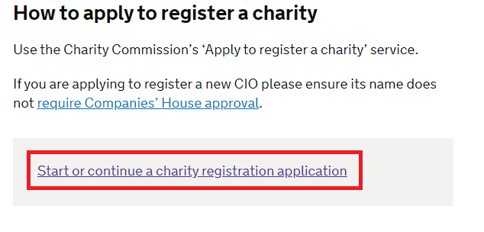
Upon clicking the link, you will be prompted to log on to the system. If you have not registered as a user, you will have to do this now. Click the link to register as a new user:
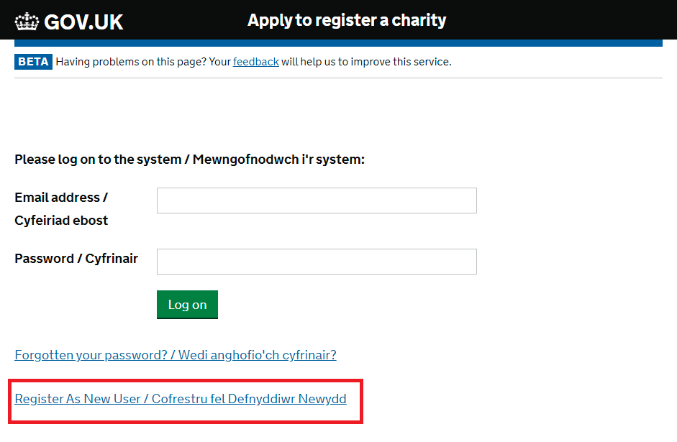
Upon clicking this link, you will be prompted to complete a short form to register. Once you have set up a password, you can come back to this screen to log on to the system to register the Chapter.

STEP 2: Starting a new application

Once you have set up a password and registered as a user, log on to the system. You will land on the Charity Registration Service page. Click the green box to start a new application to register a charity:
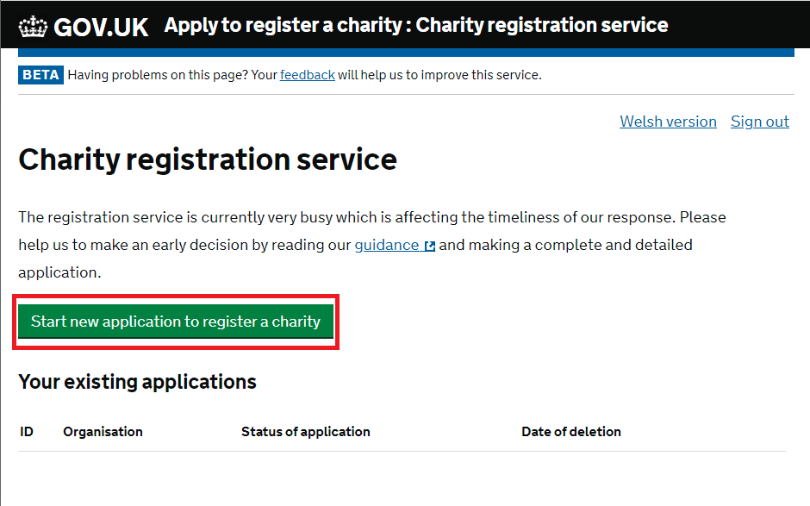
Clicking this link will take you to the Introduction page. Read this page and click the green box to save and continue at the bottom of the page:
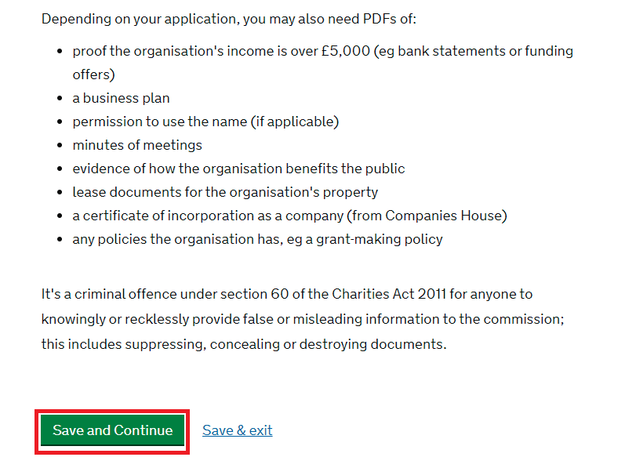

STEP 3: About charity

About charity: Governing document
You will now be on the Governing Document page. Read the page and select the Constitution box under the heading select the organisation’s governing document type.
Question: Has the governing document been issued by an organisation or umbrella body (often referred to as an approved governing document)?
Response: No. Although the Constitution has been issued by an organisation, the Church Commissioners are not selectable as an option.
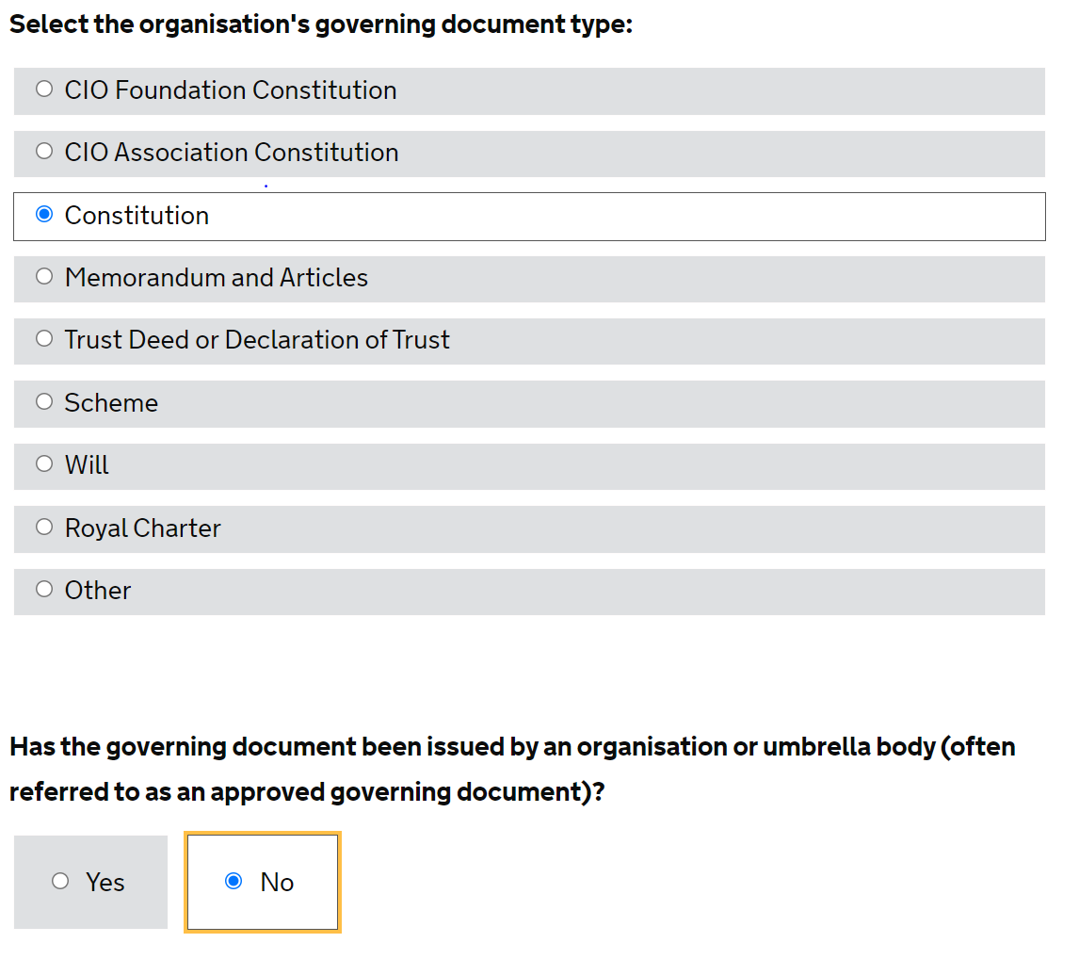
Given that you will be submitting the application form before your new Constitution and Statutes have been certified by the Church Commissioners (on Certificate Date 1), you should not attach your draft Constitution as directed. Instead, you should submit a blank PDF file. Once your draft Constitution and Statutes have been reviewed by the Church Commissioners and any changes needed have been made, the Church Commissioners will send them to the Charity Commission for comment prior to the cathedral holding the statutory consultation.

About charity: Charity name

You will now be on the Charity Name page. Under the subheading the organisation’s name, enter the name of the cathedral chapter exactly as it will be written in your new Constitution:
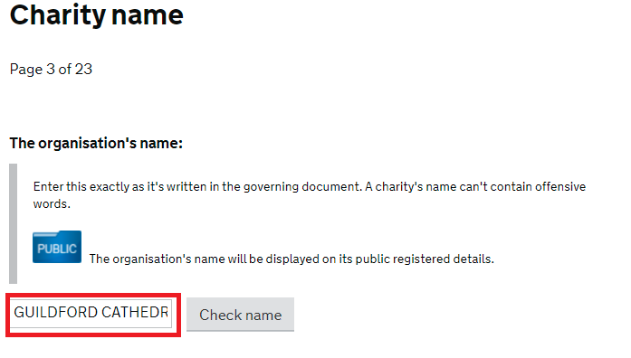
You can click the check name box to ensure that this is a unique charity name. Upon clicking this box, you should receive a pop-up saying that there are no charities with a similar name and that you should be able to use it. Click the OK box to dismiss this message:
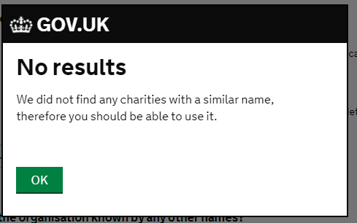

Question: Is the organisation known by any other names?
Response: Answer with the working name for the cathedral. Your response should be the name of the cathedral that is easiest for the public to identify. For example, the name in the governing document for Rochester Cathedral is “Cathedral Church of Christ and the Blessed Virgin Mary, Rochester”. Simply “Rochester Cathedral” might be a more appropriate working name.
If you answer yes, you will be prompted to add the alternative name: 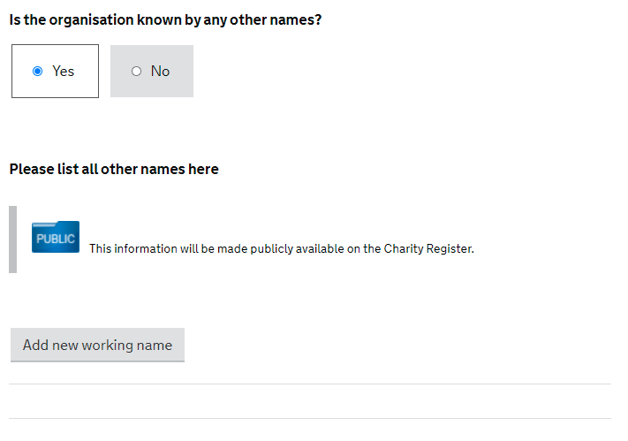
Question: Do any of the organisation’s names contain acronyms, initials, made-up or non-English language words?
Response: Answer for the cathedral. The expected answer is no. If you do answer yes, you will be prompted to provide more details.
Question: Do any names contain words that require consent from another body?
Response: Answer no:
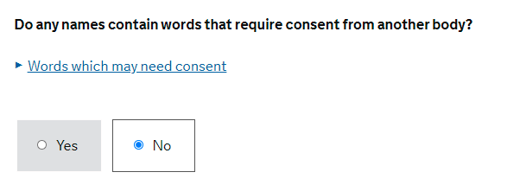
Press the save and continue box to continue to the next page.

About charity: Structure and purposes
You will now be on the Structure and purposes page. The answer for the organisation’s governing document will be greyed out as “Constitution” as you have already answered that your governing document is a constitution:
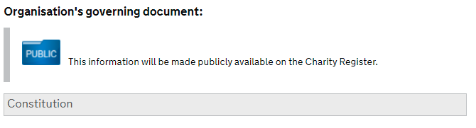
Question: Enter the date the organisation’s governing document came into effect (dd/mm/yyyy).
Response: Given that you will be submitting the application form online before Certificate Date 1, the Charity Commission has agreed a dummy date of 01/01/2001 should be given.
Question: Enter the organisation’s purposes (also known as ‘objects’) exactly as they are written in its governing document.
Response: Insert the wording from the Constitution which should be the following:
“The objects of the Chapter are—
- to advance the Christian religion in accordance with the faith and practice of the Church of England, in particular by furthering the mission of the Church of England;
- to care for and conserve the fabric and structure of the Cathedral Church building;
- to advance any other charitable purposes which are ancillary to the furtherance of the purpose referred to in sub-paragraph (a) or (b).
The Chapter must act for the public benefit within the meaning of section 4(3) of the Charities Act 2011.”

Click the save and continue box at the bottom of the screen.

STEP 4: Income
You will now be on the Income page.
Question: Enter the organisation’s gross annual income.
Response: Enter the chapter’s annual income figure from its last audited annual accounts.
Question: What proof of income are you attaching?
Response: Select latest annual accounts and attach the latest annual accounts for the Chapter by clicking the grey attach box:
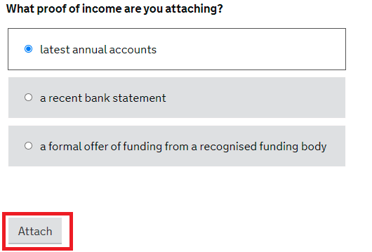
NOTE: The Charity Commission has asked, separately, for cathedrals to provide the last five years of accounts in the Due Diligence Questionnaire. Upload the latest annual accounts here only. You will upload the latest five years of accounts in support of your questionnaire responses when you are asked to attach any supplementary documentation on the “Declaration” page at the end of the application form.
Click the save and continue box to proceed.

STEP 5: Classification

Classification: What
You will now be on the Classification: What page. Read the paragraphs at the start of the page.
Question: What is the organisation set up to achieve? (select all that apply).
Response: Select religion. Select Christianity from the sub options and select Church of England from the further options given:
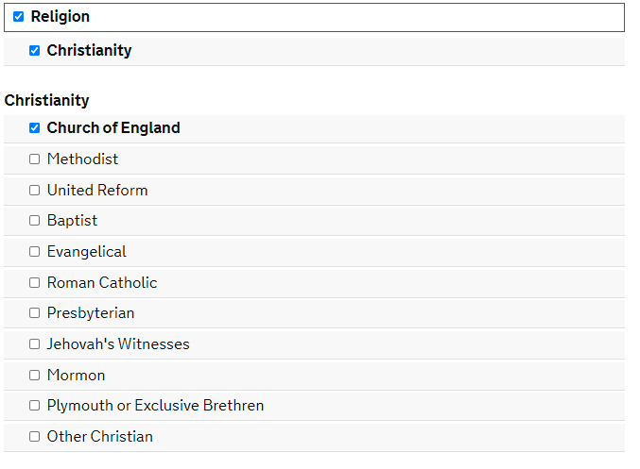

Press the save and continue button at the bottom of the page.

Classification: How

You should now be on the Classification: How page.
Question: How does the organisation achieve it? (select all that apply).
Response: Select provides buildings/facilities/open space and provides services:
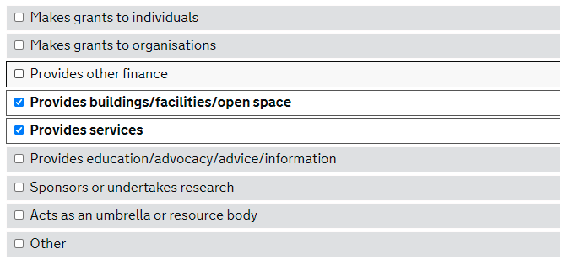
Under Religion, select the following options (NOTE: Interfaith activities and maintaining public churchyards and other public religious burial places should only be selected if relevant for the cathedral):
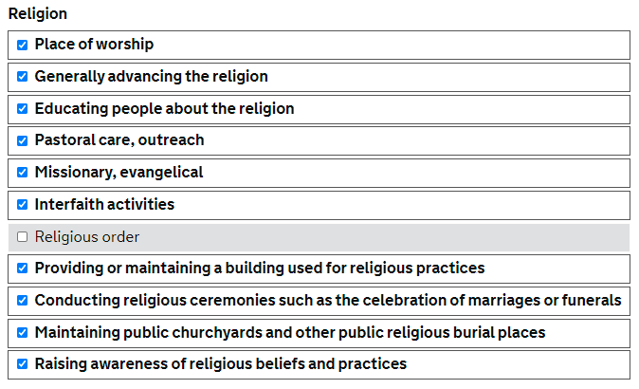
Click the save and continue button.

Classification: Who
You are now on the Classification: Who page.
Question: Who does the organisation help? (select all that apply)
Response: Select the following options:
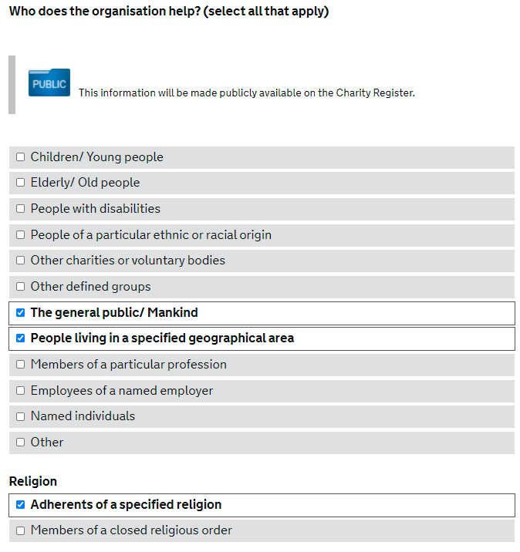
NOTE: Though your cathedral will likely help further groups listed as options, the two options selected generally cover all groups.
Click the save and continue button.

Classification: Where
You are now on the Where page.
Question: Where does the organisation operate? (select all that apply).
Response: Select specific areas in England & Wales.
Question: Does the organisation operate in England?
Response: Yes
Question: Does the organisation operate in Wales?
Response: No:
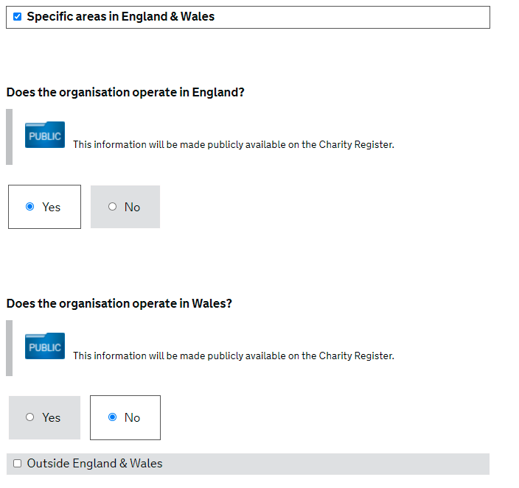
Click the save and continue button at the bottom of the page. Instead of taking you to another page, this will cause options of counties to pop up under the question does the organisation operate in England? Tick the boxes that are relevant for the cathedral. Once you have done so, click the save and continue button at the bottom of the page.

STEP 6: Public benefit

Public benefit: Religion
You will now be on the Religion page.
Question: What are the beliefs and practices of the faith the organisation promotes?
Response: Please use the agreed template text below, approved by Dr Isabelle Hamley (Theological Advisor to the House of Bishops):
“The Church of England’s beliefs are in line with trinitarian Christian churches throughout the world. Its central practices include baptism and holy communion, but day-to-day practices are largely shaped locally. The Church of England’s beliefs are held within its liturgy and historic formularies rather than one overarching declaration of faith, of which the creeds, Book of Common Prayer and declaration of assent are key.
The Church of England is part of the One, Holy, Catholic and Apostolic Church worshipping the one true God, Father, Son and Holy Spirit. It professes the faith uniquely revealed in the Holy Scriptures and set forth in the catholic creeds, which faith the Church is called upon to proclaim afresh in each generation. Led by the Holy Spirit, it has borne witness to Christian truth in its historic formularies, the Thirty-nine Articles of Religion, The Book of Common Prayer and the Ordering of Bishops, Priests and Deacons (see Canon C 15 of the Canons of the Church of England: https://www.churchofengland.org/about/policy-and-thinking/canons-church-england/section-c).”
The next section asks you to attach a copy of the statement of faith for the organisation. Visit the following link to access a PDF copy of the Nicene Creed: https://www.churchofengland.org/sites/default/files/2021-02/Nicene%20creed.pdf. Download this file and click the greyed attach box:
A pop-up box will appear asking you to add an attachment. Click the box to choose file and attach the Nicene Creed PDF document. Click the green OK box to attach the file to the application:
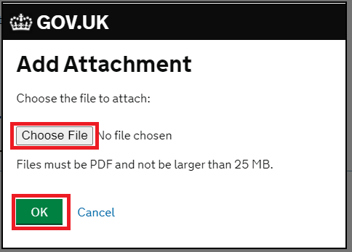
The next few questions concern providing a place of worship.
Question: Where is this provided?
Response: Provide the full address for the cathedral.
Question: How is it advertised?
Response: Provide details for the cathedral.
NOTE: It is suggested you include a link to a page on the cathedral’s website with details of the cathedral’s schedule for worship and services. Also list any other websites, such as the diocesan website, which refer to worship and services being held in the cathedral.
Question: Who can attend?
Response: See the suggested answer below:
“Worship is open to the general public to attend.”
Question: When is it open for worship?
Response: Provide details for the cathedral. If the cathedral’s website gives scheduled times for worship and services, include a link to the page.
Question: Are any fees payable for those wishing to attend?
Response: No.

The next few questions concern providing or maintaining a building used for religious practices.
Question: What exactly is the building being provided or maintained and where is located?
Response: See the suggested answer below and insert the location of the cathedral church:
“It is [a]0F the cathedral church of the diocese of [ ] and it is located [ ].”
Question: On what basis is it used and maintained?
Response: See the suggested answer below:
“The Cathedral Church building is used for worship and is maintained under the Care of Cathedrals Measure 2011 and the Cathedrals Measure 2021.”
Question: How and when is the building open to the public?
Response: Provide details of the cathedral’s opening times. If the cathedral website provides this information, include a link to the page.
Question: Who can use the building?
Response: See the suggested answer below and amend with specific arrangements for religious practice in the cathedral:
“The cathedral church building is open to all members of the public for worship and services. The building is also used for [ ].”
NOTE: This section refers to religious practices. Activities outside of religious practice (e.g. tours etc.) should not be included here. For an idea about specific arrangements for religious practice, think about arrangements such as scheduled school activities for worship etc. If any webpages are relevant, include them here.

The next few questions concern conducting religious ceremonies such as the celebration of marriages or funerals.
Question: Where is this provided?
Response: See the suggested answer below:
“In the cathedral church.”
Question: How is it advertised?
Response: Provide details for the cathedral. If the cathedral’s website refers to marriages or funerals, include the links in your response.
Question: Who leads the ceremony and how are they selected for that?
Response: See the suggested answer below. Make amendments as required for the cathedral:
“One of the cathedral clergy will [normally] lead the ceremony.”

The next few questions relate to maintaining public churchyards and other public religious burial places. If you did not tick the box for maintaining public churchyards and other public religious burial places on the Classification: How page, this section will not appear for you. If this is the case, go forward to your next section (raising awareness of religious beliefs and practices).
Question: Where is this provided?
Response: See the suggested answer below:
“This is provided within the Cathedral’s green line plan drawn up by the Cathedrals Fabric Commission for England. See the attached plan in the supplementary documentation section for reference.”1F
NOTE: This guidance will remind you to attach the green line plan in the supplementary documentation section.
Question: How is it advertised?
Response: Provide details for the churchyard and burial ground. If the cathedral website has any pages dedicated to burial or the churchyard, include them here.
Question: Who can use the burial space?
Response: Provide details for the cathedral.

The next question concerns raising awareness of religious beliefs and practices.
Question: What does the organisation do to raise awareness? (select all that apply)
Response: Select all the options that apply for the cathedral. You will also need to select the “Other” option to include worship and any other activities the cathedral participates in to raise awareness of Christianity in accordance with the beliefs and practices of the Church of England.
NOTE: Include a couple of examples of what the cathedral does to raise awareness. This may include, but is not limited to, educational activities (school trips, Sunday School, adult education such as Alpha courses etc.), community outreach programmes (interfaith activities, volunteering, supporting the local community during times of crisis etc.) and social action programmes (helping the homeless, foodbanks, soup kitchens etc.). If any webpages are relevant, include them here.
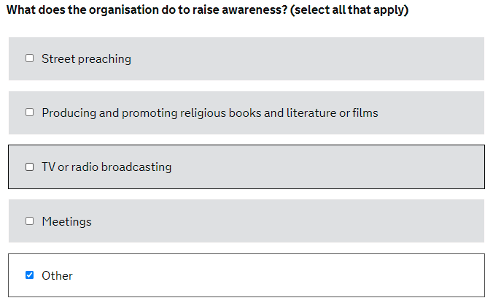
The next question concerns generally advancing the religion.
Question: How is this carried out?
Response: Explain how (i.e. through what activities) the cathedral advances the Christian faith.
NOTE: Your response should explain what activities the cathedral undertakes in each area listed in “other” in response to the previous question.

The next few questions concern educating people about the religion.
Question: Where is this provided?
Response: Provide details about the cathedral’s education programmes such as school trips, adult education, Sunday School etc.
Question: How is it advertised?
Response: Provide details for the cathedral, inserting webpage links to the cathedral website where relevant.
Question: Who can attend?
Response: Complete for the cathedral but outline that anyone can attend the education provided and indicate whether certain activities are provided to people of a specific age (e.g. children for Sunday school, adults for Alpha courses).
Question: How often is it provided?
Response: Provide details for the cathedral.
Question: Are any fees payable for those wishing to attend?
Response: Answer for the cathedral.
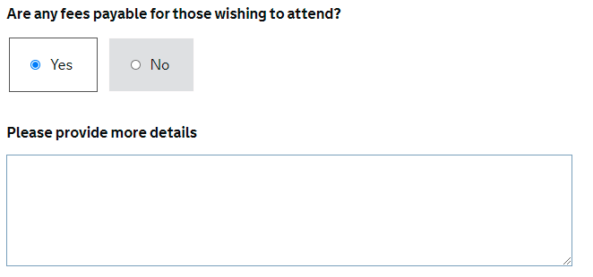
NOTE: If you answer “Yes”, another box will appear prompting you to provide more details. Complete this with details of those educational activities that do incur fees to attend. If there are subsidies or fees are waived for these activities those who are unable to afford them, make sure to state that here.
Question: Who provides the education?
Response: Provide details for the cathedral based on the activities you have outlined previously.

The next few questions relate to pastoral care, outreach.
Question: Exactly what is provided?
Response: Provide details about the pastoral and community outreach activities undertaken by the cathedral.
NOTE: Again, it is important to detail the outreach programmes the cathedral offers to the poor in the local community. This could include care for the homeless, foodbank activities, youth support etc. If any webpages are relevant, include them here.
Question: How do the trustees identify who will receive this pastoral care/outreach?
Response: Provide details for the cathedral.
NOTE: What is the cathedral’s thought process when providing pastoral care and outreach? Does the Chapter consider specific social issues afflicting the local community?
Question: Who provides it?
Response: Provide details for the cathedral.
NOTE: Does the Cathedral engage with local charities to co-ordinate efforts? Are there volunteering opportunities to support the cathedral’s outreach efforts?

The next few questions relate to missionary, evangelical.
Question: What is provided?
Response: Provide information for the cathedral. If there is a Mission/Ministry page on the website, include a link to the webpage here.
Question: Where is this provided?
Response: It is likely to be in the cathedral. If it is provided elsewhere too, please include this in your response.
Question: Who provides it?
Response: See the suggested answer below and amend accordingly. If another organisation is involved in providing the Mission/Ministry activities in the cathedral, list the main one here (e.g. the diocese):
“Cathedral clergy, lay ministers and leaders and volunteers from the Cathedral community.

The next question relates to interfaith activities. If you did not tick the box for interfaith activities on the Classification: How page, this section will not appear for you and you should go forward to the next question (on adherents of a specified religion).
Question: How is this carried out?
Response: Provide detail of the interfaith activities the cathedral participates in. Include any links to webpages where relevant.
NOTE: Is the cathedral part of a local interfaith network? What types of interfaith activities take place (panel discussions, education services etc.)? Does the cathedral participate in the interfaith activities of the diocese?

Under the subheading adherents of a specified religion:
Question: It is solely restricted to the adherents?
Response: No. This will cause a new box to appear:
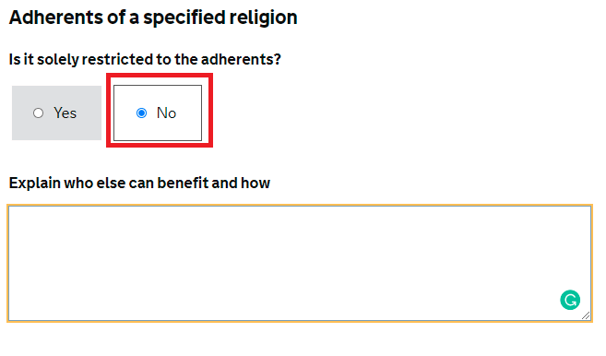
Question: Explain who else can benefit and how
Response: See the suggested text below:
“Worship and services are open to all members of the public to attend, although taking Holy Communion is restricted. The admission of Holy Communion is restricted by law (see Canon B 15A of the Canons of the Church of England: https://www.churchofengland.org/about/policy-and-thinking/canons-church-england/section-b).
[Explain here if access to the choir is formally restricted to Christians.]”
Click the save and continue button.

Public benefit: Benefits
You are now on the Benefits page.
Question: What are the benefits of the organisation’s purposes?
Response: See below for a templatised paragraph on the advancement of religion. Develop this paragraph where required and add new paragraphs detailing any further activities the cathedral participates in that provide benefit.
NOTE: A paragraph can be added detailing the social action/activities for the poor that the cathedral undertakes (e.g. foodbanks, support for the homeless, soup kitchens.). You could also refer to benefit of the educational services the cathedral provides and any further benefits of the organisation’s activities that you can think of.
If there is evidence supporting the benefits you have listed, include a reference to that evidence here and attach any documents showing this when prompted.
“The cathedral provides benefit to the general public through regular public worship, sermons and prayer which are available to all and are free of charge.”
You are then asked to attach any document which shows how the organisation provides benefit. This is optional. If you have referred to specific evidence of benefits in the paragraph above, attach any documentation that shows this evidence:
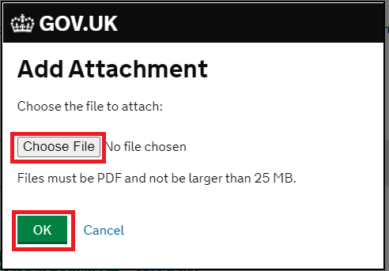

Question: Who can benefit from the organisation’s purposes
Response: Select available to everyone:
Once you have completed all the questions on this page, press the save and continue button to continue.

Public benefit: Grant making

You are now on the Grant Making page.
Question: Is the organisation a grant maker?
Response: Answer accordingly for the cathedral. If the cathedral does make grants, selecting the yes option will prompt you to answer what criteria will the organisation use to select individuals or organisations to receive grants? In response, refer briefly to the criteria in your grant making policy document (e.g. that grants are only made below £X and will only be made to charities registered with the Charity Commission).
If you have answered that the organisation is a grant maker, you will now be prompted to attach any document which explains this, such as a grant making policy. Attach the grant making policy:
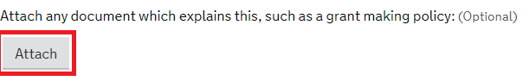
Once you have completed all the questions on this page, press the save and continue button.

Public benefit: Membership
You are now on the Membership page.
Question: Do people or organisations have to be members of the organisation to benefit from its purpose?
Response: No:
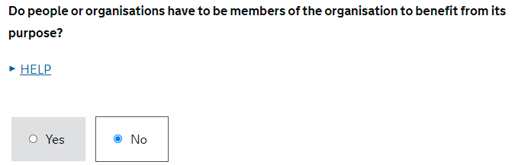
Press the save and continue button.

STEP 7: Property
You are now on the Property page.
Question: Does the organisation have use of land or property?
Response: Yes:
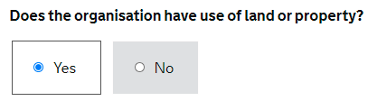
Question: Does the organisation own the land or property?
Response: Yes:
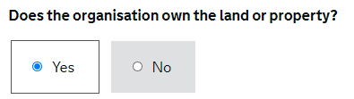
Question: What is the land or property used for?
Response: See the templatised answer below for a paragraph on worship and prayer and heritage. Supplement this paragraph with any additional information that is relevant for the cathedral.
“The cathedral church building is open to the general public for worship and prayer. The cathedral church building and [grounds] are also able to be visited by the general public.”
Question: Will any land or property used by the organisation benefit from Business Rate relief?
Response: Answer for the cathedral. If you answer yes, you will be prompted to give more details:
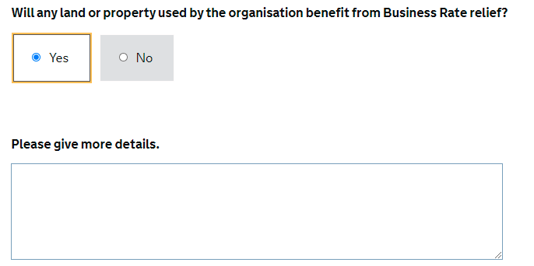
Once you have completed all the questions on this page, press the save and continue button.

STEP 8: Contact

Contact: Application
You are now on the Contact for this application page. In this section, you are asked to provide details for the main contact for this application.
Question: In what capacity are you submitting the application? (select one)
Response: Employee:
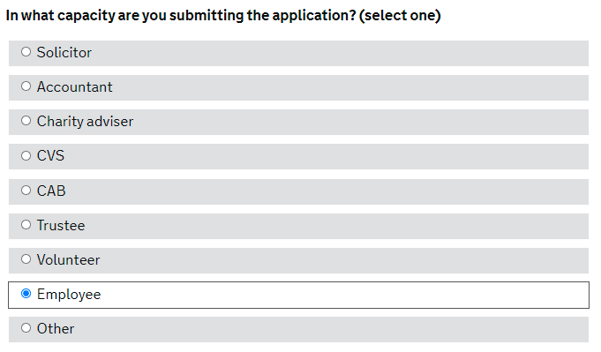
Question: Is the contact for this application an individual or an organisation?
Response: Individual:
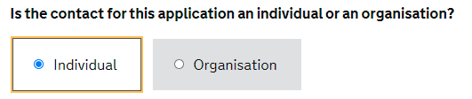
You are then prompted to add personal contact details for the application. Complete the sections with your details. Once you have done so, click the save and continue button.

Contact: Organisation

You are now on the page Organisation contact – Commission use only. On this page, you are asked to provide details of the contact the Commission can use to get in touch with the charity.
Question: Position in the organisation
Response: Employee:
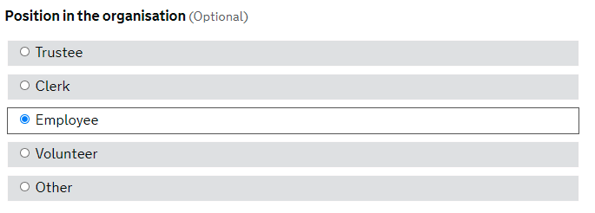
You are then prompted to add personal contact details for the application. Complete the sections with your details. Once you have done so, click the save and continue button.

Contact: Public address

You are now on the Organisation details page.
Question: Organisation’s public contact details.
Response: Provide the postcode and address for the cathedral.
Question: Organisation website.
Response: Provide the website link for the cathedral.
Question: Organisation Telephone number.
Response: Provide the appropriate telephone number for the Chapter, bearing in mind that this will be made publicly available on the Charity Register.
Question: Organisation email address.
Response: Provide the appropriate e-mail address for the Chapter, bearing in mind that this will be made publicly available on the Charity Register.
Question: Does the organisation operate from this address?
Response: Yes:
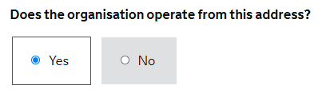
Once you have completed all the questions on this page, press the save and continue button.

STEP 9: Regulators
You are now on the Other regulators page.
Question: Are you registered with any of the following regulators? (select all that apply)
Response: Do not select any of the options.
Question: Do you have a gift aid number from HMRC?
Response: Yes. Although you will need to provide your gift aid number, this option will only appear once you have clicked the green “Save and Continue” button. Once you have clicked the button, find the “Regulators” section on the navigation panel on the left-hand side of the screen and click the link:
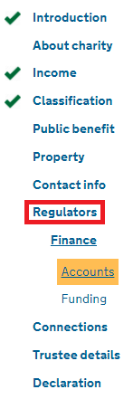
You should now be back on the other regulators page. You should now see a question asking What is your gift aid number?
Response: Provide your gift aid number. Click the save and continue button.

STEP 10: Finance

Finance: Accounts
You should now be on the Income and bank details page.
Question: Please attach the organisation’s latest accounts.
Response: Because you have already attached accounts for proof of income, you do not need to attach them again.
Question: Estimated gross annual income.
Response: Insert the figures for the cathedral.
Question: Year to date income.
Response: Insert the figures for the cathedral.
Question: Does the organisation have a bank account?
Response: Yes:
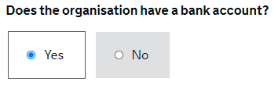
Question: Is the organisation’s main account a bank or a building society account?
Response: Select the option that is relevant for the cathedral and provide the requested details that follow. Click the save and continue button.

Finance: Funding
You are now on the Funding page.
Question: Next financial year end date (dd/mm/yyyy).
Response: Insert the relevant date for the cathedral.
Question: Please explain how the organisation is or will be funded in the future (select all that apply).
Response: It is likely that the cathedral is or will be funded through public donations, legacies, grants and charging for services. If any further options apply, please select all which are relevant and provide a brief explanation about the arrangements for each. For explanations of the typical options that may apply, please see below.
When selecting the public donations option, you will be asked to please tell us what procedures the trustees have put in place to identify and verify the donors and consider any conditions attached to any donations?”.
Response: Please see Charity Commission guidance concerning donation policies and produce an answer for the cathedral.
Question: Do you intend to claim Gift Aid on these?
Response: Yes.
When selecting the legacies option, you will be asked to please tell us what procedures the trustees have put in place to identify and verify the donors and consider any conditions attached to any donations?
Response: Please see Charity Commission guidance concerning legacies and produce an answer for the cathedral.
When selecting the grants option, you will be asked to please advise who is providing the grants.
Response: See below for a paragraph concerning the Church Commissioners grants that can be made under the Cathedrals Measure:
NOTE: If the cathedral has been accepted for heritage grant funding or other grant funding, please provide brief details in addition to the below paragraph.
“Under the Cathedrals Measure 2021, the Church Commissioners must pay the stipend for the dean of the cathedral and for two full-time equivalent residentiary canons of the cathedral.
The Church Commissioners may also make other grants to the cathedral and, in the last financial year this amounted to £X (s.23 grant) and £X (any CSF grant).”
When selecting the charging for services option, you will be asked to please give more details.
Response: See below for a templatised answer on statutory fees. If these statutory fees are not relevant for the cathedral (i.e. the cathedral is not a parish church), do not include this paragraph. Supplement this answer with details about the services that the cathedral charges for and the costs incurred for doing so.
“Certain statutory fees apply for certain services provided in the cathedral, such as baptisms, marriages, searches in church registers, funerals and burials. Please see the latest Parochial Fees Order for reference. These cannot be reduced as they are required by law to be charged (see: https://www.churchofengland.org/sites/default/files/2019-11/2020_parochial_fees_table_a4.pdf).”
If the cathedral charges visitors for entry, refer to this here.
Once you have completed all of the relevant sections relating to the funding of the organisation you are asked other than Public Donations that are eligible for Gift Aid, do the trustees intend that the proposed charity will take part in any other arrangement which might reduce the amount of tax payable by any other person?
Response: Answer accordingly for the cathedral. If you answered yes, provide an explanation when prompted to please give more details.
Question: Is it intended that the organisation will hold any funds or assets in overseas investment companies or trusts?
Response: Answer accordingly for the cathedral. If you answered yes, provide an explanation when prompted to please give more details.
Once you have answered all the questions on this page, click the save and continue button.

STEP 11: Connections

Connections: Employment
You will now be on the Employment page.
Question: Does or is it likely the organisation will employ: a trustee; its founder; a person related to a trustee; a person related to the founder; an organisation connected to a trustee; or an organisation connected to the founder?
Response: No, unless the cathedral wishes to seek specific permission for the current Administrator to remain on the Chapter, in which case this will need to be done separately.
In other information, you should note that the dean and executive residentiary canons receive a stipend from the Church Commissioners and/or cathedral, but they are not employees but office holders.
Once you have completed this page, click the save and continue button.

Connections: Goods/Services

You will now be on the Goods or Services page.
Question: Does or is it likely the organisation will buy goods or services from: a trustee; its founder; a person related to a trustee; a person related to the founder; an organisation connected to a trustee; or an organisation connected to the founder?
Response: The expected answer is no.
Once you have completed this page, click the save and continue box at the bottom of the page to continue.

Connections: Other benefits

You will now be on the Other Personal Benefits page.
Question: Are there any close links which the organisation has, or is likely to have, with any other person or body, which might be relevant to the work of the organisation?
See the examples below:
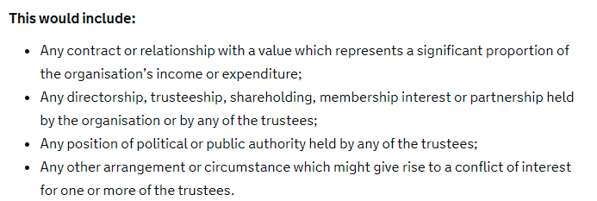
Response: Answer for your cathedral. If you answer yes, you will be prompted to add the details of the organisation, the personal benefit provided and the relationship to a table.
NOTE: The Charity Commission have confirmed that they are looking for relationships where an organisation is closely linked to the cathedral or the trustees themselves. If there are any paid relationships between bodies and trustees, these should be outlined.
Once you have completed this page, click the save and continue button.

Connections: Connections

You will now be on the Connections page.
Question: Is the organisation linked to, or has it been established by a non-charitable organisation?
Response: No:
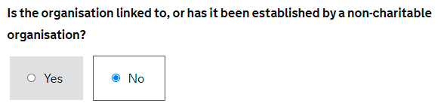
Once you have completed this page, click the save and continue button.

STEP 12: Trustee details

Trustee details: Risks
You will now be on the Managing Risks page.
Question: Does the organisation work with children or vulnerable people?
Response: Yes:
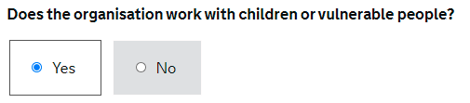
Upon answering yes, you will be asked to confirm the trustees have read, understood and are following the Charity Commission’s safeguarding guidance. Ensure that this is the case (you can click the link on the page or this link for the Charity Commission’s safeguarding guidance) and tick the box confirming that trustees have “read, understood and are following the Charity Commission’s safeguarding guidance”.
Once you have completed this page, click the save and continue button.

Trustee details: Trustee type

You will now be on the Trustee Numbers page.
Question: How many trustees does the organisation currently have? (total)
Response: Given that the membership of chapter will change following Certificate Date 1, the Charity Commission has asked that you give the number of ex officio Chapter members that you expect to remain on Chapter following Certificate Date 1 (i.e., the dean and residentiary canons). This is because it is not possible to know who the Chapter will appoint and who the bishop will appoint as the SNEM (and, if applicable, who will be elected). A brief explanation is included in the additional information section (see Step 13 of this guidance).
Question: What is the minimum number of trustees the organisation’s governing document says it must have?
Response: Answer with the minimum number to be permitted in the draft new Constitution.
NOTE: A minimum of eight members of Chapter are required under Para 1(7) to Schedule 1 of the Cathedrals Measure 2021, so the minimum number cannot be lower than 8.
Given the direction for the first question on this page, it is likely that you have answered that the organisation currently has less trustees than the minimum number of trustees permitted in your draft new Constitution and you will be asked to explain why there are fewer trustees than identified in the governing document. See the answer below:
“The governing document at the point of registration will be the new Constitution. The new Constitution requires a minimum number of trustees that is larger than the minimum number of Chapter members required under our current Constitution.”
Question: Are there any special circumstances for the organisation that require all the names of the trustees to be kept off the public register?
Response: No.
Once you have completed this page, click the save and continue button.

Trustee details: Add a Trustee

You will now be on the Trustees page.
You are invited to add details for each trustee separately. Give the details for the ex officio Chapter members that you expect to remain on Chapter after the adoption of your new Constitution and Statutes.
Once you have completed the trustee details for each Chapter member you are to include, you are asked to attach a completed and signed trustee declaration. Given that the Chapter is not yet eligible in law to apply for registration, and that the membership of Chapter will change following the adoption of new Constitution and Statutes, rather than attaching a completed and signed trustee declaration, attach a blank PDF instead. This has been agreed with the Charity Commission and the Chapter will complete a bespoke trustee declaration which will be submitted to the Charity Commission on/following Certificate Date 2.
NOTE: You are not permitted to attach a file with the same file name as a file previously attached in prior sections. Make sure to save two separate blank PDFs with different names to attach when asked for your Constitution and for the trustee declaration.

STEP 13: Declaration

You will now be on the Declaration page.
Question: Do you want to attach any supplementary documentation?
Response: Yes:
Click the grey attach box to attach the required supplementary documentation. You can only upload one document at a time. Continue to add the attachments and click the green OK button on the pop-up box to confirm when all the documentation has been attached:
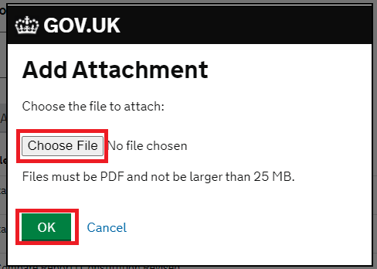
Attach your responses to the Due Diligence Questionnaire and any documents to support your answers to the Questionnaire (including your latest five years of accounts). Please see the Due Diligence Questionnaire guidance for more information on the documentation required. You should also attach the cathedral’s green line plan.
Question: Is there any additional information that the Charity Commission should take into account?
Response: Include the text below. If relevant, provide any additional information for the application.
This is a draft application made under the Protocol relating to the registration of English Anglican Cathedrals, agreed between the Charity Commission for England and Wales and the Church Commissioners for England in April 2021. This draft application should be sent directly to Mike James.
NOTE: Blank PDFs have been submitted for the governing document and trustee declaration, as directed by Stuart Wood (Head of Registrations).
The template governing document on which the new Constitution of the Cathedral is based has been issued by the Church Commissioners and agreed with the Charity Commission. The Church Commissioners will provide the Charity Commission with a copy of the draft Constitution (and Statutes) once the Church Commissioners are content that the draft documents comply with the requirements set out in the Cathedrals Measure 2021.
An updated list of trustees, together with a bespoke trustee declaration agreed by the Charity Commission in accordance with the Protocol, will be provided to the Charity Commission by the Chapter on/shortly after Certificate Date 2, prior to registration.
If you have any questions concerning this application, please contact Mike James, Jenny Stewart or Stuart Wood.
The final section on this page asks you to certify that all information provided has been checked by the trustees and is correct and complete to the best of your knowledge and all trustees agree to this submission and have read and accept the commission’s privacy notice. You will need to check that this is the case and tick this box:
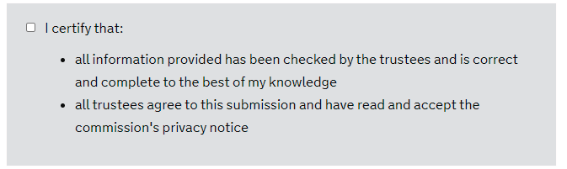
Read all the detail on this page.
Once you are satisfied with the contents of the application form, make a note of your application reference number:
Ensure you send this application reference number, together with the pdf copy of your application form and a copy of your completed due diligence questionnaire, to: cathedrals.regulation@churchofengland.org.
Submit your application by clicking the button at the bottom of the Declaration page.

Use “a cathedral church of the diocese…” rather than “the cathedral church of the diocese…” if you are one of the 3 cathedrals in the diocese of Leeds.
If you do not have your green line plan to hand, please contact the Church Commissioners (cathedrals.regulation@churchofengland.org).

