SIAMS Inspector Training Day I

Activity 1

What part do these boxes play in SIAMS?

What are the implications for report writing?

Add a number to each box to indicate which strand the box refers to.

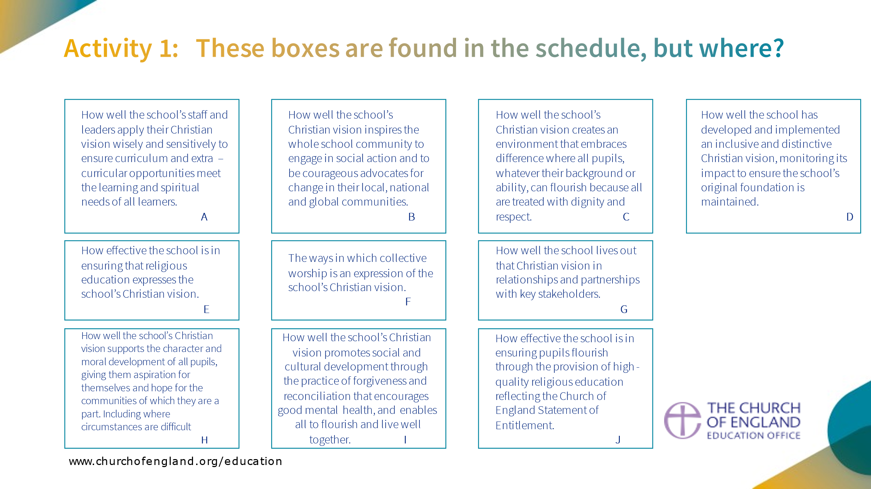

Activity 4

Reorder the sentences below to reflect the order of the inspection process.

Start by dividing them into the three coloured boxes on the right. Use any method you wish.

A | QA reviews report (several drafts) |  | Pre-inspection day
B | Final feedback
C | Inspector researches information about the school in the public domain
D | Inspector sends contract to the school
E | Inspector makes call to diocese
F | Inspector sends PIP to school
G | Evidence gathering activities
H | Evidence gathering activities |  | Inspection day
I | Inspector writes report
J | Inspector makes initial call to headteacher
K | Report is published
L | Inspector completes analysis of evidence so far and identifies LOE
M | School is notified of inspection
N | National SIAMS Team allocates inspection and date is agreed
O | Inspector reflects on evidence for LOE and emerging grades
P | Final briefing of headteacher and discussion of areas for development |  | Post inspection day
Q | Inspector receives (summary) self-evaluation from school
R | Headteacher checks report for factual accuracy
S | Inspector updates headteacher on progress of inspection
T | Inspector sends timetable requests to school
U | Headteacher drafts timetable
V | Preparation of final feedback

Council claims Newbury nightlife is outstandingly safe

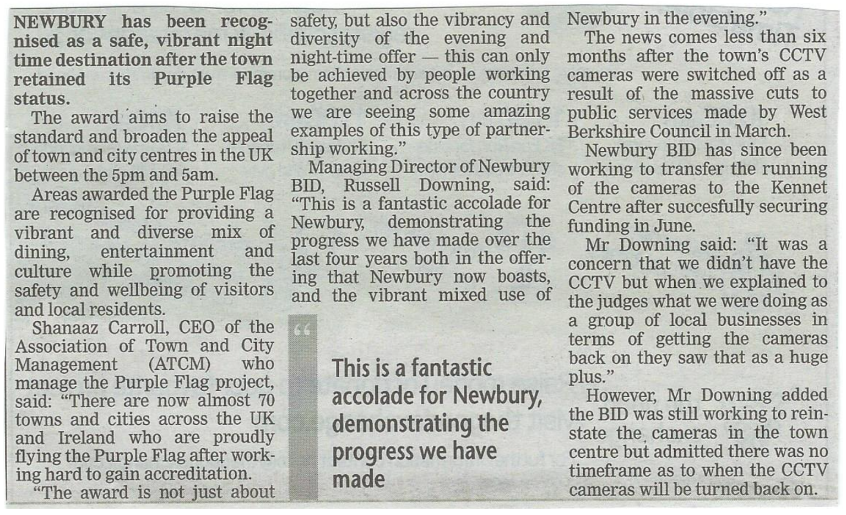

A summary SEF has been received from a VA school after the initial phone call

Our vision is to create a family rooted in love for one another where children and adults can flourish and achieve their potential to reach their own spiritual, academic and personal goals.
“Love one another. As I have loved you, so you must love one another” John 13:34

Strand 1: Vision and Leadership
- Our pupils consistently achieve well academically across the school and for all groups.
- Vulnerable groups make good progress across the school. The curriculum helps them to flourish.
- Our vision is reflected in policies. We are an inclusive, welcoming family showing compassion and forgiveness.
- Christian values and the teaching of Jesus are very evident across our community at all levels.
- We have created a place of belonging and shared purpose where everyone is valued.
- The previous inspection issue has been fully addressed through careful cataloguing of our provision for future generations.
- Our very close involvement in the local church and diocese enriches all we do.

Next steps: Publish new reward cards based on our Christian values.

Strand 2: Wisdom, Knowledge and Skills
- We set high expectations which inspire, motivate and challenge our pupils, allowing them to flourish as well-rounded unique individuals.
- Teachers have excellent curriculum knowledge. They foster and inspire our children.
- Teachers adapt their planning to respond to the strengths and needs of all pupils.
- Our pupils’ ‘Questions to God’, with answers, show strong development of spirituality.

Strand 3: Character Development: Hope, Aspiration and Courageous Advocacy
- All children are celebrated and valued for a wide range of achievements.
- All children see that persevering to overcome is as valued as achieving. They are resilient.
- Service to others runs throughout our school at all levels. This has been reinforced during the pandemic.
- Our pupils aspire to be the best they can be.
- Huge range of charities supported. £6,000 raised 2020-21.
- We have mutually beneficial relationships with a wide range of schools and overseas links.
- Our pupils will stand up for what is right and look after others without being told to do so.

Strand 4: Community and Living Well Together
- Across the school pupil behaviour is exemplary. Pupils and adults consciously look after each other and are pleased to do so.
- Children are very aware of how their behaviour impacts on others and of other people’s feelings. They are genuinely sorry if they make a poor choice.
- Vulnerable pupils are supported most effectively through nurture and individual plans.
- Exclusions are extremely rare. Support plans for the child and their family are strong.
- Our pupils are able to express and exchange views respectfully.
- Our trained peer mediators are highly effective in bringing about reconciliation.
- Mental health training has helped staff identify and cater for needs both in children and adults.

Strand 5: Dignity and Respect
- All staff and pupils have awareness of all groups and the need to treat all fairly without discrimination and with respect.
- Our behaviour policy is consistent and fair with the central thread of reconciliation.

Next Steps: To implement the Sex and Relationships government guidelines fully.
.

Strand 6: The impact of collective worship
- Worship is central to our school
- Children enjoy collective worship (see pupil voice) as evident through their voluntary participation in our over-subscribed Worship Group.
- Children enter and participate in collective worship respectfully and thoughtfully.
- We all grow as people through the weaving of our Christian values through our worship.
- Pupils are well aware of the teaching of Jesus and the relevance to our lives. They are able to reflect on their behaviour in the light of this.
- Our excellent clergy support was maintained during the rector’s study leave.

Next Steps: Development of a new whole school prayer.

Strand 7: The effectiveness of religious education
- Our medium term plans integrate Understanding Christianity with school and diocese designed units effectively. KS2 teaching is balanced between Christianity (80%) and one other world faith per year group enabling our pupils to make clear comparisons.
- Our pupils receive a rich and varied programme enabling the vast majority of pupils to achieve at least age related expectation. Many exceed.
- RE has high status. Standards and expectations are high and at least in line with all core subjects.
- We have a clear idea of the progress our pupils are making and adapt future teaching to their needs. Parents are informed of their child’s progress in RE and find this useful.

