SIAMS Inspector Training Day 4

Activity 3

Spiritual development | KS1 | KS2 | KS3
Outside
Senses
Ritual and Symbol
Solitude and simplicity
Confrontation
Loving others
Mystery and celebration
Mind
Adoration

Activity 5

Courageous advocacy

Example 1
Teachers arranged for the whole school to part in The Climate Coalition’s ‘Show the Love’ campaign. Pupils assembled on the school field in the shape of a huge heart and used a drone to take an aerial picture. They tweeted this picture and sent it out with a press release to local media.

Example 2
Pupils decided the bin collection for the school which is situated in a cul-de sac caused a traffic jam for the residents. They wrote to the council who altered the bin route

Example 3
Pupils raised money for a Save the Hedgehog campaign and held cake sales – they raised over £200

Example 4
Following an English unit on freedom pupils wrote letters to their MP about a prisoner who they considered was wrongly imprisoned

Example 5
Single use plastic bottles are banned in school and each pupil is provided with a re-fillable bottle to use. More water fountains are installed around school.

Example 6
Year 3 pupils saved their ‘lego cards’ collected from a local supermarket and sent them to children in a hospice.

Activity 6
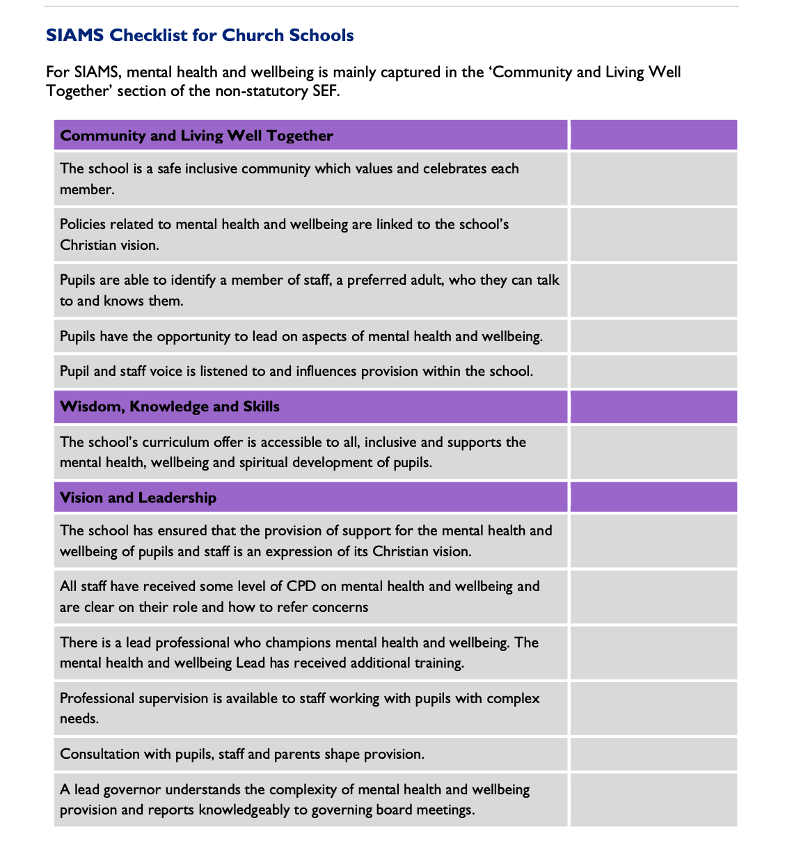
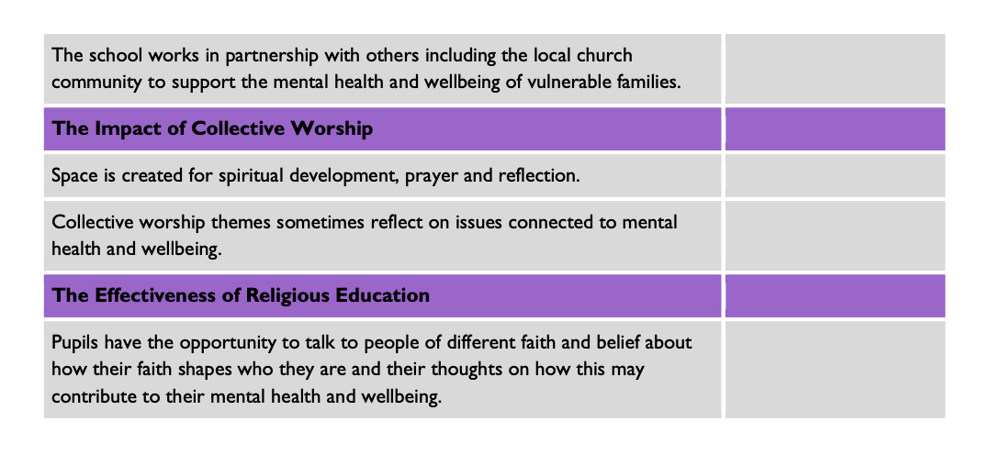

Activity 9

Extract A
Inclusivity and love for every unique individual is what is at the very heart of the school. The vision upholds the value of all as children of God, in an inclusive environment. Pupils enjoy and are excited by all the school offers. They are enthused by the creative curriculum which is enhanced by extra-curricular activities. Pupils have a good understanding of choices, consequences and learning from their mistakes. At present, there isn’t a common understanding of the concept of spirituality. This means that times when spirituality might be developed tend to be ‘in the moment’ rather than planned for. Consequently, planning does not foster a progressive understanding of how spirituality can be built on as the children mature. Excellent relationships and behaviour are a strength of the school and fully reflect the core values of friendship and respect. As a result, pupils flourish personally and socially. Pupils challenge injustice and inequality and are courageous advocates for change in support of local and national charities. Through both fundraising and the curriculum, they are aware of global issues. Within this community, pupils’ characters are shaped and they are inspired to action. For example, following work on plastic pollution pupils are passionate about reducing, reusing and recycling waste. One pupil commented that ‘God made the world and we have to look after it’.

Extract B
Pupils behave extremely well at XXXX. This is because they truly understand the purpose of the school’s golden rule and the importance of the school vision and values. ‘If we didn’t have the values, we wouldn’t get on so well’, explained a child in Year 4. Pupils really understand how the need to ‘treat others as you would like to be treated’ is an important benchmark for life. In this way they are learning to treat everyone, whatever their faith or background, with dignity and respect. The school has worked hard to give pupils many experiences that, underpinned by the vision, enable them to understand diversity and difference. Pupils recognise that if they are to live life in all its fullness, they need to try new things, including some that might scare them! This links with their recent work on good mental health where they were challenged to ‘Find your Brave’. Pupils have chosen two charities this year, one of which raises funds for schools in Africa. This is a clear example of how pupils are seeing the school’s vision in action. They have a real sense of challenging injustice and relate it explicitly to the right of everyone to be treated fairly. The school has not explored what it means to be spiritual. Whilst a difficult concept, understanding what this means for pupils and staff is an important step. Attendance is good because children enjoy a well-thought-out and creative curriculum. The headteacher works closely in supporting families so that they see the importance of their child being in school.

Extract C
Recognising that all children are created in the image of God, school leaders have developed an exciting, broad and balanced curriculum in line with its Christian vision which strongly supports the holistic development of all pupils. Data shows that progress and attainment are good across the school. Innovative enrichment days with alternative timetables including Forest School and learning Mandarin, ensure personal growth in resilience, confidence and independence, and ‘value days’ are times set aside to focus on the school’s Christian values in an atmosphere of togetherness and time for reflection. Pupils gain hugely from these days and they contribute well to developing their sense of spirituality. Pupils are keen to discuss their learning, and effort and success is celebrated. This is a highly hospitable community where diversity is embraced. The SENCO has introduced a flexible range of programmes to support vulnerable groups and progress is monitored. Behaviour is good and there is a school Pets As Therapy (PAT) dog who supports good mental health for pupils and adults. The school’s Christian ethos underpins behaviour management through the practice of forgiveness and reconciliation. Leaders provide quality opportunities for pupils to question injustice and inequality and the Christian vision of the school is lived out in the passion with which pupils care about God’s world and people. Pupils have become highly confident advocates of change. Whilst supporting a range of charities, pupils organise fund raising to educate a child in the Philippines, whom they view as a member of their school, and to support a sick child in this country.

