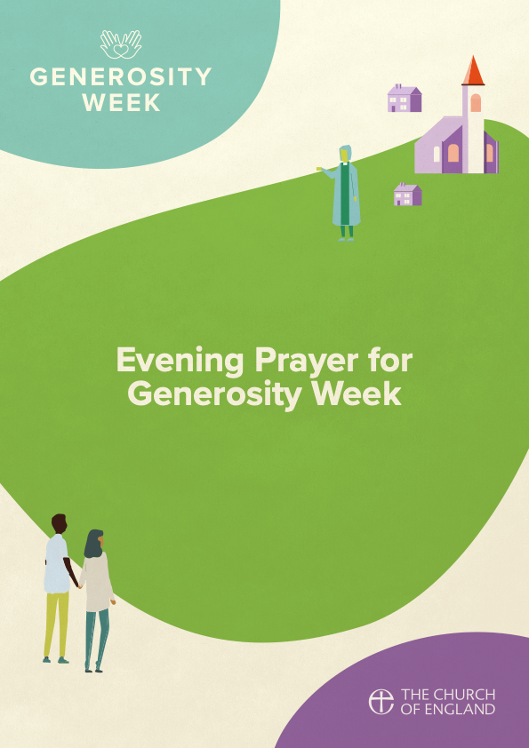

­**Preparation**



O God, make speed to save us.  
**O Lord, make haste to help us.**

Blessed are you, Lord God, creator of day and night:   
to you be praise and glory for ever.  
As darkness falls you renew your promise  
to reveal among us the light of your presence.  
By the light of Christ, your living Word,  
dispel the darkness of our hearts  
that we may walk as children of light  
and sing your praise throughout the world.  
Blessed be God, Father, Son and Holy Spirit:  
**Blessed be God for ever.**

*This opening prayer may be said*

That this evening may be holy, good and peaceful,  
let us pray with one heart and mind.

*Silence is kept*

As our evening prayer rises before you, O God,  
so may your mercy come down upon us  
to cleanse our hearts  
and set us free to sing your praise  
now and for ever.  
**Amen.**

**THE WORD OF GOD**

*Psalmody: Psalm 119.33-56*

**My delight shall be in your commandments.**

1. Teach me, O Lord, the way of your statutes ♦  
   and I shall keep it to the end.
2. Give me understanding and I shall keep your law; ♦  
   I shall keep it with my whole heart.
3. Lead me in the path of your commandments, ♦  
   for therein is my delight.
4. Incline my heart to your testimonies ♦  
   and not to unjust gain.
5. Turn away my eyes lest they gaze on vanities; ♦  
   O give me life in your ways.
6. Confirm to your servant your promise, ♦  
   which stands for all who fear you.
7. Turn away the reproach which I dread, ♦  
   because your judgements are good.
8. Behold, I long for your commandments; ♦  
   in your righteousness give me life.
9. Let your faithful love come unto me, O Lord, ♦  
   even your salvation, according to your promise.
10. Then shall I answer those who taunt me, ♦  
    for my trust is in your word.
11. O take not the word of truth utterly out of my mouth, ♦  
    for my hope is in your judgements.
12. So shall I always keep your law; ♦  
    I shall keep it for ever and ever.
13. I will walk at liberty, ♦  
    because I study your commandments.
14. I will tell of your testimonies, even before kings, ♦  
    and will not be ashamed.
15. My delight shall be in your commandments, ♦  
    which I have greatly loved.
16. My hands will I lift up to your commandments,  
    which I love, ♦  
    and I will meditate on your statutes.
17. Remember your word to your servant, ♦  
    on which you have built my hope.
18. This is my comfort in my trouble, ♦  
    that your promise gives me life.



1. The proud have derided me cruelly, ♦  
   but I have not turned aside from your law.
2. I have remembered your everlasting judgements, O Lord, ♦  
   and have been comforted.
3. I am seized with indignation at the wicked, ♦  
   for they have forsaken your law.
4. Your statutes have been like songs to me ♦  
   in the house of my pilgrimage.
5. I have thought on your name in the night, O Lord, ♦  
   and so have I kept your law.
6. These blessings have been mine, ♦  
   for I have kept your commandments.

**My delight shall be in your commandments.**

**Glory to the Father and to the Son  
and to the Holy Spirit;   
as it was in the beginning is now  
and shall be for ever. Amen.**

**Scripture Reading**

An Oracle.

The word of the Lord concerning Israel: Thus says the Lord, who stretched out the heavens and founded the earth and formed the human spirit within: See, I am about to make Jerusalem a cup of reeling for all the surrounding peoples; it will be against Judah also in the siege against Jerusalem. On that day I will make Jerusalem a heavy stone for all the peoples; all who lift it shall grievously hurt themselves. And all the nations of the earth shall come together against it. On that day, says the Lord, I will strike every horse with panic, and its rider with madness. But on the house of Judah I will keep a watchful eye, when I strike every horse of the peoples with blindness. Then the clans of Judah shall say to themselves, ‘The inhabitants of Jerusalem have strength through the Lord of hosts, their God.’

On that day I will make the clans of Judah like a blazing pot on a pile of wood, like a flaming torch among sheaves; and they shall devour to the right and to the left all the surrounding peoples, while Jerusalem shall again be inhabited in its place, in Jerusalem.

And the Lord will give victory to the tents of Judah first, so that the glory of the house of David and the glory of the inhabitants of Jerusalem may not be exalted over that of Judah. On that day the Lord will shield the inhabitants of Jerusalem, so that the feeblest among them on that day shall be like David, and the house of David shall be like God, like the angel of the Lord, at their head. And on that day I will seek to destroy all the nations that come against Jerusalem.

And I will pour out a spirit of compassion and supplication on the house of David and the inhabitants of Jerusalem, so that, when they look on the one whom they have pierced, they shall mourn for him, as one mourns for an only child, and weep bitterly over him, as one weeps over a firstborn.

*Zechariah 12.1-10*

**Canticle**

**Rejoice and be glad  
for you are the light of the world,  
and great is your reward in heaven.**

1. Blessed are the poor in spirit, ♦  
   for theirs is the kingdom of heaven.
2. Blessed are those who mourn, ♦  
   for they shall be comforted.
3. Blessed are the meek, ♦  
   for they shall inherit the earth.
4. Blessed are those who hunger  
   and thirst after righteousness, ♦  
   for they shall be satisfied.
5. Blessed are the merciful, ♦  
   for they shall obtain mercy.
6. Blessed are the pure in heart, ♦  
   for they shall see God.
7. Blessed are the peacemakers, ♦  
   for they shall be called children of God.
8. Blessed are those who suffer persecution  
   for righteousness’ sake, ♦  
   for theirs is the kingdom of heaven.

*Matthew 5.3-10*

**Glory to the Father and to the Son  
and to the Holy Spirit;  
as it was in the beginning is now  
and shall be for ever. Amen.**

**Rejoice and be glad  
for you are the light of the world,  
and great is your reward in heaven.**

**Scripture Reading**

Jesus and his disciples came to Jerusalem. As he was walking in the temple, the chief priests, the scribes, and the elders came to him and said, ‘By what authority are you doing these things? Who gave you this authority to do them?’ Jesus said to them, ‘I will ask you one question; answer me, and I will tell you by what authority I do these things. Did the baptism of John come from heaven, or was it of human origin? Answer me.’ They argued with one another, ‘If we say, “From heaven”, he will say, “Why then did you not believe him?” But shall we say, “Of human origin”?’—they were afraid of the crowd, for all regarded John as truly a prophet. So they answered Jesus, ‘We do not know.’ And Jesus said to them, ‘Neither will I tell you by what authority I am doing these things.’

*Mark 11.27-end*

**Responsory**

Lord, you will guide me with your counsel  
and afterwards receive me with glory.  
**Lord, you will guide me with your counsel  
and afterwards receive me with glory.**For I am always with you;  
you hold me by my right hand.  
**And afterwards receive me with glory.**  
Glory to the Father and to the Son  
and to the Holy Spirit.  
**Lord, you will guide me with your counsel  
and afterwards receive me with glory.**



*from Psalm 73*

**Gospel Canticle**

**Remember your promise of mercy,  
to Abraham and his children for ever.**

1. My soul proclaims the greatness of the Lord,  
   my spirit rejoices in God my Saviour; ♦  
   he has looked with favour on his lowly servant.
2. From this day all generations will call me blessed; ♦  
   the Almighty has done great things for me  
    and holy is his name.



1. He has mercy on those who fear him, ♦  
   from generation to generation.
2. He has shown strength with his arm ♦  
   and has scattered the proud in their conceit,
3. Casting down the mighty from their thrones ♦  
   and lifting up the lowly.
4. He has filled the hungry with good things ♦  
   and sent the rich away empty.
5. He has come to the aid of his servant Israel, ♦  
   to remember his promise of mercy,
6. The promise made to our ancestors, ♦  
   to Abraham and his children for ever.

*Luke 1.46-55*

**Glory to the Father and to the Son  
and to the Holy Spirit;   
as it was in the beginning is now  
and shall be for ever. Amen.**

**Remember your promise of mercy,  
to Abraham and his children for ever.**



**Prayers**

*Intercessions are offered and may conclude*

God of awe and wonder,

creator of both night and day,

you count the number of the stars

and call them all by their names.

Help us to cherish your abundant creation,

grateful for the gift that it is to us,

living in harmony with our common home,

through him who is the firstborn of all creation,

Jesus Christ our Lord.

**Amen.**

Joining our voices with all creation,

as our Saviour taught us, so we pray

**Our Father, who art in heaven,  
hallowed be thy name;  
thy kingdom come;  
thy will be done;  
on earth as it is in heaven.  
Give us this day our daily bread.  
And forgive us our trespasses,  
as we forgive those who trespass against us.  
And lead us not into temptation;  
but deliver us from evil.  
For thine is the kingdom,  
the power and the glory,  
for ever and ever.  
Amen.**



**The Conclusion**

**The grace of our Lord Jesus Christ,  
and the love of God,  
and the fellowship of the Holy Spirit,  
be with us all evermore.  
Amen.**

Let us bless the Lord.  
**Thanks be to God.**

Material in this service is taken from Common Worship, copyright © The Archbishops’ Council 2000-2006 and is used here with permission. [www.commonworship.com](http://www.commonworship.com). This order has been compiled by Revd Trevor Marshall. This compilation is copyright © The National Giving Team 2021.