How to edit & download a Canva file:

- Open file/design.
- Double click on the church name and edit it to your church’s name.

To download:
- Click “Share” in the top right corner
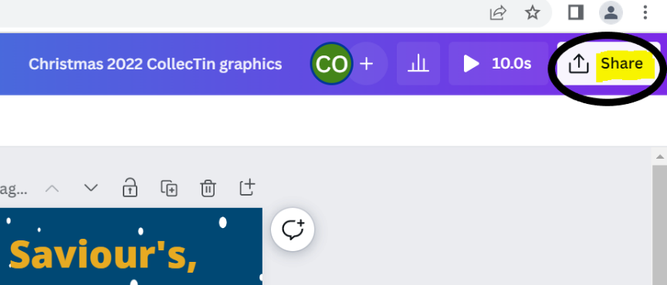

- Then click “Download”.
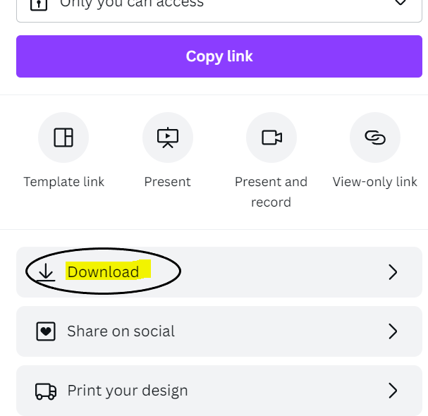

- You will then need to download each page individually by unticking/ticking each page then click “Done”. So make sure Page 1 is the only one ticked, then once repeating the steps, tick Page 2 only.
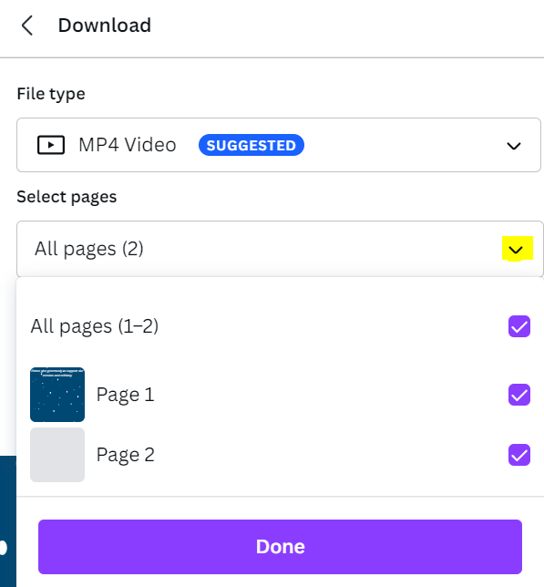

- Once you have pressed “Done”, you’ll then be able to “download” an individual page at a time. So once you’ve downloaded page 1, you’ll need to repeat the steps to download page 2.
