Generous Church Review Facilitator Guide
Introduction
The Generous Church Review (which was the Generosity Toolkit) is designed to help PCCs reflect on their shared experience of generosity in the life of their church. By working through the cards in the Generous Church Review, the group will be able to look in depth at what generosity is, consider what they are doing well, and examine where they could improve to grow in generosity. The focus is around what God is calling us to do – it’s not about what we can achieve in our own strength.
Who is the Generous Church Review aimed at?
The Review is aimed at PCCs, although reflections could be explored by a wider group from the church. The actions taken away from the session should be led by PCC members, as they have the authority to make changes. The group can work through the cards together if they are small in number. If there are more than 10(??), they can break into smaller groups to work through cards and feed back after completing each card. If different churches are coming together to do the Review, they should stay in groups from the same church.
How long does it take?
To complete the whole Review, you’ll need at least 3 hours, which will allow for a 15 minute introduction and icebreaker, 15 minutes per card, 15 minutes to agree actions and a conclusion.
Ideally the Review would be conducted at a PCC Away Half Day. If this isn’t possible, it can be done in four shorter sessions of 1 hour. Alternatively, it’s possible to focus on just one or two of the cards.
Who should facilitate the session?
Ideally, there would be a neutral facilitator, who is skilled in this area. If this is not possible, the incumbent or a churchwarden should lead the session.
Where should the Review take place?
You can host the session anywhere the group is happy to meet – at the church, in a church hall or another venue. It’s important to ensure there is plenty of space to break out into small groups to work through the cards.
What supporting materials are needed?
- Pens and paper to complete the cards.
- Laptop, projector and speakers if you want to use the presentation slides.
- Coloured post-it notes or cards to hand to note down responses to the ‘Discuss’ questions.

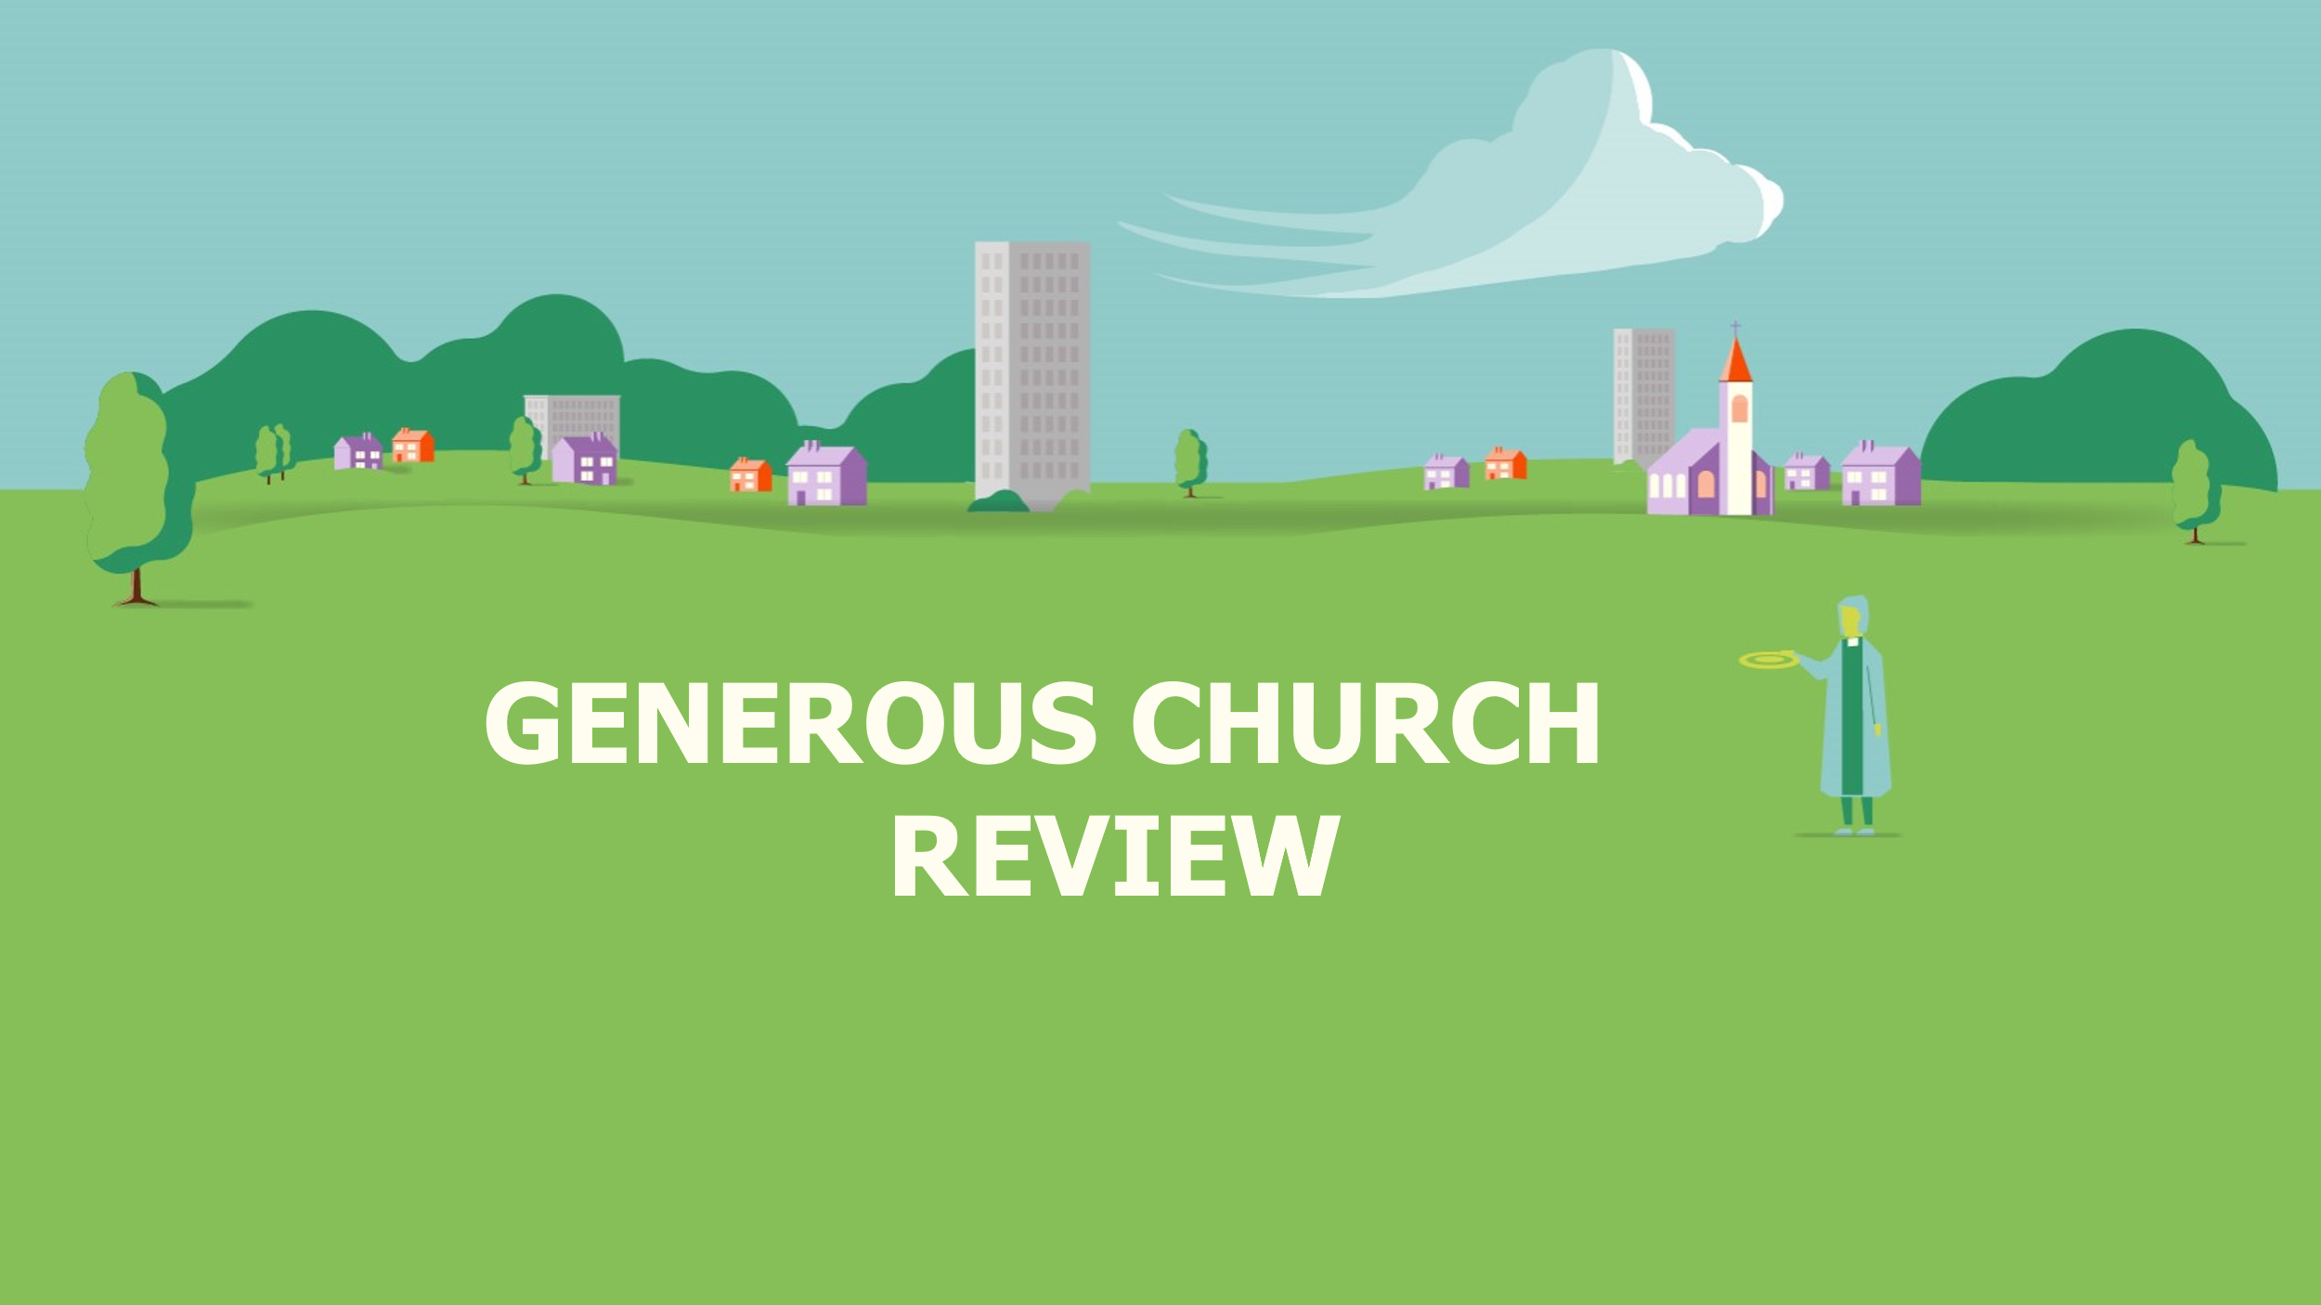 | Have this slide showing as people arrive and while you’re welcoming them and introducing yourself.  Open in prayer or ask a member of the group to do so.
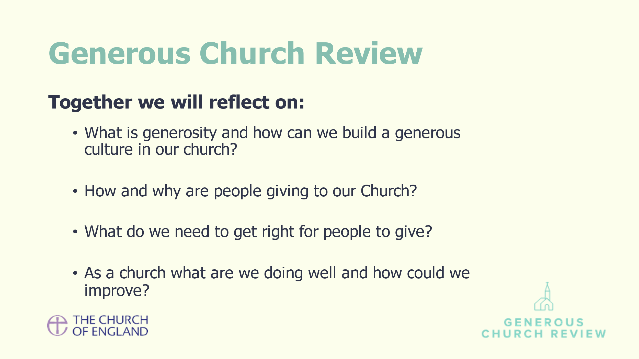 | Explain what the Generous Church Review is and talk through the schedule. Say you may adapt it to allow conversations to reach a natural conclusion.  What will happen – short intro and then group work to determine what generosity is; what they’re doing well and where they could improve. Emphasise that the focus is around what God is calling us to do, not what we can achieve in a human sense.
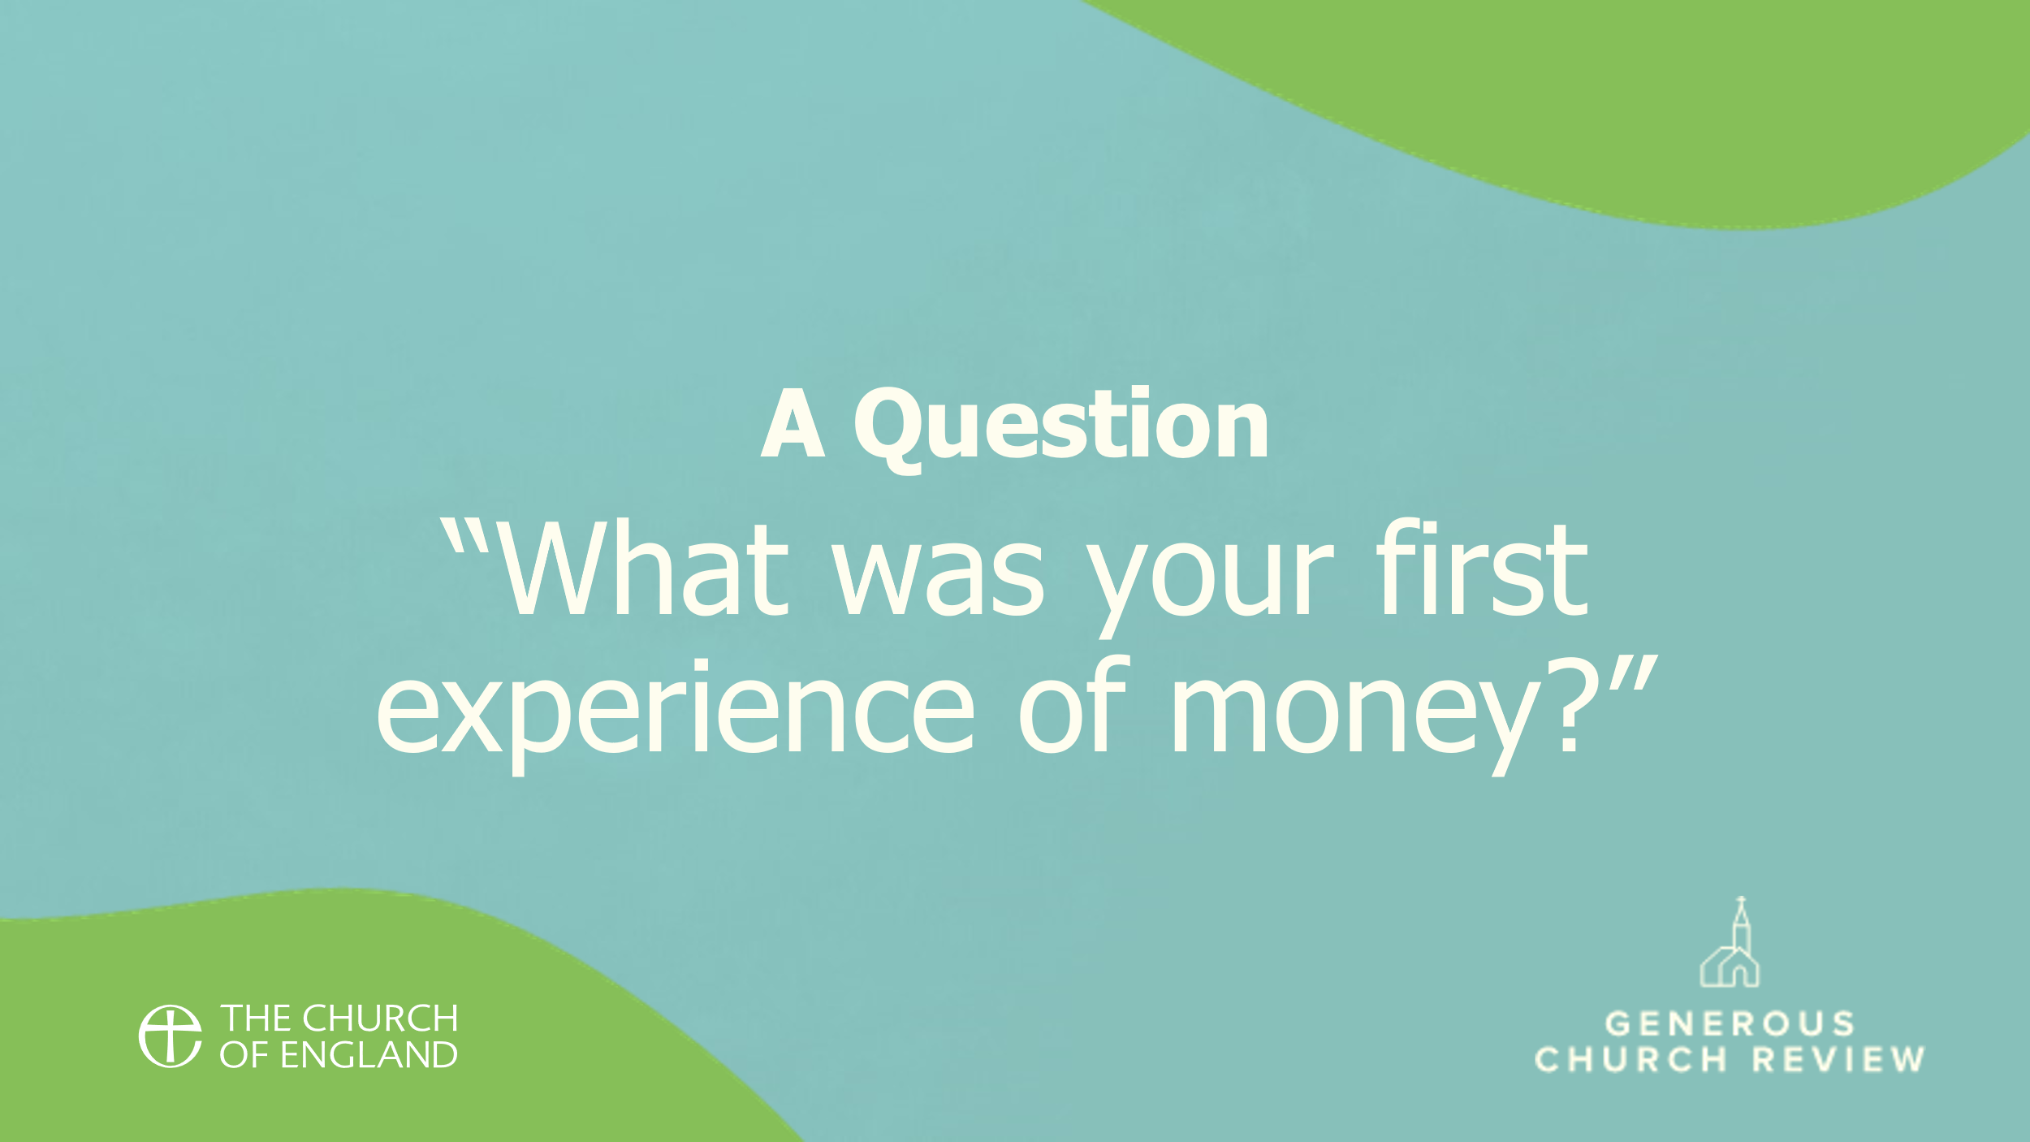 | If you feel you need an ice breaker, this can work well – you can ask people to shout out their responses, or get them to chat to their neighbour. You might like to offer a contribution first.

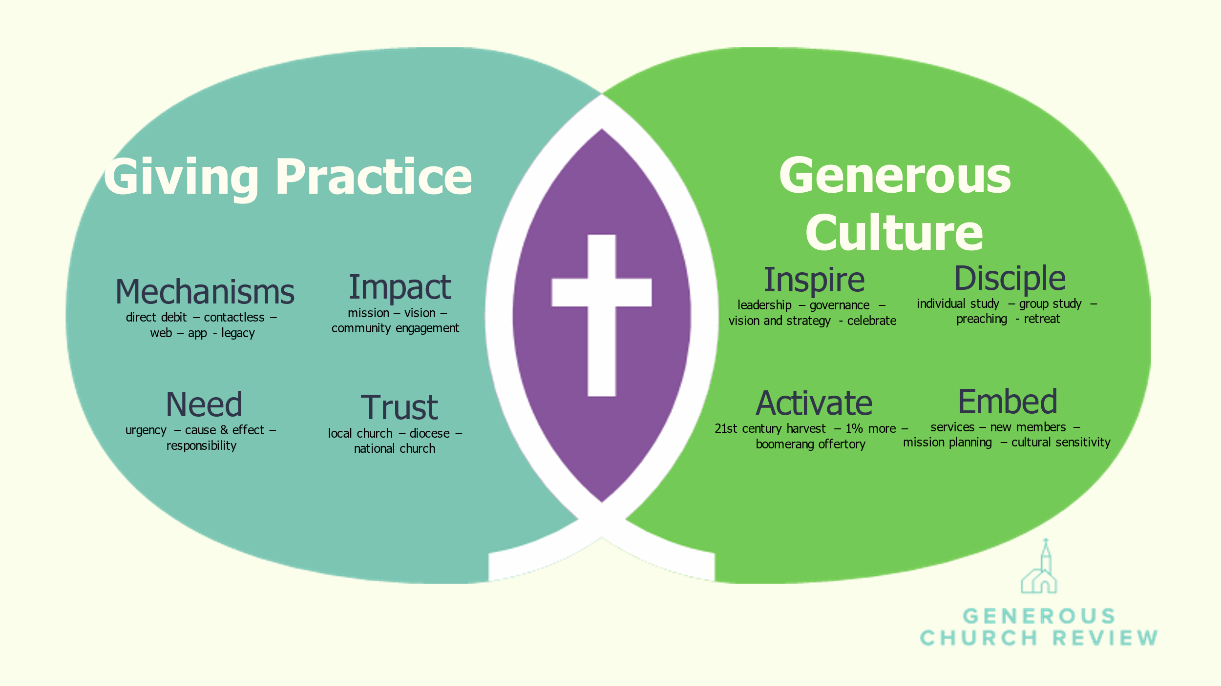 | The vision for giving and generosity within the church is illustrated in this graphic. There are two main dimensions to this:  Improving giving practice which is how the church enables people to give, and  Encouraging a generous culture which is how churches enable people to live generous lives.
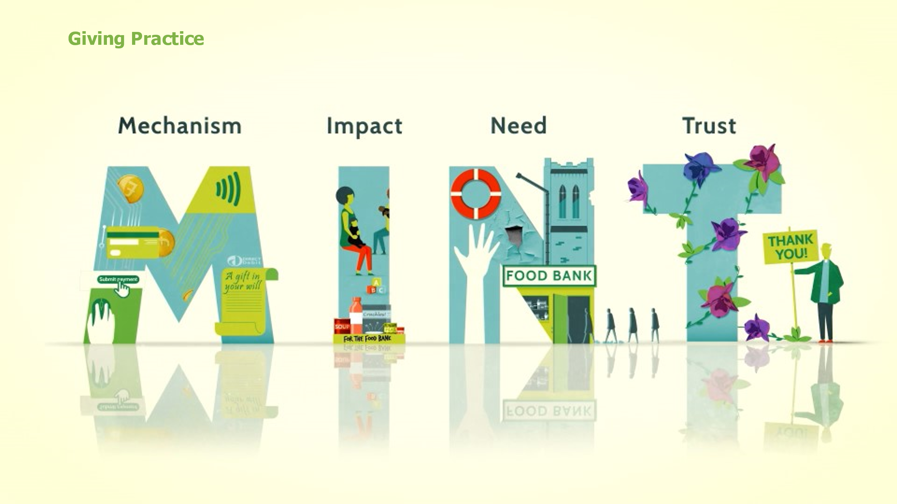 | When encouraging people to give, there are four things we need to get right, which make up our  church’s giving practice. These four things form the acronym MINT.
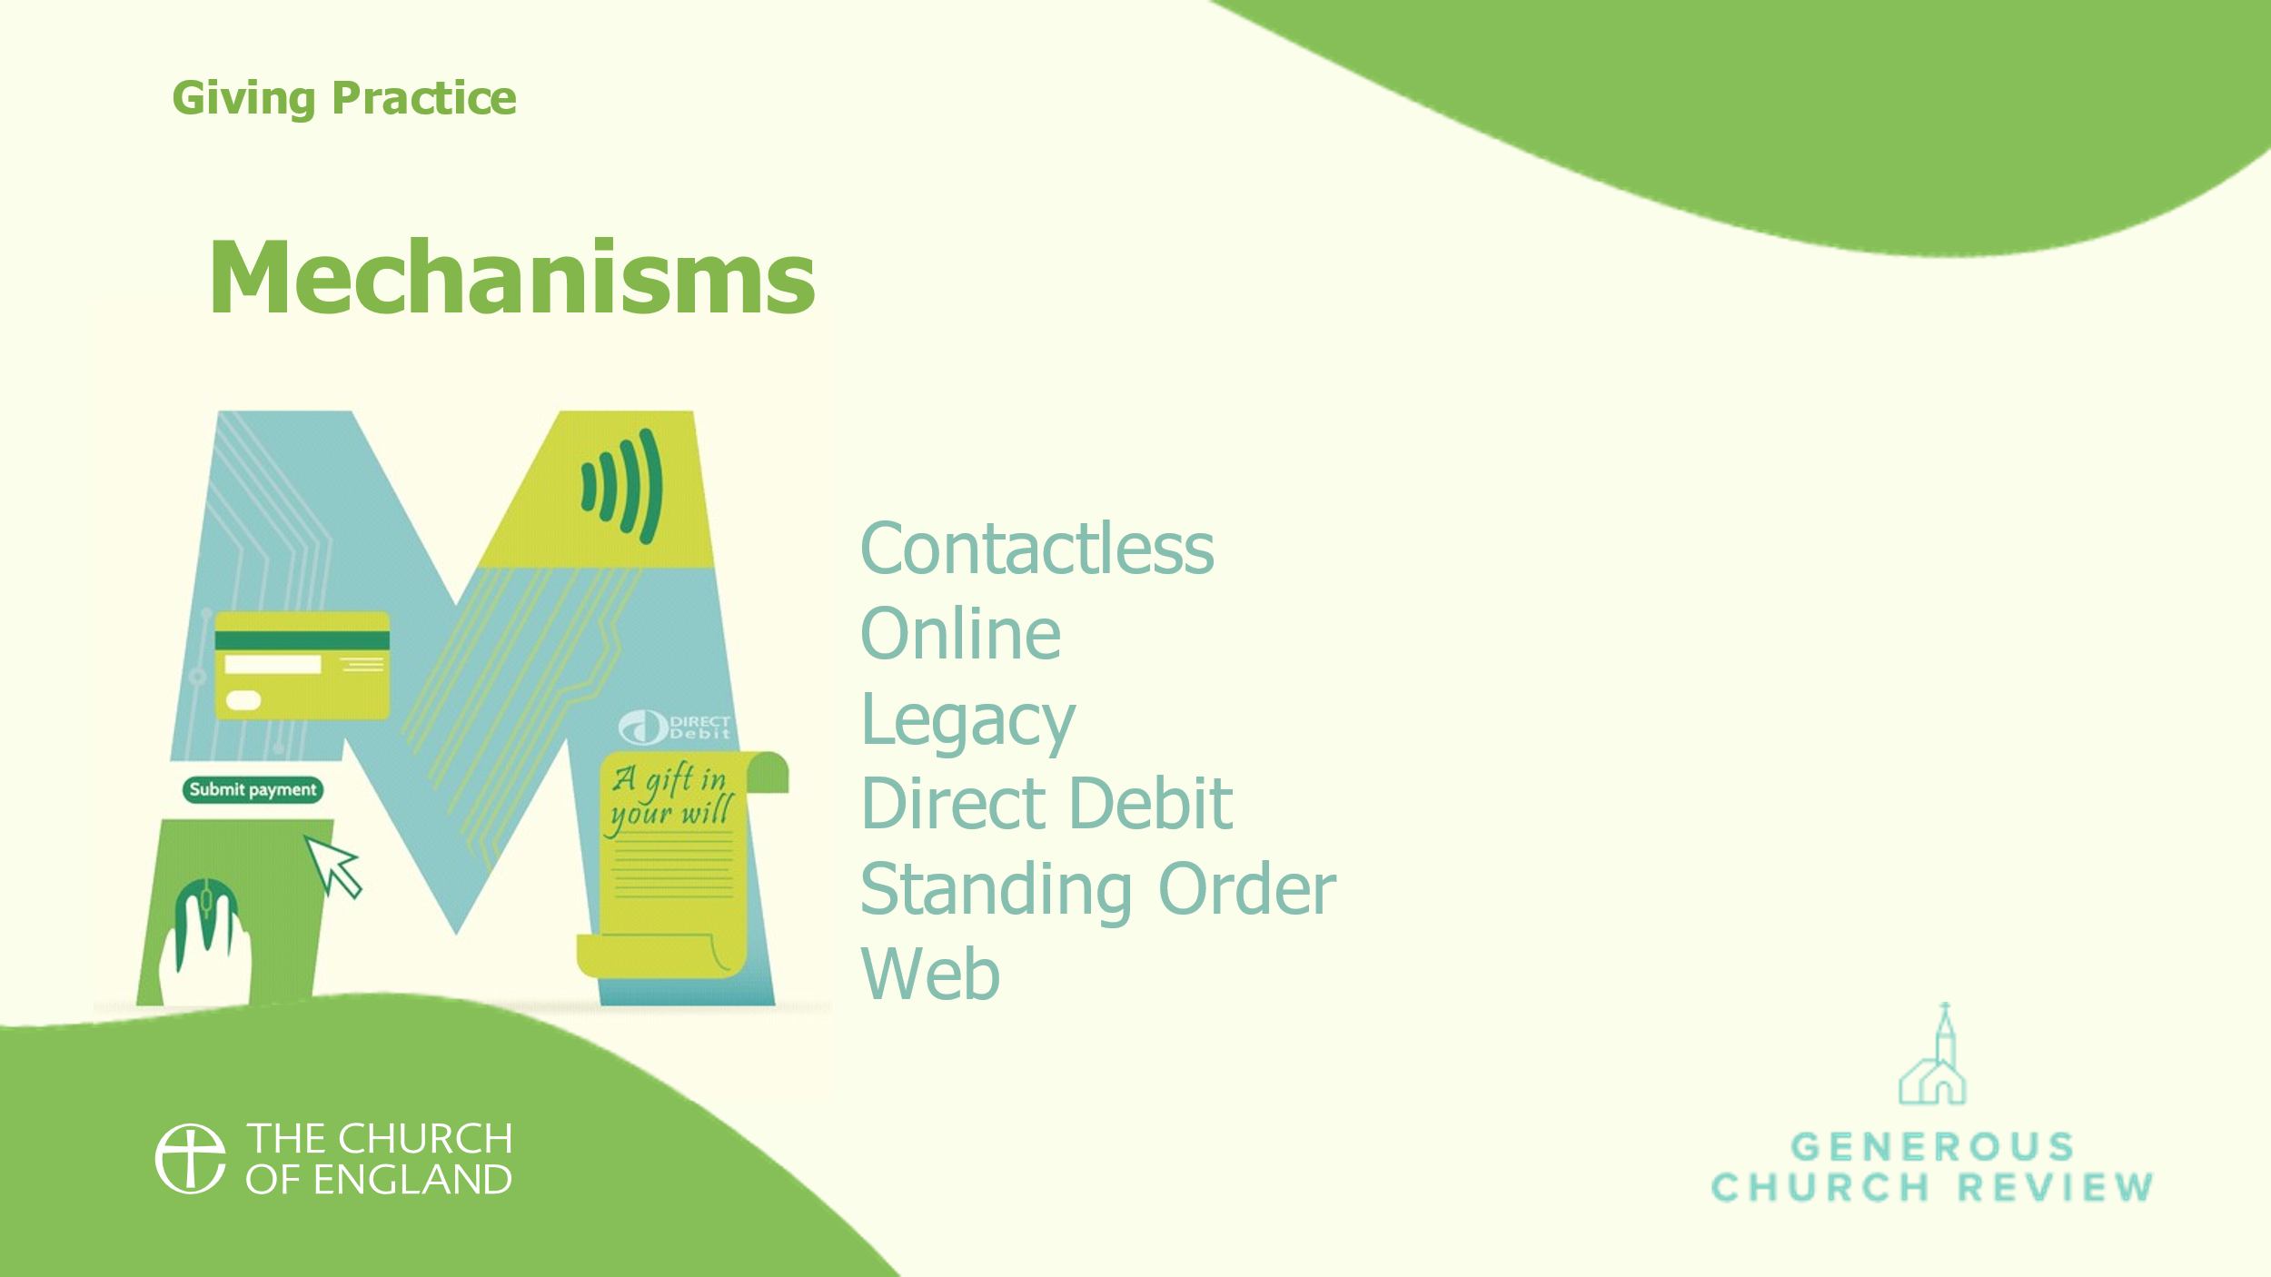 | We need to give people the right mechanisms to give. That might be as simple as making it easy to sign up to give regularly by standing order or direct debit, but there is also contactless and online giving, and helping people to leave a gift in their will. The more options we can provide, the more people are likely to give, especially if we make it as easy as possible to give too.
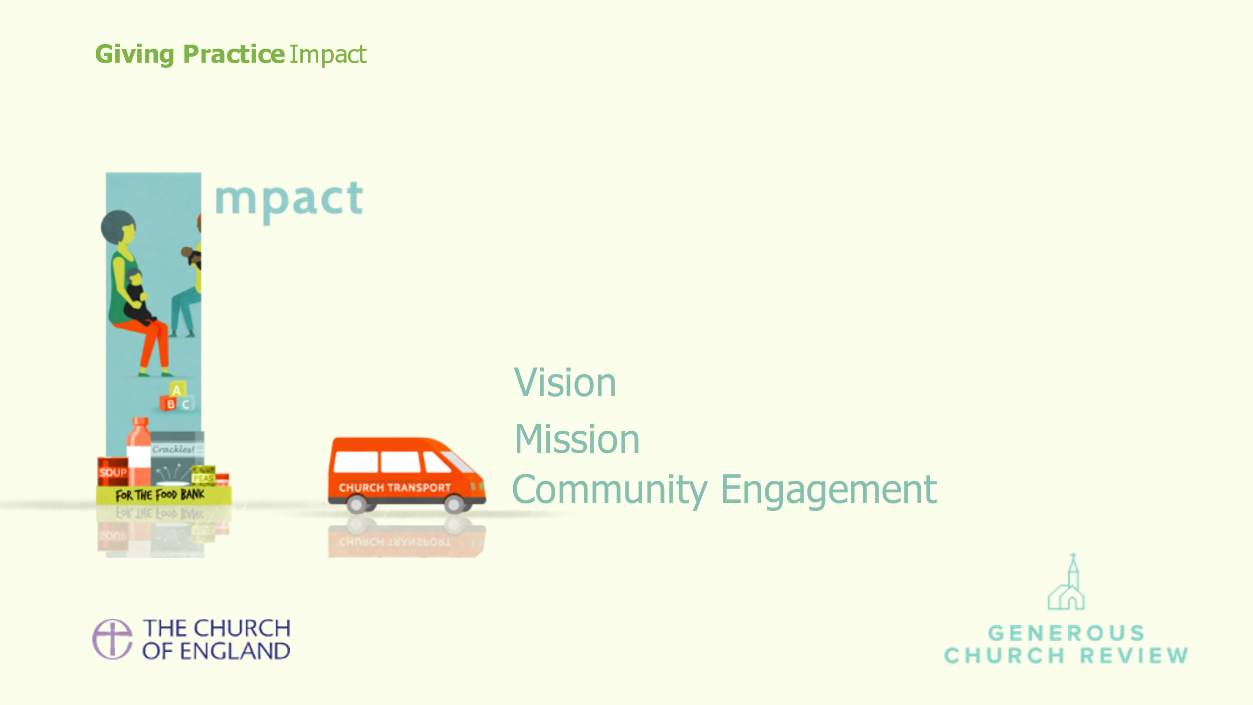 | We need to explain what impact we are making with the money people are giving. This isn’t the cost of running the Church, but what is happening as a result of the money that people give and how giving is enabling our mission and ministry.
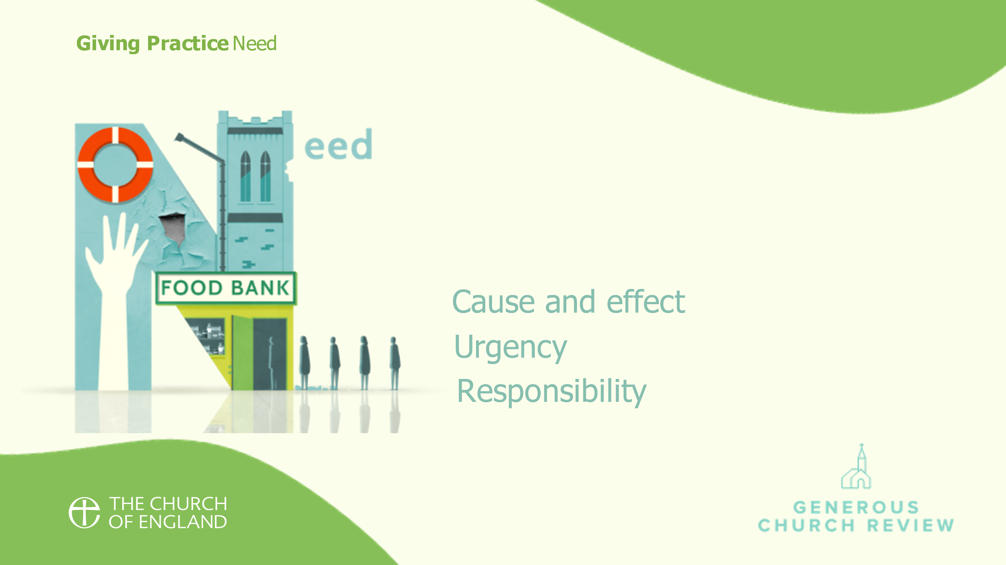 | We must make it clear why we need people to give; being persuaded of the need to give is crucial to people choosing to give.
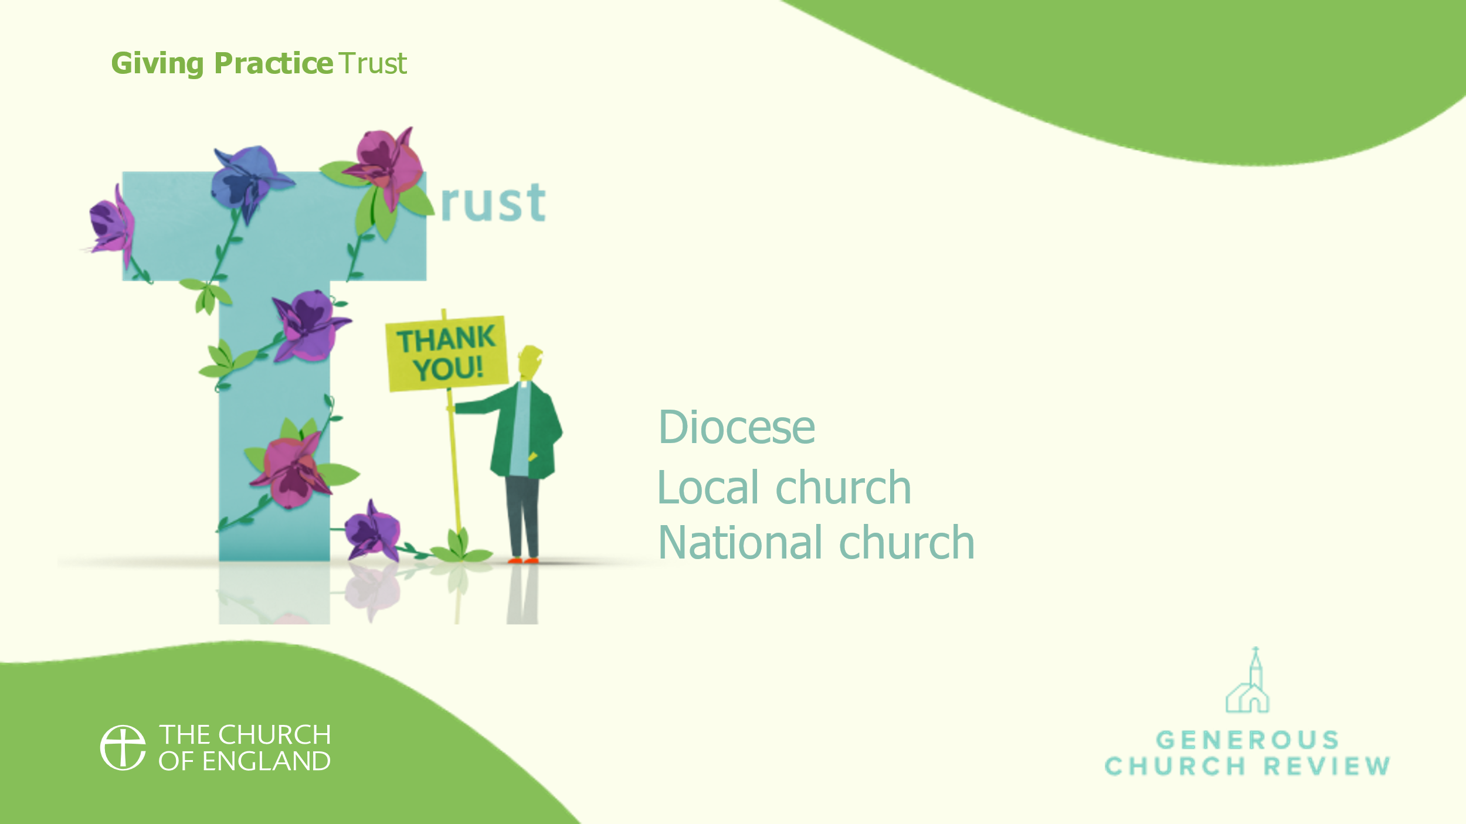 | It’s essential that we build trust with the giver so they feel confident we will look after their gift well and spend it wisely. In order to enable people to trust us as a church we must be transparent about how we handle the money given to us, and about how it is managed and spent.

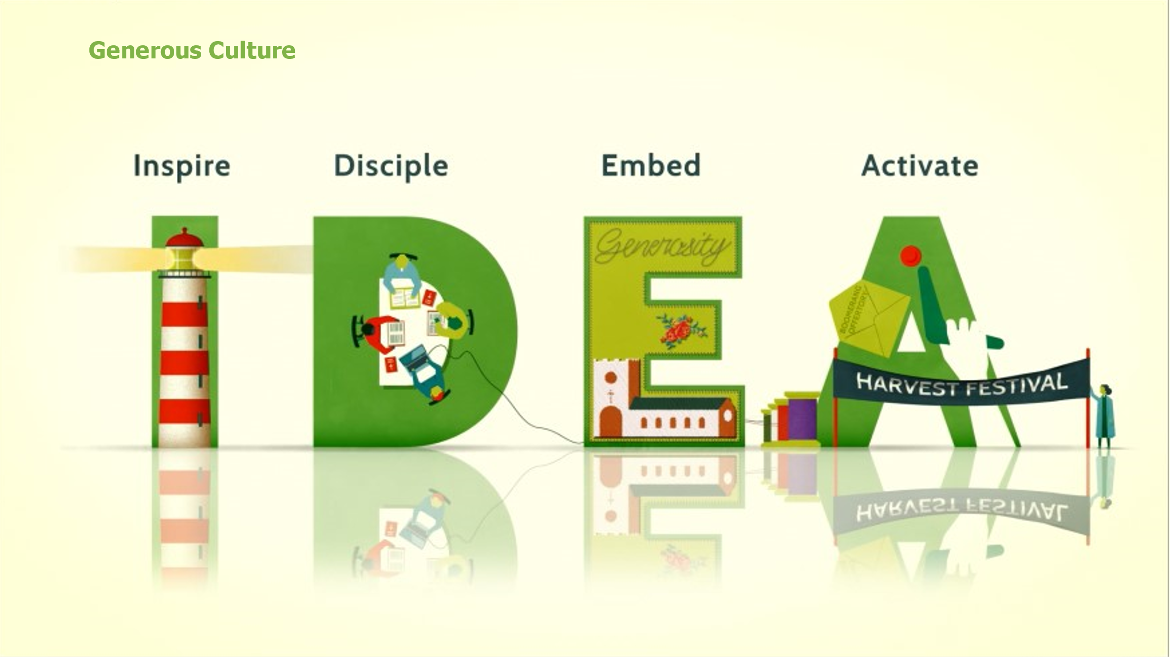 | As a church we also need to encourage generosity whenever we can by cultivating a culture of generosity. When we grow in understanding of the generosity of the God who loves us, we are transformed to live generously in response to it. There are four ways to enable this culture and we can remember them through the acronym IDEA.
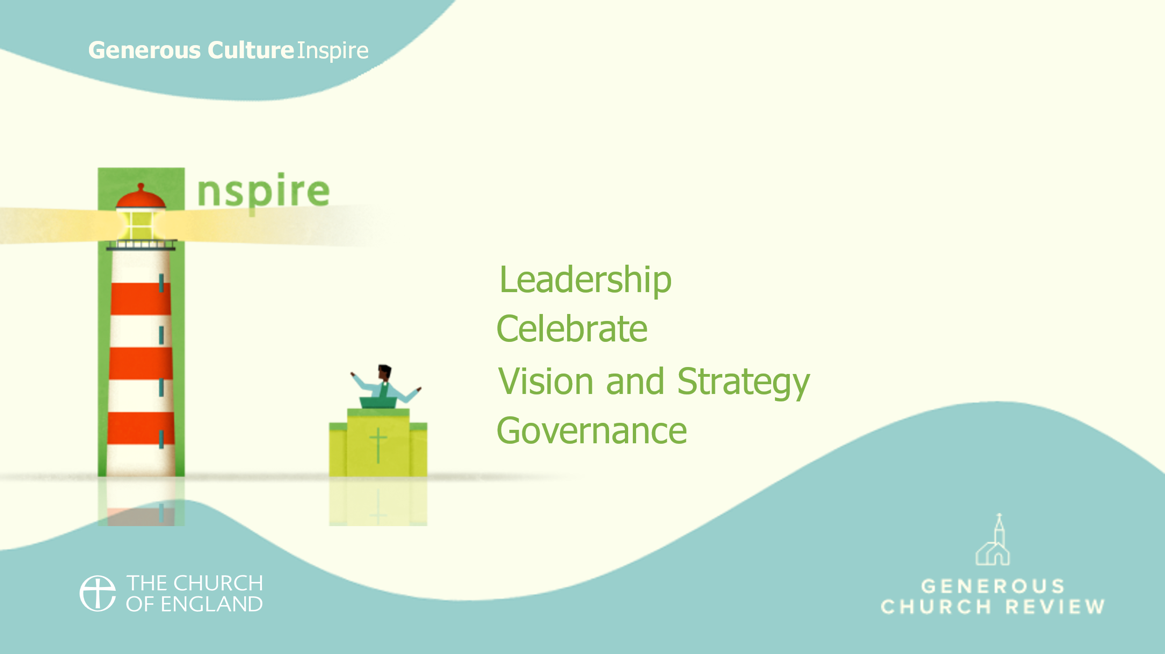 | Leaders need to inspire people to give, and to model generous lives.
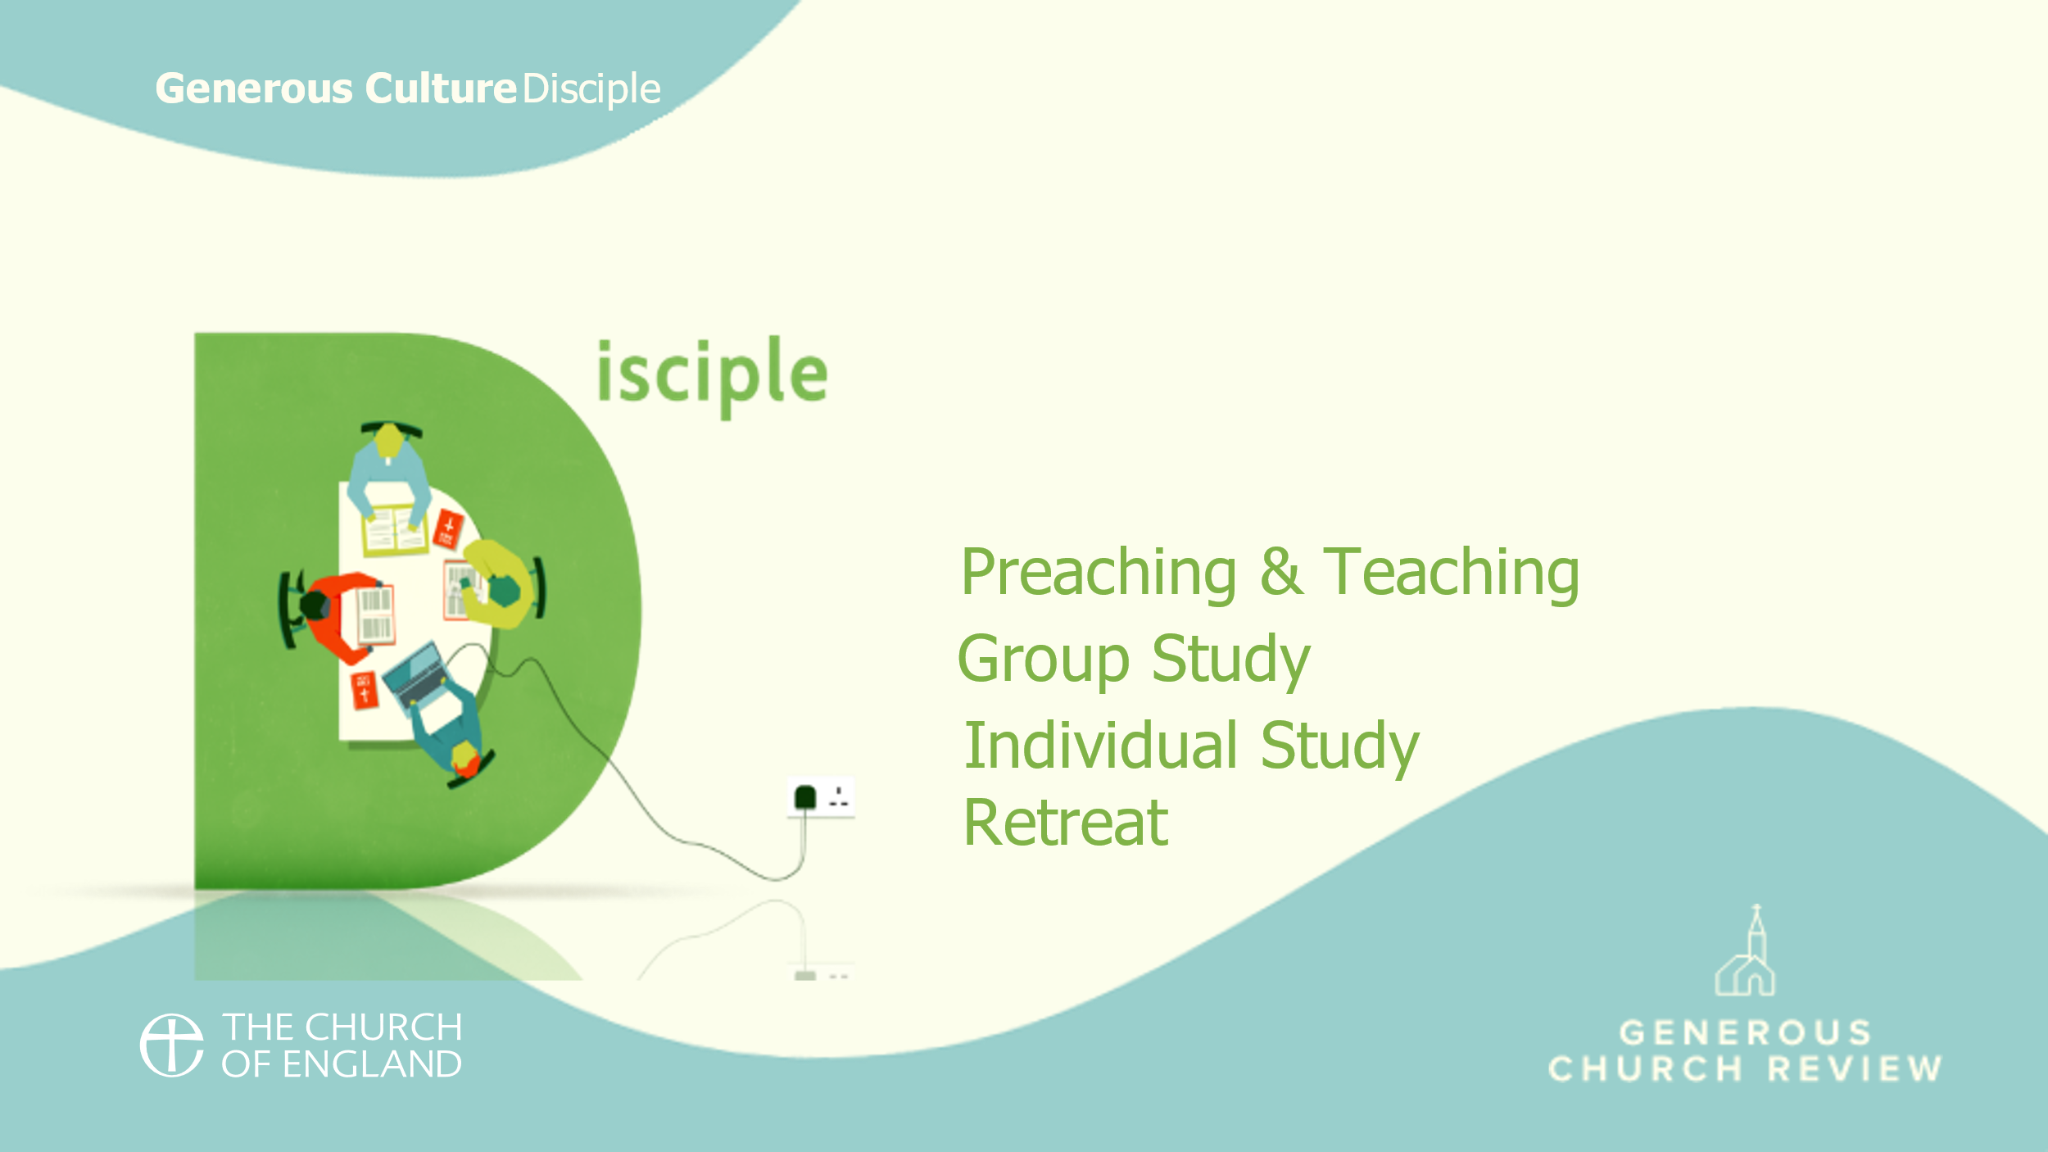 | We need to give people the opportunity to learn and reflect on what it means to live generously as a core part of their discipleship.
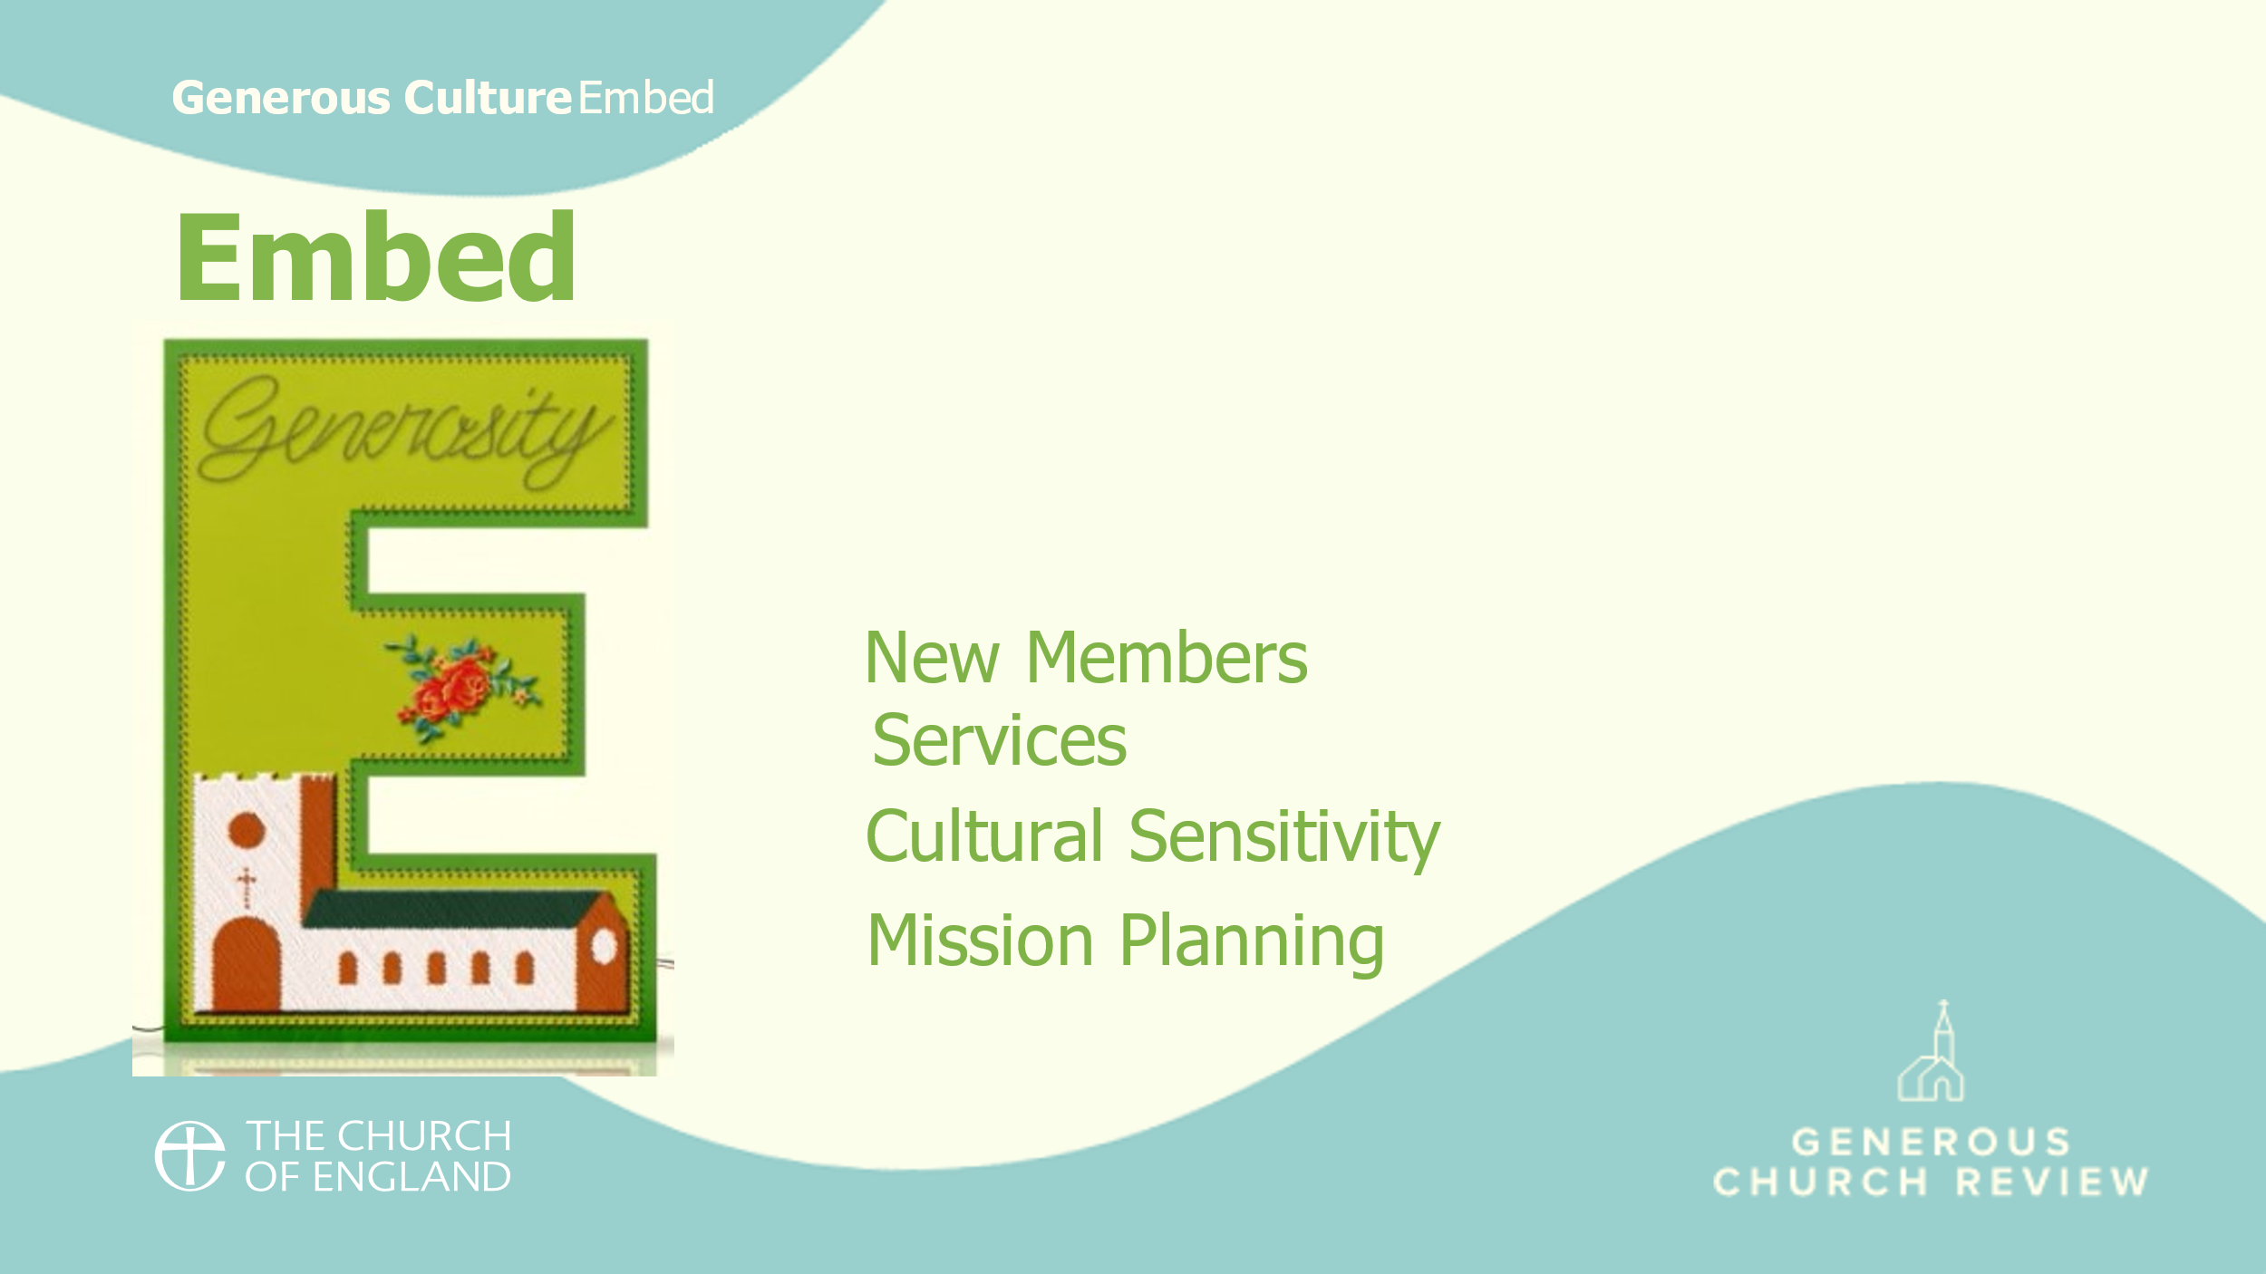 | We need to embed generosity in our plans, our services, and our wider provision and make it a part of all we do.
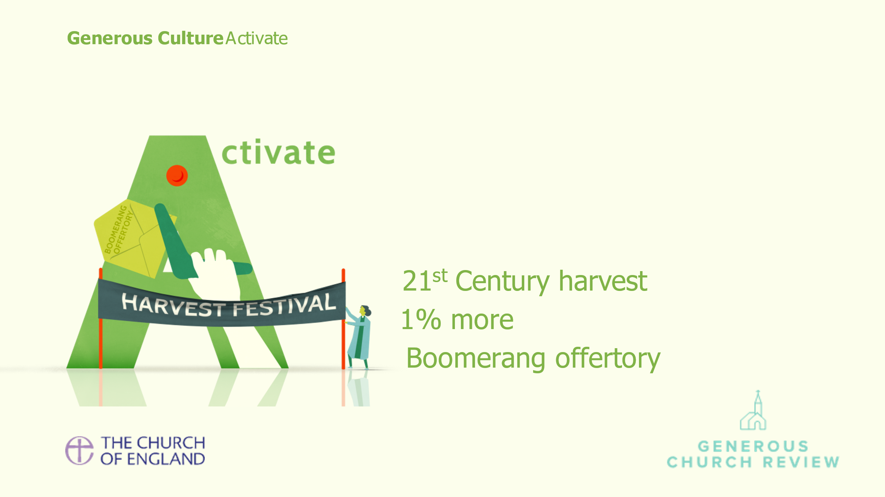 | And we must enable people to activate their generosity by providing programmes and activities that give people the opportunity to grow in their generosity.
I’m now handing out eight cards. Each of the 8 cards covers one aspect of giving practice and generous culture.
Each card will take you through a process of appreciative inquiry. This technique encourages personal reflection by asking a series of positive questions that help leaders to explore what they are doing well and what changes could be made to achieve their vision for the future.

Each card has 5 steps to read and discuss:
Define - What does this mean?
Discern - What is God calling us to?
Discuss - What is our experience?
Discover - What are we doing well?
Dream - What else could we do?

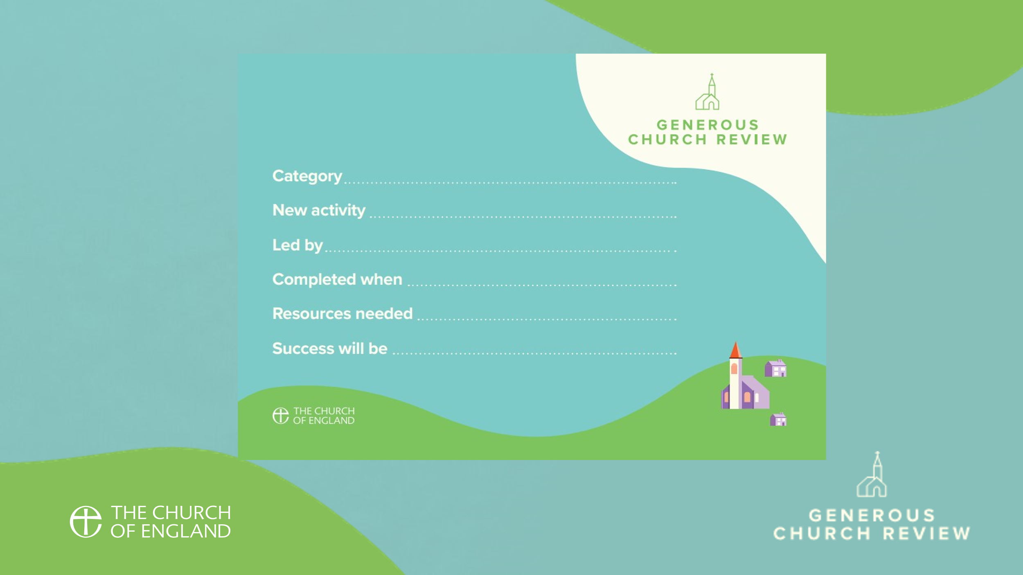 | At the end of the session, once you have been through all the cards, you’ll be given different cards on which you can list one or two actions for each MINT and IDEA building block, so that you have concrete plans to take forward. These will be assigned to an individual or group who will have overall responsibility. Actions should be realistic and achievable.  Together, the group should agree:  - An action or new activity for each of the 8 MINT/IDEA building blocks  - Who will be responsible for leading this action  - When this action will be completed by  - What success will look like
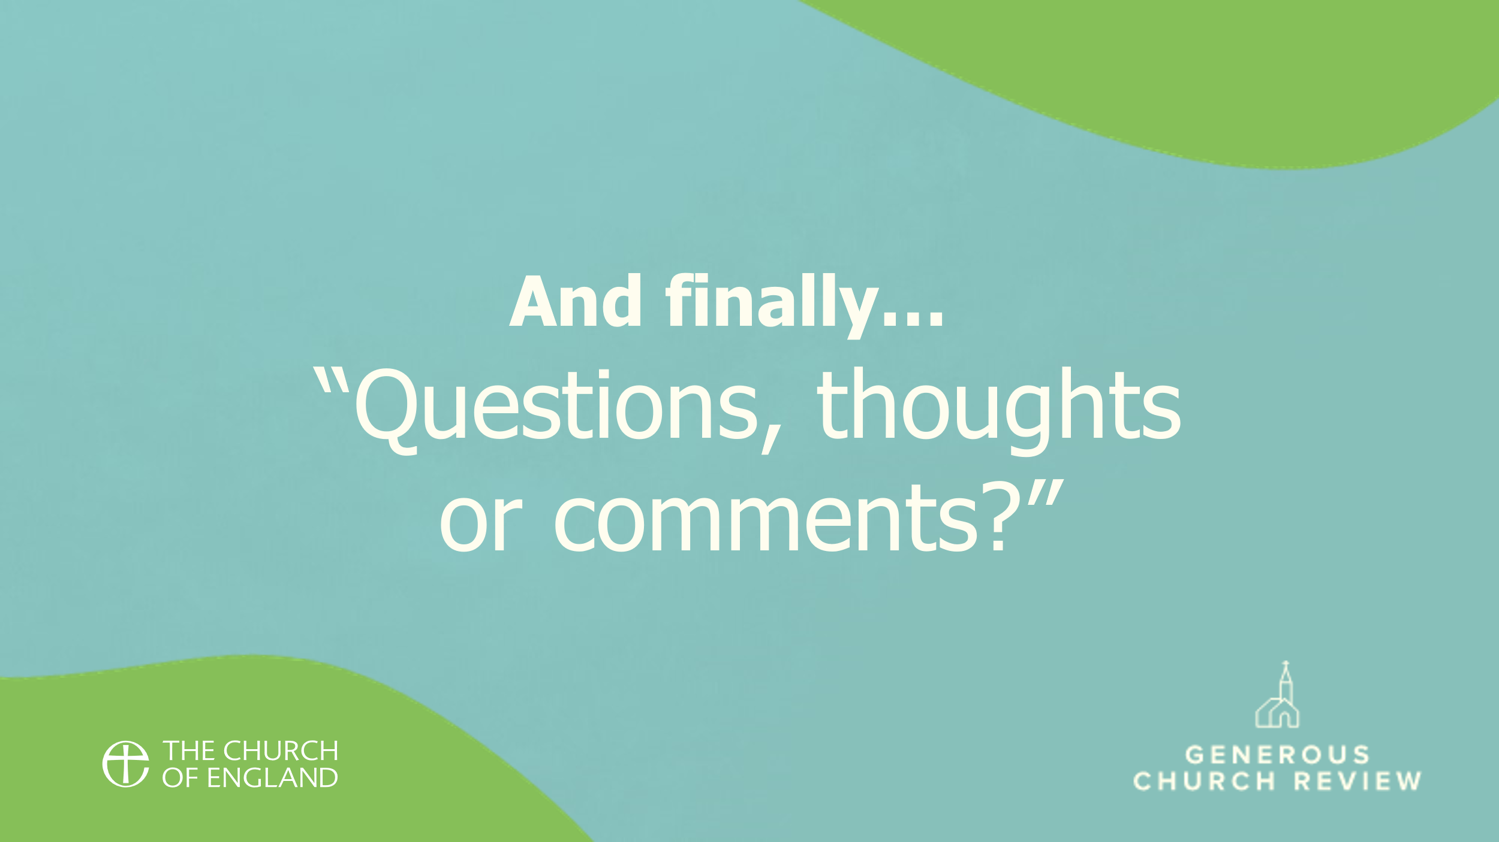 | To wrap up the session, conclude by sharing some key points about living as a generous disciple, such as:  We believe in a generous God, a God who gave up everything for us and gave us everything we could ever need.  We are called by God to use the gifts He has given us to fulfil His mission and ministry within this community.  Generosity takes many forms. We can give of our time, talents and material possessions.  Allow time for thoughts and questions.
 | End by standing together and saying the Grace.

