Myths, Miracles, Mysteries, Mission – following the Saints
Introduction

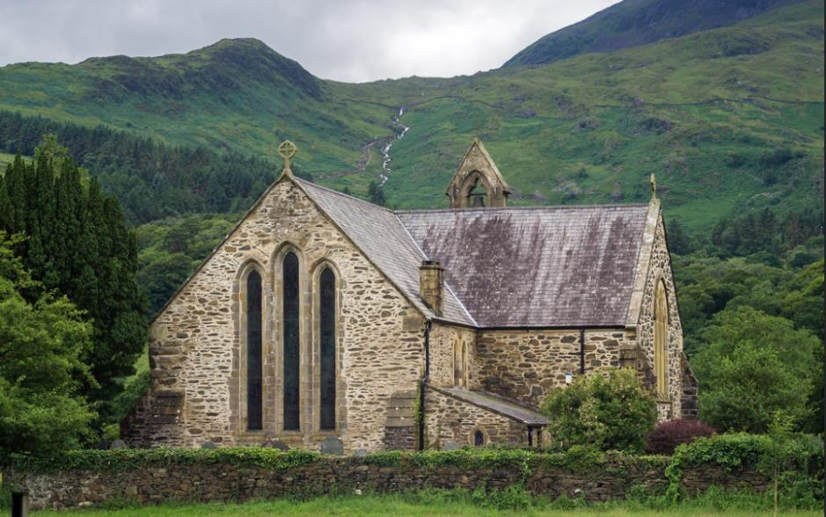
Adam Court/flickr St Mary’s Church, Beddgelert, Wales, UK
Have you ever walked past a church and noticed that its name is that of a saint? And have you ever wondered why so many churches seem to be called after saints?
By the fourth century, it began to be the practice to dedicate new churches to a ‘patron’ saint. Images of that person were often displayed in the churches and the name of the saint would be displayed. Today, many churches are dedicated to all kinds of saints, but some Christian denominations now do not use them to dedicate their buildings.
The Christian creeds, our statements of what we believe, say that ‘we believe in the communion of saints’, - holy women and men who have been faithful followers of Jesus Christ and who have often lost their lives through persecution of the Christian faith. Some Christian denominations recognise saints ‘days’ in the Christian calendar when particular saints are especially remembered and churches dedicated to particular saints hold special services, ‘patronal festivals’, on those particular days. Across the world, some of these dates are very well known outside the Church, such as St Valentine’s Day on February 14th or the St Patrick’s Day celebrations on March 17th.
Some saints are said to be ‘patron saints’ of particular groups of people, sometimes because of some event or legend about their own story. In the UK there are four ‘nation’ saints, St George for England, St David for Wales, St Patrick for Ireland, and St Andrew for Scotland.
This set of sixteen resources is designed to offer you a range of ways of finding out more about a saint called St David (Dewi), the patron saint of Wales and finding out about the mission, myths, miracles, and mysteries associated with him and to ask how we understand these things today.
There are four ‘pathways’ for you to follow, and you can mix and match them if you like. They are:
YELLOW JOURNEY – word-based resources for people who like to read information, talk about things and consider questions, perhaps in a study group. The Yellow Journey also guides you through the best information we have (eg the Bible for biblical saints) moving on to how we learn from, evaluate and use other traditions about the saints.
BLUE JOURNEY – for people who like to engage with Scripture, use prayers, and use Christian reflections. The Blue Journey also begins from the best information we have (eg the Bible) through to prayers and traditions associated with particular saints.
GREEN JOURNEY – image and activity based for people who like to explore, create, look at images and get out and about. The Green Journey also delves into things like the traditions of saints around the world, seeing them through the eyes of other Christians.
PINK JOURNEY – for people who want to explore Christian faith more deeply, find out more about following Jesus, and using the ‘lens’ of the saints to create opportunities for thinking about how we live our lives.
Another way to mix and match the resources is to follow the information across the four journeys about the person first and as much factual material as is available, then think about the mission of that person and where and how that was recorded, then move on to the miracles associated with that person and finally the mystery of the saints and what their stories might mean for us today.
You can use these resources whether you are a Christian or not, as an individual study or in a group of friends.

This grid shows you the range of the resources for St David and how you can mix them:

 | The Man | The Mission | The Miracles | The Mystery
Yellow Journey | David – the stag, the fish and the swarm of bees | David as Pilgrim and Evangelist | The rising hill | Filled with angels
Blue Journey | Mary’s Song of Praise | Love one another | Jairus’ daughter | Elijah goes to heaven
Green Journey | Seeing David | Dedication to Christ | The Resurrection of the child and healing blindness | 1st March: a nation saint
Pink Journey | David the Water-drinker | Do the Little Things | The coming of the dove | Death Tapers

The Man: David (Dewi in Welsh)
The Stag, the Fish and the Swarm of Bees

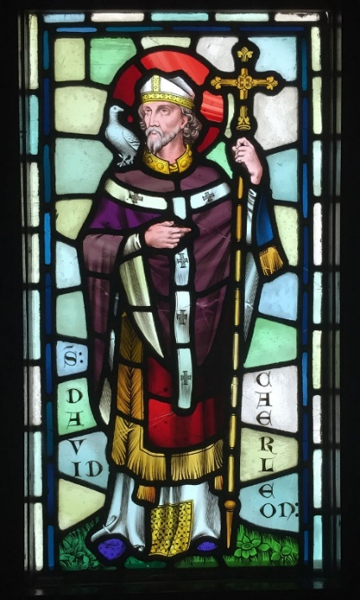
By Hchc2009 - Own work, CC BY-SA 4.0, https://commons.wikimedia.org/w/index.php?curid=43152858

Most of the information about St David comes from an account by a person called Rhygyfarch (1057-1099) whose Life of St David contains the story of his life and the miracles surrounding him. Other saints’ lives also recall those saints encountering St David, so there is other evidence in those accounts for his existence and for the stories about him. Hard facts about St David are rather difficult to find, but it is likely he was alive around 500 years after Christ. He was born in Wales, perhaps in what is today Ceredigion or Dyfed, and is said to have died on 1st March which is today kept as St David’s day. He was a monk who was renowned for preaching and teaching the gospel, refuting beliefs such as Pelagianism (which denied fundamental Christian doctrines about sin and salvation), and for his strict and ascetic rule of life. However, he was active in founding monastic communities and, according to Rhygyfarch, founded the abbeys at Glastonbury, Bath and Leominster among others. St David’s shrine is at St David’s cathedral in Pembrokeshire. The shrine was restored and rededicated in 2012.
According to the tradition, St David’s mother was also a member of religious order, St Non. Strictly celibate, she is said to have met Sant, the king of Ceredigion, who then ‘took by force and violated’ Non who conceived David as a result of this attack.
Rhygyfarch surrounds these basic facts about St David with portents and mysteries. For example, his father, and St Patrick, are supposed to have had revelations about his spiritual importance in dreams. In the dream, some mystical gifts were found by a river, - a hunted stag, a fish and a swarm of bees. The stag is supposed to represent the power of good over evil (since deer were thought to trample on snakes and a serpent was supposed to have been the voice of evil in the Garden of Eden). So David would also bring goodness into the world. The fish was supposed to represent David’s ascetism. Since fish only drink water, so David would only drink water. Finally, the honeycomb of the bees was supposed to represent wisdom – the wisdom of religious teaching which David would bring to the people in following Christ. The dream, then, offered a series of metaphors for David’s life. Some people think Rhygyfarch might have been (deliberately?) misinterpreting another meaning to these things, which is that the animal, fish and insect represent rule over land. So David would be born to represent territory as over against the claims of others: he would be indisputably Welsh and stand against the interference of others in Welsh affairs.
What this means for us today
Rhygyfarch also introduces some details which make St David sound rather like Jesus. St Gildas, for example, says that David is greater than him, sounding rather like John the Baptist. And a tyrant who wants to kill David is thwarted by great stones keeping his mother hidden (rather like Herod). Similarly, Rhygyfarch says that when St David was baptised, a healing fountain burst forth, and that as he began to grow up as a Christian, a dove with a gold beak appeared to teach him the faith and teaching him to sing hymns. This sounds a little bit like the baptism of Jesus.
These echoes of Jesus in David’s story can remind us to go back to the gospels. The lives of the saints can signpost back to Christ and remind us that we stand in a great tradition of people who have tried to follow Jesus and live according to his teaching.
Some questions to think or talk about:
- Rhygyfarch was at pains to show that St David was a special and holy person. What do you think are the hallmarks today of a ‘holy’ person or a person who sincerely tries to follow Christ in their lives?
- If you were to choose three things to represent your life what would you choose and what might those things represent?
- Rhygyfarch was also at pains to remind his readers of stories about Jesus. How would this help his readers imagine St David?
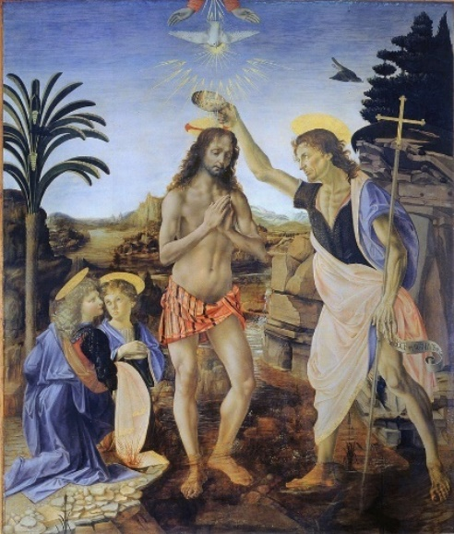
Verrocchio, Leonardo da Vinci - Battesimo di Cristo - Google Art Project.jpg:, Public Domain, https://commons.wikimedia.org/w/index.php?curid=64292521

The Mission: David as Pilgrim and Evangelist

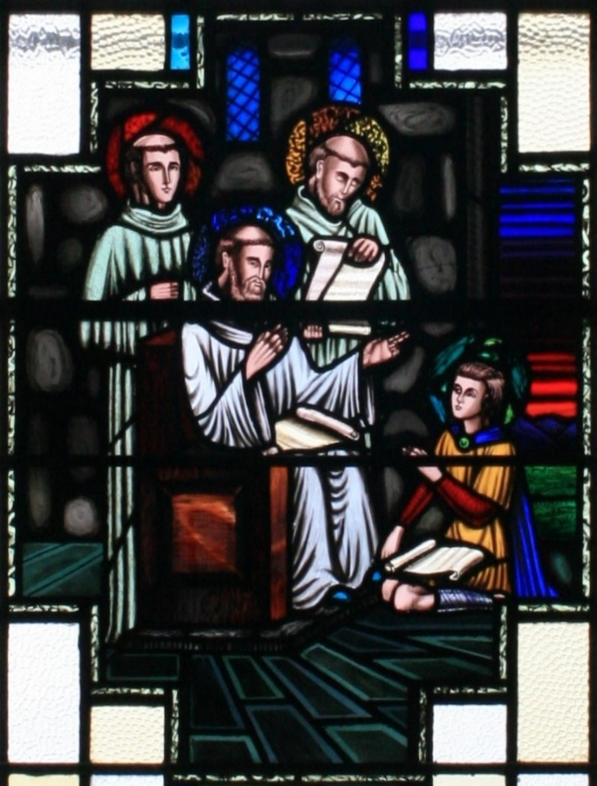
By Andreas F. Borchert, CC BY-SA 4.0, https://commons.wikimedia.org/w/index.php?curid=2795226
Rhygyfarch’s Life of St David tells us that St David was renowned as a preacher, a teacher and a healer. He also went on an important pilgrimage to Jerusalem:
Saint David, making no delay, settled what was necessary for the monastery, received the blessing of the brethren, and started on his way early in the morning. He arrives at the appointed place, finds there the promised brethren, and together they enter on the journey. Their pilgrimage is on terms of equality, for none in mind is prior to another, each of them being servant, each being master. They persevere in prayer, and water the way with tears. The further the foot proceeded, the reward increased, they being one as to their mind, one in joy, one in sorrow. When they had sailed over the Britannic sea and were come into the Gauls and were hearing the strange languages of diverse nations, father David was endowed with the gift of tongues like that apostolic gathering of old, lest when in need among foreign peoples they might want an interpreter, and also that they might confirm the faith of others with the word of truth. At length they arrive at the confines of the desired city, Jerusalem.
Rhygyfarch is at pains to show David as being Christ-like as well as a Christ-follower, gathering around him a company of disciples and going forth to share the gospel with others. He models the principle of equality and service which Jesus pressed on his own disciples when he washed their feet and asked them to love one another. Encountering other people in Europe, on his way to Jerusalem, the Holy City, David is endowed with the gift of speaking other languages as happened on the Day of Pentecost.
When David arrives in Jerusalem he is welcomed with joy. An angel is supposed to have come to the Patriarch of Jerusalem in a dream to tell of David’s arrival with his friends and to ask the Patriarch to receive them with joy and give them special places. In addition, David is to be made an Archbishop.
Following this, David goes out and about in Jerusalem, preaching and teaching and converting many people there to the Christian faith.
When they leave, the Patriarch offers David gifts symbolising his priesthood and place in the Church – an altar, a mystical bell, a bishop’s staff and a priest’s garment. Being too difficult to carry, an angel sends them back to the monastery in Wales. All of these things are proclaimed to enable miracles.
What this means for us today
While we learn from stories about St David that he was a founder of monasteries and of a monastic way of life, we also learn that he and his followers went out into the world to spread the gospel. But it is not just a matter of what is said in telling others about Jesus, but also what happens in Christian witness about how we live and show care and compassion to others. David is given great gifts as a priest, and an archbishop, but these gifts are not about his aggrandisement but miracle-workers to give help and care to others. The story is about how power, status and leadership need to be modulated through following the example of Jesus. If people cannot see Jesus when they encounter us, then we have let our power and status get in the way.
Some things to think or talk about:
- Contemporary forms of pilgrimage are becoming more popular. Why do you think that is?
- On his journey, St David shows what it means to life out a life which reflects Jesus. How could we do better at doing the same?
- How might preaching, teaching and healing those in need be related to one another?
- What comes to mind when you think of the ‘gifts’ given to St David?

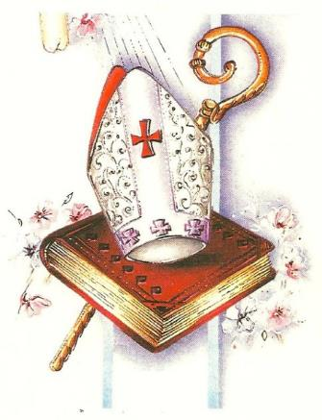Nathan Hughes Hamilton/flickr

The Miracles: The Rising Hill
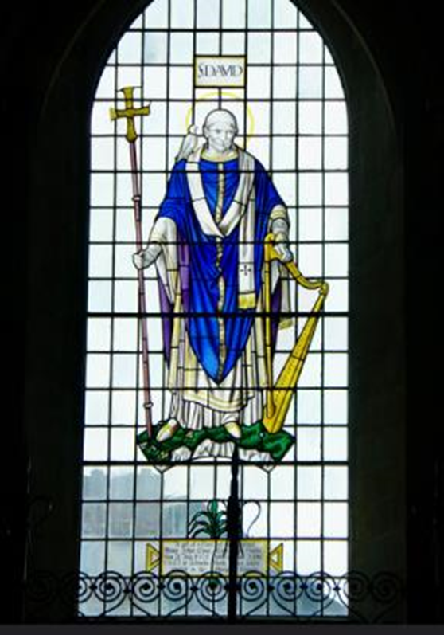
David Merrett/flickr
The most famous miracle associated with St David is the rising up of a hill beneath his feet so that all might both see him and hear him speak. Rhygyfarch says:
‘Then he enters the synod. The company of bishops rejoices. The people are glad. The whole army exults. He is asked to preach. He rejects not the wish of the council. They bid him mount the pile of garments, but he refused. So he orders the boy newly raised from the dead to spread his handkerchief under his feet. On this he stands, and expounded the gospel and the law as from a trumpet. In the presence of all a snow-white pigeon, sent from heaven, settled on his shoulders, which remained as long as he preached. While he was holding forth in a voice clear to all, both to those nearest to him and equally to those who were far off, the ground beneath him swells upwards and is raised into a hill. Placed on the top he is seen by all, so that standing on a high hill he might lift his voice like a trumpet. On the top of this hill a church is situated. The heresy is expelled. The faith is confirmed in sound hearts. All are in agreement. They pay thanks to God and to Saint David.’
https://archive.org/stream/MN5136ucmf_5/MN5136ucmf_5_djvu.txt
In the illustration, you can see the dove on David’s shoulder, and the hill arching up under his feet.
This miracle is associated with David’s attendance at a synod of the church around the year 550 at Brefi. Today, Llanddewi Brefi is said to stand on the location of the miraculous hill. The heresy referred to in Rhygyfarch’s account was Pelagianism, which challenged prevailing beliefs about sin. As a result of his eloquence and persuasiveness, David was then proclaimed Archbishop.

What this means for us today
The story of St David and the rising hill, can remind us that church leaders are called to preach the gospel and teach about Jesus. We are all called to share our faith with others, but preaching is a special skill. Some preachers go out on the streets or into open spaces, but many church services have a sermon, or homily, in which the church leader reflects on Scripture or invites the people in church to think about how the Christian faith has a direct relevance to the way we engage with the world today. Some sermons invite people to deeper and stronger faith and attention to prayer; others may be a call to action, to love neighbours more or to make change happen in the world. Some sermons may be about love, fellowship and joy; others may offer lament, or seek to bring comfort and reassurance. Sometimes a preacher will warn of assaults on Christian faith and encourage people to stand firm in their own faith against those who might want to damage or destroy it. Many sermons conclude by bringing the congregation back to the significance of worship, being together as a Christian family and what is to happen in the rest of the service. Many traditional churches have pulpits, raised speaking platforms where the church leader can be easily seen by everyone in the church, a bit like David, except that he had a hill for a pulpit!
The story might also remind us of what it might feel like to be a preacher addressing a lot of people. How do you engage a crowd of people? How do you ensure they can see and hear you? What about people who cannot see, or hear, or who end up pushed out or are excluded?
Some things to think or talk about:
- What do you think this story tells us about the importance of preaching and teaching the Christian faith?
- Can you think of a sermon that particularly inspired you? What was it about?
- What do think the appearance of the dove settling on David’s shoulder meant?

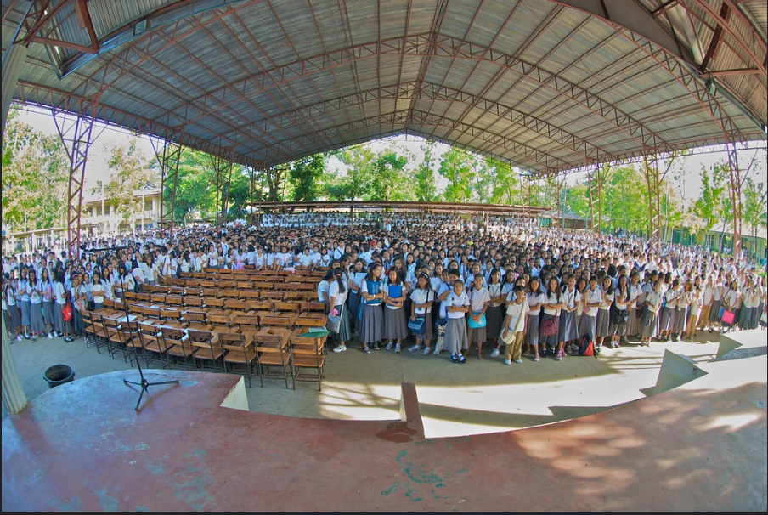
Moyerphotos/flickr Preaching to 5000 students
The Mystery – Filled with Angels

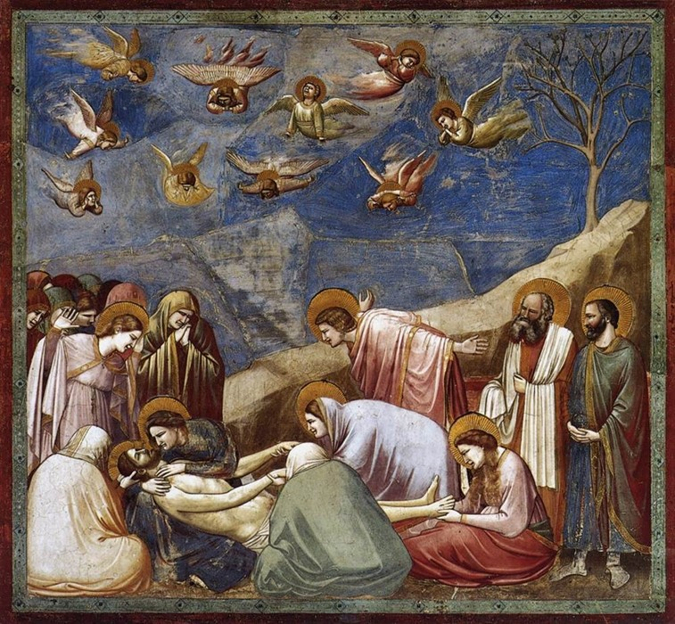
Giotto, The Mourning of Christ

Rhygyfarch says that when St David was about to die, the monastery was filled with angels.
And so when the third day of the week was come, at cock crowing the monastery is filled with angelic choirs, and is melodious with heavenly songs, and is full of sweetest fragrance. At the hour of matins, when the clerks were replying to the songs with psalms and hymns, the Lord Jesus deigned to bestow his presence for the consolation of the father, as he had promised by the angel. When he saw him, he altogether rejoiced in spirit. ‘Take me,’ said he, ‘after thee.’ With these words he gave back his life to God, Christ being his companion, and accompanied by the angelic host he went to the abodes of Heaven.
The angels are heard in music and apparent to those round about by a sweet scent as the worlds of earth and heaven seem to mingle. At last Jesus arrives to take David home and David is glad to die.

What this means for us today
In his poem, To an Old Philosopher in Rome, the American poet Wallace Stevens imagines a person at the end of his life and about to die. Gradually, very ordinary things, fluttering banners, the sound of bells, newsboys in the street, the smell of medicine, become transformed into a vision of heaven, a threshold on which to pause and reflect on life, say goodbye to it, and then step over into death and the life to come.
The account of St David’s death is rather like this. In fact many people report seeing Jesus or loved ones just before they die. Families also often say that the dying person seems to be living in two worlds and might be visited by people from their past who are more than just memories, but a preparation for what is to come.
These experiences are very mysterious, but when they occur they may seem to be particularly comforting and peaceful. So what the story of St David teaches us here, is to think about what we believe about ‘the life everlasting’ and be ever ready for glimpses of the heavenly realm in our ordinary lives.
Some things to talk and think about:
- Many people today believe that they have supernatural encounters like this or have met Jesus in this way. Have you ever encountered an angel yourself? Or, what might such an encounter be like?
- Rhygyfarch seems to be implying that although the death of a holy person like David was a sad occasion, it was also a ‘good death’. How does this story speak of hope and the promises of the Christian faith concerning the end of life?
- David dies surrounded by his community, all those who loved him, and enveloped by prayer and singing, amplified by the heavenly host. What do we learn about the things we need at the end of our lives, the things which enable us to ‘let go’?
- This is a profoundly mysterious event. In today’s world, have we lost some of the mystery of what it means to live and die in the presence of God? What kinds of things stop us from pondering the mystery of life and death?

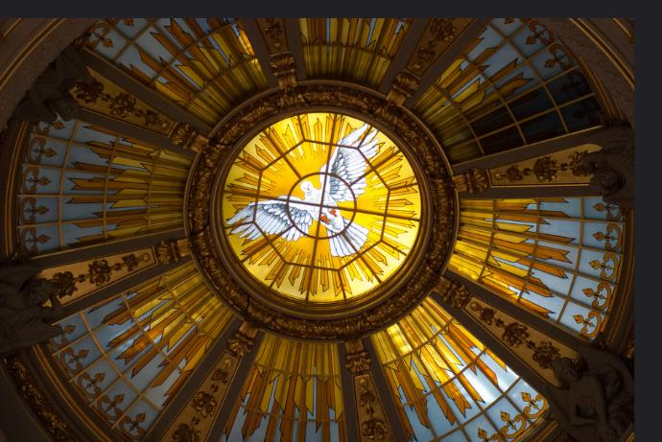
Thomas Quine/flickr
The Man, David: Mary gives thanks to God for her child

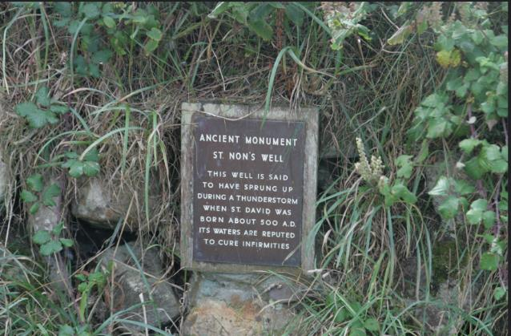
Odd Wellies/flickr
The site of St David’s birth is shown by the ruins of an ancient chapel close to a holy well (see above). There is also an 18th century chapel dedicated to his mother Non which can be seen near St. David’s Cathedral. St David’s birth is said to have taken place in a huge thunderstorm and the stones curved over to protect his mother, who was about to give birth to the special child, protecting him from a murderous tyrant who had a heard a prophecy that a child would be born who would have great power.
And Mary said,
‘My soul magnifies the Lord,
and my spirit rejoices in God my Saviour,
for he has looked with favour on the lowliness of his servant.
Surely, from now on all generations will call me blessed;
for the Mighty One has done great things for me,
and holy is his name.
His mercy is for those who fear him
from generation to generation.
He has shown strength with his arm;
he has scattered the proud in the thoughts of their hearts.
He has brought down the powerful from their thrones,
and lifted up the lowly;
he has filled the hungry with good things,
and sent the rich away empty.
He has helped his servant Israel,
in remembrance of his mercy,
according to the promise he made to our ancestors,
to Abraham and to his descendants for ever.’
Luke 1.46-55

Some questions to think about:
- St David’s mother, St Non, was a virgin, forcibly taken, who then became pregnant and gave birth to a son. How does this story both echo, and differ from, the story of Jesus’s birth?
- When the birth takes place, the natural world responds to protect mother and child. What echoes of the birth of Jesus can you also see in that story?
- How do you think the story of St David’s conception and birth reflects on modern concerns about pregnancy, violence against women and the need to protect vulnerable women and their children?
- Mary’s song of joy at the birth of her child is full of thanks and gratitude to God for the gift of her child, Jesus, yet being the mother of Jesus was also full of anxiety, and grief. What do you think it was like in those days for St Non to care for her son David, as he grew up? What modern joys and worries do parents feel about their children today?

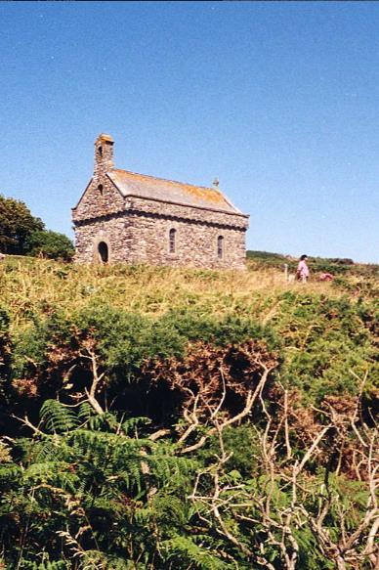
John W. Schulze/flickr
The Mission: Love One Another

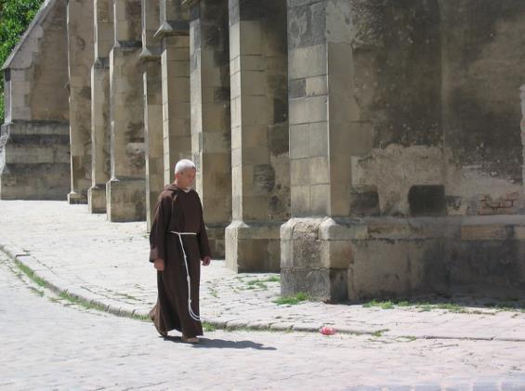
Karaian/flickr

I give you a new commandment, that you love one another. Just as I have loved you, you also should love one another. By this everyone will know that you are my disciples, if you have love for one another.’
John 13.34-35
For he founded twelve monasteries to the praise of God : first, arriving at Glastonbury, he built a church there ; then he came to Bath, and there causing deadly water to become salutary with a blessing, he endowed it with perpetual heat, rendering it fit for people to bathe; afterwards he came to Croyland, and Repton ; thence to Colva, and Glascwm, and he had with him a two-headed altar; after that he founded the monastery of Leominster ; afterwards in the region of Gwent, in a place which is called Raglan, he built a church; then he founded a monastery in a place which is called Llan Gyvelach, in the region of Gower, in which, afterwards, he received the altar, which was sent to him.
One of the particular features of St David’s life is that he spent his time founding and building up monasteries and monastic life. His mission was to create communities of love and service, constantly teaching his fellow monks and helping them to follow Christ while living under the discipline of monastic rule.
Some questions to think about:
- Why do you think so many people today searching for roots for their spirituality, turn to forms of monastic community and discipline?
- Why do you think it was important for St David’s monastic communities to build churches? What is the significance of your church building to your wider community?
- Today there are many monks and nuns who have significant following, either through social media, or through online spaces where they post thoughts and reflections. How many do you know about, or maybe follow? Why do you think non-Christians also seek out monks and nuns to follow?
- Why do you think so many missionary saints understood their mission in terms of establishing rooted communities of prayer and service to others? What could we learn from this way of doing mission?
- The figure of Christ on the Cross below, comes from a modern monastery, which has a traditional herb garden but also a spa and wellness centre for pilgrims. Christ folds arms in an embrace to show welcome and care for all, gathering the world to himself. If you were to found a monastery today, what would you put in it to attract others and to show Christ’s love and care to all?

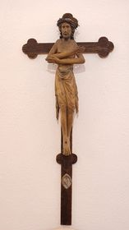
Photo: Anne Richards

The Miracles: Jairus’s Daughter

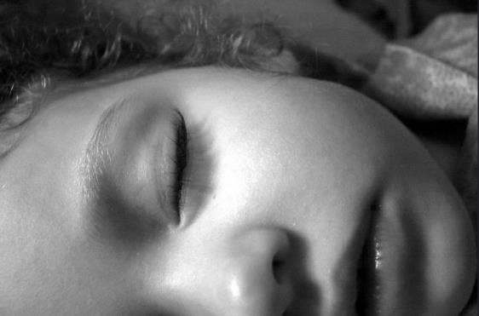
Tempophage/flickr
When they came to the house of the leader of the synagogue, he saw a commotion, people weeping and wailing loudly. When he had entered, he said to them, ‘Why do you make a commotion and weep? The child is not dead but sleeping.’ And they laughed at him. Then he put them all outside, and took the child’s father and mother and those who were with him, and went in where the child was. He took her by the hand and said to her, ‘Talitha cum’, which means, ‘Little girl, get up!’ And immediately the girl got up and began to walk about (she was twelve years of age). At this they were overcome with amazement. He strictly ordered them that no one should know this, and told them to give her something to eat.
Mark 5.38-43
The man of God, having compassion on human weakness, went near to the body of the deceased, and watered the face with tears, and threw himself on the body of .the dead, and prayed to the Lord, and said, " O Lord, my God, who didst descend into this world for us sinners from the bosom of the Father to redeem us from the jaws of the old enemy, have pity on this widow, and restore life to her only son, and breathe into him the breath of life, that Thy name may be magnified in all the earth." Then the limbs became warm, the soul returned, the body stirred. And taking the boy's hand, he restored him alive and well to his mother.
In the stories of the saints, one of the hallmarks of living a holy life dedicated utterly to God is to show Christ through miraculous healing or even raising people from death to life. In recounting these stories, the writers not only wanted to attest to the spiritual powers of the saints, but recall the miracles of Jesus to their listeners and readers.

Some questions to think and talk about:
- What similarities and differences can you see in the story of Jairus’s daughter and the story of St David and the widow’s son?
- What other biblical story of raising to life might the St David story of healing the widow’s son remind you of?
- The miracles are intended to glorify God and provide powerful witness of God’s love and compassion. What do you suppose the family of Jairus’s daughter and the widow in the St David story did next?
- Today, when people ‘pray for a miracle’, what do you think happens?
- It is a tremendously worrying time when our children fall sick. Who do we most trust to help us through the worry when we feel helpless and alone?
- How good are we at giving thanks and spreading the gospel when God works wonderful things in our own lives?

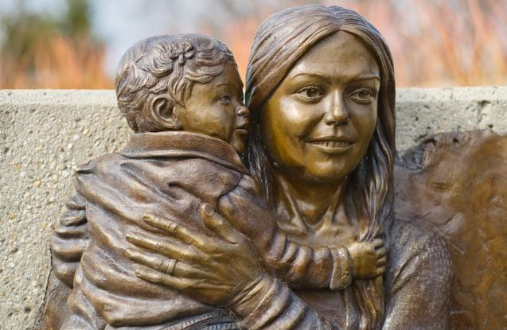
Chris Rycroft/flickr

The Mystery: Elijah is taken to heaven

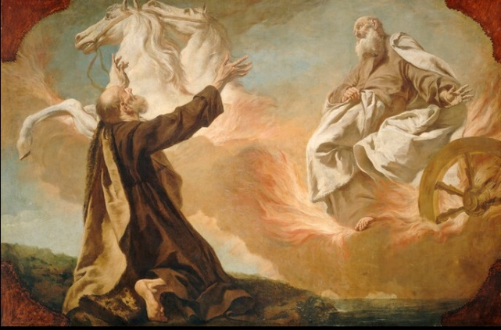
Guiseppe Angeli, public domain
2 Kings 2. 9-12
Elijah said to Elisha, ‘Tell me what I may do for you, before I am taken from you.’ Elisha said, ‘Please let me inherit a double share of your spirit.’ 10 He responded, ‘You have asked a hard thing; yet, if you see me as I am being taken from you, it will be granted you; if not, it will not.’ 11 As they continued walking and talking, a chariot of fire and horses of fire separated the two of them, and Elijah ascended in a whirlwind into heaven. 12 Elisha kept watching and crying out, ‘Father, father! The chariots of Israel and its horsemen!’ But when he could no longer see him, he grasped his own clothes and tore them in two pieces.
And so when the third day of the week was come, at cock crowing the monastery is filled with angelic choirs, and is melodious with heavenly songs, and is full of sweetest fragrance. At the hour of matins, when the clerks were replying to the songs with psalms and hymns, the Lord Jesus deigned to bestow his presence for the consolation of the father, as he had promised by the angel. When he saw him, he altogether rejoiced in spirit. "Take me," said he, "after thee." With these words he gave back his life to God, Christ being his companion, and accompanied by the angelic host he went to the abodes of Heaven.
According to Rhygyfarch, St David had a stormy and tempestuous birth and a joyful death accompanied by angels into heaven with supernatural music and fragrance. In Scripture too, Elijah’s end is described as mysterious and extraordinary as he is taken to heaven in a fiery chariot. Living a holy life seems to entwine heaven and earth together at the end, as the person transitions from this life to the next.
Some things to talk and think about:
- What do we learn from these holy deaths about preparation and readiness for death?
- Elisha saw ‘the chariots of Israel and its horsemen’; St David saw Jesus. All kinds of people, not just believers, experience unusual sights, sounds and scents when they, or people they love, are near death. How might such experiences help people with faith and help them form ideas about what happens when we die?
- How do these stories help us think about the mystery of our life with Christ beyond our death?
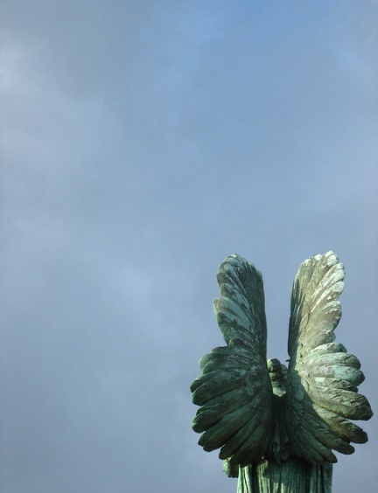
Jeremy Keith/flickr
A Prayer
Lord Jesus Christ,
We thank you for the example of holy women and men
Who have kept the faith and witnessed to others that they might believe.
Watch over all who seek to serve you,
And over all who are persecuted and die for your name’s sake.

We thank you for the mystery of grace and miracles of healing,
We ask your blessing on all who seek you
That they might meet you through prophets in places of injustice;

Through your loving invitation and call to serve you;
At places where people come for healing and salvation;
At places where all hope seems lost.
Amen
The Man: Seeing David
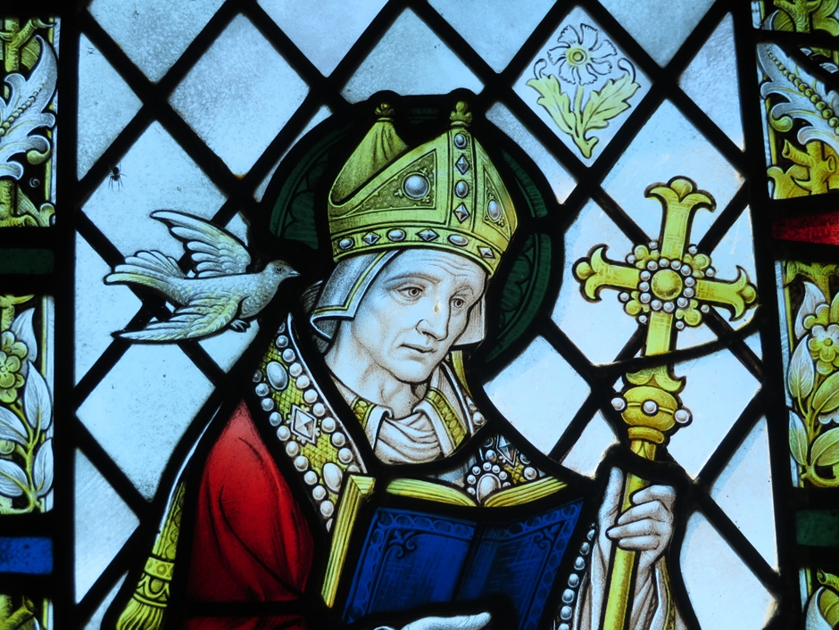
By Llywelyn2000 - Own work, CC BY-SA 4.0, https://commons.wikimedia.org/w/index.php?curid=106639347
Writing about the saints is called hagiography – a way of presenting holy women and men as marvellous individuals for all their human faults, who can be sources of inspiration to Christians as they follow Jesus Christ in their daily lives.
Also important are the traditions of art and representation. Saints are often portrayed with items relating to their stories and to their Christian witness, which provides a way of finding out about them without words. This is a tradition which may feel unfamiliar, but it can be very rewarding just using our eyes and think about what the colours, shapes and symbols mean. Many people are drawn to, and love looking at, stained-glass in churches, for example.
In this stained-glass representation, St David is dressed as a bishop. He wears a mitre on his head and carries a staff with a cross on top of it. His clothes are richly decorated, indicating his status and importance. He is pictured reading a book, perhaps the Bible, indicating his wisdom and learning. The dove at his shoulder recalls the dove which was said in legend to have taught him, but also the dove which landed on him during his most famous miracle when the ground rose up beneath him to enable him to preach and teach to all the people. He wears an air of concentration or meditation.
The colours are bright and bold in gold, blue and red, but the person inside all the finery is pale and features are delicate, perhaps reminding us to see the man, David, called to poverty as a monk, as well as his status as an Archbishop. And he is often shown reading Scripture or a prayer book – to remind us of the source of his faith.
Some things to do:
- How would you imagine St David if you were going to describe him to someone else? (You could look at some of the pictures on some of the other resources for ideas.)
- If you were going to produce a picture of St David to encapsulate his life and story for others, what would you put into the picture and why? You even could try icon making, tapestry or painting if you wanted to make something more elaborate than just a drawing.
- If you were going to represent St David, perhaps as a painting or banner in a church, what features of his life would you want to emphasise? Is it important that we know he was a bishop? Or would you also want to try to show his faithfulness to Christ and holy life? How could you tell some of his story in a visual image? Have a look at Yellow Journey (Mission).
- Try to visit a church or place associated with St David (or look online) and find out how St David is celebrated visually there.

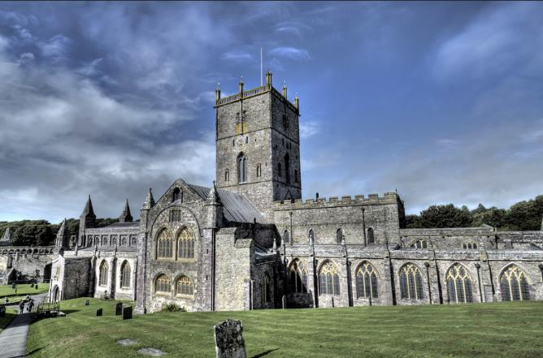
John Fielding/flickr St David’s Cathedral, Pembrokeshire, Wales
The Mission: Dedication to Christ
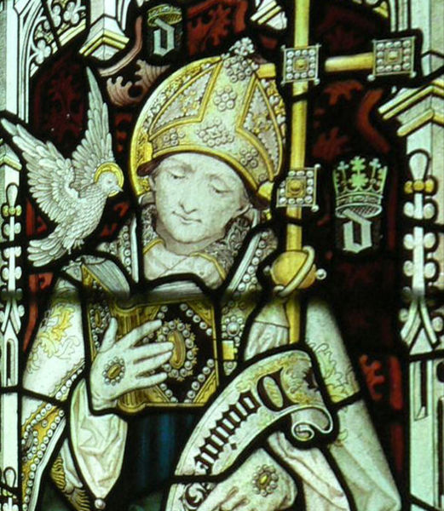
Stained glass window in Jesus College Chapel, Oxford, showing St David. Late 19th century.
In The Life of St David we hear about what life was like at St David’s monastery:
Therefore with increasing zeal they labour with hand and foot; they place the yoke on their shoulders; with unwearied arm they dig into the ground mattocks and spades; they carry in their saintly hands hoes and saws for cutting; they provide with their own labour all the necessities of the community. Possessions they regard with disdain; they reject the gifts of the unjust; they detest riches. No care of oxen is introduced for ploughing. Each to himself and the brethren is riches, each too an ox. When work was done, no complaint was heard, no conversation was held beyond what was necessary.
One of the things St David is renowned for, is the simplicity of life that was practised within his monastic order. As recounted above, the monks did not even use oxen to pull the plough. They did it themselves, which would have been back-breaking and exhausting work.
The monks are also attentive to the cycle of prayer and live communally: no one is to have possessions of their own and to say ‘my’ or ‘mine’; everything belongs to everyone in the monastery. The monks live on simple food and drink and look after one another and also all those who come for help.
Afterwards he was wont to spend the whole day, unshaken and unwearied, in teaching, praying, and genuflecting, in care for the brethren, and also in feeding a multitude of the bereft, orphans, widows, the needy, the weak, the infirm, and pilgrims. So he began, continued, and ended.
Rhygyfarch also tells us that if someone came wanting to be a monk, they were severely tested in their vocation, being sent away and rebuked at first. But if they persisted and were patient, they were eventually admitted as long as they gave up their former lives and all their possessions. St David however, refused to let them give their wealth to the monastery: a person had to enter spiritually ‘naked’ in order to enter into a new life completely dedicated to Christ.
Digging into the Mission – some things to do
- Find out about monks and nuns living in religious orders today. What different kinds of religious orders are there? Where and how do they live? What do they offer to people?
- Find out about things like living by a rule of life and the cycles of prayer. Could you live by a simple rule of life which shaped your day? Why not have a look for one?
- ‘Decluttering’ is quite a fashionable idea these days. If you were going to ‘declutter’ your life, what would you get rid of and why? What could you not bear to part with? Why not?
- What examples of famous preachers can you think of? Who are the most important teachers and helpers in your life? How have they shaped your ideas, thoughts and decisions? Have you ever thought about finding a spiritual director, spiritual companion or soul friend?

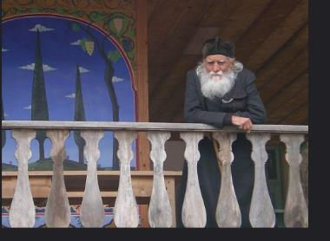
Lisa Cyr/flickr

The Miracles: Death and Restoration to Life

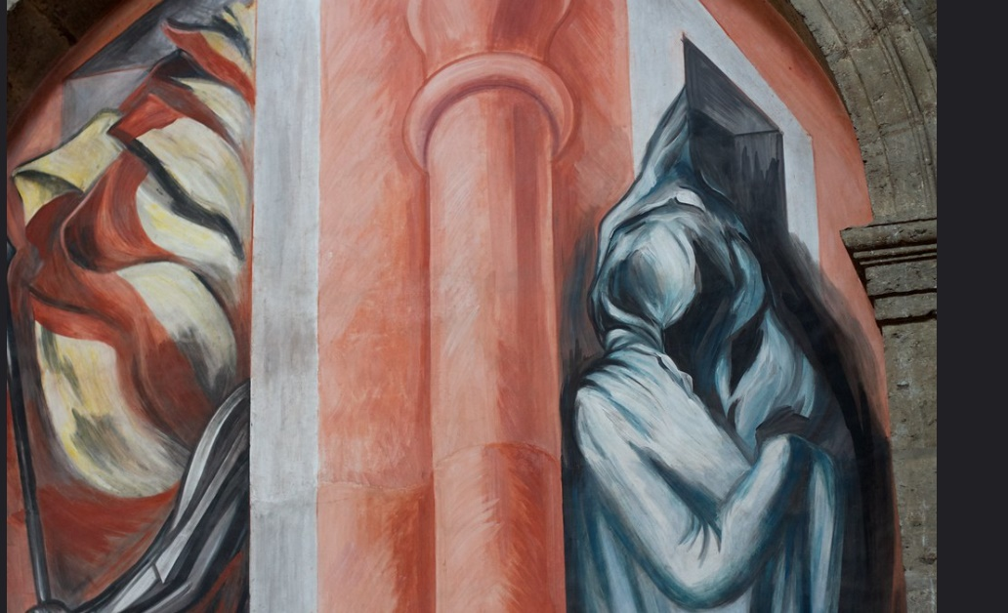
Alan Levine/flickr La Llorona or The Weeping Woman
art of José Clemente Orozco at Instituto Cultural Cabañas

They start out and arrive at a place very hear to the synod, and lo ! they hear lamentable mourning close by. Says the saint to his companions, " I will go where this great wailing may be." His companions answered and said, "We will go to the assembly lest our delay vexes those who are waiting for us." But the man of God went forward and came to the place where the lamentation was, by the river Teivi. And lo ! a widowed mother was watching over the body of her dead boy, who was called Magnus. Blessed David consoled the mother and comforted her with salutary admonitions, but she, having heard of his fame, threw herself at his feet, and begged with distressing appeals that he should have pity on her. The man of God, having compassion on human weakness, went near to the body of the deceased, and watered the face with tears, and threw himself on the body of .the dead, and prayed to the Lord, and said, " O Lord, my God, who didst descend into this world for us sinners from the bosom of the Father to redeem us from the jaws of the old enemy, have pity on this widow, and restore life to her only son, and breathe into him the breath of life, that Thy name may be magnified in all the earth." Then the limbs became warm, the soul re- turned, the body stirred. And taking the boy's hand, he restored him alive and well to his mother. The mother turns her sad weeping into joyful tears and says, "To me my son was dead, but to thee and God let him live hence- forth." The holy man took the boy and placed on his shoulders the copy of the Gospel which he always carried on his breast, and caused him to go with him to the synod. Afterward, as long as he lived, he led a holy life for many years. And all, who beheld that miracle, praised the Lord and holy David.
This extraordinary account of a miracle, with St David bringing a person back to life, is all about transformation. There is physical transformation, as the cold, dead body is changed back to its warm, living state. There is transformation for the mother of the boy, as her hopes and dreams are restored to her and her relationship with her son. There is spiritual transformation too, as the boy is set upon the path of the gospel, serving God and leading a holy life.
Many people who experience Christian conversion speak of this powerful sense of conversion, of being brought from ‘death’ to life, to restoration of relationships and to a sense of being called by Jesus to follow him in a life of discipleship. Many people speak of the sense of miracle, of being changed and want to tell that story of salvation and God’s challenge and love transforming their lives. So there is a great deal in this story, echoing the great healing miracles of Jesus, which reminds us that no matter how damaged our lives may be, Christ’s healing love can change us utterly.

Digging into the Miracle – something to do
- Do some research and find out about places where miracles are supposed to take place, or ‘thin places’ where people might go to feel close to God. See if you can find one near to where you live and go for a visit. Otherwise, why not just visit a local church (or a church you don’t normally visit) and see what about it speaks to you of a living faith.
- How would you start a conversation about miracles? How might telling the story of St David create a good framework for talking about faith?
- Miracles and prayer are closely related. People pray for something to change, - perhaps for help, or healing, or direction. How might God answer our prayers, but in a different way from what we expected?
- Many people pray in words, write down what they want to say and leave it at a particular place, or they might light a candle. But there are lots of other ways to pray, - creating visual prayers in a drawing or piece of sewing, or painting a pebble, or singing or chanting or playing an instrument. Some people like to create visual prayers which show what is being prayed for but leave spaces to show how God has responded afterwards, so the prayer is completed later, possibly much later. Why not have a go at doing prayer differently?

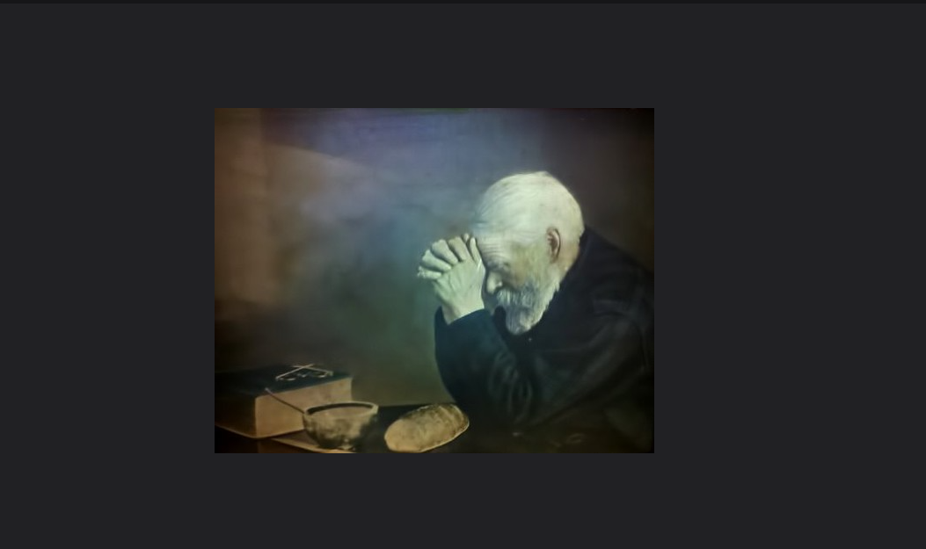
Chris Yarzab/flickr

The Mystery: 1st March – A Nation’s Saint

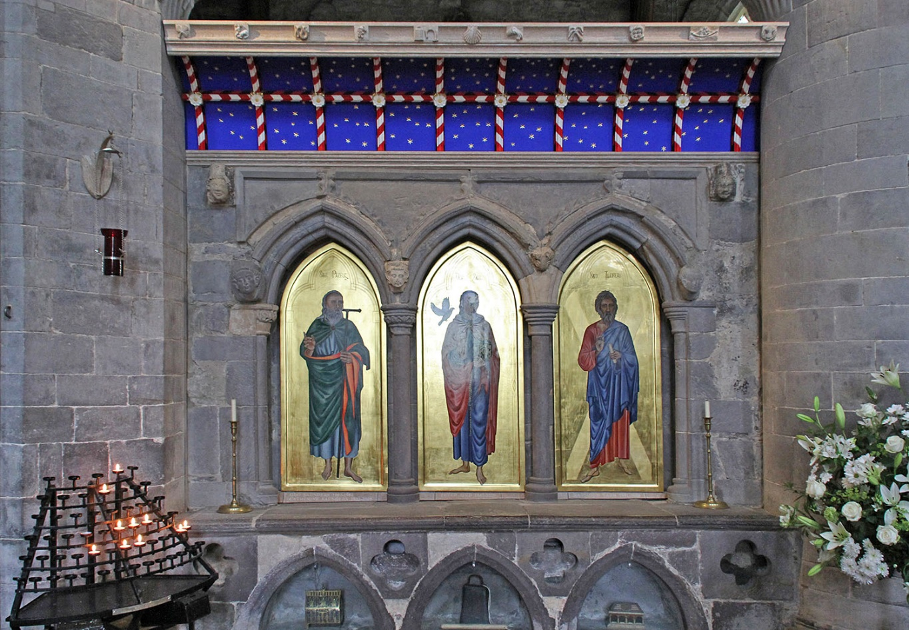
St Davids Shrine after restoration. Image: Tony Hisgett, CC BY 2.0.

Reimagining Relics and Shrines
In the early centuries of Christianity, the remains of holy men and women were considered especially precious and capable of working miracles. These relics were powerful objects to be treated with the utmost care and veneration. Wherever they rested, the place of their rest was to be considered holy and so very often became a place of pilgrimage as people sought out that holiness, often for superstitious reasons as well as genuine expressions of faith.
Today, we might wonder why Christians of the past set such store by bits of bone and human remains that may or may or not have belonged to a particular person from long ago, and why those Christians wanted to create shrines where people could start or end a pilgrimage, or kneel in prayer.
So how can we reimagine relics for today?
It might help to think about how relics point us to a physical body and a real person, and remind us that the saints are not some work of fiction or shadowy myth. In a sense, it doesn’t matter whether we can prove that such a relic actually belonged to this or that person; rather the relic points backwards in time to a human being made and loved by God, who lived and died and who can set us an example. Relics create linkages between miracle stories and the hard facts of our existence, - that we are creatures who live and die, and the fact that so many Christians have died because they loved God and were true to their faith – something which is still going on in the world today.
So what about shrines? Why does having a shrine to some person in an abbey or a cathedral have anything to do with modern Christian faith?
People still feel the urge to make temporary shrines today. If we read in the newspapers about people who have died by violence, who should have been safe and happy, you will doubtless see that many people come out in public to grieve and leave flowers, candles, gifts and messages at the places where they died, even if they did not know the people concerned. There is a powerful human urge to express solidarity and sadness when tragedies occur, as well as the need to look for change and hope. Shrines dedicated to saints do not tell us that the saint was more deserving of attention, but become fixed locations where people can pray, find solace and a more focused direction for the journey of faith. That is why pilgrimage as a physical journey can be a good way to reflect and ponder on where next in the Christian life you might want to go.
Some people find it helpful as part of their tradition to believe that saints can pray for us. But you don’t have to believe that to find praying at a shrine meaningful. Just the idea that we are part of an ancient tradition of pilgrimage and prayer can connect us, not just to our own Christian community but to so many who have gone before and believed that prayer is not an empty gesture but that God does hear us and respond to us, and that the Holy Spirit directs us and inspires us.
So the physical locations associated with the body of St David as a physical person who lived and died as a faithful Christian, have become places where people find inspiration for their own lives, healing and a sense of new life as they discover, through prayer and pilgrimage, what wonderful things God has in store for them.
Digging into the Mystery – something to do
- Imagine you are an archaeologist and have just discovered a small human bone from the time of St David. Now imagine the body the bone belonged to, and then imagine that body as a living, breathing person. Now imagine that person’s family around them, and their daily lives. What might they have eaten for dinner? What clothes might they have worn? How would they travel around and what dangers might they have faced? If you find it difficult to imagine, do a bit of research to find out about life in those days long ago.
- Now imagine having a conversation with St David back then. What might you want to talk about? What might you want to ask him?
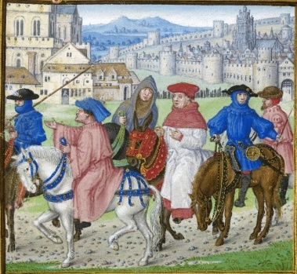
- Or: imagine meeting some pilgrims arriving at the monasteries founded by St David or meeting him on his journeys. Where might they have come from and what might they have hoped for?
- Or: go and visit one of the locations associated with St David, and talk to some of the other visitors about what they are doing there and what the visit means to them? See if that enables you to say something about your own faith and faith-journey.

David the Water-drinker
Because St David is said to have only eaten bread, herbs and vegetables and because he only ever drank water, David became known as Aquaticus or Dewi Ddyfrwr (the water drinker) in Welsh. He is associated with water in other ways. As a self-imposed penance he would also stand up to his neck in a lake of cold water, reciting Scripture. In telling us the story of St David, Rhygyfarch tells us that important events during his life were marked by the appearance of springs of water.
A story:
Wilf Davies, a farmer in the Teifi Valley, told the Guardian:
‘I’ve had the same supper for 10 years, even on Christmas Day: two pieces of fish, one big onion, an egg, baked beans and a few biscuits at the end. For lunch I have a pear, an orange and four sandwiches with paste. But I allow myself a bit more variety; I’ll sometimes have soup if it’s cold.
When I go to the supermarket, I know exactly what I want. I’m not interested in other food. I’ve never had Chinese, Indian, French food. Why change? I’ve already found the food I love. It would be a job to alter me. My uncle, a bachelor and farmer like me, had the same food for every meal. He had bread, butter, cheese and tea for breakfast, lunch and dinner (although he would bring out the jam for visitors).
Whether it’s Easter Day or Christmas Day, being a farmer means every day is the same. The animals still need to be fed. Feeding the sheep and seeing how happy they are makes me happy, too. They never ask for anything different for supper.’
https://www.theguardian.com/lifeandstyle/2021/apr/16/experience-ive-had-the-same-supper-for-10-years?CMP=fb_gu&utm_medium=Social&utm_source=Facebook&fbclid=IwAR1zcuB4QU3YWUI0dIt5ciwXygn8fs85BLkKSRD6f9YrbQc6-k9zpieVlDI#Echobox=1618569890

Responding to the challenge St David sets us:
- We might be encouraged to give up drinking alcohol in Dry January or for Lent. We might also choose to give up meat for particular periods of fasting or as a discipline. How does periods of fasting or abstinence from alcohol or other foods or drink make you feel?
- What do you think about Wilf’s story? Could you live on just a few simple foods, or is variety the spice of life? What do we need for a simple, but complete, diet to keep us healthy?
- St David is known for being a person who lived a very simple life. Do you think that simplifying life helps with your spiritual life?
- Why not start a conversation with someone you know and tell them something interesting about how St David is thought to have lived?
- Why not invite someone on a short pilgrimage to a church or other holy place and talk about the importance of simple things like walking and talking together?

Mike Finn/flickr

The Mission: Do the Little Things

Linda 1 day at a time/flickr

St David’s last words are alleged to have been: ‘Be joyful. Keep the faith. Do the little things that you have seen and heard me do’. These words can resonate for us because they invite us to count our blessings, love Jesus and attend to the small things in our lives which can have great impact. In Welsh, do the little things in life is often said: Gwnewch y pethau bychain mewn bywyd.
Quite often our Christian life can feel overwhelming, even burdensome. Some people are asked to do far too much and forget to take care of themselves and end up feeling burnt out and losing their faith under the pressure to do too many big things.
But when you think about it, it can be the little things that matter most: a kind word perhaps can completely change the sort of day a person is having. Just taking the time to notice that someone is having a hard time or ‘one of those days’ and helping with that can have an impact far beyond the time taken or the effort involved. A ‘little thing’, a detail observed and acted on, can be like a small stone in a pool, rippling out and having a much greater impact.
St David’s words are wise. When we delight in our faith and keep it, we can also become more attentive, more loving and more careful. When we get bogged down in worries, little things can be overlooked, making matters worse. In our own spiritual lives, we need to attend to the little things, the attention we give to prayer, to spending time with God, and to loving our neighbours as ourselves.

Responding to the Challenge St David sets us:
- What do you think are the ‘little things’ in your own life?
- Why do you think ‘do the little things’ is important to living a life of faith?
- What one small thing could you do in your own spiritual life, or living your faith out in the world, that would make a difference to others?
- Where do you see the ripples of the small things making a difference in your home, community or workplace?
- What ‘little things’ would you like to acknowledge, be thankful for, or celebrate in your church or Christian community?
- Why not go on a walk or a pilgrimage to a church or other holy place to meditate on joyful faith and the little things in life?
- What do you think St David wanted his friends to go and do after he had said these things? How could we best follow his example?

Ashok Boghani/flickr

The Miracles: The Coming of the Dove

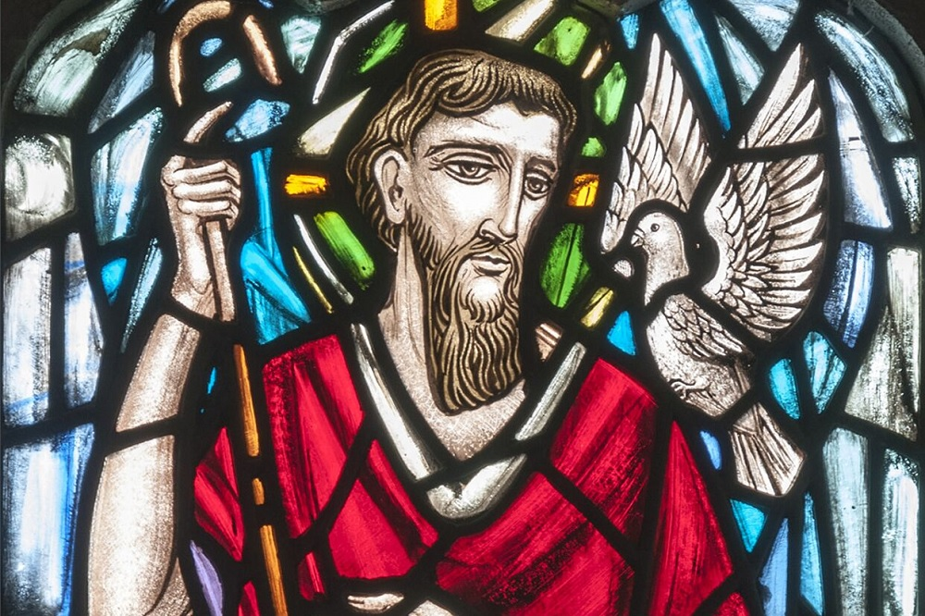

In representations of St David, we see a dove alighting on his shoulder. Traditionally, the dove is the symbol of peace, but also the symbol of the Holy Spirit, and can represent holiness, dedication to a holy life, but also the coming of wisdom, insight and inspiration. As in the baptism of Jesus, the coming of the dove can also represent God’s favour and delight in a person who has chosen the way of obedience and dedication to discipleship. When people saw the dove on St David’s shoulder they knew it was a sign that God had chosen him.
What does it mean to us today to seek the guidance and inspiration of the Holy Spirit, to have, as it were, the dove at our shoulder? Do we remember enough to trust in God’s spirit and Advocate to guide us and what would it mean for people to see the dove in our own lives and Christian witness?

Responding to the Challenge:
- Where do you find inspiration and a sense of God’s nearness?
- Who among your teachers and friends throughout your life has been for you a source of guidance, wisdom and grace?
- What do you think it means to be wise? How do you recognise a wise person? Who might you go to for advice, or trust to guide you well? What happens when people are let down or hurt by the people they think should be sources of wisdom?
- Have you been guided by the Spirit in your own life?
- Why not invite a friend to go on a walk, a visit to a church or make a short pilgrimage to a holy place to seek God’s guidance and wisdom for your life?
Frank Kiesel/flickr

The Mystery: Death Tapers

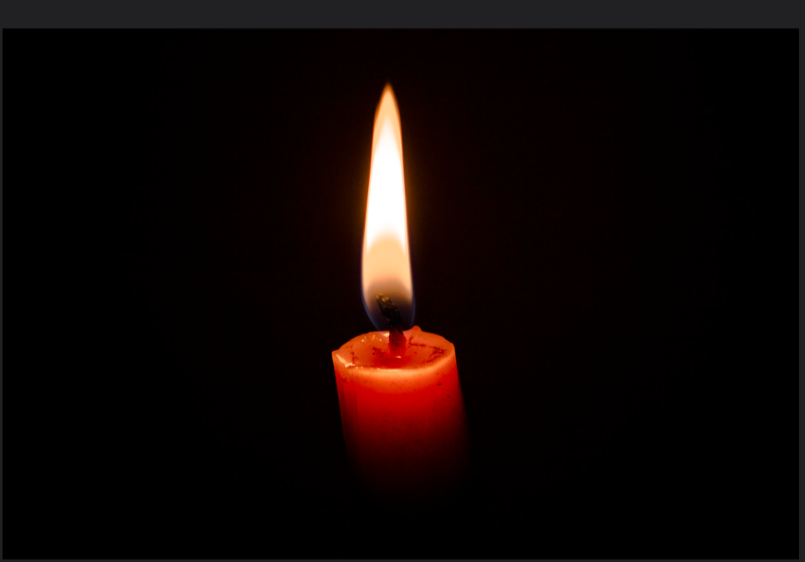
AKASH UK/flickr

Psalm 39.4-6 says:
‘Lord, let me know my end,
and what is the measure of my days;
let me know how fleeting my life is.
You have made my days a few handbreadths,
and my lifetime is as nothing in your sight.
Surely everyone stands as a mere breath. Selah
Surely everyone goes about like a shadow.
Surely for nothing they are in turmoil;
they heap up, and do not know who will gather.

Another tradition associated with St David is that his people implored him to ask God to send them some sign of when a death was near, so that a person would never have to die alone. God granted this wish by means of ‘corpse candles’, dimly flickering lights seen before houses or in streets which would alert people to send for a priest to attend the dying person and make sure they were appropriately accompanied in their transition from death to life with God. In some versions of this transition the length and colour of the candle light told others whether the person on the threshold of death was an adult or a child.
Corpse candles, as supernatural lights, appear in many cultures, and historically were considered a blessing, a generous gift to make sure that people got the chance to say goodbye, and depart in peace, going home to God.

Responding to the Challenge:
One of the things we might think about in relation to this tradition associated with St David is how we see ‘signs’ from God about the pathway our life should take.
- Have you ever received a sign that God is prompting you in a particular direction?
- If you look back over your life, how did you make choices and decisions? Was your faith a factor in the choices you made?
- If you come to a crisis or turning point in your life, what would convince you you were making a good decision or know that you had come to a point of spiritual growth?
- What kinds of spiritual signs might be a blessing to people in today’s world?
- If his people asked St David for the gift of death tapers, what kind of life tapers can we offer to younger people today?
- How can we be lights in the darkness for those who struggle and need companionship and kindness in their daily lives?
- Why not seek a spiritual companion on a walk around a church or other holy place to light a candle at the end of it for your own intentions?

Melvin E/flickr

